# Department of Computing

# Class: SE-7B

# Lab 1: Introduction to Python

# Date: 28-09-2016

# Time: 2pm-5pm

# Instructor: Dr. Muhammad Muddasir Malik

# Lab 1: Introduction to Python

**Introduction**

The purpose of this lab is to get familiar with Python programming language.

**Tools/Software Requirement**

Python

### Python Basics

The programming assignments in this course will be written in [Python](http://www.python.org/about/), an interpreted, object-oriented language that shares some features with both Java and Scheme. This tutorial will walk through the primary syntactic constructions in Python, using short examples.

We encourage you to type all python shown in the tutorial onto your own machine. Make sure it responds the same way.

#### Invoking the Interpreter

Python can be run in one of two modes. It can either be used *interactively*, via an interpreter, or it can be called from the command line to execute a *script*. We will first use the Python interpreter interactively.

You invoke the interpreter by entering python at the command prompt.   
Note: you may have to type python2.4, python2.5, python2.6 or python2.7, rather than python, depending on your machine.

[cs188-ta@nova ~]$ python   
Python 2.6.5 (r265:79063, Jan 14 2011, 14:20:15)   
[GCC 4.4.1] on sunos5   
Type "help", "copyright", "credits" or "license" for more information.   
>>>

#### Printing

#### We will use print to print messages.

#### >>> print(1 + 1)

2

>>> print("The Latin 'Oryctolagus cuniculus' means 'domestic rabbit'.")

#### Operators

The Python interpreter can be used to evaluate expressions, for example simple arithmetic expressions. If you enter such expressions at the prompt (>>>) they will be evaluated and the result will be returned on the next line.

>>> 1 + 1   
2   
>>> 2 * 3   
6

>>> 17//10  
1  
>>> -17//10  
-2  
  
>>> 27%10  
7  
>>> -27%10  
3

#### Operators Precedence

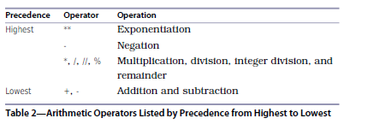

>>> 100+27/8+6  
109.375

#### Variables

>>> length= 22.0  
>>> width= 5.0  
>>> Area= length *width  
>>> Area  
110

Variables are called variables because their values can vary as the program executes. We can assign a new value to a variable:

>>> degrees_celsius = 26.0  
>>> 9 / 5 * degrees_celsius + 32  
78.80000000000001

>>> degrees_celsius = 0.0  
>>> 9 / 5 * degrees_celsius + 32  
32.0

>>> difference = 20  
>>> double = 2 * difference  
>>> double  
40

#### Augmented Assignment Operators

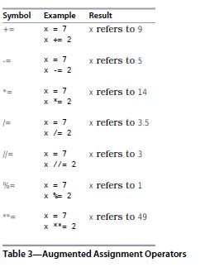

In order to split up a statement into more than one line, you need to do one of two things:

1. Make sure your line break occurs inside parentheses, or

2. Use the line-continuation character, which is a backslash, \.

Note that the line-continuation character is a backslash (\), not the division symbol (/).

Here are examples of both:

>>> (5 +  
… 3)  
8

>>> 5 + \  
… 3  
8

#### Input

Another built-in function that you will find useful is input, which reads a single line of text from the keyboard. It returns whatever the user enters as a string, even if it looks like a number:

>>> species = input()

Homo sapiens

>>> species

'Homo sapiens'

>>> population = input()

6973738433

>>> population

'6973738433'

In Python, every input result is char type. We can convert it into other types i.e int, float etc as:

>>> x= int(input())  
57

>>> x

57

There is no quotation marks which indicates that it is int type.

#### Lab Tasks:

1. Assign two variables and then swap their values.

2. Write a program that inputs three different integers from the keyboard, and then prints the sum, the average, the product. The screen dialogue should appear as follows:

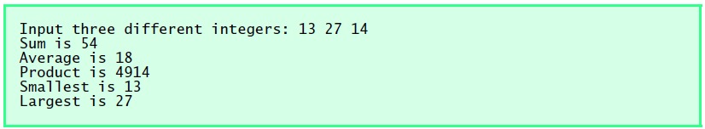

3. Write a program in C that inputs the radius of a circle and displays the circumference by using the formula

4. Write a program that inputs one five-digit number and then separates the number into its individual digits and prints the digits separated from one another by three spaces each. [Hint: Use combinations of integer division and the remainder operation.] For example, if the user types in 42139, the program should print:



5. Using only the techniques you have learned so far, write a program that calculates the squares and cubes of the numbers from 0 to 10 and uses tabs to print the following table of values:

