# Department of Computing

# Fundamental of Computer Programming

# Class: SE-7AB

# Lab 3: Introduction to Python

# Date: 5 October, 2016

# Time: 10am-1am & 2pm-5pm

# Instructor: Muhammad Muddasir Malik

# Lab 3: Operators Precedence, Augmented Assignment Operators & Functions

**Introduction**

The purpose of this lab is to get familiar with functions in Python.

**Tools/Software Requirement**

Python

#### Operators Precedence

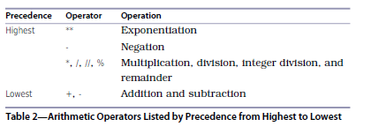

>>> 100+27/8+6  
109.375

#### Augmented Assignment Operators

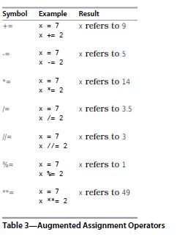

In order to split up a statement into more than one line, you need to do one of two things:

1. Make sure your line break occurs inside parentheses, or

2. Use the line-continuation character, which is a backslash, \.

Note that the line-continuation character is a backslash (\), not the division symbol (/).

Here are examples of both:

>>> (5 +  
… 3)  
8

>>> 5 + \  
… 3  
8

***Functions***

* abs() for absolute value of a number:

>>> abs(-9)  
9

>>> abs(3.3)  
3.3

$pow\left(a,b\right)= a^{b}$

$pow\left(a,b,c\right)=a^{b} \% c$

* round() function round-off the number
* If you’re not sure what a function does, try calling built-in function help, which shows documentation for any function:

>>> help(abs)

Help on built-in function abs in module built-ins:

abs(...)

abs(number) -> number

Return the absolute value of the argument

Apart from built-in functions, we can make function and can use it many times.

>>> def quadratic(a, b, c, x):

first = a * x ** 2

second = b * x

third = c

return first + second + third

>>> quadratic(2, 3, 4, 0.5)  
6.0

>>> quadratic(2, 3, 4, 1.5)  
13.0

***Lab Tasks***

1. Write a program that converts a person’s height from inches to centimeters, as well as feet. Use functions in your program.

**Hint: 1 inch = 2.54 cm**

1. Write a program that calculates the volume of a cylinder. Calculations must take place in a custom function.

Note: Take diameter as input.

1. Write a program that takes two numbers as input from the user and uses 10 functions of math module.
2. Implement the power function that takes 3 arguments.

Note: $power\left(a,b,c\right)= a^{b} \% c$