**Department of Computing**

**CS 212: Object Oriented Programming**

**Class: BESE-7AB**

**Lab02: Control Structures**

**Date: February 24, 2017 Instructor:**

**Dr. Muhammad Muneeb Ullah**

# Activity #1

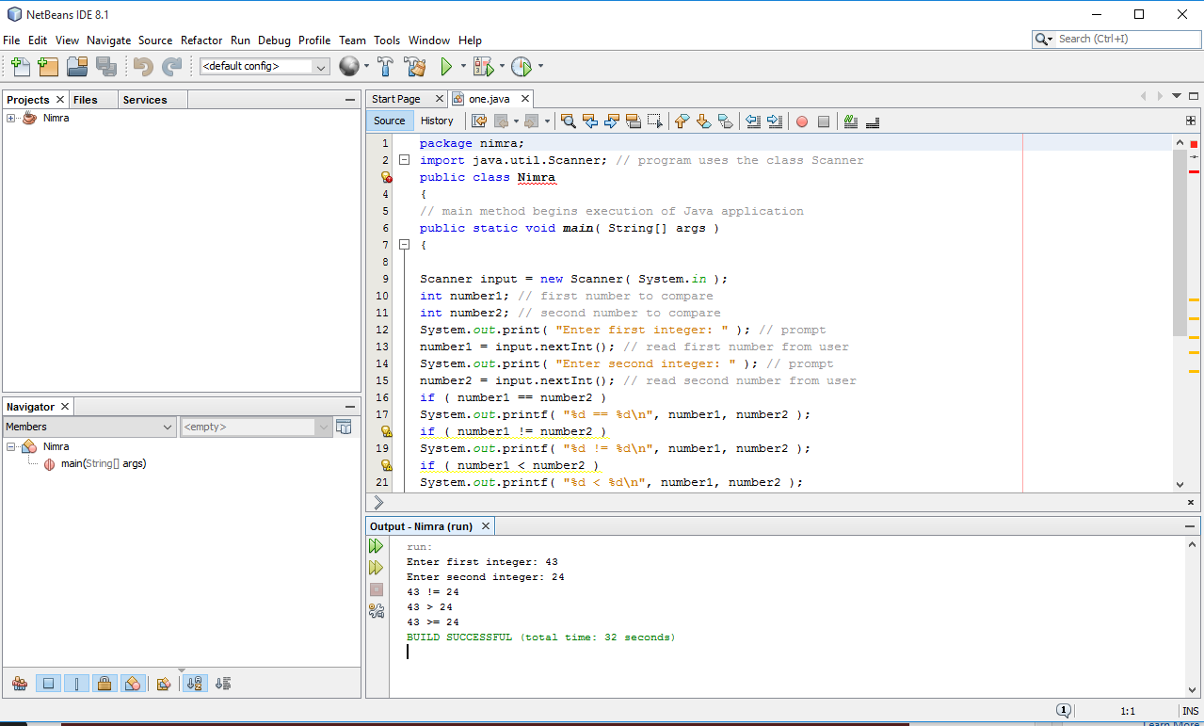

# Activity #2

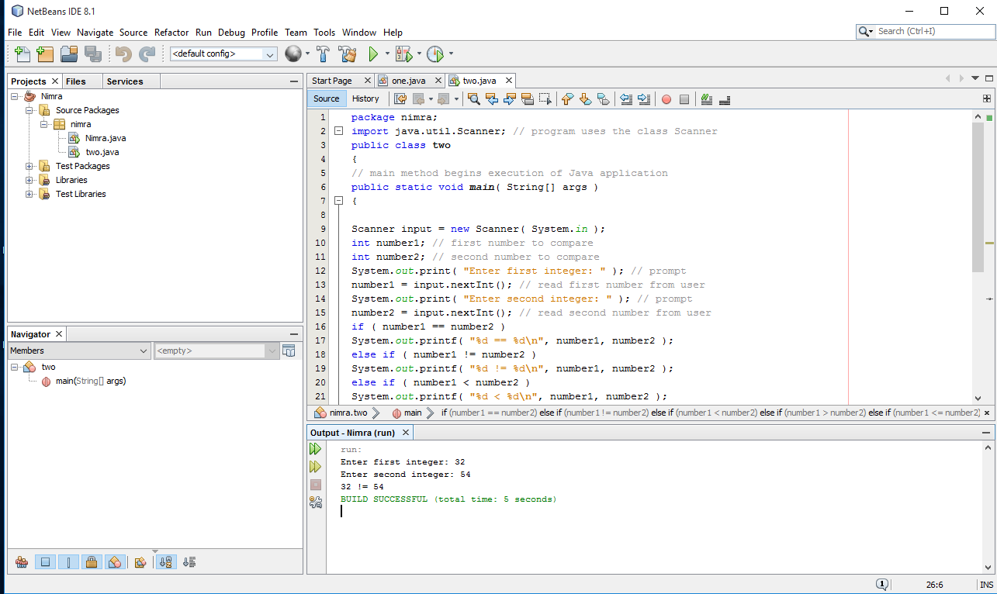

# Activity #3

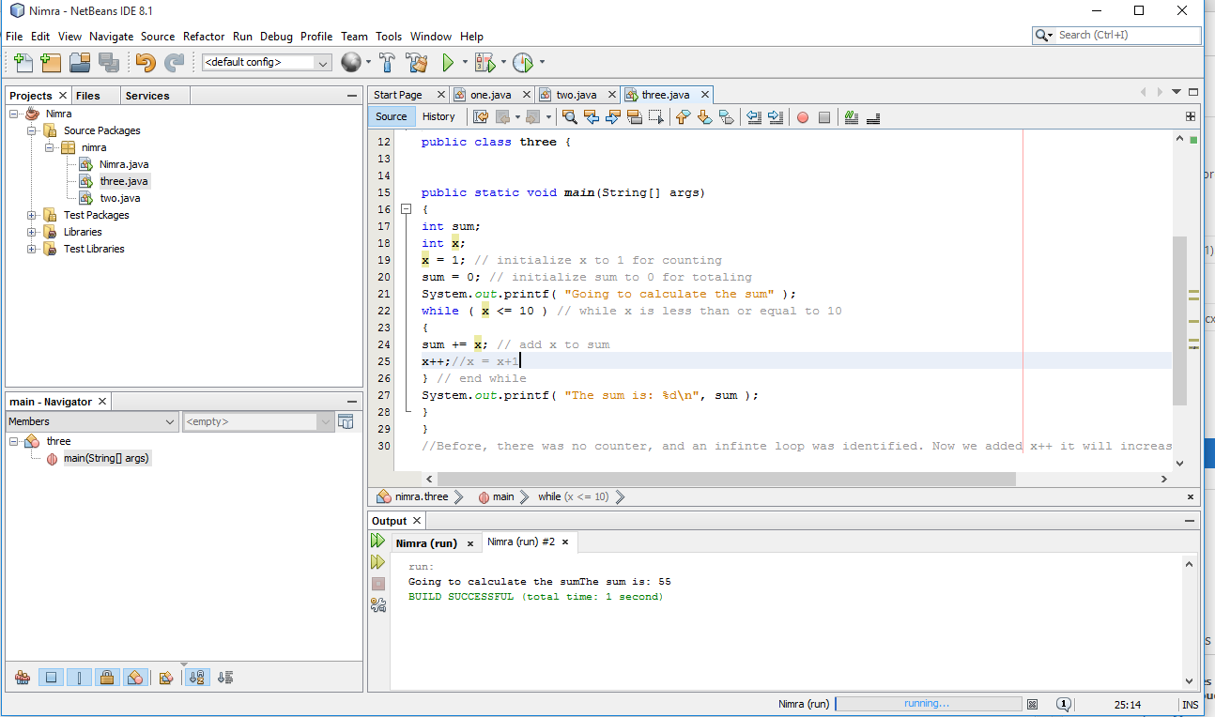

# Activity #4

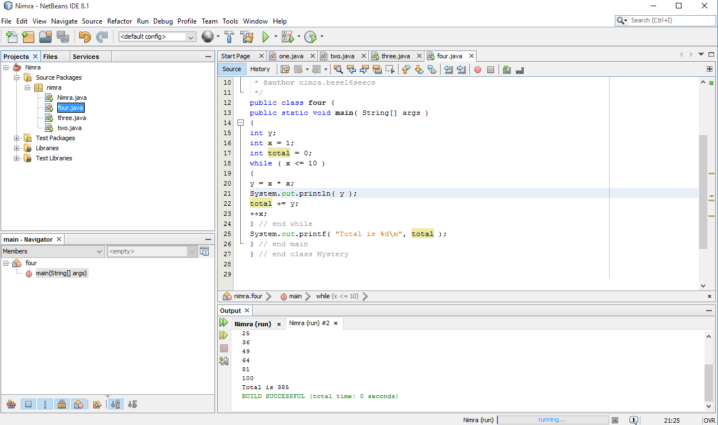

# Task #1

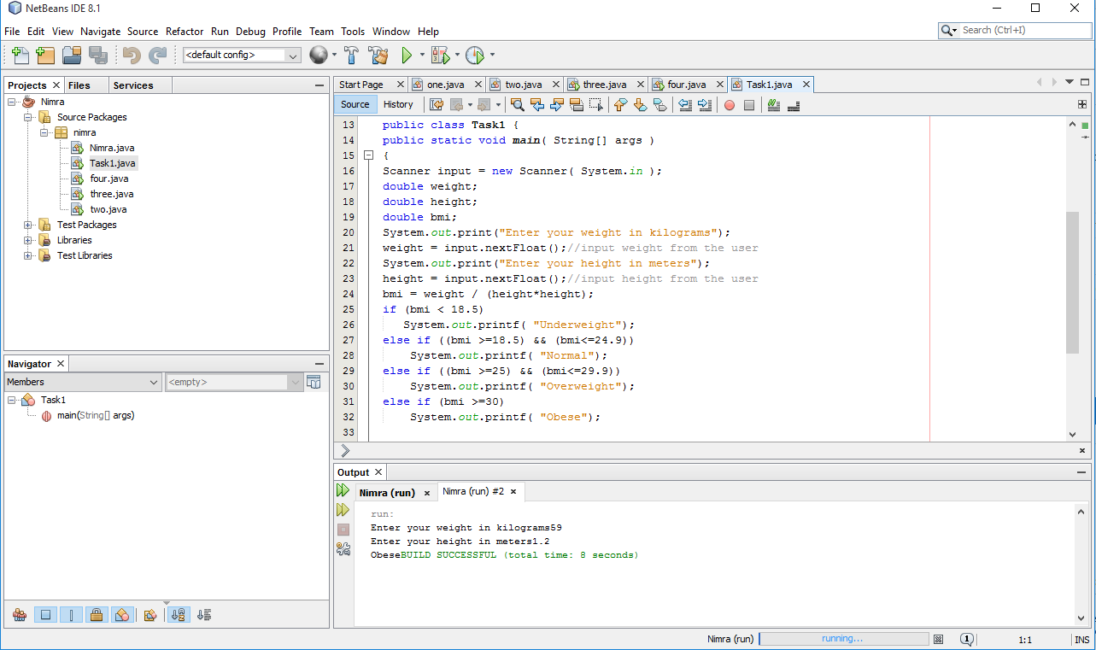

# Task #2

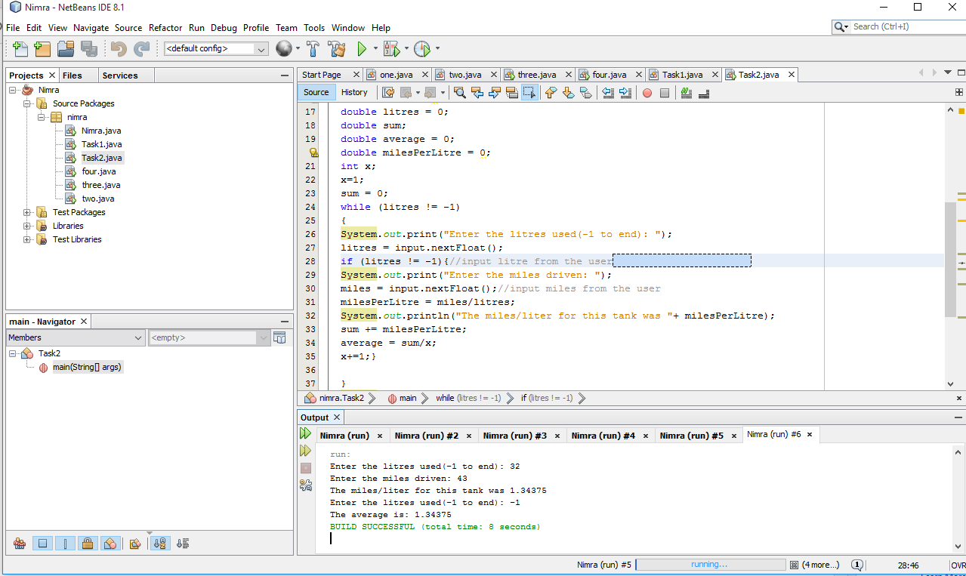

# Task #3

