WEEK 1 TASK
Data Acquisition, Cleaning, and Exploratory Analysis
Public Dataset: Iris Flower Dataset
Tools: Python, Pandas, NumPy, Matplotlib
Prepared as a Week 1 data-science workflow report

Item | Details
Dataset | Iris
Source | UCI Machine Learning Repository
Original records | 150
Features | 4 numeric measurements + 1 categorical class
Cleaning performed | Type validation, missing-value check, duplicate removal
Final records | 149
Visualizations | 4
Estimated work time | 32 hours

1. Objective
The objective of this task is to demonstrate a complete introductory data-preparation workflow: acquire a publicly available dataset, inspect its structure, clean and validate the data, perform exploratory data analysis (EDA), create meaningful visualizations, and document the reasoning behind each step. The Iris dataset was selected because it is small, well documented, publicly available, and contains both numerical measurements and a categorical target suitable for EDA.

2. Data Acquisition
The Iris dataset is a classic tabular dataset originally introduced by R. A. Fisher. The current UCI Machine Learning Repository entry lists 150 instances, four continuous features, and three iris classes. The repository also states that the dataset has no missing values and is licensed under CC BY 4.0. The dataset can be imported using the UCI repository interface or downloaded as iris.data.
Dataset source:
https://archive.ics.uci.edu/dataset/53/iris
The report workflow uses the following five fields:
Column | Type | Meaning
sepal_length | Numeric | Sepal length in cm
sepal_width | Numeric | Sepal width in cm
petal_length | Numeric | Petal length in cm
petal_width | Numeric | Petal width in cm
class | Categorical | Iris species: setosa, versicolor, virginica

2.1 Acquisition code
import pandas as pd
url = "https://archive.ics.uci.edu/ml/machine-learning-databases/iris/iris.data"
columns = ["sepal_length", "sepal_width", "petal_length",
"petal_width", "class"]
df = pd.read_csv(url, names=columns)
print(df.head())
print(df.shape)
For reproducibility, the final report also stores a local CSV copy of the dataset used for the analysis. The UCI page is the authoritative dataset reference, while the analysis below focuses on the 150-row Iris data structure.

3. Initial Data Inspection
The initial dataset contains 150 rows and 5 columns. The four measurement columns are numeric and the class column is categorical. A missing-value check found 0 missing cells. One duplicate row was detected during preprocessing.

3.1 Inspection code
print(df.head())
print(df.tail())
print(df.shape)
print(df.dtypes)
print(df.isnull().sum())
print(df.duplicated().sum())
print(df.describe())

4. Data Cleaning and Preprocessing
The cleaning process was deliberately simple because the dataset is already relatively clean. First, text values in the class column were standardized with strip/lower operations. The four measurement columns were explicitly converted to numeric values with invalid values coerced to missing values. Missing values were then checked and would be imputed with the median for numeric columns and the mode for the categorical column if they were present. Finally, duplicate records were removed.
Check / action | Before | After / result
Rows | 150 | 149
Columns | 5 | 5
Missing cells | 0 | 0
Duplicate rows | 1 | 1 removed
Numeric conversion | 4 measurement fields | Validated as numeric
Class values | Text labels | Standardized lowercase labels

4.1 Cleaning code
clean = df.copy()
clean["class"] = clean["class"].astype(str).str.strip().str.lower()
numeric_cols = [
"sepal_length", "sepal_width",
"petal_length", "petal_width"
]
for col in numeric_cols:
clean[col] = pd.to_numeric(clean[col], errors="coerce")
for col in numeric_cols:
if clean[col].isna().any():
clean[col] = clean[col].fillna(clean[col].median())
if clean["class"].isna().any():
clean["class"] = clean["class"].fillna(clean["class"].mode()[0])
clean = clean.drop_duplicates().reset_index(drop=True)
After preprocessing, the working dataset contains 149 unique records. No missing values remained, and the measurement fields were ready for statistical analysis and visualization.

5. Exploratory Data Analysis
EDA was performed using descriptive statistics, class-wise summaries, distribution plots, a scatter plot, and a correlation matrix. The purpose was to identify differences among the three classes and relationships between the measured flower dimensions.

5.1 Descriptive statistics
Statistic | sepal_length | sepal_width | petal_length | petal_width
mean | 5.844 | 3.060 | 3.749 | 1.195
std | 0.831 | 0.436 | 1.768 | 0.763
min | 4.300 | 2.000 | 1.000 | 0.100
50% | 5.800 | 3.000 | 4.300 | 1.300
max | 7.900 | 4.400 | 6.900 | 2.500

5.2 Class-wise means
Class | sepal_length | sepal_width | petal_length | petal_width
setosa | 5.006 | 3.428 | 1.462 | 0.246
versicolor | 5.936 | 2.770 | 4.260 | 1.326
virginica | 6.604 | 2.980 | 5.561 | 2.029

6. Visualizations and Observations
Visualization 1 — Class distribution
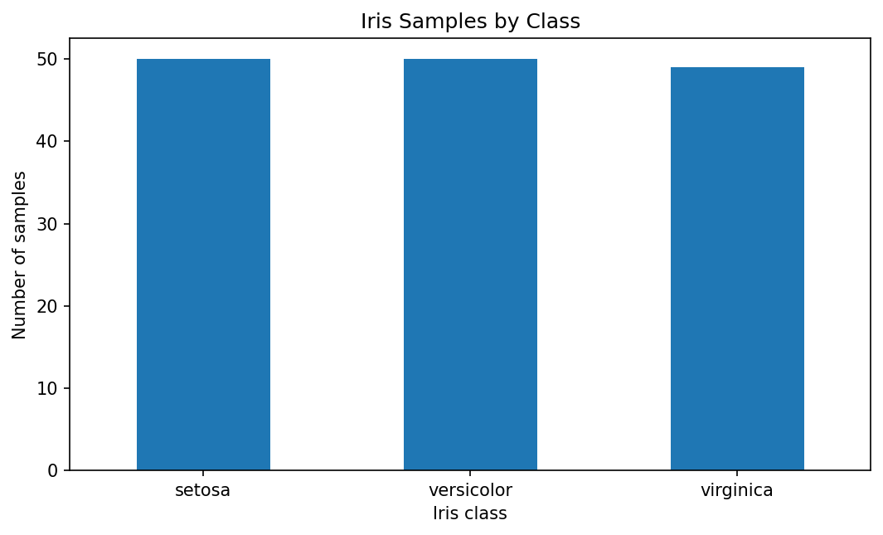
Observation: the three classes are represented almost equally. The original Iris dataset contains 50 examples of each class; duplicate removal changes the total unique-record count but does not remove an entire class.
Visualization 2 — Petal length distribution by class
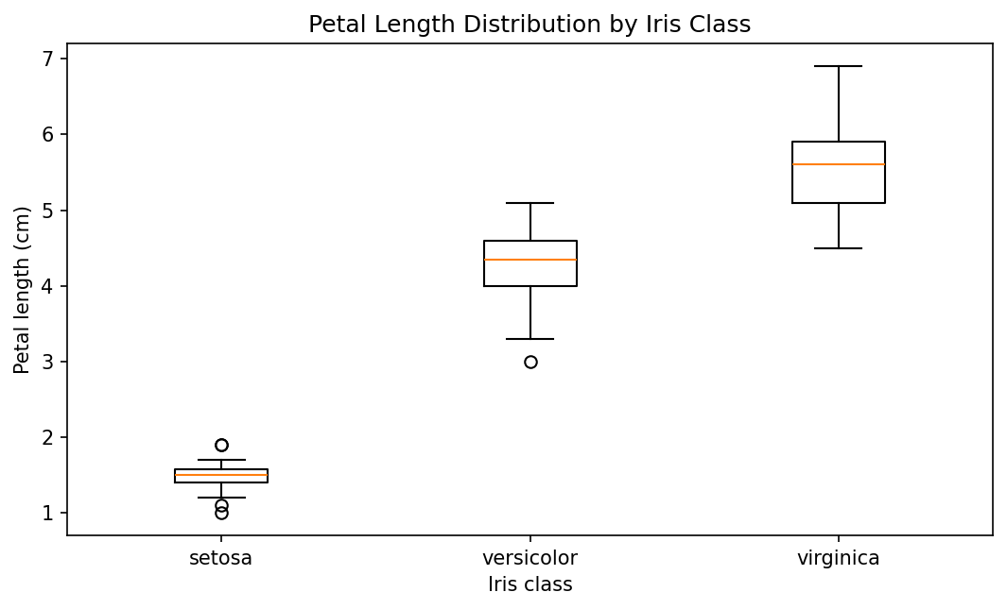
Observation: setosa has substantially shorter petals than versicolor and virginica. The versicolor and virginica distributions are higher and overlap more than setosa does with either of them.
Visualization 3 — Petal length versus petal width
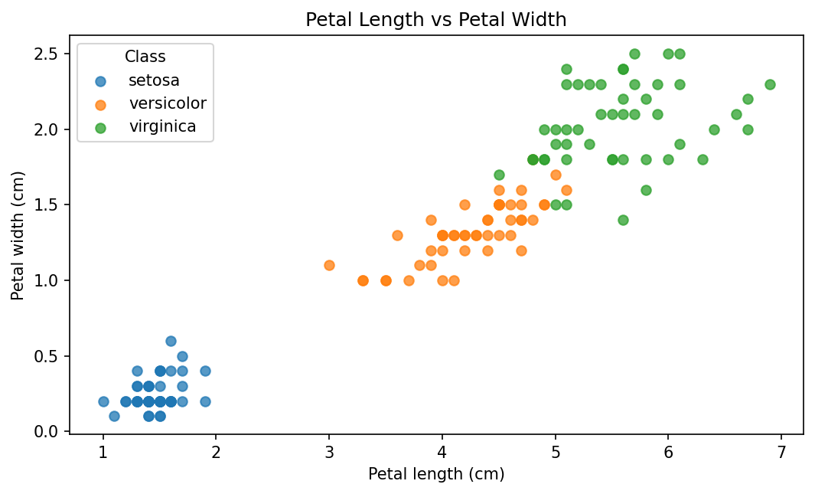
Observation: petal length and petal width increase together, and the three classes form visually distinct groups. Setosa occupies a compact low-length/low-width region, while versicolor and virginica occupy higher ranges with some separation.
Visualization 4 — Correlation matrix
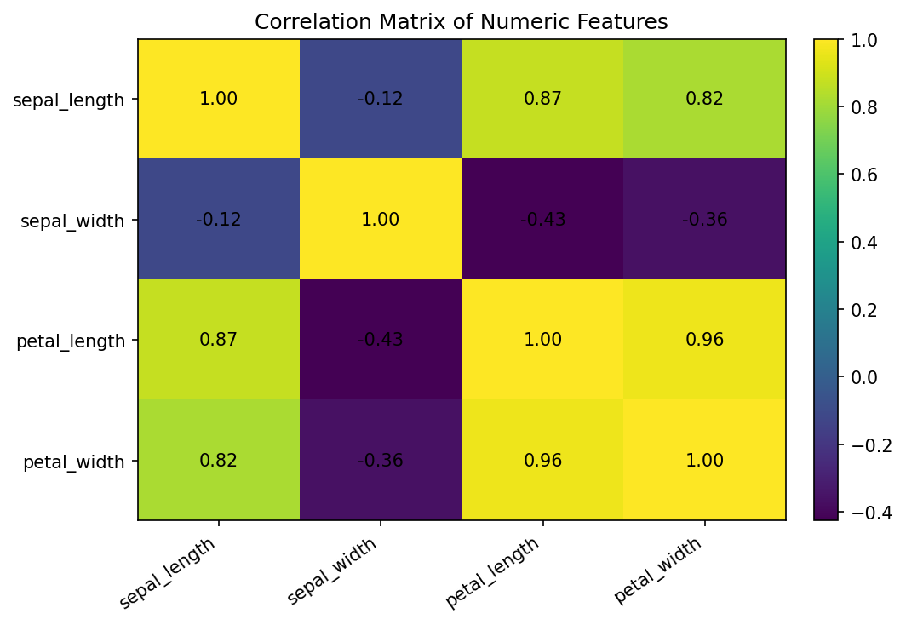
Observation: petal length and petal width have a very strong positive correlation (0.96). Sepal length is also strongly positively associated with petal length (0.87) and petal width (0.82). Sepal width has weaker relationships with the other measurements.

7. Key EDA Code Snippets
# Class counts
print(clean["class"].value_counts())
# Class-wise means
print(clean.groupby("class")[numeric_cols].mean())
# Correlations
print(clean[numeric_cols].corr())
import matplotlib.pyplot as plt
# Scatter plot
for cls in clean["class"].unique():
subset = clean[clean["class"] == cls]
plt.scatter(
subset["petal_length"],
subset["petal_width"],
label=cls
)
plt.xlabel("Petal length (cm)")
plt.ylabel("Petal width (cm)")
plt.title("Petal Length vs Petal Width")
plt.legend()
plt.show()

8. Summary of Insights
- The dataset is small and balanced, with three flower classes represented in nearly equal numbers.
- The cleaning stage confirmed that the numeric measurement fields are suitable for quantitative analysis.
- One duplicate record was removed during preprocessing, leaving 149 unique rows for the cleaned EDA dataset.
- Petal length and petal width show the strongest linear relationship among the four measurements.
- Setosa is clearly separated from the other two classes using petal dimensions, while versicolor and virginica have more overlap.
- Class-wise means show a steady increase in petal length and petal width from setosa to versicolor to virginica.
- The EDA suggests that petal measurements are informative variables for a later classification task, although this report does not build or evaluate a predictive model.

9. Potential Areas for Further Analysis
- Build classification models such as Logistic Regression, Decision Tree, K-Nearest Neighbors, or Support Vector Machine.
- Use train/test splitting and cross-validation to evaluate generalization.
- Standardize features and compare model performance before and after scaling.
- Investigate feature importance and dimensionality reduction using PCA.
- Evaluate confusion matrices and per-class precision, recall, and F1-score.

10. Methodology and Reproducibility
The workflow followed a reproducible sequence: identify a public dataset; load it into a Pandas DataFrame; inspect dimensions, types, missing values, duplicates, and descriptive statistics; clean and validate fields; remove duplicate records; calculate class-wise statistics and correlations; create visualizations; and document the findings. The report does not claim predictive accuracy because no machine-learning model was trained as part of this Week 1 task.

11. Estimated Time Frame
Activity | Estimated time
Dataset selection and source review | 3 hours
Data acquisition and initial inspection | 4 hours
Cleaning and preprocessing | 6 hours
Descriptive statistics and EDA | 7 hours
Visualization creation and interpretation | 6 hours
Documentation, code snippets, and review | 6 hours
Total | 32 hours
The planned effort is approximately 32 hours, which is within the requested 30–35 hour estimated time frame.

12. Conclusion
This Week 1 task demonstrates the complete foundation of a data-science workflow using the public Iris dataset. The data was inspected, validated, cleaned, and explored with Python. The analysis identified strong relationships among petal measurements and clear distribution differences between the iris classes. The resulting visualizations and documented code provide a reproducible starting point for future statistical analysis or machine-learning work.

13. References
1. UCI Machine Learning Repository, Iris Dataset, Dataset ID 53. https://archive.ics.uci.edu/dataset/53/iris
2. Fisher, R. A. (1936). The use of multiple measurements in taxonomic problems. Annals of Eugenics, 7(2), 179–188.

Appendix A — Submission Checklist
✓ Publicly available dataset identified and documented.
✓ Data acquisition method and Python code included.
✓ Data cleaning and preprocessing rationale included.
✓ Missing-value and duplicate checks documented.
✓ At least three visualizations included (four provided).
✓ Exploratory observations and insights summarized.
✓ Detailed code snippets included.
✓ Report is organized with headings and subheadings.
✓ Estimated effort documented as 32 hours.

