WEEK 2 TASK
Advanced Data Visualization and Storytelling with Python
Dataset: UCI Wine Recognition Dataset
Tools: Python, Pandas, Matplotlib, scikit-learn
Focus: Turning multivariate data into a clear analytical narrative
Project item | Details
Dataset | UCI Wine Recognition Dataset
Observations | 178
Variables | 13 chemical measurements + class label
Classes | 3 wine classes
Visualizations | 6
Advanced technique | PCA after standardization
Estimated workload | 33 hours

1. Objective
This task extends the Week 1 data workflow from basic exploration to advanced visualization and data storytelling. The goal is not only to produce charts, but to arrange them into a coherent narrative that a non-technical reader can follow. The analysis asks three questions: how are the wine classes distributed, which chemical measurements distinguish the classes, and whether the multivariate feature space reveals broader structure when viewed together.

2. Dataset Selection and Context
The UCI Wine Recognition dataset contains chemical analysis results for wines grouped into three classes. It has 178 observations and 13 numeric features, including alcohol, malic acid, ash, magnesium, flavanoids, color intensity, hue, proline, and other measurements. The dataset is publicly accessible through the UCI Machine Learning Repository and is a standard example of multivariate scientific data.
The dataset was selected because it supports a strong visual story: individual features can be compared, relationships between features can be explored, and dimensionality reduction can summarize many variables in a two-dimensional view.
Reference: UCI Machine Learning Repository, Wine Recognition Dataset (Dataset ID 109): https://archive.ics.uci.edu/dataset/109/wine

3. Data Readiness and Preprocessing
The working dataset contains 178 rows and 14 columns. The analysis found 0 missing cells and 0 duplicate rows in the loaded copy. The class field was represented using readable wine-class labels. Because PCA is sensitive to feature scale, the 13 numeric features were standardized to zero mean and unit variance before PCA was applied. No aggressive transformation was performed so that the original measurement structure remained interpretable.
Check | Result | Decision
Rows / columns | 178 / 14 | Retained
Missing values | 0 | No imputation required
Duplicate rows | 0 | No duplicate removal required
Feature scale | 13 numeric variables use different units | Standardized before PCA
Categorical field | 3 class labels | Mapped to readable labels

4. Data Story: From Overview to Multivariate Structure
The visual narrative follows an intentional sequence. First, the audience sees the composition of the dataset. Next, one feature is isolated to reveal differences among groups. A two-feature scatter plot then shows how combinations of variables can separate classes. The correlation heatmap widens the lens to relationships across all 13 measurements. A standardized class-profile heatmap compares group-level patterns across selected variables. Finally, PCA compresses the full multivariate feature space into two dimensions, allowing the reader to see whether the earlier patterns persist when many variables are considered simultaneously.

5. Advanced Visualizations

5.1 Visualization 1 - Sample Distribution
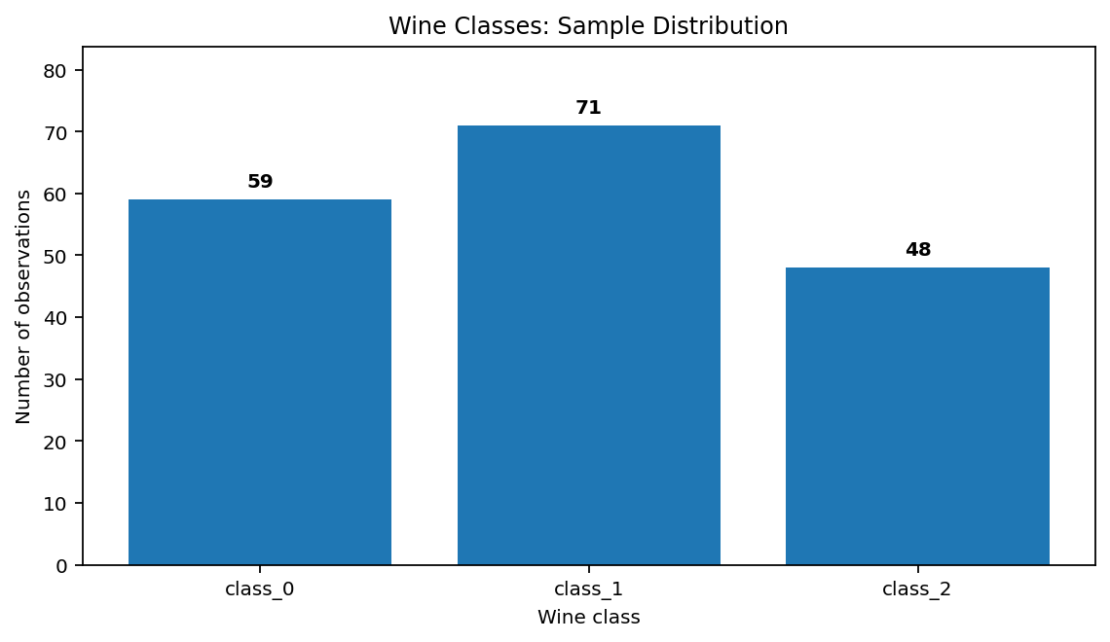
Figure 1. Number of observations in each wine class.
Narrative role: This chart establishes the baseline composition of the dataset. The class counts are not identical, so later visual comparisons should be interpreted with awareness that the groups have different sample sizes. This is important for preventing the visual story from being mistaken for a perfectly balanced experiment.

5.2 Visualization 2 - Proline Distribution by Class
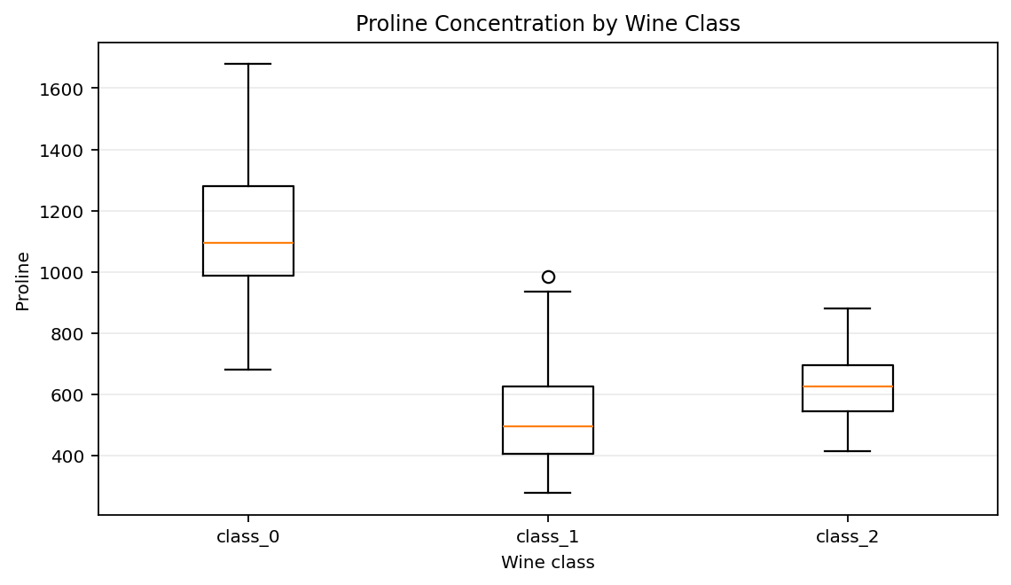
Figure 2. Distribution of proline values across the three wine classes.
Narrative role: The box plot moves from counts to a distributional question. It shows the center, spread, and potential outliers of proline within each class. The classes occupy noticeably different ranges, indicating that this single chemical measurement carries information about class differences. The use of a box plot makes both within-class variability and between-class separation visible at the same time.

5.3 Visualization 3 - Alcohol versus Flavanoids
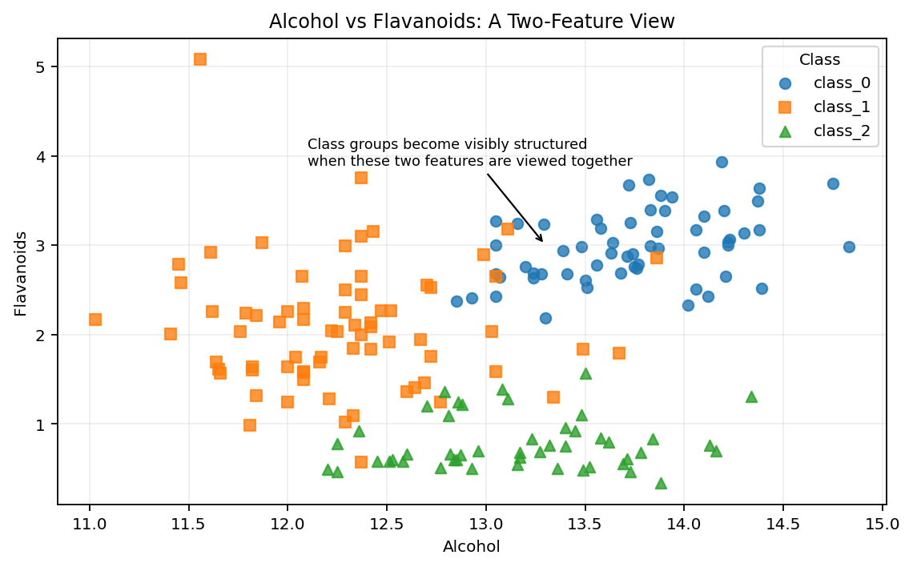
Figure 3. Two-feature relationship between alcohol and flavanoids, separated by class.
Narrative role: A scatter plot adds the idea of interaction. Instead of looking at one variable at a time, the chart shows how two measurements combine to form structured groups. The class clusters are visibly different, showing why multivariate analysis is useful when the question is classification or group profiling rather than simple summary statistics.

5.4 Visualization 4 - Full Correlation Matrix
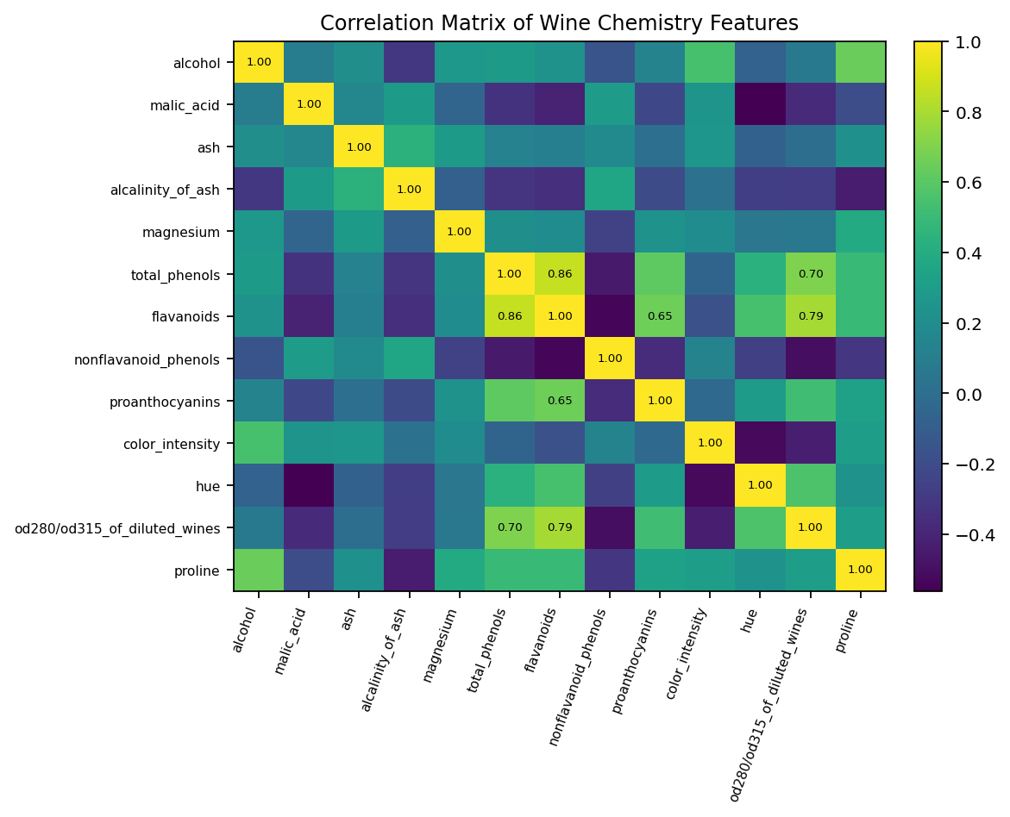
Figure 4. Pairwise correlations among all 13 numeric chemical features.
Narrative role: The correlation heatmap expands the story from two variables to the whole feature set. Several feature pairs show strong positive or negative associations, indicating that some measurements carry related information. This matters for later modeling because highly related predictors can reduce the amount of independent information available to a model and can complicate direct interpretation of individual coefficients.

5.5 Visualization 5 - Class Profile Heatmap
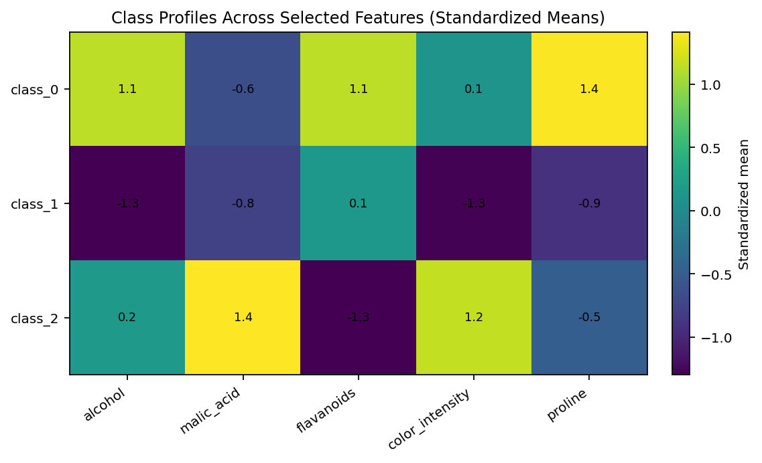
Figure 5. Standardized class means for selected chemical features.
Narrative role: This chart compares the three classes across several selected variables simultaneously. Standardizing each feature converts the different measurement scales into comparable deviations from the overall feature mean. The result is a compact profile view that helps a non-technical reader see how the classes differ in relative chemical composition rather than comparing raw units that are not directly comparable.

5.6 Visualization 6 - PCA Projection
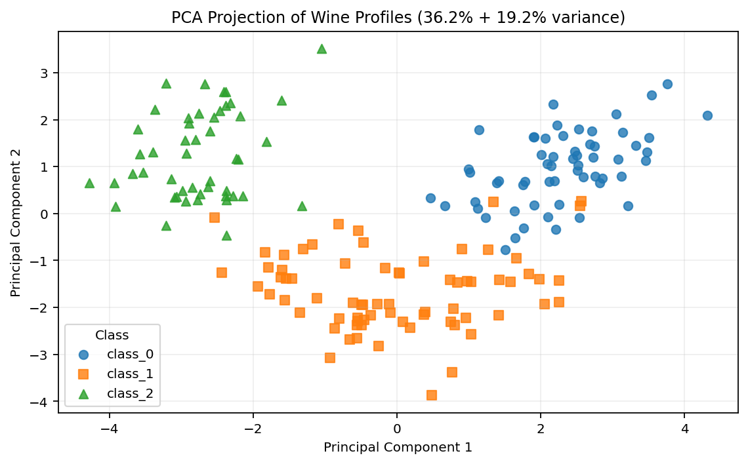
Figure 6. PCA projection after standardization; PC1 explains 36.2% and PC2 explains 19.2% of standardized variance.
Narrative role: PCA provides the final synthesis. Thirteen variables are reduced to two principal components so that the overall structure can be visualized at a glance. The plot shows that the three classes occupy different regions of the reduced feature space, supporting the earlier observation that the classes have multivariate structure rather than being separated by a single measurement alone. PCA is a visualization and dimensionality-reduction technique here; it is not being presented as a predictive model.

6. Key Insights from the Visual Story
- The dataset contains three wine classes with different sample counts, so class size should be considered when comparing group-level patterns.
- Proline shows visible between-class differences in both central tendency and spread, making it a useful feature for understanding class profiles.
- The alcohol-versus-flavanoids scatter plot reveals structured clusters, demonstrating that combinations of features can provide clearer separation than one feature in isolation.
- The correlation matrix shows that the chemical variables are not independent; some measurements move together strongly while others have weaker relationships.
- The standardized class-profile heatmap shows distinct multivariate signatures across selected chemical properties.
- The PCA projection preserves visible class structure in a two-dimensional summary of all 13 standardized measurements, giving a compact overview of the dataset for a non-technical audience.

7. Potential Scientific and Business Implications
From a scientific perspective, the visuals suggest that chemical measurements contain structured information about the wine classes. A future analysis could investigate which variables contribute most strongly to discrimination and whether the observed relationships remain stable under cross-validation. The findings can also motivate domain-specific questions about how chemical composition varies between groups.
From a business or operational perspective, a well-designed visual story can support quality-control dashboards, product profiling, or exploratory segmentation workflows. These visualizations could help analysts identify unusual observations, understand group profiles, and decide which variables deserve closer measurement or monitoring. The dataset itself is a benchmark rather than evidence for commercial wine decisions, so the implications should be treated as methodological examples rather than direct recommendations.

8. Visualization Design Choices and Rationale
Chart | Why this chart was chosen | Question answered
Bar chart | Fast comparison of group counts | How is the dataset distributed?
Box plot | Shows center, spread, and outliers | How does one feature differ by class?
Scatter plot | Reveals two-feature patterns and clusters | Do feature combinations separate groups?
Correlation heatmap | Compresses many pairwise relationships | Which variables move together?
Profile heatmap | Compares classes across multiple features | What is each class's multivariate signature?
PCA scatter | Summarizes many standardized variables | Does overall feature structure separate classes?
The visualizations were intentionally ordered from simple to complex. Captions explain what the reader should notice instead of merely naming the chart type. This supports the task requirement to create a coherent narrative for a non-technical audience.

9. Key Python Code Snippets
from sklearn.datasets import load_wine
from sklearn.preprocessing import StandardScaler
from sklearn.decomposition import PCA
wine = load_wine(as_frame=True)
df = wine.frame.copy()
df["class"] = df["target"].map(dict(enumerate(wine.target_names)))
df = df.drop(columns=["target"])
# Standardize 13 numeric features before PCA
X = StandardScaler().fit_transform(df[wine.feature_names])
pca = PCA(n_components=2, random_state=42)
pc = pca.fit_transform(X)
print(pca.explained_variance_ratio_)
# Scatter plot with class-level annotation
for cls in wine.target_names:
subset = df[df["class"] == cls]
plt.scatter(subset["alcohol"], subset["flavanoids"],
label=cls, alpha=0.8)
plt.xlabel("Alcohol")
plt.ylabel("Flavanoids")
plt.legend(title="Class")
plt.show()

10. Further Analysis
- Train and compare classification models such as Logistic Regression, K-Nearest Neighbors, Decision Tree, and Support Vector Machine.
- Use cross-validation and confusion matrices to test whether the visible class separation translates into reliable predictive performance.
- Examine feature importance or model coefficients to identify variables that contribute most to classification.
- Test alternative dimensionality-reduction methods and compare their stability with PCA.
- Create an interactive dashboard using Plotly or another visualization library for filtering classes and features.

11. Estimated Workload
Activity | Hours
Dataset selection and source review | 3
Data validation and preprocessing | 5
Exploratory analysis and feature selection | 6
Visualization development and experimentation | 10
Storytelling, annotations, and interpretation | 5
Documentation, code cleanup, and final review | 4
Total | 33
The estimated effort is 33 hours, which fits the requested 30-35 hour workload range.

12. Conclusion
This Week 2 project transforms a multivariate wine dataset into a structured visual narrative. The sequence begins with composition, moves through distribution and two-feature relationships, expands to correlation and class profiles, and ends with a PCA summary of the full feature space. Together, the six visualizations communicate both specific patterns and the broader multivariate structure. The main lesson is that effective data storytelling depends not only on choosing charts, but also on ordering them, adding context, and explaining why each visualization matters.

13. References
1. UCI Machine Learning Repository. Wine Recognition Dataset, Dataset ID 109. https://archive.ics.uci.edu/dataset/109/wine
2. scikit-learn documentation. load_wine dataset utility. https://scikit-learn.org/stable/modules/generated/sklearn.datasets.load_wine.html

Appendix - Submission Checklist
✓ Publicly accessible dataset identified and documented.
✓ At least five visualizations provided (six included).
✓ Visualizations use captions and explanatory commentary.
✓ Story progresses from overview to multivariate synthesis.
✓ Advanced technique (PCA) included and explained.
✓ Scientific and business/operational implications discussed.
✓ Python code snippets included.
✓ Document is structured with clear headings and sections.
✓ Estimated workload is 33 hours.

