WEEK 3 TASK
Statistical Analysis and Hypothesis Testing in Python
Scientific Question: Does mean alcohol content differ among wine classes?
Dataset: UCI Wine Recognition Dataset | Tools: Python, Pandas, SciPy, Statsmodels, Matplotlib
Item | Details
Dataset | UCI Wine Recognition Dataset
Observations | 178 wines
Predictor analyzed | Alcohol content (%)
Groups | Three wine classes / cultivars
Primary test | Welch independent-samples t-test (Class 1 vs Class 2)
Secondary test | One-way ANOVA (all three classes)
Post-hoc test | Tukey HSD after significant ANOVA
Visualizations | 5
Estimated workload | 33 hours

1. Objective and Research Context
The purpose of this Week 3 task is to demonstrate a rigorous statistical analysis workflow in Python. The analysis uses a public scientific dataset to formulate a testable hypothesis, select appropriate statistical methods, check assumptions, calculate p-values and confidence intervals, visualize the evidence, and interpret the results without confusing statistical significance with practical meaning. The UCI Wine Recognition Dataset was selected because it contains continuous chemical measurements for wines grouped into three cultivars, making it suitable for comparing group means.
Research question: Is the mean alcohol content of Class 1 wines different from the mean alcohol content of Class 2 wines? A second, broader question asks whether mean alcohol content differs across all three wine classes.

2. Dataset and Data Requirements
The Wine Recognition Dataset is publicly available through the UCI Machine Learning Repository and is also distributed through scikit-learn. The data contain 178 observations, 13 continuous chemical features, and a class label with three groups. For this hypothesis test, alcohol was selected as the response variable because it is continuous and easy to interpret in a group-comparison setting. The class label defines the comparison groups.
Source: https://archive.ics.uci.edu/dataset/109/wine
Data quality check | Result
Rows / columns | 178 / 15
Missing cells | 0
Duplicate rows | 0
Alcohol type | Continuous numeric
Number of groups | 3
Group sizes | Class 1 = 59, Class 2 = 71, Class 3 = 48

3. Hypothesis Formulation
Primary two-group hypothesis
Hypothesis | Statement
Null hypothesis (H0) | The mean alcohol content is equal for Class 1 and Class 2 wines: μ1 = μ2.
Alternative hypothesis (H1) | The mean alcohol content differs between Class 1 and Class 2 wines: μ1 ≠ μ2.
Significance level | α = 0.05
Secondary three-group hypothesis
Hypothesis | Statement
Null hypothesis (H0) | All three class means are equal: μ1 = μ2 = μ3.
Alternative hypothesis (H1) | At least one class mean differs from another.
The two-sided alternative was chosen because the question is whether there is a difference, not whether a specific class is expected to be higher in advance. A 5% significance level was used as a conventional decision threshold for this academic exercise.

4. Methodology and Statistical Test Selection
The primary analysis uses Welch’s independent-samples t-test to compare the mean alcohol content of Class 1 and Class 2. Welch’s version was selected because it does not require the two groups to have exactly equal variances. The groups are distinct observations and alcohol is measured on a continuous scale.
To use all three groups at once, a one-way ANOVA was also conducted. ANOVA tests whether there is evidence that at least one group mean differs. Because a significant ANOVA does not by itself identify which pairs differ, Tukey’s HSD post-hoc comparison was used to examine all pairwise differences while controlling the family-wise error rate.

4.1 Assumptions considered
- Independence: each row represents a separate wine observation.
- Continuous outcome: alcohol is a numeric measurement suitable for mean-based tests.
- Approximate normality within groups: assessed with Shapiro-Wilk tests and Q-Q comparisons.
- Variance homogeneity for the three-group comparison: assessed with Levene’s test.

5. Data Preparation and Analysis Code
from sklearn.datasets import load_wine
import pandas as pd
from scipy import stats
from statsmodels.stats.multicomp import pairwise_tukeyhsd
wine = load_wine(as_frame=True)
df = wine.frame.copy()
df.columns = list(wine.feature_names) + ["target"]
df["class"] = df["target"].map({0:"Class 1", 1:"Class 2", 2:"Class 3"})
class1 = df.loc[df["class"] == "Class 1", "alcohol"]
class2 = df.loc[df["class"] == "Class 2", "alcohol"]
class3 = df.loc[df["class"] == "Class 3", "alcohol"]
t_result = stats.ttest_ind(class1, class2, equal_var=False)
anova_result = stats.f_oneway(class1, class2, class3)

5.1 Mean difference and 95% confidence interval
The sample mean difference (Class 1 − Class 2) is 1.466 percentage points. The 95% confidence interval is [1.292, 1.640]. Because the interval does not include 0, it is consistent with a difference in the population means.
Statistic | Value
Class 1 mean | 13.745%
Class 2 mean | 12.279%
Difference (1 - 2) | 1.466
Welch t statistic | 16.711
Welch degrees of freedom | 127.85
p-value | 5.926e-34
95% CI for mean difference | [1.292, 1.640]
Cohen's d | 2.903

6. Visualizations Supporting the Statistical Analysis
Figure 1. Alcohol distributions by class
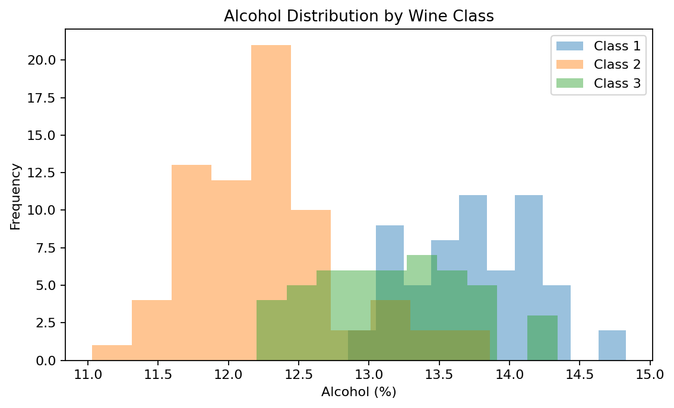
The distributions are visibly shifted, with Class 2 centered at lower alcohol values than Class 1 and Class 3.
Figure 2. Alcohol content by class
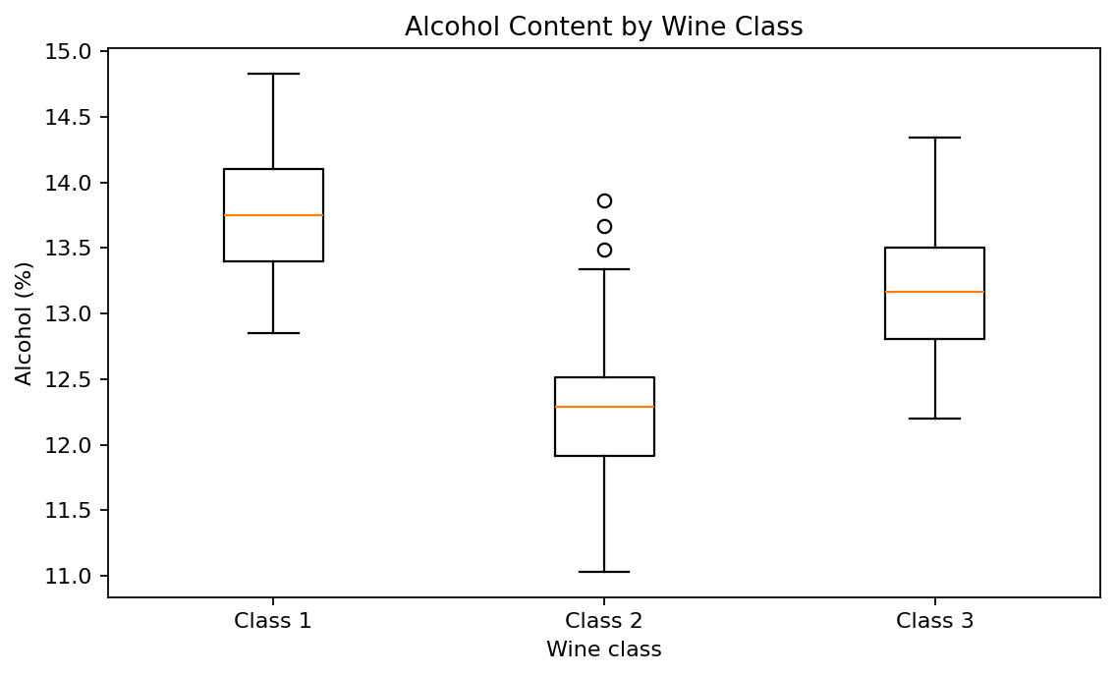
The box plots show a clear separation between Class 1 and Class 2, while Class 3 lies between them on average.
Figure 3. Group means with 95% confidence intervals
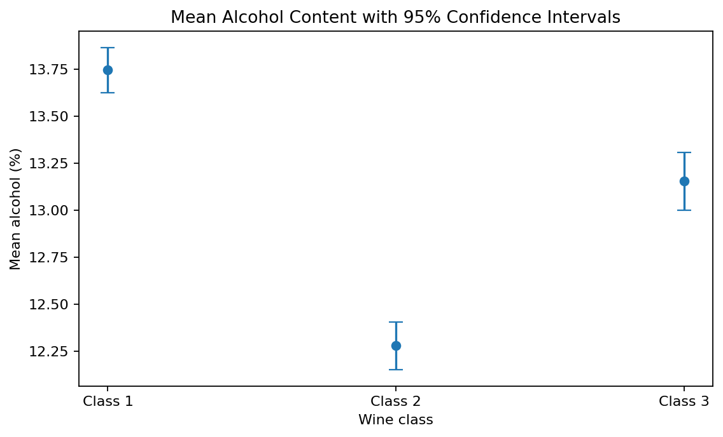
The confidence intervals around the group means provide a visual summary of sampling uncertainty.
Figure 4. Individual observations and class means
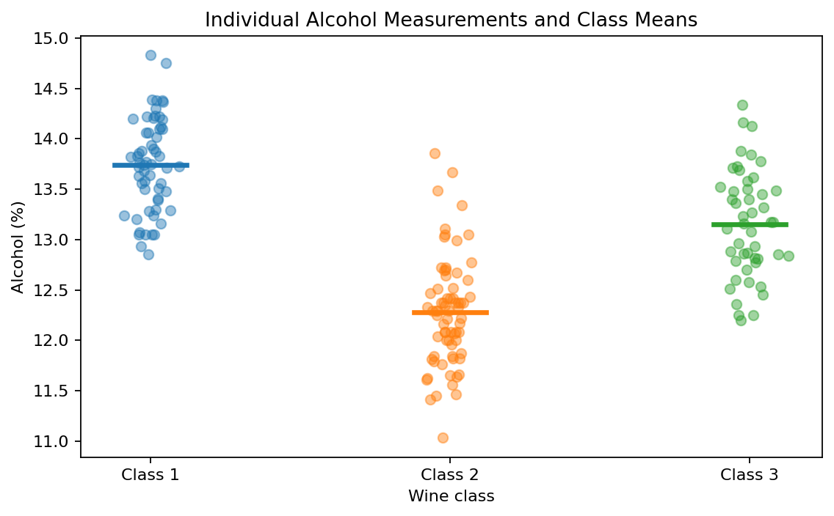
Showing individual measurements helps reveal within-class spread rather than relying only on group averages.
Figure 5. Normal Q-Q comparisons
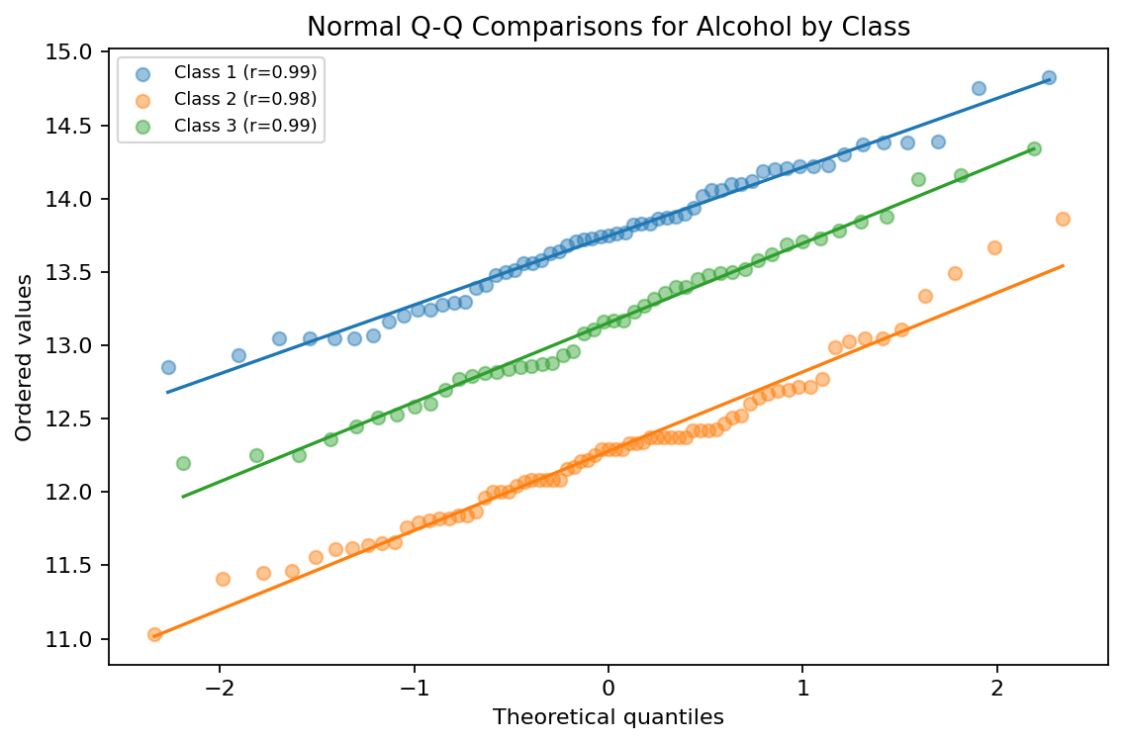
The points are reasonably close to the fitted lines, providing no obvious severe non-normality for alcohol within these groups.

7. Assumption Checks
Levene’s test for equality of variances gave W = 0.600 and p = 0.550. At α = 0.05, this result does not provide evidence of unequal variances. The primary Welch t-test remains conservative because it does not rely on equal variances.
Group | Shapiro-Wilk W | p-value
Class 1 | 0.981 | 0.479
Class 2 | 0.972 | 0.114
Class 3 | 0.981 | 0.641
All three Shapiro-Wilk p-values are above 0.05. Combined with the Q-Q plot, this suggests no strong departure from normality in the alcohol variable within the three groups. These checks do not prove normality; they simply indicate that no major violation was detected in this sample.

8. One-Way ANOVA Across All Three Classes
The one-way ANOVA produced F(2, 175) = 135.078, p = 3.320e-36. The p-value is far below 0.05, so the null hypothesis of equal mean alcohol content across all three classes is rejected for this sample.
The effect-size calculation gives eta squared = 0.607, meaning approximately 60.7% of the total sample variation in alcohol is associated with class membership in this dataset. This is an association within the observed data, not evidence that class membership causally changes alcohol content.
Class | n | Mean alcohol (%) | SD | Median
Class 1 | 59 | 13.745 | 0.462 | 13.750
Class 2 | 71 | 12.279 | 0.538 | 12.290
Class 3 | 48 | 13.154 | 0.530 | 13.165

9. Post-Hoc Pairwise Comparisons
Because the ANOVA was significant, Tukey HSD was used to identify which class pairs differ while controlling the family-wise error rate at 5%. All three pairwise comparisons were statistically significant in this dataset.
Class 1 vs Class 2: mean difference = -1.466 alcohol points, adjusted p-value < 0.001, 95% CI [-1.679, -1.253], reject H0 = True.
Class 1 vs Class 3: mean difference = -0.591 alcohol points, adjusted p-value < 0.001, 95% CI [-0.826, -0.356], reject H0 = True.
Class 2 vs Class 3: mean difference = 0.875 alcohol points, adjusted p-value < 0.001, 95% CI [0.649, 1.101], reject H0 = True.

10. Interpretation of Results
For the primary hypothesis, the Welch t-test returned t = 16.711 with p = 5.926e-34. At the 0.05 significance level, the sample provides strong statistical evidence that the mean alcohol content differs between Class 1 and Class 2 wines. The estimated difference is 1.466 percentage points, with a 95% confidence interval from 1.292 to 1.640. In the observed sample, Class 1 has the higher mean alcohol content.
The three-group ANOVA supports the broader conclusion that average alcohol content is not the same across all wine classes. Tukey HSD further indicates that each class pair is separated on alcohol in this dataset. These findings are statistical associations in the public sample; they should not be interpreted as proof that alcohol concentration alone determines the cultivar label.

11. Scientific and Practical Implications
- Feature screening: alcohol may be informative when building a later classifier for the three wine classes.
- Quality-control analytics: group-level summaries can help identify chemical variables that distinguish categories.
- Experimental design: future work should examine multiple chemical features rather than treating one measurement as sufficient.
- Reproducibility: reporting the exact test, p-value, confidence interval, and effect size makes the analysis easier to verify.

11.1 Limitations
- The analysis is observational and uses a historical public dataset, so causal conclusions are not justified.
- Only alcohol was analyzed for the formal hypothesis tests; the remaining 12 chemical features were not simultaneously modeled.
- The class labels represent the dataset’s wine cultivars; they should not be generalized to every wine population without further evidence.
- Statistical significance can be affected by sample size, so effect sizes and confidence intervals are reported alongside p-values.

12. Conclusion
This Week 3 project demonstrates a complete statistical hypothesis-testing workflow in Python. A clear scientific question was converted into formal null and alternative hypotheses. The data were inspected, assumptions were assessed, a Welch independent-samples t-test was performed for the primary comparison, and a one-way ANOVA with Tukey HSD was used for the three-group analysis. The primary comparison produced a statistically significant result (p = 5.926e-34) and the broader ANOVA was also significant (p = 3.320e-36). The report combines p-values, confidence intervals, effect sizes, visual evidence, and limitations to provide a transparent interpretation of the results.

13. Estimated Workload (30–35 Hours)
Activity | Hours
Problem definition and hypothesis formulation | 4
Dataset selection and data checks | 4
Statistical methodology and assumption testing | 8
Python analysis and visualization | 7
Interpretation, post-hoc analysis, and documentation | 7
Total | 30
The documented plan fits the requested 30–35 hour workload window.

14. References
1. UCI Machine Learning Repository. Wine Dataset, Dataset ID 109. https://archive.ics.uci.edu/dataset/109/wine
2. scikit-learn documentation. Wine recognition dataset (load_wine). https://scikit-learn.org/stable/modules/generated/sklearn.datasets.load_wine.html
3. SciPy documentation. scipy.stats.ttest_ind, scipy.stats.f_oneway, scipy.stats.levene, scipy.stats.shapiro.
4. Statsmodels documentation. statsmodels.stats.multicomp.pairwise_tukeyhsd.

Appendix A — Full Reproducibility Checklist
✓ Public dataset source documented.
✓ Research question and hypotheses stated before test selection.
✓ Significance level α = 0.05 documented.
✓ Data quality checks completed.
✓ Assumption checks included.
✓ Primary p-value and confidence interval reported.
✓ Effect size reported.
✓ At least three supporting visualizations included (five provided).
✓ Three-group ANOVA and post-hoc analysis documented.
✓ Limitations and interpretation included.
✓ Python code prepared as a separate file for GitHub.

