WEEK 5 FINAL PROJECT REPORT
Comprehensive Data Science Project: Reporting and Strategic Recommendations
Integrated Dataset: UCI Wine Recognition Dataset
Tools: Python, Pandas, Matplotlib, SciPy, Statsmodels, scikit-learn
Integration of Weeks 1-4 into an end-to-end analytical narrative

Project component | Summary
Week 1 foundation | Data acquisition, cleaning, preprocessing, EDA
Week 2 extension | Advanced visual analytics and data storytelling
Week 3 validation | Statistical analysis and hypothesis testing
Week 4 modeling | Machine-learning development and evaluation
Week 5 synthesis | Executive reporting, implications, recommendations
Dataset | 178 observations, 13 chemical features, 3 classes
Estimated workload | 33 hours

1. Executive Summary
This final project integrates the analytical skills developed across Weeks 1-4 into a single, coherent data-science workflow using the UCI Wine Recognition Dataset. The project progresses from data quality inspection and exploratory analysis through advanced visualization, hypothesis testing, and machine-learning model evaluation. The final report converts those technical results into an evidence-based narrative suitable for a non-technical stakeholder while preserving enough methodological detail for reproducibility.
The dataset contains 178 observations, 13 numerical chemical measurements, and three wine classes. The quality review found 0 missing cells and 0 duplicate records. Class counts were 59, 71, and 48 for class_0, class_1, and class_2 respectively. Standardized feature profiles show that the groups differ across multiple chemical dimensions, while the modeling stage demonstrates that simple supervised-learning baselines can capture much of this structure.
On the held-out test set, Logistic Regression achieved accuracy of 1.000 and ROC-AUC of 1.000; the depth-limited Decision Tree achieved accuracy of 0.956 and ROC-AUC of 0.963. Five-fold stratified cross-validation gave mean accuracy of 0.983 for Logistic Regression and 0.882 for the Decision Tree. These figures are treated as evidence about this dataset and split design, not as a guarantee of future performance.

2. Key Findings from the Full Project
Finding | Evidence | Implication
Data quality is suitable for analysis | 0 missing cells; 0 duplicates detected | Minimal preprocessing was needed before analysis.
Classes differ across multiple chemistry features | Class-profile means show visible separation across several standardized variables | Multivariate analysis is appropriate for distinguishing the groups.
Alcohol differs by class | Class-wise alcohol means are visibly different | Supports formal group comparison and hypothesis testing.
Some features are strongly related | Total phenols vs flavanoids correlation = 0.865 | Interpret correlated variables together and avoid treating every feature as independent evidence.
Baseline models capture class structure | Logistic CV mean = 0.983; Tree CV mean = 0.882 | A simple, scaled linear baseline is a strong starting point for this dataset.
Feature influence is concentrated | Permutation importance places proline, alcohol, flavanoids and other chemistry variables near the top | Prioritize high-value measurements for monitoring and future feature analysis.

3. Integration of Weeks 1-4

3.1 Week 1 - Data Acquisition, Cleaning, and EDA
Week 1 established the reproducible data foundation. The dataset was loaded into Pandas, inspected for dimensions, data types, missing values, and duplicates, and summarized with descriptive statistics. Visualizations were then used to identify distributional patterns, class differences, and feature relationships. This stage answers: What data do we have, and what does it look like?
df = pd.read_csv("wine_dataset.csv")
print(df.shape)
print(df.isna().sum())
print(df.duplicated().sum())

3.2 Week 2 - Advanced Visualization and Storytelling
Week 2 extended the exploratory work into a visual story. Box plots, scatter plots, correlation heatmaps, standardized class profiles, and PCA views were used to move from isolated variables to a multivariate narrative. The objective was not simply to produce charts, but to connect each chart to a question: where are the classes different, which variables move together, and what overall structure appears after dimensionality reduction?

3.3 Week 3 - Statistical Analysis and Hypothesis Testing
Week 3 formalized selected exploratory observations through hypothesis testing. Group differences in alcohol content were examined using an independent-samples t-test, while broader class differences were evaluated with one-way ANOVA and post-hoc comparisons. Confidence intervals and assumption checks were included so that statistical conclusions were not based on p-values alone. This stage answers: Are observed differences compatible with random variation under a defined null hypothesis?

3.4 Week 4 - Machine Learning Model Development and Evaluation
Week 4 converted the descriptive structure into a multiclass prediction problem. Logistic Regression and a depth-limited Decision Tree were trained and evaluated using accuracy, macro-averaged precision, recall, F1-score, and ROC-AUC. Confusion matrices and ROC curves made classification errors visible, while permutation importance helped examine which features contributed most to predictive performance. This stage answers: Can the observed structure support reliable class prediction on unseen records?

4. Visual Data Story

4.1 Dataset composition
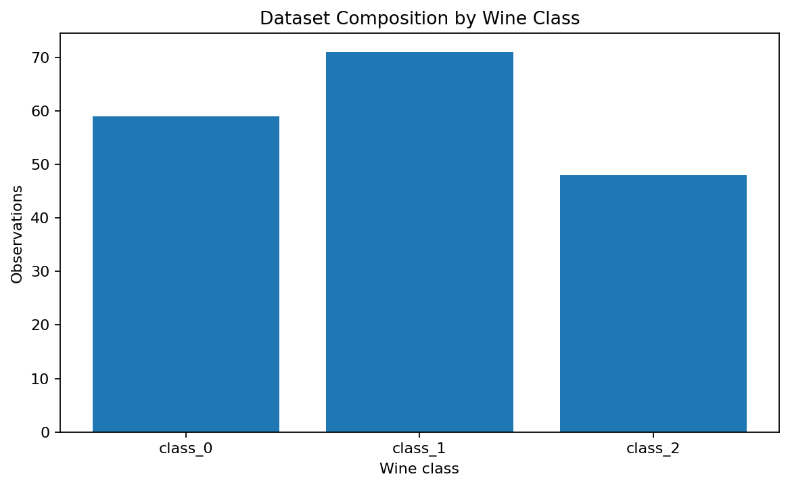
The dataset is moderately imbalanced rather than perfectly balanced, with class_1 containing more records than class_2. Stratified splitting and macro-averaged evaluation metrics were therefore appropriate because they reduce the chance that the largest class dominates the evaluation story.

4.2 Multivariate class profile
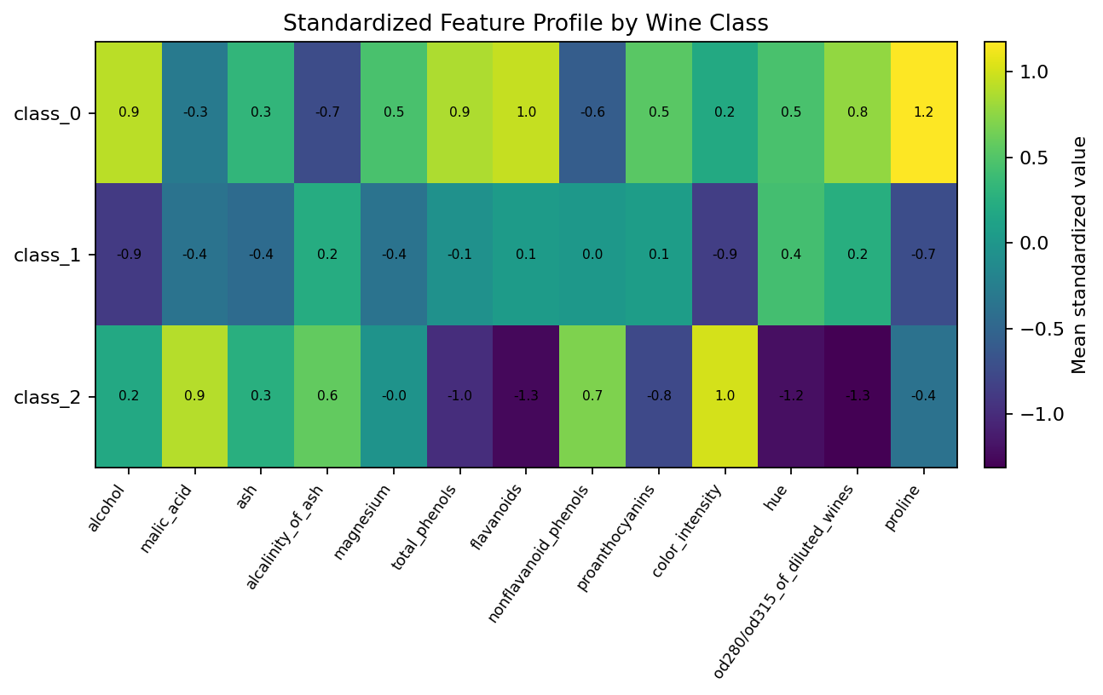
The standardized profile highlights the multivariate nature of the problem. Class_0 shows comparatively high standardized values for proline, flavanoids, total phenols, and several related chemistry measures, while class_2 is characterized by higher color intensity and a lower standardized profile for several phenolic variables. These differences motivate both statistical comparison and classification modeling.

4.3 Model performance
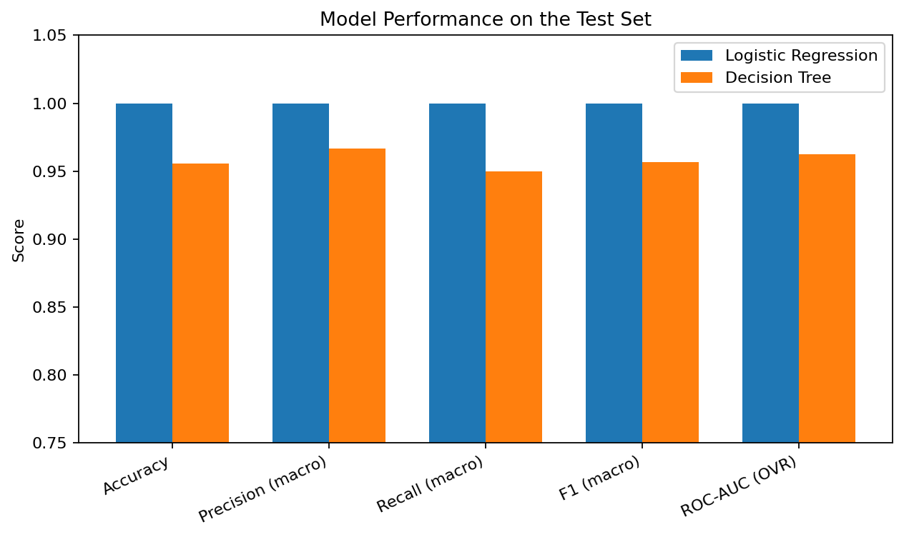
Both baseline models perform strongly on the test set, but their cross-validation behavior provides important context. The logistic model maintains a high average accuracy across five folds, while the Decision Tree shows more variability. This suggests that a regularized linear baseline is a useful benchmark before moving to more complex models.

4.4 Feature importance
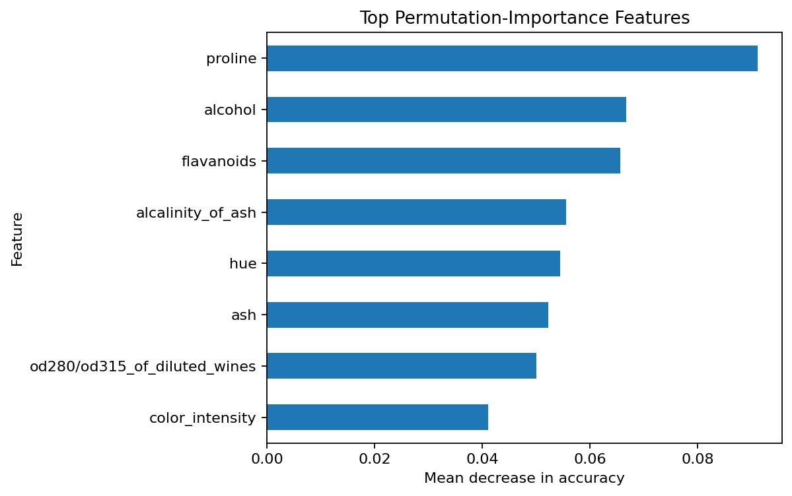
Permutation importance identifies proline, alcohol, flavanoids, and several other variables as influential for the logistic model on the held-out data. The result should be interpreted as model-specific and data-specific: a high permutation-importance score indicates that shuffling that feature reduced predictive performance under this evaluation design; it does not by itself prove causality.

4.5 PCA as a final narrative view
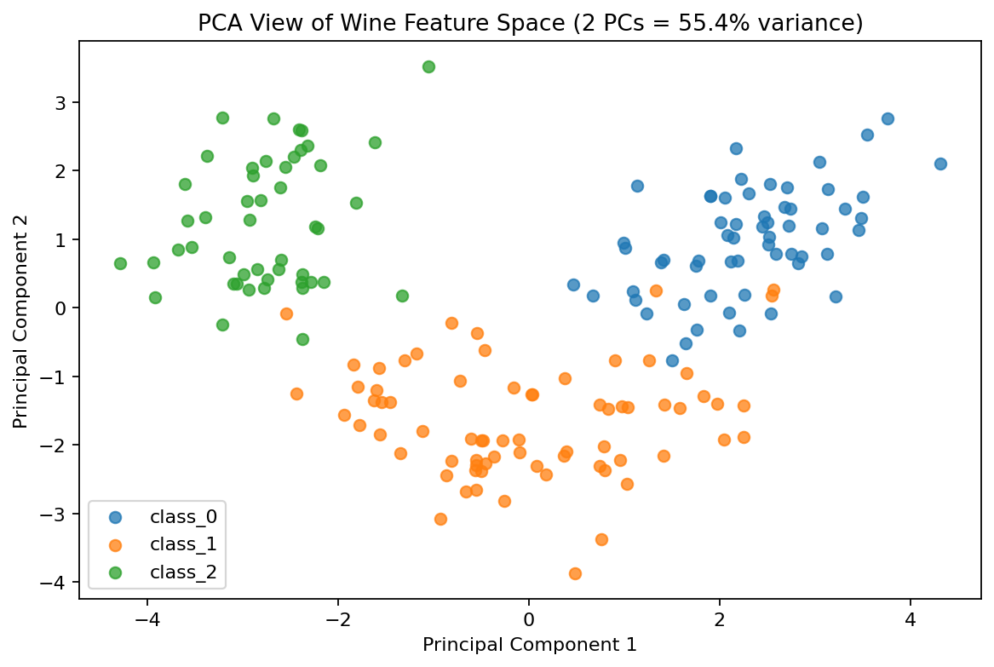
The first two principal components capture about 55.4% of the standardized feature variance. The PCA plot provides a compact visual summary of the multivariate structure and helps explain why a classifier can separate the classes. PCA is used here for visualization and dimensionality reduction, not as proof that the original variables are causally responsible for class membership.

5. Statistical Evidence and Interpretation
The Week 3 analysis selected alcohol content as a representative continuous variable and compared group means. The broader project uses that statistical work as evidence that the visual differences are not merely artifacts of a chart. The final interpretation emphasizes effect magnitude, uncertainty, assumptions, and the distinction between statistical association and business or scientific causation.

5.1 Hypothesis framing
- Null hypothesis (H0): mean alcohol content is equal for the compared groups.
- Alternative hypothesis (H1): mean alcohol content differs for the compared groups.
- A two-sided independent-samples test was used for the primary pairwise comparison, with Welch’s formulation providing robustness when equal variances cannot be assumed.
- One-way ANOVA extended the comparison to all three classes, followed by Tukey HSD when the omnibus result indicated class-level differences.

5.2 Practical interpretation
The statistical tests support the narrative that chemical measurements differ systematically between wine classes. However, the correct use of this evidence is comparative: the results show that the observed class differences are unlikely to be explained by random sampling variation under the tested assumptions. They do not establish why the differences occur or guarantee that the same patterns will hold in a different population, harvest, laboratory setting, or measurement process.

6. Strategic Recommendations
The following recommendations translate the project findings into practical next steps for an analytics or quality-control workflow. They are recommendations derived from the analyzed dataset rather than claims about a real operating organization.
Priority area | Recommendation | Rationale / evidence | Implementation idea
1. Data quality | Maintain a validation layer before analytics and model scoring. | The workflow begins with structured checks for missing values, duplicates, data types, and class composition. | Automate schema, range, null, duplicate, and class-balance checks in each ingestion run.
2. Feature monitoring | Monitor high-information chemical variables such as proline, alcohol, and flavanoids. | These variables are prominent in permutation importance and class-profile differences. | Create a monthly distribution and drift report for high-impact features.
3. Model governance | Keep Logistic Regression as an interpretable baseline before adopting more complex models. | The logistic model has strong cross-validated performance and provides a transparent benchmark. | Track accuracy, macro F1, ROC-AUC, confusion matrices, and data drift together.
4. Validation | Use repeated stratified cross-validation and external validation data before operational deployment. | A single train-test split can overstate or understate performance. | Add repeated CV and a fixed untouched validation set from a later collection period.
5. Explainability | Pair predictive scores with feature-importance and error analysis. | Aggregate metrics alone do not explain why a classification failed. | Store per-class errors and use permutation importance or SHAP in later iterations.
6. Decision support | Use model output as analytical support rather than as an automatic decision rule. | Model performance is dataset-specific and does not establish causal suitability for real-world decisions. | Add human review and documented acceptance thresholds in any production workflow.

7. Potential Business and Scientific Implications

7.1 Business implications
In a hypothetical wine-quality or product-classification setting, a validated model could support faster screening, consistency checks, and prioritization of samples for further laboratory review. A visual dashboard could summarize current feature distributions, compare batches with historical profiles, and flag observations that fall outside expected ranges. These are potential applications, not claims of demonstrated operational savings.

7.2 Scientific implications
For scientific analysis, the dataset demonstrates how multivariate chemical measurements can be combined to characterize groups. Statistical testing helps quantify selected differences, while machine learning examines whether the combined pattern is predictive. Future work could investigate robustness across independent datasets, measurement error, laboratory effects, and potential domain shifts.

8. Limitations and Improvement Areas
- The dataset is relatively small (178 observations), so performance estimates can vary with the train-test split.
- The analysis uses a single public benchmark dataset; external validation on another dataset is necessary before generalization.
- The project uses baseline models rather than a full hyperparameter-optimization study.
- Permutation importance is model-specific and should not be interpreted as causal feature influence.
- Statistical significance does not automatically imply practical importance; effect sizes and operational thresholds should be added in future work.
- Potential domain shift, measurement protocol differences, and data-collection changes were not modeled explicitly.

8.1 Improvement roadmap
Stage | Next action | Expected benefit
1 | Repeat stratified CV with multiple random seeds | More stable performance estimates
2 | Tune Logistic Regression and tree hyperparameters | Better calibrated baseline comparisons
3 | Add Random Forest / Gradient Boosting / SVM | Test nonlinear and ensemble alternatives
4 | Create an interactive dashboard | Improve stakeholder exploration and communication
5 | Validate on external or future-period data | Measure generalization and drift

9. Technical Methodology and Core Code

9.1 Data and analysis workflow
1. Load the public Wine dataset into Pandas
2. Validate shape, schema, missing values, and duplicates
3. Compute descriptive statistics and correlations
4. Standardize variables for scale-sensitive analysis
5. Compare group distributions and means
6. Train Logistic Regression and Decision Tree baselines
7. Evaluate test-set metrics and five-fold CV
8. Review permutation importance and PCA
9. Translate evidence into strategic recommendations

9.2 Model development snippet
X_train, X_test, y_train, y_test = train_test_split(
X, y, test_size=0.25, random_state=42, stratify=y
)
model = Pipeline([
("scaler", StandardScaler()),
("clf", LogisticRegression(max_iter=2000))
])
model.fit(X_train, y_train)
pred = model.predict(X_test)

9.3 Evaluation snippet
print("Accuracy:", accuracy_score(y_test, pred))
print("Precision:", precision_score(y_test, pred, average="macro"))
print("Recall:", recall_score(y_test, pred, average="macro"))
print("F1:", f1_score(y_test, pred, average="macro"))

10. Deliverables and Reproducibility
File | Purpose
Week5_Comprehensive_Data_Science_Project_Report.docx | Final written project report
week5_comprehensive_data_science_project.py | Reproducible analysis and modeling code
wine_dataset.csv | Dataset used for the integrated analysis
01_dataset_composition.png | Dataset composition visualization
02_feature_profile_heatmap.png | Multivariate class-profile visualization
03_model_performance.png | Model metric comparison
04_feature_importance.png | Permutation feature-importance chart
05_pca_story.png | PCA storytelling visualization
The same dataset, analysis code, and figures should be uploaded to the Week 5 GitHub repository so that the written conclusions can be traced to reproducible artifacts.

11. Estimated Workload
Activity | Hours
Review and synthesize Weeks 1-4 outputs | 5
Data validation and integrated analysis | 5
Statistical and model-result consolidation | 6
Visualization and storytelling refinement | 6
Strategic recommendations and limitations | 4
Documentation, code cleanup, and final review | 7
Total | 33
The planned effort is 33 hours, which falls within the prescribed 30–35 hour workload range.

12. Conclusion
The final project demonstrates an end-to-end data-science process: acquire and validate data, explore patterns, communicate the evidence visually, test key hypotheses statistically, build baseline predictive models, evaluate uncertainty and errors, and translate results into structured recommendations. The integrated narrative shows how each stage answers a different question and why the stages are stronger when interpreted together. The main opportunity for future work is to strengthen generalization through external validation, repeated cross-validation, model tuning, drift monitoring, and interactive reporting.

13. References
1. UCI Machine Learning Repository. Wine Recognition Dataset. https://archive.ics.uci.edu/
2. Fisher, R. A. (1936). The use of multiple measurements in taxonomic problems. Annals of Eugenics, 7(2), 179-188.
3. Pedregosa, F. et al. (2011). Scikit-learn: Machine Learning in Python. Journal of Machine Learning Research, 12, 2825-2830.

Appendix A - Week 5 Submission Checklist
✓ Executive summary included.
✓ Findings from previous weeks integrated into one narrative.
✓ Visualizations with captions and explanations included.
✓ Statistical evidence and machine-learning evaluation consolidated.
✓ Potential business/scientific implications discussed.
✓ Limitations and future improvements documented.
✓ Strategic recommendations linked to observed evidence.
✓ Core code snippets included.
✓ 33-hour workload documented.

