**CHAPTER 1**

**THE PROBLEM AND ITS BACKGROUND**

This chapter contains the background of the research project. It also includes the problem, general and specific objectives, scope and limitation, opportunities and hindrances of the project in designing a Guidance Information and Monitoring System for Ifugao State University – Lagawe Campus which leads for acceptability of this research project.

**Introduction**

Guidance Program has become an integral part of the overall educational program. With the basic assumption that all students need direction in their personal, educational, and career planning, it has become the instructional responsibility of the guidance counselor, administrator and staff to provide the students the specific knowledge and skills required to address the needs (Arevalo, 2009).

An important aspect of the Guidance program is the recognition that some students require special assistance in dealing with developmental problems and immediate crisis. With this teacher and other staff who are in direct contact with the students require support that can best be supplied by the guidance program. Guidance program moreover is based on the belief that all students, including those with challenging needs have the right to benefit from effective instruction to ensure optimal development.

The Manual systems are things of the past. It’s a quite tedious, time consuming, less efficient, more error prone and inaccurate in comparison to computerized system. A manual-based system will see information recorded and kept in different ways such as in files in paper form. While a computer based information system will see data stored on various computer [programs](http://www.blurtit.com/q8167870.html) including on databases, Word documents, Excel etc. Both types of information system are designed to help a business carry out its daily running and operations. In recent times, computer-based systems are generally considered to be more popular as more businesses are choosing to keep up with the developments in information [technology](http://www.blurtit.com/q8167870.html).

The Ifugao State University – Lagawe Campus Guidance Office has been using the manual processing of guidance information and monitoring student information for many years now. With the growth of population of students enrolled in the university, the guidance office must perform more efforts in maintaining a reliable and accurate data. They also suffer from a very time-consuming retrieval of student information for academic purposes. With that stated problem, the researchers wanted to design a system called IFSU- Lagawe Guidance Information and Monitoring System (IFSU-LAG GIMS). It is a software application for educational establishments to manage and monitor student data. This system will be designed to provide capabilities for managing student’s information, such as tracking student attendance, penalties, and assessments of other student-related data in schools, colleges, or universities.

The University does not implement any application regarding organizing files or records of the students, so, as researchers they would like to create one for the University. They will design a system that will concentrate on the Guidance Center to make the management of student records be a lot easier, efficient, less time consuming and reliable without sacrificing quality.

**CONCEPTUAL FRAMEWORK**

**INPUT PROCESS**

**Computer Knowledge**

**Users**

* + Guidance Counselor/Admin
  + Faculty

**Hardware**

* Computer
* Server
* Router/Switch

**Software**

* Operating System
* Xampp
* Web Browser

Yes

**IFSU-Lagawe Guidance Information and Monitoring System**

**Design**

**1. Problem Identification**

* Providing an easy and modern way of Student Data Management in IFSU – Lagawe Campus Guidance Office.

**2. Data Gathering**

* Look into websites and books to guide in preparing the study.
* Interview guidance personnel.
* Organized and analyzed the gathered data.

**3. Design and Procedure**

* Design Program Flowchart
  + Development Flowchart
  + User story
  + Use case diagram
  + Use case specification
* Draft System Web Layout

Diagram 1. Conceptual Framework of IFSU-LAG GIMS

A conceptual framework is very useful in a research to outline the possible processes. It illustrates how and why a project takes place, and about how we understand its activities. An indication of designs and practices that shape the way work is done in a project.

The diagram 1. illustrates the Input-Process-Output concept of IFSU-Lagawe Guidance Information and Monitoring System. The input framework is composed of requirements in terms of the user, software and hardware. The user requirements consist of the ID number and password of the authorized personnel such as the Guidance Center. The system will run in an Operating system that must be Windows XP or higher, XAMPP version 5.2x or higher and a web browser (Mozilla Firefox, Internet Explorer, or Google Chrome). The process framework is composed of 3 processes, the problem identification; data gathering; and design and procedure. If the process 1 – 3 is successfully done it will precede to the output framework, the IFSU-Lagawe Guidance Information and Monitoring System Design.

**Statement of the Problem**

The Ifugao State University-Guidance Office is currently using a manual operation in monitoring students’ activities and performance. To a large extent, the work load is very taxing to retrieve files, offense, and implements standards adhere from the student manual. Considering that these are the factors subjectively experienced by the guidance counselors, the researchers prompted to design the Guidance management system for better quality service. These problems need to be addressed promptly. Specifically, it should answer the following:

1. How to prevent losing of information of students' records?
2. How to easily monitor the students' records especially on offenses?
3. Will a guidance management system lessen the hassle and time consumption during work?
4. Is the current method in monitoring students' records consistent and reasonably convenient?

**Objectives of the Study**

**General Objective:**

The general objective is to design Guidance Information and Monitoring System in IFSU-Lagawe Campus.

**Specific Objectives:**

The project specifically aims the following:

* + - 1. To design a system that will give detailed information of the students such as basic information, educational background and parent’s information.
      2. To design a module that will track the student’s attendance such as absent and late.
      3. To design a module that will track student’s penalties.

**Hypothesis**

1. The manual operation in monitoring student’s activities and performance is not a difficult to retrieve files, offenses and implement standard adhere from the student’s manual.

**Significance of the Project Study**

This project study aims to design a Guidance management System that will help the university to have an easier management on student’s records.

The system will give benefit to the university, especially guidance office because the system will provide a secure and computerized records keeping system for creating records. It will provide an up-to-date and accurate record of students and will resolve the possibility of losing the information because it has database. The system will also offer easily retrieval of records and generates report such as student’s information, and educational background.

The system will give benefit to the students because it will provide sufficient information about the Guidance office such as their services and they’ll be aware of committing offense because they’ll receive a notification from the Guidance.

**Scope and Limitation**

This project study was design to automate the manual operation of Guidance office in monitoring students' records. The functions focus into the students’ information/profile, mission and vision of the school, rules and regulations based on the handbook, problems, and proposed solutions to problems.

This section explains about the scope and limitation of the project to fully understand the possible opportunities and restrictions of the study.

1. Scopes:

1.1 Provides database for student’s information (personal information, educational background, and offenses).

1.2 Provides accessible information about Guidance services.

1.3 Monitor the students' status such as no records, warning and dropped.

2. Limitations

2.1 No access to students.

2.2 Only authorized personnel (Guidance Center) will be allowed to use the system.

2.3Does not include registrar office.

2.4 No capture of student’s picture.

**Definition of Terms**

Computer – an electronic device designed to manipulate data so that useful information can be generated.

Computer-based system - system which uses a computer for performing task with database for storing data and a programming language for its platform.

Data - raw facts.

Database - a collection of [information](http://whatis.techtarget.com/definition/0,289893,sid9_gci212343,00.html) that is arranged so that it can easily accessed and managed.

Flow chart - graphical representation of a system process.

Guidance Information- displays the information about the Guidance Office mission, vision, officer hierarchy, services, and office location.

Guidance Monitoring – supervised the students’ records such as attendance, offenses, exit, and students’ information.

Manual-based system - system which does not use any computer devices, thus all data would be kept in paper.

Operating System (OS) - the most important [program](http://www.webopedia.com/TERM/P/program.htm) that [runs](http://www.webopedia.com/TERM/R/run.htm) on a [computer](http://www.webopedia.com/TERM/C/computer.htm). It performs basic tasks, keeping track of [files](http://www.webopedia.com/TERM/F/file.htm) and [directories](http://www.webopedia.com/TERM/D/directory.htm) on the [disk](http://www.webopedia.com/TERM/D/disk.htm), and controlling [peripheral devices](http://www.webopedia.com/TERM/P/peripheral_device.htm).

Personal Computer (PC) - a [computer](http://whatis.techtarget.com/definition/0,,sid9_gci212566,00.html) designed for use by one person at a time.

Primary data - data that has not been previously published or the so-called first-hand data.

Prototype- a model that represents a product suitably for designers to visualize and test the design.

Secondary data - data that have been already collected readily available from other sources or the so-called second-hand data.

Software- different kinds of [program](http://searchsoftwarequality.techtarget.com/sDefinition/0,,sid92_gci212834,00.html)s used and installed to operate [computer](http://searchwinit.techtarget.com/sDefinition/0,,sid1_gci211829,00.html)s and related devices.

System - organized assembly of resources and actions united to accomplish a [set](http://www.its.bldrdoc.gov/fs-1037/dir-033/_4806.htm) of specific functions.

Video Graphics Adapter (VGA) - an integrated circuit [card](http://whatis.techtarget.com/definition/0,,sid9_gci211746,00.html) in a computer or a [monitor](http://searchcio-midmarket.techtarget.com/sDefinition/0,,sid183_gci212588,00.html) that provides digital-to-analog conversion so that data can be sent to a computer's [display](http://whatis.techtarget.com/definition/0,,sid9_gci211965,00.html).

Windows command prompt- command line interpreter that allows the entering of [commands](http://pcsupport.about.com/od/termsc/g/commands.htm) and then executes those commands to the [operating system](http://pcsupport.about.com/od/termshm/g/term_os.htm).

X (to be read as "cross", meaning [cross-platform](http://en.wikipedia.org/wiki/Cross-platform)) Apache, MySQL, PHP and Perl (XAMPP)- a [free and open source](http://en.wikipedia.org/wiki/Free_software) [cross-platform](http://en.wikipedia.org/wiki/Cross-platform) [web server](http://en.wikipedia.org/wiki/Web_server) [solution stack](http://en.wikipedia.org/wiki/Solution_stack) package .

**Chapter II**

**Review of Related Literature and Studies**

**Project Concept**

This chapter contains related Foreign and Local literature and studies.

**Related Foreign Literature**

**1.** Capture IT is a trademark of Vizual Management Solutions Limited. © 2009. Vizual is a leading supplier of Student Attendance Monitoring Systems. One of their projects is the International Student Attendance Monitoring and Recording System to help with Tier 4 compliance and to reduce the administration cost. It eliminates the unreliability associated with manual registers and the difficulty of all those manually maintained spreadsheets of attendance data. The system keeps fully informed about the student’s attendance, inform about the students to be reported at the United Kingdom Board Agency (UKBA), and those whose attendance behavior is putting them at risk.

**2.** WebEIM is a student information management solution that was developed to accomplish the requirements of different schools. The mission of Teledata Systems and Services, WebEIM's parent company is to develop an automated Student Information System capable of handling every bit of information in a school's database and delivering results in an accurate and a hassle free method. This solution has been designed with the unique set of features:

* 1. **Integrated:** From the time a new student is registered in a schools database to when he graduates to middle school WebEIM moves data seamlessly and transparently.
  2. **Configurable:** WebEIM allows schools to use their specific codes can be configured while restructuring the work process.
  3. **Centralized:** WebEIM eliminates the need for double inputting data. When a teacher supervises his/her individual class, the principal can supervise the entire school as one without any duplication of effort.
  4. **100% Web-based:** Information on WebEIM can be accessed from anywhere at any time with a standard browser on a Mackintosh or Microsoft platform.

**3.** Rediker Software's [student information system](http://www.rediker.com/student_information_system.html), Administrator's Plus®, is the trusted choice of school administrators across the USA and in over 110 countries. Founded over 30 years ago by school educators for educators, their software is designed to meet the unique student information management needs of all types of schools and districts, public, private, charter and international, elementary to post-secondary. Every day more than 550,000 students log on to Focus' student information system to check homework, take quizzes and engage electronically. Our SIS has a focus on affordability, interoperability, usability, and scalability. Focus School Software offers advanced school management software. The implementation process of its school management software has four key components: Installation, Data migration, Integration, and Training.

**4.** Focus’ mission is to deliver an affordable, flexible, scalable, and easy-to-use student information system that will allow the client to easily manage their data and make informed, timely decisions. They are committed to delivering the very best online student information systems on the market that will increase efficiency and facilitate higher attendance and test scores.

“The program is very user-friendly. If I do run into any problems, I simply pick up the phone or email tech support and I get a response in a timely manner. Everyone at Focus has been very helpful!”

Patricia G. Mahaney - Director of Guidance - Kenston Forest School

“When describing Focus to another district, I tell them that it is user-friendly, very intuitive and that the company is always adding functions that meet teacher’s needs.”

Meg Brown - Director of Technology - Flagler County Schools

**5.** Follett Software Company is dedicated helping the K-12 community reinvent education for the 21st century. Their integrated educational technologies are designed to help to create and withstand a rich, collaborative, technology-enabled environment that supports the life cycle of active learning and inspires student success. Last Feb. 16, 2011 Follett Software Company has announced the release of version 3.1 of Aspen, its student information system, with sets of improved features focused in the fields of navigation, scheduling, health management, conduct and special education. The Aspen Student Information System is a popular web-based application for school that combines the resources across the education community. Simplifying school data management through the integration of key K-12 applications, Aspen is used by more than 700,000 students in eight states.

According to Brad Lindaas, Vice-president of business operations for the Aspen product line, Aspen 3.1 continues the direction of simplifying features, making Aspen more natural and providing automated assistance to end users.

**Related Foreign Studies**

**1.** The Tanzania Student Association Hyderabad Student Information System (TSAH SIS) is contributed and programmed by Nassib Junior is programmed by Bachelor of Computer student. The software has complete database system, but there are some other panels in the software that the user can develop by you like staff registration panel etc. He develops this software to help our student association in India-Hyderabad. The TSAH SIS used the Visual Basic 6 platform, Microsoft Access for the database, and Crystal Report v8.5 for printing of reports. The following figures are the screenshots of TSAH SIS. The programmer will soon develop version 2.0 by using SQL Server 2008 for the database, Crystal Report V9/10 and Microsoft Visual Studio 2010 for the platform.

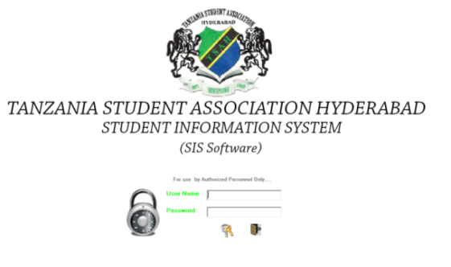

Figure 1. TSAH SIS Login

Figure 1. Shows the Login form of the system. The user name and password is provided by the programmer (Username: admin Password: 1234).

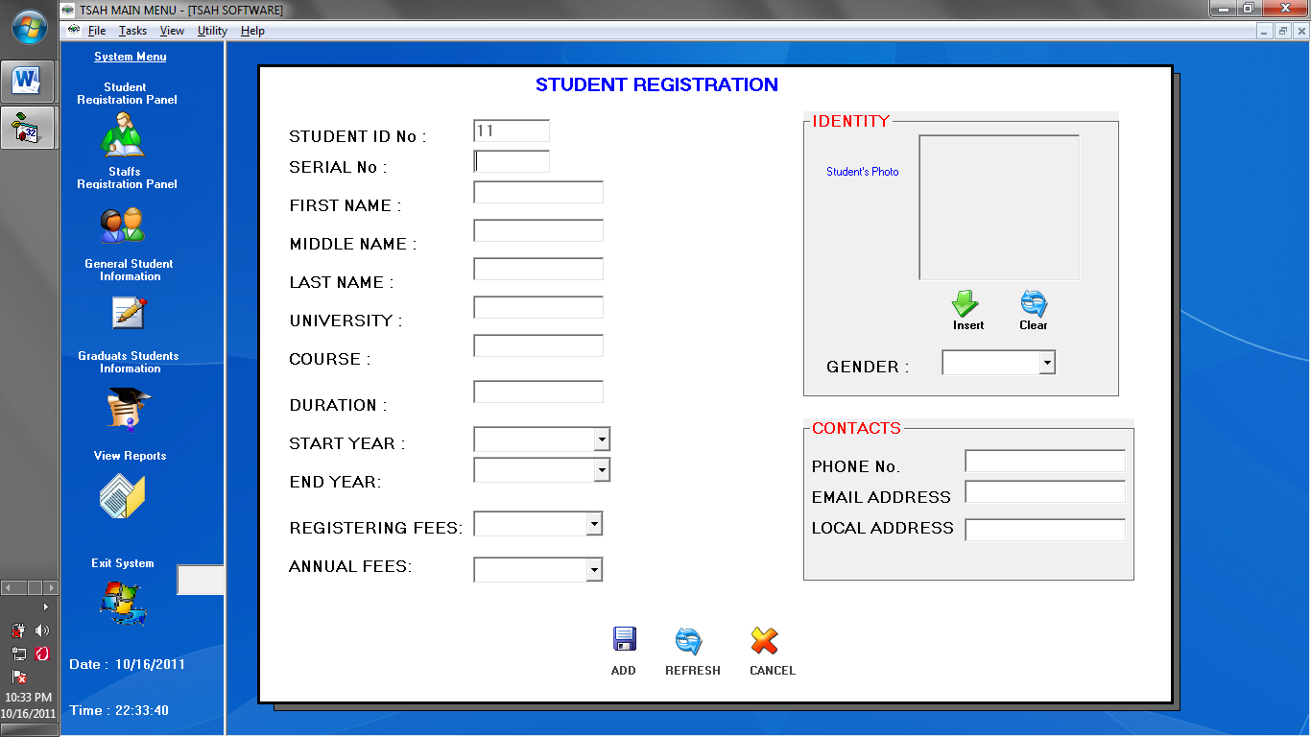

Figure 2. Student Registration Panel

Figure 2. Shows the Student Registration Panel wherein the user allows to input the needed information of a certain student and records it in database

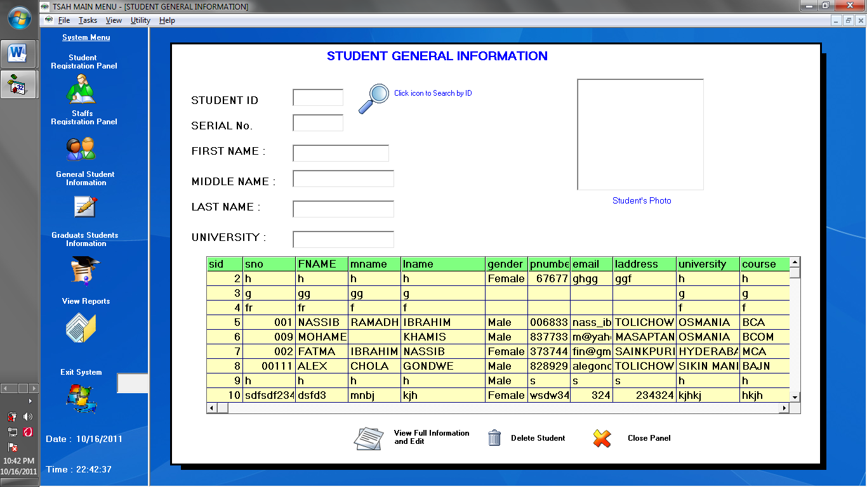.

Figure 3. Student General Information Panel

Figure 3. Shows the saved student information. It allows the user to search, delete, and view the full profile of the student. The Staff Registration Panel and the Graduates Student Information Panel are under maintenance.

**2.** The School of Math Engineering Technology and Science at Olympic High School of North California uses the Google groups to create Guidance and Student Services. The site is composed of Home (OCS Guidance Webpage *shown in Figure5,* school profile, and the sitemap), Procedures (Appointments, Transcripts, Recommendations, Drivers’ Education, and Worker’s permit), Senior and Junior Information, Scholarships, and College Admission.

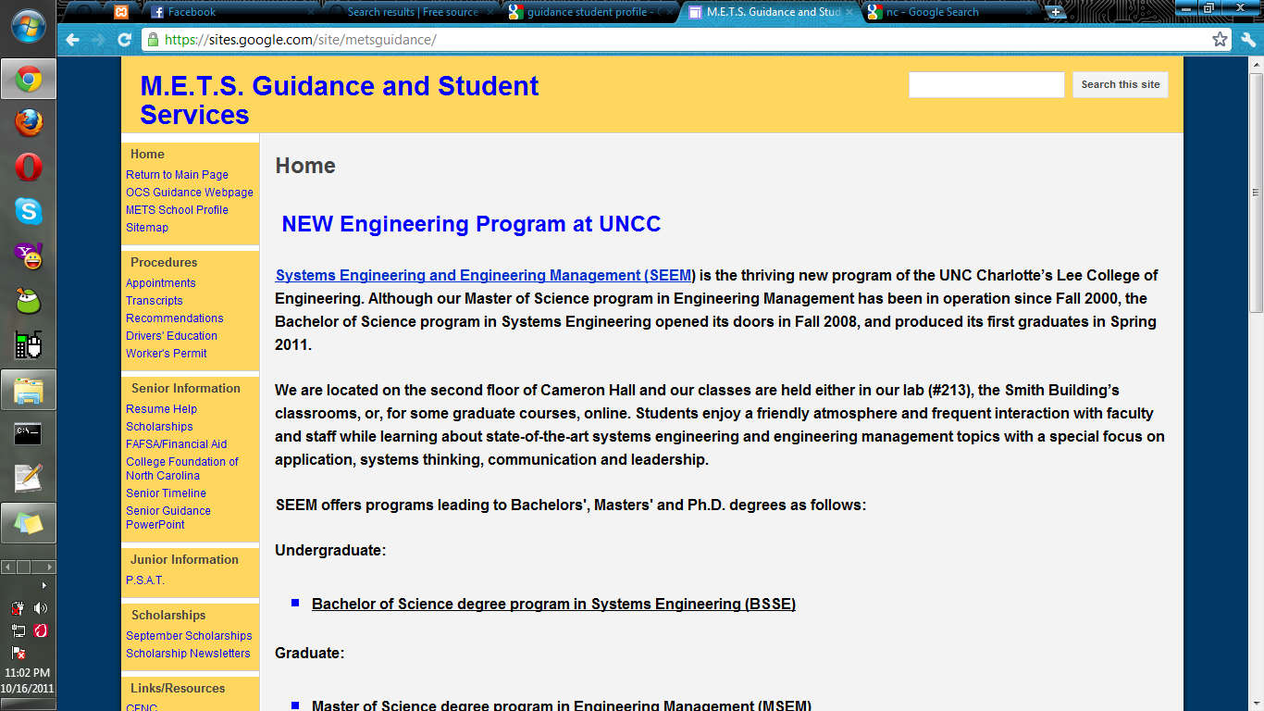

Figure 2.1. Math Engineering Technology and Science at Olympic High School Site

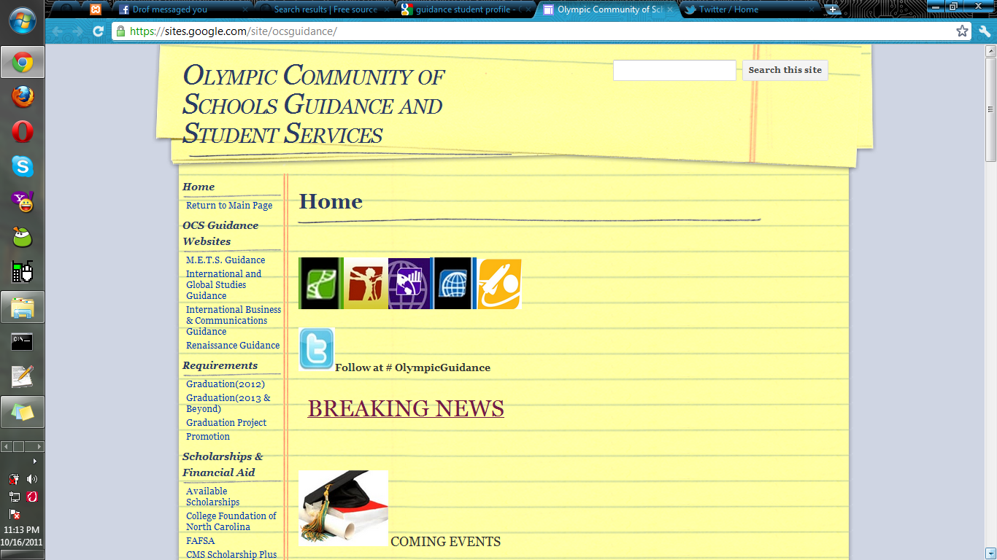

Figure 2.2. Olympic Community of Schools (OCS) Guidance and Student Services

Figure 2.2 shows the OCS Guidance and Student Services it consist of OCS Guidance Website (METS Guidance, International and Global Studies Guidance, International Business and Communications Guidance, and Renaissance Guidance), Requirements for graduation, Scholarship and financial aid, Community resources, Credit recovery, and an Anti-bullying article.

**3**. The CIBER Enterprise Solutions of Ohio present a result in discovery and planning process for Ohio University’s application of Oracle’s PeopleSoft Campus Solutions. OHIO has used the Informs SIS products (previously owned by AMS – American Management Systems and currently owned by Informs, Inc.) for more than fifteen years, and it is the official system of record for student information including, but not limited to Admissions, Advising, Student Records, and Student Accounts. The replacement of the current student system started when Informs announced that their support would be discontinued for its middleware (Enterprise Server aka CORE) product. The replacement for the Informs Student Information System was approved and implemented on 2006.

According to O'Malley *(2011),* it has been said that change is inevitable at Ohio University including in their systems and even in their schedules. Over the next several weeks students, faculty and staff will be learning about the new SIS*.* The Ohio University provides a website to learn more about the new SIS shown in Figure6.

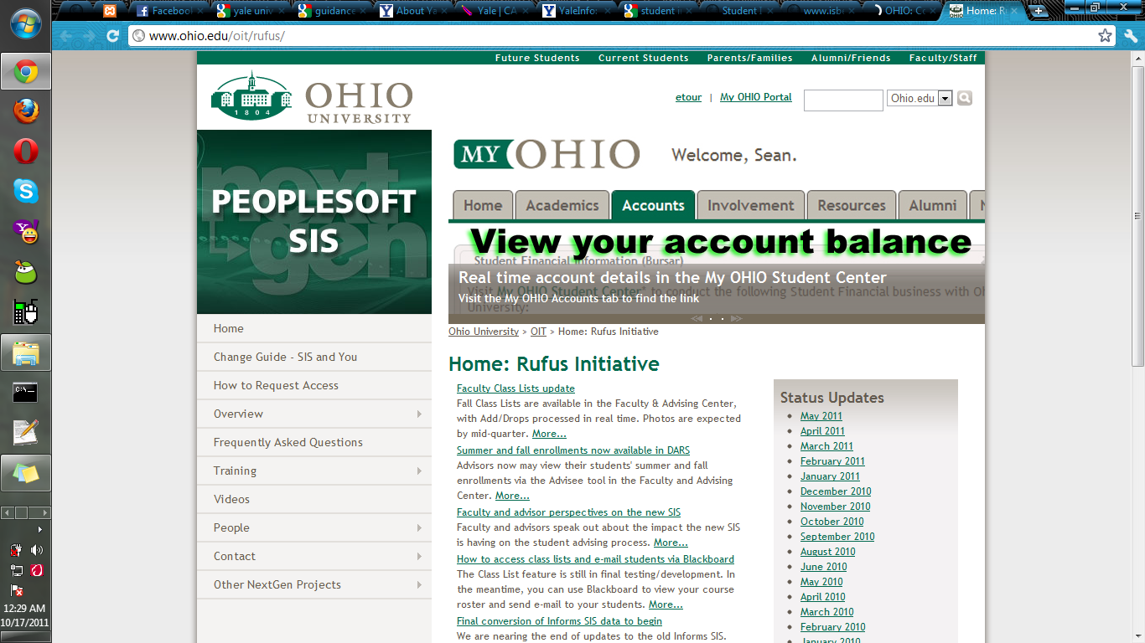

Figure 3.1 OHIO University Tutorial Site

**4.** The Illinois State Board of Education is planning to have a Student Information system increase the state's capacity to follow a student's progress over time, provide better quality data to drive more enlightened policy decisions resulting in enhanced educational opportunities for all children; reduce data collection burden on schools and districts; and enhance the use and relevance of state data by districts and schools.

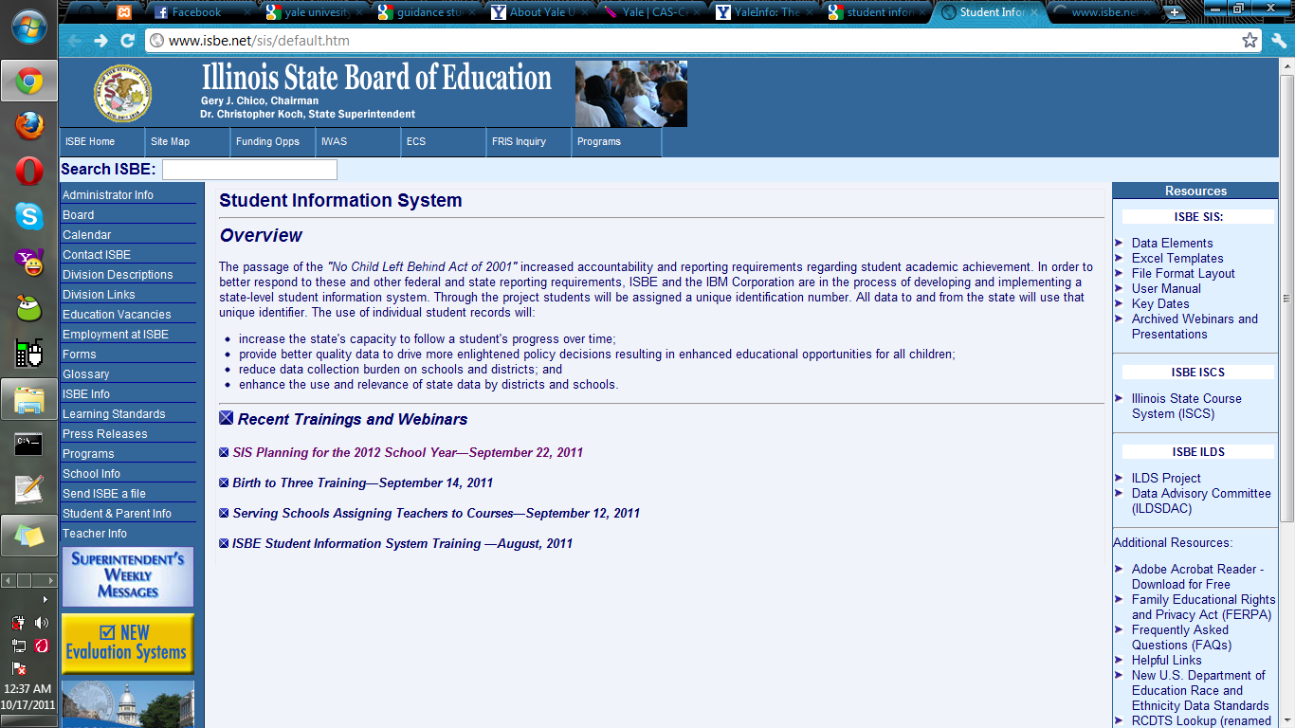

Figure 4.1. Illinois State Board of Education SIS information

Figure 4.1. Shows the Illinois State Board of Education SIS (ISBE SIS) announcement. The ISBE SIS has a resource panel that composed of Data Elements (approved codes and indicators), Excel Template (student data input into SIS), File Format Layout, User Manual, Key Dates, and Archived Webinars and Presentations.

**5.** Electronic Student Profile, or ESP, is an online system that manages student records and enables the parents to keep in touch with their child’s performance and development at the school. It is the first online student profile system in Australian public schools for the primary-levels. It compiles the entire student’s data in all Australian public schools and acts as a central Student Profile System. Although this kind of system will need a quite amount of time to be finished and implemented, external cooperation is critical for this system. The main page contains a brief explanation of the system,

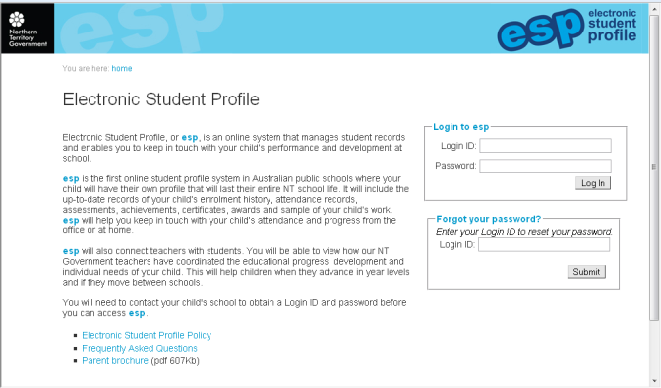

Figure 5.1. Australia’s Electronic Student Profile for public schools.

**Related Local Literature**

**1.** Calibara, Desiree V., Co, Ruben Jr., D. and Luriz, Edneil Josef B. (2010), created a system for their project study. The system is entitled “TUP-T Student Information System”. This system is similar to Student Data Management. According to them TUP-T Student Information System is a big help for the guidance personnel and for the student assistant for managing Student Information. And it will also provide more functional and reliable module for organizing the student information achieving accurate data. The system they made will also serve as an electronic data bank for the Guidance Center.

These are the following features can be access by the designated officer: Manipulating of student’s records, attendance and offenses.

Retrieved from http://ivythesis.typepad.com/term_paper_topics/2010/07/student-information-system-review-of-related-literature.html, Fabe created a review on related literature on student information system (SIS). His pointing out that student information systems has been changing very fast over the time since the presence of the internet was introduced. For him Student Information System can be categorized on how big the systems scope. He is also said that SIS is really a big help in a certain schools. These are selected quotations from his work:

Notably, student information system or SIS incurs such application software designed for educational establishments to manage student data. Student information systems provide capabilities for entering student test and other assessment scores, building student schedules, tracking student attendance as well as managing many other student-related data needs within the institution university. Thus, many of these systems applied in the Philippines can be scaled to different levels of activity and can be configured by their home institutions to meet local needs. Student information systems have been changing and are fast adopted through the presence of a web medium as a channel for accessing SIS without any hassle upon viewing student details and information. Educational institutions are under constant pressure to demonstrate both willingness and capacity to incorporate the latest developments in student information systems along with communications technology supporting various teaching ways.

**2.** Elsa V. Isip and Melissa P. Picones (2010), created a journal entitled “Interactive Students’ Performance Monitoring System for Guidance and Counseling Center”. According to them this system will help the guidance counselors, psychometrician, and staff of the Guidance and Counseling center in tracking and monitoring the academic performance of the students. This system was conceptualized in view of the difficulty of the GCC in managing and monitoring students’ academic performance as well as their guidance records. The developed system is capable of managing, monitoring and organizing student academic performance and guidance records. It integrates a decision support system that automatically interprets psychological exam results based on standard table used by the guidance counselors, and it also provides an interactive virtual interview module to record interview sessions with the students. The system will give easily retrieval of records and generation of reports.

**Related Local Studies**

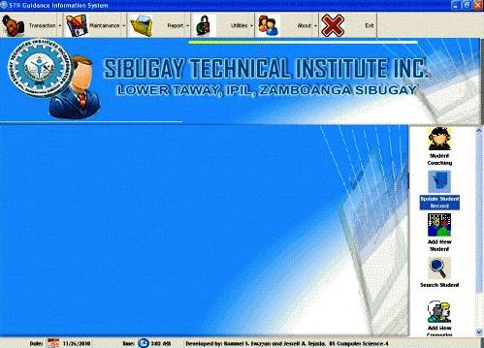

Figure 6. Sibugay Technical Institute Inc. Guidance Information System

Figure 6. Shows the Guidance Information System of Sibugay Technical Institute Inc. of Mr. Rommel Roldan. This system will help the guidance office to manage student’s records and exclusively for the guidance office of Sibugay Technical Institute Inc. To access the system, the user must enter his/her username and password.

The main form consists of commands for transactions, maintenance, utilities, report, about, edit and manipulation of student’s records. It also views time, date and developers.

The functions of the system included the following:

* + - 1. User Verification.
      2. Add, edit, delete and save commands for manipulating student’s records.
      3. Search student records.
      4. View records of all students, transactions, maintenance and utilities
      5. Add new counselor for student.
      6. Displays information about STII Guidance office.
      7. Add, edit, delete and save commands for Guidance office transactions.
      8. Add, edit, delete and save commands for Guidance office maintenance.
      9. Add, edit, delete and save commands for Guidance office utilities.
      10. Generate reports.

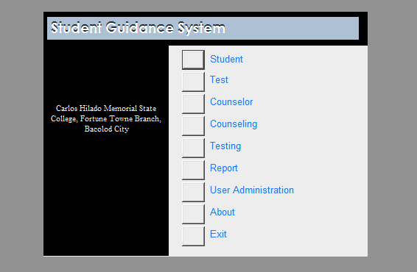

Figure 7. Student Guidance System Main Form

Figure 7. Shows the Student Guidance System of Carlos Hilado Memorial State College Fortune Towne Campus. This system will help the guidance office in utilizing student’s records and exclusively for the guidance office of Carlos Hilado Memorial State College Fortune Towne Campus. To access the system, the user must enter his/her username and password. This main form consists of command buttons for Student, Test, Counselor, Counseling, Testing, Report, User administration, about and Exit.

The functions of the system included the following:

1. User Verification.

2. Add, edit, delete, search and save commands for manipulating student’s records.

3. View records of all students, counselor, counseling, test and testing.

4. Displays information about CHMSC Guidance office.

5. Add, edit, delete and save commands for Guidance office counselor.

6. Add, edit, delete and save commands for Guidance office counseling.

7. Add, edit, delete and save commands for Guidance office test and testing.

8. Generate reports.

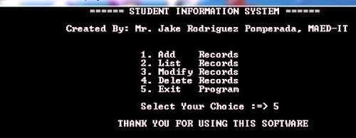

Figure 8. Main form of Student Information System

Figure 8. Shows the main form of student information system created by Mr. Jake Rodriguez Pomperada, an Instructional Technology Programmer, Teacher, Computer Technician and Electronics Technician. He developed this system to help those programmers that developing a SIS and to spread his work to all the users who are visiting in his site. He also accepts programming jobs like assignments, projects and thesis in a very reasonable and affordable price.

The system he made will help the guidance office in managing student’s records. The functions of the system are users can add records, delete records, modify records and view list of records.

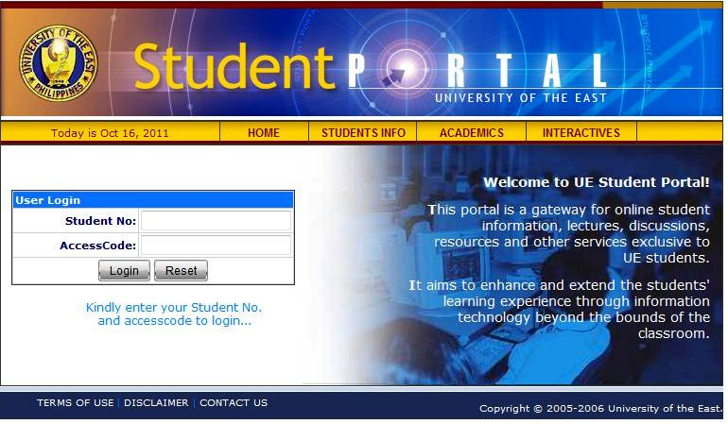

Figure 9. University of the East Users Login

Figure 9. Shows the login page of UE. This system allows students to manage their profiles and view other related activities. This system also is exclusively for students of the UE. To access the system, the user must enter his/her student number and access code. It system allows students view student information, lectures discussions, resources and other services. This also facilitates communication between professors and students beyond class hours and is available. This page is composed of the User Verification form that includes fields for student no, access code, terms of use, disclaimer and contact us.

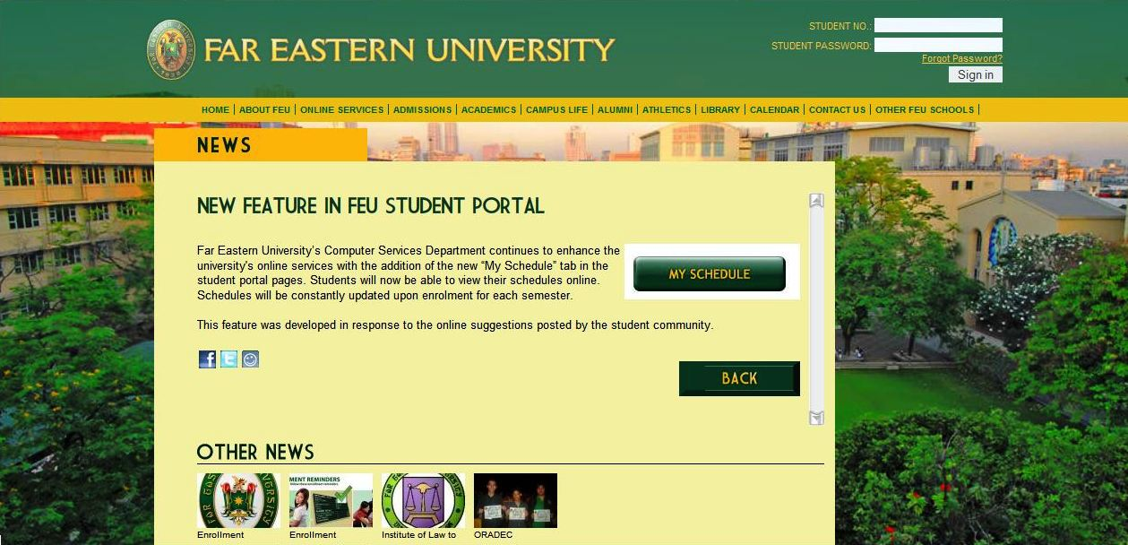

Figure 10. Far Eastern University Users Login

Figure 2.4.5. Shows the login page of FEU. A system of the Far Eastern University that views detailed information about the University for Users. This system is exclusively for students of the FEU. To access the system, the user must enter his/her student number and student password. It system allows students to view online their schedules. This system also constantly updated upon enrollment for each semester.

This page is composed of the User Verification form that includes fields for student no, student password, and student password Recovery.

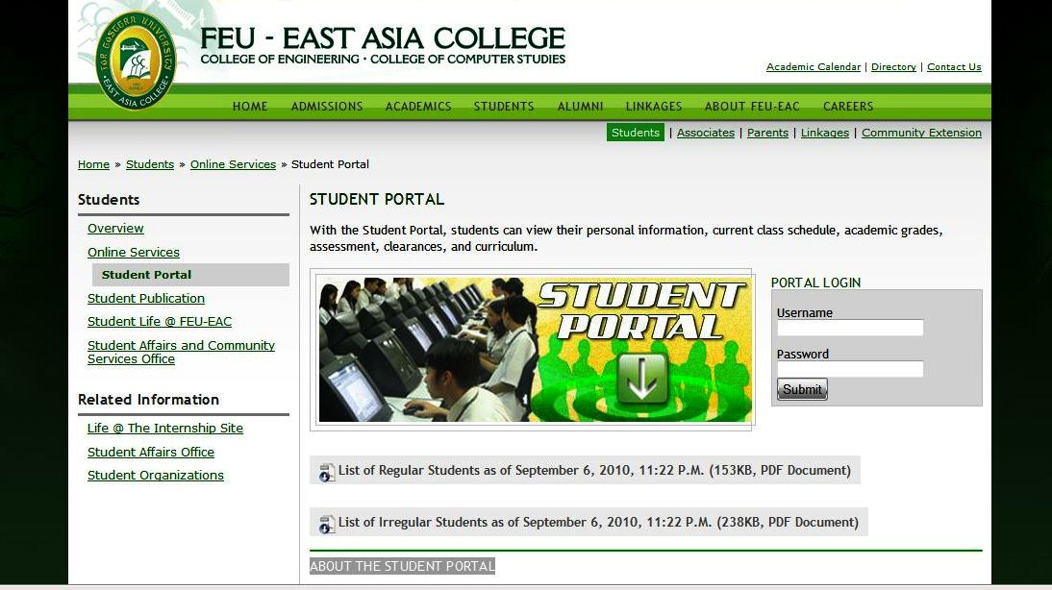

Figure 10.1. Far Eastern University – East Asia College Users Login

Figure 10.1 shows the login page of FEU-EAC. A system of the Far Eastern University – East Asia College that views detailed information about the University for Users. This system is exclusively for students of the FEU-EAC. To access the system, the user must enter his/her student username and password. It allows students to view information, registration and other school transactions. Students can also view their personal information, current class schedule, academic grades, assessment, clearances, and curriculum. It also view list of regular and irregular students per day in pdf form.

This page is composed of the User Verification form that includes fields for student no, student password, academic calendar, and directory and contacts us.

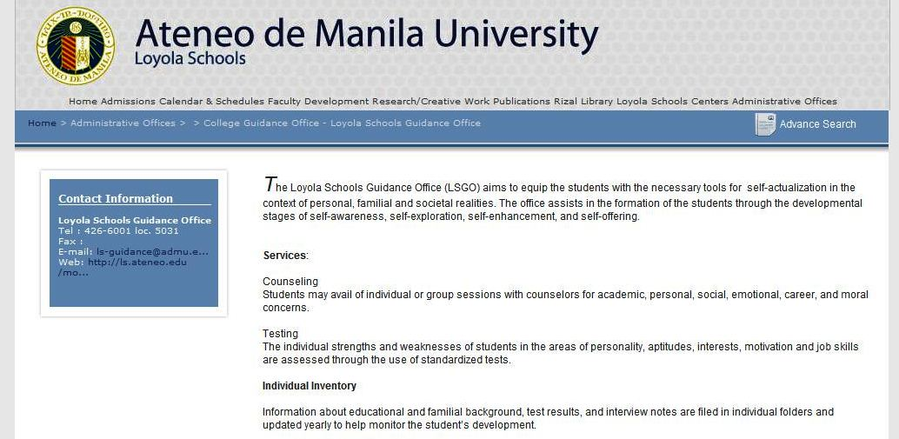

Figure 11. Loyola Schools Guidance Office (LSGO) Portal

Figure 11. Shows the Guidance office information portal of Ateneo de Manila. A system of the Ateneo de Manila Loyola Schools that views detailed information about the University for Users. This system allows students to view information, registration and other school transactions. They don’t have users login because of this anyone can view their portal. This page is composed of contact information, services, individual inventory, Faculty/Parent Consultations Research, Educational & Occupational Information, Introduction to Ateneo Culture (INTACT), Scholar’s Program, Special Program Designs/Workshops, Academic/Probation Follow-up Program and announcements.

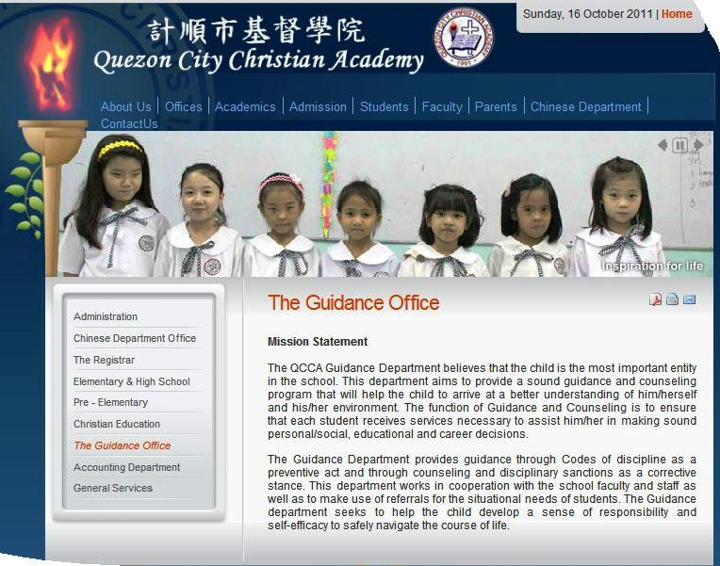

Figure 12. QCCA Guidance Department Portal

Figure 12. Shows the Guidance Department portal of Quezon City Christian Academy. A system of the Quezon City Christian Academy that views detailed information about the University for Users. This system shows also the mission statement of QCCA Guidance Department, offices, academics, admission, students, faculty, parents and Chinese department. This not also required users login because they allow anyone to view their portal.

**Synthesis**

The proponents believe that each and every literature and studies stated in this research is similar on the present study.

The Guidance Information and Monitoring System design will help to gain the technical skills needed to design and implement high-quality system that support business needs. This specialization will also build your knowledge of developing and maintaining system.

**Chapter III**.

**METHODS AND PROCEDURES OF THE STUDY**

This chapter deals with the methods of research used, sample and sampling technique, data gathering procedure and instrument used.

**Research Method**

This research was conducted in order to determine whether the questionnaire play a significant role in the study**.** The method used by the researchers is the descriptive research method. To define the descriptive type of research, Calderon (1993) stated that the descriptive method of research describes and interprets what it is. It is about the conditions of relationships that exists; practices that succeed; beliefs, processes that is going on; effects that are being felt, or trends that are developing. Descriptive research on the other hand is a type of research that is mainly concerned with describing the nature or condition and the degree in detail of the present situation.

In this study, the researchers choose to use this research method considering the objective to obtain first hand data from the end user. It involves the recording, description, analysis and the presentation of the present system, composition or processes of phenomena. The descriptive method is very useful for the researcher due to its flexibility; this method can use either qualitative or quantitative data or both, giving the researcher greater options in selecting the instrument for data gathering.

**Sampling Procedures**

The researchers randomly selected 50 respondents for the study and a face-to-face interview to the guidance counselor. Calderon (1993) defined Sampling as measuring a part of population and making a general report about the whole. Under the Descriptive Research Method, the techniques used are the face-to-face interview and the survey method.Face-to-face interview is the most widely used in the research of any topic and based on a direct meeting between interviewer and interviewee while the survey is collecting measurable information to find the condition of the respondents with an accurate interpretation. They’re using the Guidance counselor as a respondent from the IFSU- Lagawe Campus Guidance Office in the first method, the face-to-face interview and the students of IFSU-Lagawe Campus in the second method, the survey, in order to gather relevant data; the descriptive method is then appropriate as this can allow the identification of interviewee answers. For this research, two types of data were gathered. These included the primary and secondary data types. The primary data were derived from the answers of the interviewee given during the interview process. The secondary data on the other hand, were obtained from published documents and literatures that were relevant to IFSU-LAG GIMS.

Additionally, the development of the system and the design will use PHP for their front-end, MYSQL for the back-end, and some picture editing application software like Paint, Adobe Photoshop, and Macromedia Fireworks, Flash and Dreamweaver.

**Locale of the Study**

The study was conducted in Ifugao State University-Lagawe Campus, located at Poblacion West, Lagawe, Ifugao. Particularly in the Guidance office.

**Respondents**

The 50 students and the guidance counselor were the respondents in this study. 10 students from the college of Engineering and Industrial Technology, 10 from the college of Teacher Education, 30 from the college of Business Management.

**Instrument Used**

The survey questionnaire was used to gather the data to draw conclusions. This instrument was validated by the specialist and experts that suit the needs of the study. Likewise, it was item analyze to infer the components needed for the study. In addition, some tools are interviews, observations, research and analysis used in the study.

**Research.** Research is the systematic search for related information on a specific topic or problem. The research materials are drawn from internet, books, and theses. It is for the purpose of answering questions posed by the researcher. This technique includes the most of the part of Chapter 2: The Review of Related Studies.

**Observation.** This technique is used when the researcher cannot secure valid data through the use of the two methods, the face-to-face interview and the survey.

**Interview.** An Interview is an act of questioning to receive a desired answer that is necessary in solving a specific problem. This is where data gathering occurs by asking questions for much needed information from the interviewee verbally and directly.

**Analysis.** Analysis is the process of summarizing the whole study into its essential parts of the data gathered according to the specific questions under the statement of the problem.

**Questionnaire.** A sequence of questions used in gathering important information’s from one or more persons. This will be distributed to the students of IFSU-Lagawe Campus to satisfy the researcher’s goal, which is to get and measure the opinions and polls of the respondents of the study. The questionnaire used for data gathering is consists of 5 questions intended to the guidance counselor while 9 questions were equally distributed to the students and faculties.

**Data Gathering Procedure**

1. **Problem Identification**

This study covers the student record, tracking and monitoring attendance, performance and offenses.

**b. Data Gathering**

To gather the needed information the researchers conducts the following:

* + - 1. Gather information about the existing systems related in this study.
      2. Research into related literature and local study of the design system of this study.
      3. Conduct an interview in the guidance counselor that managing students records.
      4. Organized, interpreted and analyzed the data gathered.

1. Observation

Before the system is designed, researchers have been observing the Guidance counselor on how their daily business operations. A Student logs-in on the counter, then the student’s proceed to the desk of the guidance counselor for consultation.

1. Interview

The researchers conducted interview, as they list down the user’s story that will be their basis in creating a design. The guidance counselor is given the autonomy to describe in details about the environment and what the system is.

**Statistical Treatment of Data**

Statistics is one approach of getting the information’s organized. The data will be treated in relation to what was asked in the specific objectives. These data will be tabulated, analyzed and interpreted

**Percentage**

P= f/n*100

* + Where P = percentage

f= number of respondents who answered yes/no in a particular question.

n= total number of respondents

**Weighted Mean**

Weighted points 5, 4, 3, 2 and 1 were allocated to the responses for qualitative analyses.

X = Σfx / n

* + Where X = computed weighted mean

Σ = summation symbol

x = scale value

f = frequency response

n = total number of respondents

|  |  |  |
| --- | --- | --- |
| Rating | Weight | Equivalent |
| 5.00 – 4.51 | 5 | Excellent |
| 4.50 – 3.51 | 4 | Very good |
| 3.50 – 2.51 | 3 | Good |
| 2.50 – 1.51 | 2 | Fair |
| 1.50 – 1.00 | 1 | Poor |

Table 3.1. Likert Scale

**Chapter IV**

**PRESENTATION, ANALYSIS AND INTERPRETATION OF DATA**

This chapter presents analysis and interpretation of data gathered.

Question No.1: Do you have sufficient information about the Guidance office like their mission and vision, Guidance officer’s hierarchy, and office location together with the activities?

Figure1. Graphical representation of data for Question No.1

Figure 1. In the figure above it shows that 34 students out of 50 respondents don’t have sufficient information about the Guidance office like their mission and vision, Guidance officer’s hierarchy, and office location together with the activities while 16 students have sufficient information about the Guidance office.

Question No.2: Does the Guidance Office provide adequate assistance to students and faculty that may need such information follow-up, program, and activities?

Figure 2. Graphical representation of data for Question No.2

Figure 2. Shows that 30 students out of 50 respondents agreed that the Guidance Office provide adequate assistance to students and faculty may need such information follow-up, program and activities while 20 students don’t agree that the Guidance Office don’t provide adequate assistance to students and faculty don’t need such information follow-up, program and activities.

Question No.3: Is the Guidance Office a place accessible for wide dissemination of information in the campus?

Figure 3. Graphical representation of data for Question No.3

Figure 3. Shows that 26 students out of 50 respondents agreed that the Guidance Office a place accessible for wide dissemination of information in the campus while 24 students don’t agree that the Guidance Office is not a place accessible for wide dissemination of information in the campus.

Question No.4: Do you experience problems to process request, certificates, and other papers?

Figure 4. Graphical representation of data for Question No.4

Figure 4. Show that 28 students out of 50 experienced problems in processing a document in the Guidance office while 22 students don’t experience processing document in the Guidance office.

Question No.5: Does the record available anytime for efficient purpose?

Figure 5. Graphical representation of data for Question No.5

Figure 5. Shows that 20 students out of 50 respondents answered that the records are available anytime for efficient purpose while 30 students answered that the records are not available anytime for efficient purposes.

Question No.6: Are you aware on how the guidance office monitors students’ attendance such as absences, tardiness, and sickness?

Figure 6. Graphical representation of data for Question No.6

Figure 6 shows that 27students out of 50 respondents are not aware on how the guidance office monitors students’ attendance such as absences, tardiness and sickness while 23 students are aware on how the guidance office monitor student’s attendance such as absences, tardiness and sickness.

Question No.7: Do you agree if the guidance office wanted the faculty to pass student attendance per month?

Figure 7. Graphical representation of data for Question No.7

Figure 7. Shows that 35 students out of 50 respondents agreed that the guidance office wanted the faculty to pass student attendance every month while 25 students dis agree that the guidance wanted the faculty to pass students attendance every month.

Question No.8: Does the Guidance Office keep record for confidentiality?

Figure 8. Graphical representation of data for Question No.8

Figure 8. Shows that 42 students out of 50 respondents answered that the Guidance Office keep record for confidentiality while 8 students answered that the Guidance Office does not keep record for confidentiality.

Question No.10: Does the guidance office need the IFSU- Guidance Management System (GMS) to closely monitor the performance of the students?

Figure 10.Graphical representation of data for Question No.10

Figure 9. Shows that 42 students out of 50 respondents want to implement the IFSU-Guidance Management System (GSM) to closely monitor the performance of the students.

**The Survey Questionnaire Tally**

|  |  |  |  |  |
| --- | --- | --- | --- | --- |
| **QUESTIONS** | **YES** | **NO** | **PERCENTAGE** | |
| **YES** | **NO** |
| 1. Do you have sufficient information about the Guidance office like their mission and vision, Guidance officer’s hierarchy, and office location together with the activities? | 16 | 34 | 32% | 68% |
| 1. Does the Guidance Office provide adequate assistance to students and faculty that may need such information follow-up, program, and activities? | 30 | 20 | 60% | 40% |
| 1. Is the Guidance Office a place accessible for wide dissemination of information in the campus? | 26 | 24 | 52% | 48% |
| 1. Do you experience problems to process request, certificates, and other papers? | 28 | 22 | 56% | 44% |
| 1. Does the record available anytime for efficient purpose? | 20 | 30 | 40% | 60% |
| 1. Are you aware on how the guidance office monitors students’ attendance such as absences, tardiness, and sickness? | 23 | 27 | 46% | 54% |
| 1. Do you agree if the guidance office wanted the faculty to pass student attendance per month? | 35 | 15 | 70% | 30% |
| 1. Does the Guidance Office keep record for confidentiality? | 42 | 8 | 84% | 16% |
| 1. Does the guidance office need the IFSU-Lagawe Guidance Information and Monitoring System (IFSU-LAG GIMS) to closely monitor the performance of the students? | 42 | 8 | 84% | 16% |

Table 1. Survey Tally Results per Question

In the table above in question no. 1. it shows that more than half (68%) of the respondents does not have sufficient information about the Guidance office like their mission, vision, Guidance officer’s hierarchy and office location together with the activities only more than one fourth of the respondents (32%) have sufficient information about the Guidance office like their mission, vision, Guidance officer’s hierarchy and office location together with the activities. In question no.2 more than half of the respondents (60%) are aware that Guidance Office provide adequate assistance to students and faculty that may need such information follow-up, program, and activities, more than one fourth (40%) are not aware that the Guidance office provide adequate assistance to students and faculty that may need such information follow-up, program and activities. In question no.3 half of the respondents (52%) is aware that the Guidance Office a place accessible for wide dissemination of information in the campus while less than half (48%) insist that the Guidance Office is not a place accessible for wide dissemination of information in the campus. In question no.4 half of the respondents (56%) experience problems to process request, certificates, and other papers while less than half of the respondents (44%) did not experience problems to process request, certificates and other papers in the Guidance office. In question no.5 more than one fourth (40%) of the respondents answered that the record is available anytime for efficient purpose while more than half of the respondents (60%) answered that the record is not available anytime for efficient purpose. In question no.6 more than one fourth (46%) of the respondents are aware on how the guidance office monitors students’ attendance such as absences, tardiness, and sickness while half of the respondents (54%) are not aware on how the guidance office monitors students’ attendance such as absences, tardiness, and sickness. In question no. 7 less than three fourth (70%) of the respondents agree that the guidance office wanted the faculty to pass student attendance per month while more than one fourth (30%) of the respondents disagree that the guidance office wanted the faculty to pass student attendance per month. In question no.8 more than three fourth (84%) of the respondents believe that the Guidance Office keep record for confidentiality while less than one eight (16%) of the respondents don’t believe that the Guidance Office keep record for confidentiality. In question no.9 more than three fourth (84%) of the respondents say yes that the guidance office need the IFSU-Lagawe Guidance Information and Monitoring System (IFSU-LAG GIMS) to closely monitor the performance of the students while more than one eight (16%) of the respondents say no that the guidance office don’t need the IFSU-LAG GIMS to closely monitor the performance of the students.

**Interview Results**

|  |
| --- |
| 1. Is the current procedure for monitoring student’s records time consuming?   Yes   1. Do you find difficulties in monitoring students records especially offenses and attendance?   Yes   1. Do you have a database for your documents?   yes   1. Do you find difficulties in managing and organizing student’s records?   Yes   1. Do you prefer to use a system?   Yes   * Logging name * Main Menu * Basic Information of IFSU- Students * Educational Background of IFSU- Students * Parents Information of IFSU- Students * Student Disciplinary Action Form * Attendance Monitoring Sheet |

Table 2. Result of Interview Conducted

Table 2. Shows the result of the interview that the researchers conducted. Based on this table the researchers find out that the main problem is how this system will help the guidance office to have an easier management on student’s records and at the same time to monitor also the student’s records. The guidance officers have difficulties in managing, organizing and monitoring student’s records. Specific problems time monitoring and possible loss of records. To solve this problem the researchers prompted to design a project study regarding in this method that has title of IFSU-Lagawe Guidance Information and Monitoring System. In the first question the officer answered it yes. This means that the current procedure they used in monitoring students records is time consuming since there’s a lot of students in IFSU-Lagawe and they are only few who will do this job. In question no.2 the officer answered it yes. The officer finds difficulties in monitoring student’s records because they cannot easily track the student’s offenses and attendance. In question no.3 the officer answered it yes. They have a database for their documents. In question no.4 the officer answered it yes. The officer finds difficulties also in organizing and managing student’s records. In the last question the officer answered it yes and with a certain things that the officer wants to see in a system.

The officer wants to see this following in the system

* + - * 1. The system must be easy to use.
        2. There’s user verification.
        3. In the main form of the system there are commands for search, new record/update, delete and save data.
        4. For basic information of students it must have id number, students name, provincial address, address, date of birth, place of birth, nationality, civil status, gender, telephone number/mobile number, course, year graduated, degree course,
        5. For educational background it must have elementary information, high school information, awards, organization and scholarship.
        6. For parents information it must have father and mother name, occupation and address. And In case of emergency this will consists of contact person, telephone number and relationship.
        7. For student disciplinary action this must contain of major offense and minor offense.
        8. For attendance monitoring sheet this must contain of year and section, name of student, absences, tardiness, total number of absences and tardiness.
        9. System must have reports for the following

Students offenses

Students courses

Attendance

Scholarship

Information about exit interview form

Number of students in certain area

In every operation officer conduct it must have reports.

**Analysis**

The study attempted to identify the current method in monitoring student’s records and offenses in IFSU-Lagawe.

Based on the observations of the researchers during the conduct of the interview shown in the table 2 above that the guidance officer have difficulties in managing, organizing and monitoring student’s records because they cannot easily track the student’s offenses and attendance. Specific problems time monitoring and possible loss of records. In the questionnaire that being floated most of the students are not aware on the guidance vision, mission and Guidance officer’s hierarchy, the records are not available anytime for efficient purposes and some of the students not aware on how the guidance office monitor students’ attendance such as absences, tardiness and sickness provided with this analysis the design of the system can be a help to address the problem of the study.

**Relevance of the Related Studies in the design System**

* + - 1. The Guidance Information System of Sibugay Technical Institute Inc. gave the researcher an idea on how will be the process of the design system. It suited one of the bases of the study because of its concepts and its functions of inputting, viewing of student information and records.
      2. The Student Guidance System of Carlos Hilado Memorial State College Fortune Towne Campus serves a big help to the design system because it contains the same process with the IFSU-Guidance Management System.
      3. The TUP-T Student Information System of Calibara, Desiree V., Co, Ruben Jr., D. and Luriz, Edneil Josef B. (2010), this system is similar to Student Data Management. TUP-T Student Information System is a big help for the design system to be the one of the basis. It is not yet implemented because of some error issues so that the researches develop a web application version of it. This system provides functional and reliable module for organizing the student information achieving accurate data. The system they made will also serve as an electronic data bank for the Guidance Center. These are the following features can be access by the designated officer: Manipulating of student’s records, attendance and offenses.

**System Analysis and Design**

* + - 1. **User Story**

The researchers used this tool in software design to capture a description of a software feature from an end-user perspective. The user story describes the type of user, what they want and why. A user story helps to create a simplified description of a requirement.

As a Guidance Counselor/Assistant:

* 1. I want a Guidance Information and Monitoring System so that I can easily manage students’ records.
  2. I want to search profile through input of student school ID Number.
  3. I want to create and enter new student profile.
  4. I want to update/ edit student profile.
  5. I want to delete an old/ graduated student profile.
  6. I want to view students name with his/her
     + 1. **Use Case Diagram**

Guidance Counselor

Guidance Assistant

It shows the Use case of the Administrator. Use case describe the interactions that take place between actor (Guidance counsellor/Assistant) and system during the processes. Based on the shown figure, the Guidance Counsellor/Assistant can login as Administrator to manage Student’s Profile and Student Records.

* + - 1. **Use Case Specification**

|  |  |
| --- | --- |
| Use case number | 1.0 |
| Use case Name | Login |
| Actor(s) | School Guidance Counsellor/Guidance Assistant |
| Summary | Authenticated users to the system |
| Triggers | Users need to access the system |
| Pre-condition | User must have an authenticated user account (username, password) |
| Basic Course Event | 1. User enter authenticated account  a. User name  b. Password  2. User submits authenticated account  3. The system validates authenticated account |
| Alternative Path | User cancel log-in |
| Exception Paths | User entered wrong username and password |
| Business Rules | Username must at least 8 character |
| Post Condition | User Successfully login to the system |
| References | See attached |
| Authors | Christopher D. Pumihic, Rowena G. Hinumla, Bernadette P. Natividad |

|  |  |
| --- | --- |
| Use case number | 2.1 |
| Use case Name | Create/Add Client Profile |
| Actor(s) | School Guidance Counsellor/Guidance Assistant |
| Summary | Create/Add a Client Profile |
| Triggers | User would like to Create/Add a Client profile |
| Pre-condition | The user must log in to the system |
| Basic Course Event | a. HR Manager will enter Student profile   * Student ID Number * Student Name (First Name, M.I. and Last Name) * Course * Age * Birthdate * Address (Home and Boarding House Address) * Status * Hobbies * Contacts (In case of Emergency) * Parents Name (father and mother)   b. User submits student profile  c. The system validates student profile  d. System: Enter student account to the Database |
| Alternative Path | User will cancel the submission of account for validation |
| Exception Paths | The User should fill up important information |
| Business Rules | student must have unique Employee ID |
| Post Condition | The User successfully created/added a Client to the system |
| References | See attached |
| Authors | Christopher D. Pumihic, Rowena G. Hinumla, Bernadette P. Natividad |

|  |  |
| --- | --- |
| Use case number | 2.2 |
| Use case Name | Update/Edit Employee profile |
| Actor(s) | School Guidance Counsellor/Guidance Assistant |
| Summary | Update/Edit a client profile |
| Triggers | User would like to Update/Edit Employee profile |
| Pre-condition | The User must have log in to the system |
| Basic Course Event | a. User will Update/Edit Employee profile   * Enter student ID to display the profile information * Edit student profile   b. User will submit student profile  c. The system updates student account |
| Alternative Path | User will cancel the submission of account |
| Exception Paths | The user should fill up important information |
| Business Rules | The student must have an account to be edited/ updated |
| Post Condition | The user successfully edited the Employee profile |
| References | See attached |
| Authors | Christopher D. Pumihic, Rowena G. Hinumla, Bernadette P. Natividad |

|  |  |
| --- | --- |
| Use case number | 2.3 |
| Use case Name | Delete Client Profile |
| Actor(s) | School Guidance Counsellor/Guidance Assistant |
| Summary | Delete a student Profile |
| Triggers | User would like to Delete student Profile and Records |
| Pre-condition | The user must have logged on to the system |
| Basic Course Event | a. HR Manager will student Profile   * Enter student ID Number * Delete student Profile * Confirmation   b. The system removes student account |
| Alternative Path | User will cancel the removal of account |
| Exception Paths | The User should close the windows |
| Business Rules | An account can only be deleted when the student is graduated/dropped out from the institution. |
| Post Condition | The School Guidance counsellor successfully Deleted the student account |
| References | See attached |
| Authors | Christopher D. Pumihic, Rowena G. Hinumla, Bernadette P. Natividad |

|  |  |
| --- | --- |
| Use case number | 2.4 |
| Use case Name | View Client Profile |
| Actor(s) | School Guidance Counsellor/Guidance Assistant |
| Summary | View all student Profile |
| Triggers | User would like to View all student Profile |
| Pre-condition | The User must have log in to the system |
| Basic Course Event | a. User will View Clients Profile   * System: display all student Profile   b. User will Create/Add, Update/Edit, Delete student Profile, Create/ Add student record, view/ Update student record/ Delete student record  c. User will submit student Profile  d. The system validates student account |
| Alternative Path | User will cancel the display of account |
| Exception Paths | The User should close the windows |
| Business Rules | The Client must have an account |
| Post Condition | The User successfully Viewed the Clients Profile |
| References | See attached |
| Authors | Christopher D. Pumihic, Rowena G. Hinumla, Bernadette P. Natividad |

|  |  |
| --- | --- |
| Use case number | 3.0 |
| Use case Name | Create/ Add Student Record |
| Actor(s) | School Guidance Counsellor/Guidance Assistant |
| Summary | Create and add new student record |
| Triggers | User would like to create/add student record |
| Pre-condition | The User must have logged on to the system |
| Basic Course Event | a. User will create/add student record   * Enter Student School ID Number to display all information   b. The User will enter student   * Complaint * Problem * Date of consultation   c. User will submit student Record  d. The system updates student account |
| Alternative Path | User will cancel the submission of account |
| Exception Paths | The user should fill up important information |
| Business Rules | The student must have an account. |
| Post Condition | The User successfully created/ added Student Record |
| References | See attached |
| Authors | Christopher D. Pumihic, Rowena G. Hinumla, Bernadette P. Natividad |

|  |  |
| --- | --- |
| Use case number | 3.1 |
| Use case Name | Edit/ Update Student Record |
| Actor(s) | School Guidance Counsellor/Guidance Assistant |
| Summary | Edit/ Update Student Record |
| Triggers | User would like to create/add student record |
| Pre-condition | The User must have logged on to the system |
| Basic Course Event | a. User will create/add student record   * Enter Student School ID Number to display information   b. The User will edit/update Client’s   * Complaint * Problem * Date of consultation   c. User will submit student Record  d. The system updates student account |
| Alternative Path | User will cancel the submission of account |
| Exception Paths | The user should fill up important information |
| Business Rules | The system record only |
| Post Condition | The User successfully edited/ updated student Record |
| References | See attached |
| Authors | Christopher D. Pumihic, Rowena G. Hinumla, Bernadette P. Natividad |

|  |  |
| --- | --- |
| Use case number | 3.2 |
| Use case Name | Delete student Record |
| Actor(s) | School Guidance Counsellor/Guidance Assistant |
| Summary | Delete student record |
| Triggers | User would like to delete student record |
| Pre-condition | The User must have logged on to the system |
| Basic Course Event | a. User will delete student record   * Enter Student School ID Number to display information   b. System asks for confirmation  c. The system deletes studen account |
| Alternative Path | User will cancel the deletion of account |
| Exception Paths | The user should confirm the deletion of an account |
| Business Rules | The student must be graduate/ dropped out at least two years after. |
| Post Condition | The User successfully deleted Student Record |
| References | See attached |
| Authors | Christopher D. Pumihic, Rowena G. Hinumla, Bernadette P. Natividad |

* + - 1. **Sequence Diagram: Login**

Return Done

Return Done

Login Database

Login Controller

School Guidance Counsellor/ SGC Assistant

Login UI

Login (Username,

Password

Fetch (Username, Password)

Validates (Username, Password)

**Sequence Diagram: Student Profile**

Fetch Data

Return Done()

Validates Data

Return Done()

Validates Data

Remove Data

Return Done

Return Done

Profile Database

Profile UI

Profile Controller

School Guidance Counsellor/ Assistant

Create/Add

Update/Edit (input ID Number)()

Update/Edit (input Number

Fetch Input Data

Save Data

Return Done

Return Done

Delete (Input ID Number)

View (Input ID Number)

**Sequence Diagram: Student Record**

Fetch Data

Return Done()

Validates Data

Return Done()

Validates Data

Remove Data

Return Done

Return Done

Profile Database

Profile UI

Profile Controller

School Guidance Counsellor/ Assistant

Create/Add

Update/Edit (input ID Number)()

Update/Edit (input Number

Fetch Input Data

Save Data

Return Done

Return Done

Delete (Input ID Number)

View (Input ID Number)

**Functional Requirements**

1. Login Module

The system can only be accessed by authorized personnel in the guidance. The authority user must use username and password to login to the system. Validation on username and password is required to deny invalid user login to the system.

1. Student Record Module

Student record is a confidential data which supposed to be viewed by the system administrator only.

**Non-Functional Requirement**

1. Security Requirement

The system must provide a highly secured services on the student’s record privacy.

1. Reliability Requirement

There must be lesser risk of system errors. Error message should prompt the user when there is any validation error occurred.

1. Efficiency Requirement

The system must give good result within amount of time

1. Accessibility. The system should be accessible only by authorized personnel.
2. Interoperability. The system must work in any Operating System.
3. Effectiveness. The system should perform well.

**Design Flow Chart**

Problem Identification

Planning

Data Gathering

System Designing

It shows the flowchart for the designing of the project. The system design starts with problem identification the reason why the study is being conducted. Next is planning where the researcher plan the things needed and the requirements in designing a system. Then it proceeds to data gathering where the researcher made some interviews with the guidance counselor and additional research was done which served as secondary data for the design system. After these activities, the researcher proceeds to system designing.

**User Interface Design**

Navigation Panel appears in every module and has its corresponding links that will direct the end user to another module (shown in Figure 11). In form validation, error messages are shown (shown in Figure 12) whenever the user entered invalid inputs and leave the required fields empty. In the Log-in form (shown in Figure 4.2.2), the user must enter the exact username and password.

Error messages will prompt the user whenever the user is trying to change the website url without logging in.

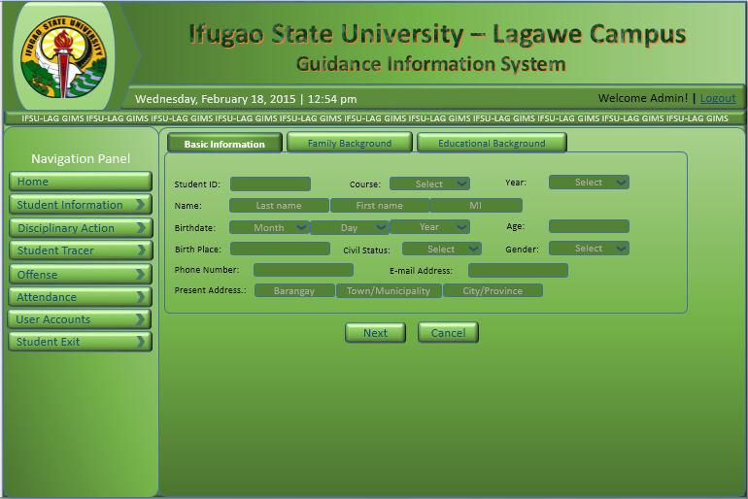

You must fill up the required fields (*)!

*

*

*

*

*

*

*

*

*

*

*

*

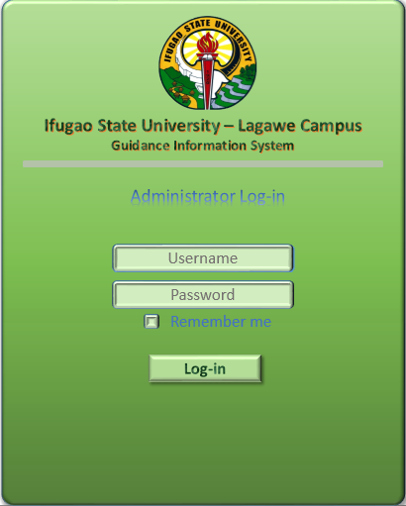Figure 11. Navigation Panel and Form Validation.

Figure 12. Login Form

Chapter V

**SUMMARY, CONCLUSION AND RECOMMENDATION**

**Summary of Findings**

This study purposively design a computerized Guidance Center to easily monitor and manage students’ record as data bank.

During the conduct of the interview shown in the table 2 above that the guidance officer have difficulties in managing, organizing and monitoring student’s records. In the first question the officer answered it yes. This means that the current procedure they used in monitoring students records is time consuming since there’s a lot of students in IFSU-Lagawe and they are only few who will do this job. In question no.2 the officer answered it yes. The officer finds difficulties in monitoring student’s records because they cannot easily track the student’s offenses and attendance. In question no.3 the officer answered it yes. They have a database for their documents. In question no.4 the officer answered it yes. The officer finds difficulties also in organizing and managing student’s records. In the last question the officer answered it yes, the officer prefer to use a system and with a certain things that the officer wants to see in a system.

1. The system must be easy to use.

2. There’s user verification.

1. In the main form of the system there are commands for search, new record/update, delete and save data.
2. For basic information of students it must have id number, students name, provincial address, address, date of birth, place of birth, nationality, civil status, gender, telephone number/mobile number, course, year graduated, degree course,
3. For educational background it must have elementary information, high school information, awards, organization and scholarship.
4. For parents information it must have father and mother name, occupation and address. And In case of emergency this will consists of contact person, telephone number and relationship.
5. For student disciplinary action this must contain of major offense and minor offense.
6. For attendance monitoring sheet this must contain of year and section, name of student, absences, tardiness, total number of absences and tardiness.

The result of the questionnaire floated most of the students does not have sufficient information about the Guidance office like their mission, vision, Guidance hierarchy, and office location together with the activities. The students experience problems to process request, certificates and other papers in the Guidance office and most of the students are not aware on how the guidance office monitor student’s attendance such as absences, tardiness and sickness. On the other hand the students are aware that Guidance Office provide adequate assistance to students and faculty that may need such information follow-up, program, and activities likewise that the Guidance Office is a place accessible for wide dissemination of information. Three fourth say yes that the guidance office need the IFSU-Guidance Management System Design (GMS) to closely monitor the performance of the students.

**Conclusion**

After analyzing the problem of the study that has been completed together with the results of the study, the design of the system is accepted that the system can be a beneficial to the University especially the Guidance Office. This will entails innovative change in technology, modernize the process and system, and reduce time and efforts work by the Guidance Counselor.

**Recommendation**

Based from the findings and conclusion formulated, we recommend that the upcoming researchers may enhance the design system for better functionality because the current design is not a complete design for a complete services of Guidance Management System. The main reason for this study is to be able to design IFSU-Lagawe Guidance Information and Monitoring System Design to enable the guidance officer work conveniently and to prevent loss of data.