1.contoller running
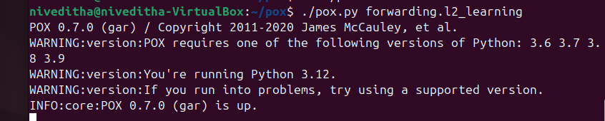
2.topology running
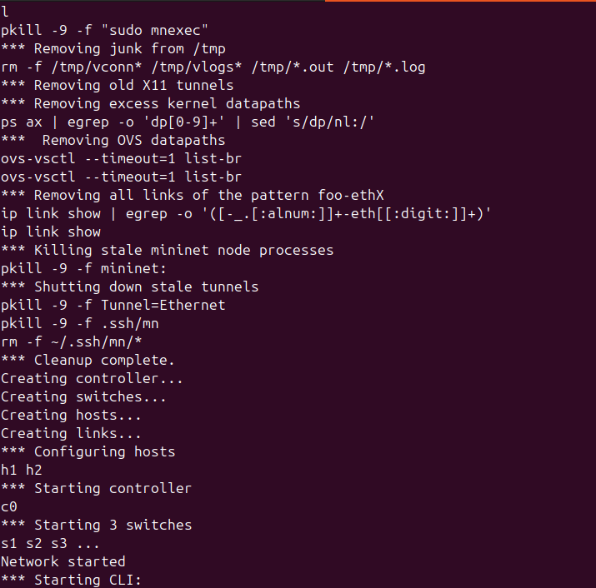
3.ping
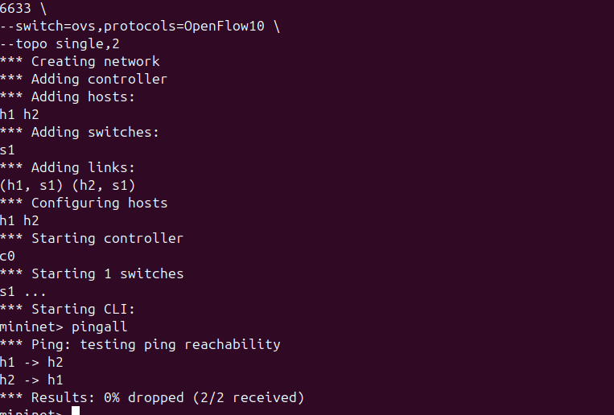
4. link failure
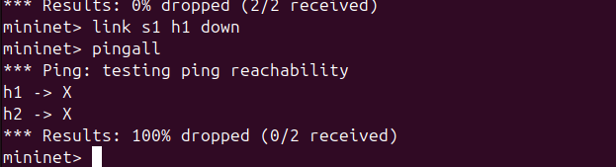
5.link recovery
