Assignment 3 Johnny N

Question 3:

1. Inorder traversal x / y + 3 \* b / c:

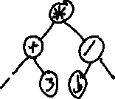

1. Postorder traversal x y z + a b – c \* / -:

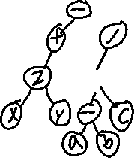

1. Preorder traversal \* + a – x y / c d:

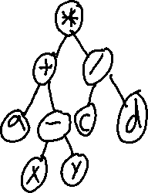

Question 4:

