Data Strucutre and Alogorithms
-------------------------------------

What are data structure?
Ans: A data structure is a way of organizing and storing data in a computer so that it can be used efficiently. It defines a set of rules or operations for manipulating the data, and it provides a way to store and retrieve information. Data structures are fundamental to computer science and are used in a wide range of applications to solve various computational problems.

There are different types of data structures, each with its own strengths and weaknesses, and the choice of a particular data structure depends on the specific requirements of the task at hand. Some common data structures include:
- Arrays: A collection of elements, each identified by an index or a key.
- Linked Lists: Elements are stored in nodes, and each node points to the next node in the sequence.
- Stacks: A last-in, first-out (LIFO) data structure where elements are added and removed from the same end.
- Queues: A first-in, first-out (FIFO) data structure where elements are added at the rear and removed from the front.
- Trees: Hierarchical data structures with a root node and branches connecting nodes.
- Graphs: Collections of nodes (vertices) and edges that connect pairs of nodes.
- Hash Tables: Data structures that use a hash function to map keys to values, providing efficient key-based retrieval.
- Heaps: Specialized tree-based data structures that satisfy the heap property, commonly used in priority queues.

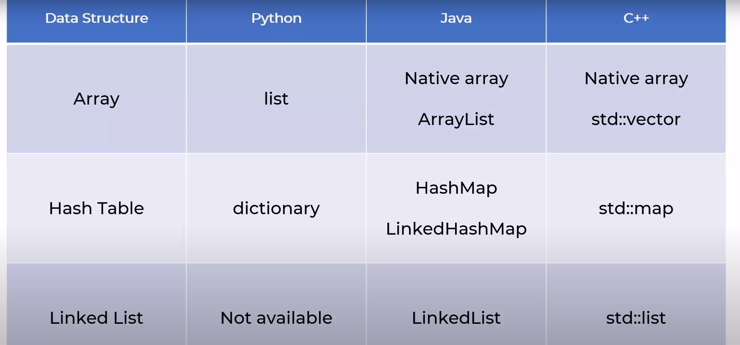

What is Big O notation?
Big O notation is a way to describe the upper bound on the asymptotic behavior of an algorithm's time complexity or space complexity as a function of its input size. It provides a simple and standardized way to analyze and compare the efficiency of algorithms without getting into the details of hardware, programming language, or constant factors.
In Big O notation, the performance of an algorithm is expressed in terms of the worst-case scenario. It describes how the runtime or space requirements of an algorithm grow relative to the size of the input. The notation is expressed using the letter "O" followed by a function. Here are some common Big O notations:
- O(1): Constant time complexity. The algorithm's performance does not depend on the input size.
- O(log n): Logarithmic time complexity. Common in algorithms that divide the problem in half at each step, like binary search.
- O(n): Linear time complexity. The performance scales linearly with the size of the input.
- O(n log n): Linearithmic time complexity. Common in efficient sorting algorithms like mergesort and heapsort.
- O(n^2): Quadratic time complexity. Common in algorithms with nested iterations over the input data, like bubble sort.
- O(2^n): Exponential time complexity. Common in algorithms with recursive calls that grow exponentially with the size of the input.
- O(n!): Factorial time complexity. Common in algorithms that generate all possible permutations or combinations of a set.
Big O notation provides a high-level perspective on algorithmic efficiency, allowing developers and computer scientists to discuss and compare the scalability of different algorithms without worrying about implementation details. It helps in making informed decisions about algorithm selection, especially when dealing with large datasets or resource-constrained environments.

