Django framwork:
----------------------
Django work on Model View Template

DTL(Django Template Language )--> it work with templates

Views: the business logic which we write in the views.

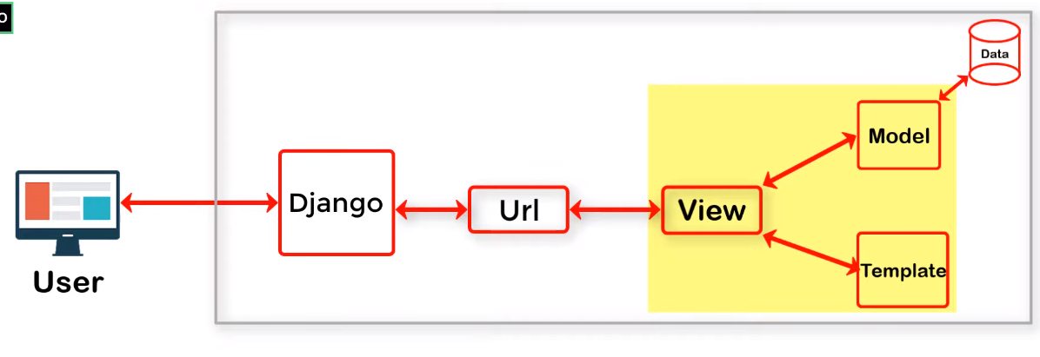
MVT Framewrok

