FastAPI working:
--------------------

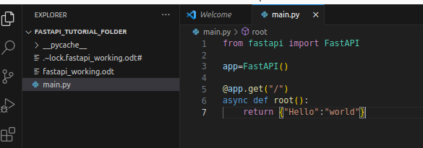

to run a uvicorn file :
cmd: uvicorn <file_name>:app

to run a uvicron file on required port :3000 is the port number it may be any thing bydefaul it is 8000
cmd: uvicorn <file_name>:app – port 3000
===================================================================
flag:
===
every time we do some changes in our file then we can use “--reload”
cmd: uvicorn main:app --reload
2nd cmd: uvicorn main:app --reload --port 8001
====================================================================
to get the “swegger” of uvicorn
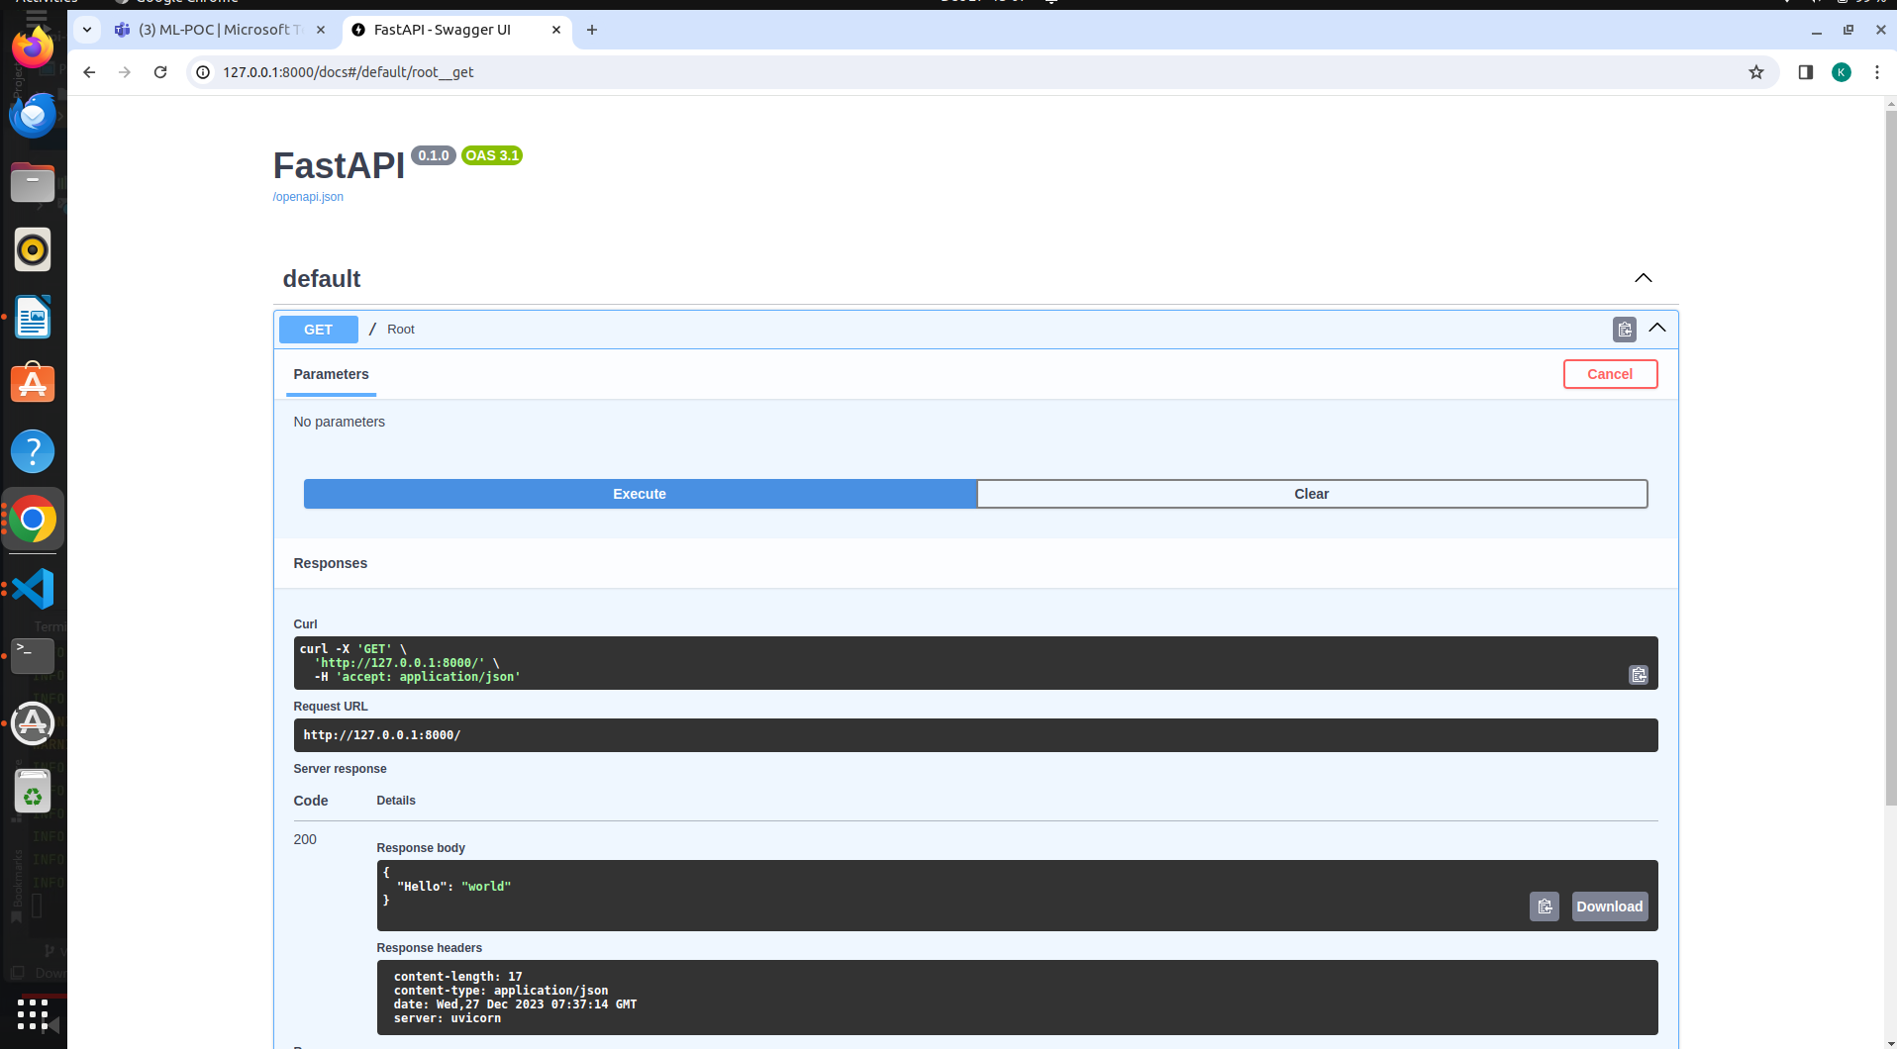

get items_id in string by default as shown in the picture
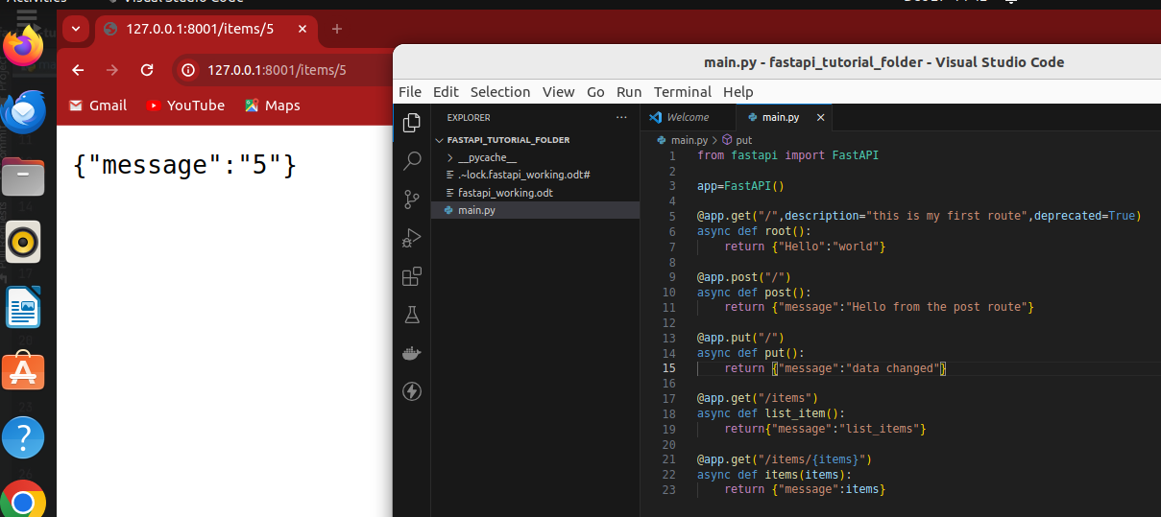
to get items_id in string we have to casting “async def items(items:int):”

======================================================================
Query parameter:
==============

