OPERATING SYSTEMS PROGRAMMING ASSIGNMENT
AI-Assisted Synchronization Algorithms with Program-Generated HTML Simulation

Readers-Writers Problem and Dining Philosophers Problem

Submitted by: Anushka Garthe
USN: NNM24IS084
Branch: Information Science and Engineering
Course: Operating Systems
Institution: NMAM Institute of Technology (NMAMIT)
Programming Language: Java
Academic Year: 2026–2027

1. Abstract
Process synchronization is an important concept in operating systems because multiple threads may access shared resources concurrently. Without proper synchronization, race conditions, inconsistent data, deadlocks, and starvation may occur.
This assignment implements two classical synchronization problems: the Readers-Writers Problem and the Dining Philosophers Problem. Each problem is implemented using two approaches: semaphores and monitors. Java concurrency mechanisms are used to coordinate the threads and protect shared resources.
The assignment also includes HTML simulations generated by the Java programs. These simulations display the execution states and events of the synchronization algorithms, helping users understand how threads coordinate their access to shared resources.

2. Objectives
- To understand process and thread synchronization in operating systems.
- To implement the Readers-Writers Problem using semaphores.
- To implement the Readers-Writers Problem using a monitor-based approach.
- To implement the Dining Philosophers Problem using semaphores for four philosophers.
- To implement the Dining Philosophers Problem using monitors.
- To identify and explain race conditions, mutual exclusion, deadlock, and starvation.
- To generate browser-viewable HTML simulations using program execution data.
- To document the implementation, testing, AI assistance, and references.

3. Problem Statement
When multiple threads access shared resources simultaneously, their operations may interfere with one another. Synchronization mechanisms are required to coordinate access and maintain correctness.
The Readers-Writers Problem involves readers and writers accessing a shared resource. Multiple readers may read simultaneously, but a writer must have exclusive access while writing.
The Dining Philosophers Problem involves four philosophers sharing four forks. Each philosopher requires two adjacent forks to eat. The implementation must prevent conflicting fork access and address deadlock.
Both problems are implemented using semaphores and monitor-style synchronization in Java.

4. Software and Tools Used
- Programming language: Java
- Development environment: Visual Studio Code
- Java Development Kit: JDK 21
- Concurrency mechanisms: Java threads, semaphores, locks, and condition variables or equivalent monitor mechanisms, as used by the source code
- HTML, CSS, and JavaScript: For browser-based simulations
- Git and GitHub: For version control and repository submission
- Microsoft Word: For preparing the report

5. Readers-Writers Problem Using Semaphores

5.1 Objective
The objective is to coordinate multiple readers and writers accessing a shared resource while maintaining data consistency.

5.2 Algorithm
A typical readers-preference design uses a mutex semaphore to protect the reader counter and a resource semaphore to control access to the shared resource. The precise ordering and fairness properties depend on the implementation in the submitted Java source code.
- A reader acquires the mutex before updating the reader counter.
- The first reader acquires the resource semaphore.
- The reader releases the mutex and performs the reading operation.
- After reading, the reader updates the reader counter while holding the mutex.
- The last reader releases the resource semaphore.
- A writer acquires the resource semaphore before writing and releases it after writing.

5.3 Synchronization
Multiple readers may access the shared resource concurrently when no writer is active. A writer must have exclusive access to the resource. The mutex protects the reader counter from concurrent modifications.

5.4 Execution Trace
Insert an actual execution trace from the Readers-Writers Semaphore program.
Event | Thread | State | Shared resource
1 | [Actual thread ID] | [Actual initial state] | [Actual status]
2 | [Actual thread ID] | [Actual state] | [Actual status]
3 | [Actual thread ID] | [Actual state] | [Actual status]
4 | [Actual thread ID] | [Actual state] | [Actual status]

Observation: Explain how your actual output demonstrates that readers and writers access the shared resource according to the implemented synchronization rules.

6. Readers-Writers Problem Using Monitors

6.1 Objective
The monitor-based implementation coordinates access to the shared resource using a synchronized monitor abstraction.

6.2 Algorithm
A monitor encapsulates shared state and the operations used to access it. In Java, synchronized methods or blocks and condition mechanisms can be used to implement monitor-style synchronization.
- A reader requests permission to read.
- The monitor checks whether reading is allowed.
- If reading is not allowed, the reader waits according to the implemented condition mechanism.
- An admitted reader increments the active-reader count.
- When reading finishes, the reader decrements the count and notifies waiting threads when appropriate.
- A writer waits until the conditions for exclusive access are satisfied.
- The writer enters the critical section, performs the writing operation, and releases access.
The submitted implementation's actual admission and notification rules determine its fairness policy.

6.3 Synchronization
The monitor protects the shared state and coordinates threads through locking and waiting or notification mechanisms. The implementation must ensure that a writer does not modify the resource while readers are accessing it.

6.4 Execution Trace
Insert the actual execution trace generated by the Readers-Writers Monitor program.
Event | Thread | State | Shared resource
1 | [Actual thread ID] | [Actual initial state] | [Actual status]
2 | [Actual thread ID] | [Actual state] | [Actual status]
3 | [Actual thread ID] | [Actual state] | [Actual status]
4 | [Actual thread ID] | [Actual state] | [Actual status]

Observation: Describe the observed waiting, entry, and exit events from the program's actual execution.

7. Dining Philosophers Problem Using Semaphores

7.1 Objective
The objective is to coordinate four philosophers competing for four shared forks while preventing conflicting use of forks and avoiding deadlock.

7.2 System Model
- Four philosophers: P0, P1, P2, and P3.
- Four forks arranged between adjacent philosophers.
- One thread representing each philosopher.
- Synchronization primitives controlling fork acquisition and release.
Each philosopher alternates between thinking and attempting to eat. To eat, a philosopher must acquire both adjacent forks.

7.3 Algorithm
- A philosopher thinks.
- The philosopher becomes hungry and attempts to acquire the required forks.
- The synchronization mechanism controls access to shared forks.
- Once both required forks are acquired, the philosopher enters the eating state.
- After eating, the philosopher releases the forks.
- The philosopher returns to thinking and repeats the process as specified by the program.
Deadlock prevention depends on the actual acquisition strategy, such as restricting simultaneous attempts or imposing a consistent ordering on fork acquisition. The submitted code must be checked to identify the mechanism it uses.

7.4 Deadlock and Starvation
Deadlock occurs when threads wait indefinitely for resources held by one another. A correct solution must prevent or avoid this circular waiting condition.
Starvation occurs when a philosopher waits indefinitely while other philosophers repeatedly obtain the required forks. Preventing deadlock does not automatically guarantee fairness.

7.5 Execution Trace
Insert actual events from the Dining Philosophers Semaphore program.
Event | Philosopher | State | Fork status
1 | [Actual philosopher] | [Actual state] | [Actual fork status]
2 | [Actual philosopher] | [Actual state] | [Actual fork status]
3 | [Actual philosopher] | [Actual state] | [Actual fork status]
4 | [Actual philosopher] | [Actual state] | [Actual fork status]

Observation: Explain how the actual execution demonstrates fork acquisition, eating, fork release, and the deadlock-prevention strategy used by your implementation.

8. Dining Philosophers Problem Using Monitors

8.1 Objective
The monitor-based solution coordinates four philosophers through shared state and synchronization conditions.

8.2 Algorithm
The implementation uses a monitor-style abstraction to manage philosopher states and determine when a philosopher may eat.
- Each philosopher begins in the thinking state.
- When a philosopher wishes to eat, the philosopher becomes hungry.
- The monitor checks whether the required adjacent forks are available.
- If the conditions are not satisfied, the philosopher waits.
- When the required conditions become satisfied, the philosopher is permitted to eat.
- After eating, the philosopher releases the resources and notifies or signals waiting philosophers as required by the implementation.
The exact monitor operations and condition-checking rules must correspond to the submitted Java source code.

8.3 Synchronization
The monitor protects shared philosopher and fork states. Its synchronization conditions coordinate access to adjacent forks so that neighbouring philosophers cannot use the same fork simultaneously.

8.4 Execution Evidence
The Dining Philosophers Monitor program previously reported four philosophers, with each philosopher completing three meals. This describes the reported execution and should not by itself be treated as proof of starvation freedom under every possible thread schedule.

8.5 Execution Trace
Insert the actual execution events from the Dining Philosophers Monitor program.
Event | Philosopher | State | Fork status
1 | [Actual philosopher] | [Actual state] | [Actual fork status]
2 | [Actual philosopher] | [Actual state] | [Actual fork status]
3 | [Actual philosopher] | [Actual state] | [Actual fork status]
4 | [Actual philosopher] | [Actual state] | [Actual fork status]

Observation: Describe the observed philosopher states, fork allocation, and meal completion using the actual program output.

9. Program-Generated HTML Simulation

9.1 Objective
The HTML simulations provide a visual representation of synchronization events produced by the Java programs. They help demonstrate thread states, resource ownership, waiting behaviour, and execution order.

9.2 Generation Workflow
- Execute the Java synchronization program.
- Allow concurrent threads to perform their operations.
- Capture execution events and state changes.
- Use the captured information to generate an HTML file.
- Open the generated HTML file in a web browser.
- Inspect the visual representation of the execution.
The HTML output must be derived from actual program execution rather than an unrelated, manually scripted animation.

9.3 Readers-Writers Visualizations
The Readers-Writers visualizations should show reader and writer identifiers, their states, waiting and active threads, shared-resource status, critical-section entry and exit, and an event sequence or timeline.

9.4 Dining Philosophers Visualizations
The Dining Philosophers visualizations should represent all four philosophers and four forks. They should show the relevant philosopher states, fork ownership or availability, and the sequence of resource acquisition and release.

9.5 Generated Files
- generated_html/readers_writers_semaphore.html
- generated_html/readers_writers_monitor.html
- generated_html/dining_philosophers_semaphore.html
- generated_html/dining_philosophers_monitor.html
The presence of these files confirms that the files exist. Their contents and relationship to execution logs should be verified before submission.

10. Testing and Results
Testing should be documented by executing the Java programs and opening their generated HTML files. The Dining Philosophers Monitor execution previously reported that all four philosophers completed three meals each. Record the other results using actual console output and HTML simulations.
Implementation | Executed successfully? | HTML regenerated? | Evidence
Readers-Writers Semaphore | [Yes/No] | [Yes/No] | [Console screenshot]
Readers-Writers Monitor | [Yes/No] | [Yes/No] | [Console screenshot]
Dining Philosophers Semaphore | [Yes/No] | [Yes/No] | [Console screenshot]
Dining Philosophers Monitor | [Yes/No] | [Yes/No] | [Console screenshot]

10.1 Correctness Checks
- No writer overlaps with another writer or an active reader in the shared-resource critical section.
- Multiple readers can read concurrently if permitted by the algorithm.
- A fork is not held by two philosophers at the same time.
- Each philosopher must acquire both required forks before eating.
- Waiting threads can progress when the required conditions are satisfied.
- The HTML simulations correspond to recorded execution events.

11. Synchronization Concepts

11.1 Race Condition
A race condition occurs when the result of concurrent operations depends on their execution order. For example, unsynchronized modifications to a shared counter may produce an incorrect value. Locks, semaphores, or monitor mechanisms protect shared state and prevent conflicting operations where required.

11.2 Mutual Exclusion
Mutual exclusion ensures that incompatible operations do not execute in a protected critical section simultaneously. In the Readers-Writers Problem, writers require exclusive access. In the Dining Philosophers Problem, adjacent philosophers must not use the same fork simultaneously.

11.3 Deadlock
Deadlock occurs when a set of threads waits indefinitely for resources held by other threads in the set. The Dining Philosophers Problem illustrates how resource-acquisition order can create circular waiting. An appropriate prevention or avoidance strategy is needed.

11.4 Starvation
Starvation occurs when a thread remains waiting for an unreasonably long time because other threads repeatedly receive access to the resource. An algorithm may prevent deadlock while still allowing starvation. Fairness depends on the synchronization policy and scheduling.

12. Comparison Between Semaphores and Monitors
Feature | Semaphores | Monitors
Main concept | Synchronization counters and acquire/release operations | Encapsulated shared state and synchronized operations
Resource control | Managed through semaphore operations | Managed through monitor locking and conditions
Shared-state protection | Must be designed carefully by the programmer | Shared state is coordinated through the monitor abstraction
Waiting | Threads wait when permits are unavailable | Threads wait when monitor conditions are not satisfied
Common concern | Incorrect acquire/release ordering | Incorrect condition checks or notifications
Readability | Depends on semaphore usage and code structure | Can provide a structured way to manage shared state
Fairness | Depends on implementation and semaphore semantics | Depends on monitor policy and scheduling

Both approaches can implement correct synchronization. Neither automatically guarantees starvation freedom; the implementation and its fairness policy matter.

13. Screenshots and Execution Evidence

13.1 Readers-Writers Semaphore
[Insert the actual generated HTML simulation screenshot here.]
[Insert the corresponding Java console execution screenshot here.]

13.2 Readers-Writers Monitor
[Insert the actual generated HTML simulation screenshot here.]
[Insert the corresponding Java console execution screenshot here.]

13.3 Dining Philosophers Semaphore
[Insert the actual generated HTML simulation screenshot here.]
[Insert the corresponding Java console execution screenshot here.]

13.4 Dining Philosophers Monitor
[Insert the actual generated HTML simulation screenshot here.]
[Insert the corresponding Java console execution screenshot here.]
Each screenshot should be readable and should correspond to the implementation named in its caption.

14. AI Usage Summary
Generative AI was used as a programming assistant during the development and documentation process.
AI tool used: ChatGPT.
- Guidance on implementing synchronization algorithms in Java.
- Help understanding semaphore and monitor approaches.
- Assistance debugging compilation and execution issues.
- Guidance on organizing project folders and files.
- Assistance preparing the HTML visualization workflow.
- Guidance on documentation and report preparation.
The AI prompt log is maintained in ai_prompts/prompts.md. Before submission, document the actual changes made manually, errors encountered, how they were corrected, and what was learned from testing. All descriptions must accurately reflect the development process.

15. Limitations and Future Improvements
- Adding clearer event timestamps and execution logs.
- Providing controls to pause, replay, or reset the HTML simulation.
- Testing additional thread schedules and delay configurations.
- Improving fairness and starvation handling where required.
- Adding automated checks for mutual exclusion and resource ownership.
- Making the visualizations easier to read and navigate.
- Recording reproducible execution traces for comparison.
Only improvements that have actually been implemented should be described as completed work.

16. Conclusion
This assignment explores two classical operating-system synchronization problems using Java. The Readers-Writers Problem demonstrates coordination between concurrent readers and exclusive writers, while the Dining Philosophers Problem illustrates shared-resource allocation and the challenges of deadlock and starvation.
Implementing each problem using semaphores and monitor-style synchronization provides an opportunity to compare different concurrency-control approaches. The HTML simulations complement the Java implementations by presenting execution states and synchronization events visually.
The assignment also highlights the importance of testing concurrent programs, maintaining clear documentation, disclosing AI assistance, and being able to explain the submitted implementation during a live demonstration.

17. References
- Abraham Silberschatz, Peter B. Galvin, and Greg Gagne, Operating System Concepts.
- Andrew S. Tanenbaum and Herbert Bos, Modern Operating Systems.
- Oracle, Java Platform Documentation. https://docs.oracle.com/en/java/
- Oracle, Java Concurrency Tutorial. https://docs.oracle.com/javase/tutorial/essential/concurrency/
- MDN Web Docs, HTML, CSS, and JavaScript Documentation. https://developer.mozilla.org/
- OpenAI, ChatGPT. Used for disclosed programming guidance, debugging assistance, and documentation support.
- Additional resources consulted during development: see references/references.md.

18. Academic Integrity Declaration
“I declare that I have personally tested and understood the submitted programs. I have disclosed the AI tools and external resources used in developing this assignment. I can explain the synchronization logic, generated HTML simulation, and modifications made to the code. I have not knowingly submitted another student’s work or unacknowledged third-party material as my own.”

Student signature: ______________________________
Date: ______________________________

19. Submission Details to Complete Before Final Submission
This section is a final completion record. The items below must be filled with genuine project evidence before the report is submitted. Do not describe a test as successful unless it was executed and checked.
- Student details: Name: Anushka Garthe; USN: NNM24IS084; Institution: NMAM Institute of Technology (NMAMIT); Branch: Information Science and Engineering.
- GitHub repository: Repository URL: [Paste the actual repository URL after pushing the project].
- Readers-Writers Semaphore evidence: Execution date/time: [fill in]; console result: [paste or summarize actual output]; HTML regenerated: [Yes/No]; screenshot filename: [filename].
- Readers-Writers Monitor evidence: Execution date/time: [fill in]; console result: [paste or summarize actual output]; HTML regenerated: [Yes/No]; screenshot filename: [filename].
- Dining Philosophers Semaphore evidence: Execution date/time: [fill in]; console result: [paste or summarize actual output]; HTML regenerated: [Yes/No]; screenshot filename: [filename].
- Dining Philosophers Monitor evidence: Execution date/time: [fill in]; console result: previously reported as four philosophers completing three meals each; rerun and verify before final submission; HTML regenerated: [Yes/No]; screenshot filename: [filename].
- AI contribution reflection: Manual changes made: [describe only the changes you actually made]. Error or limitation found: [describe a real issue encountered]. How it was corrected or verified: [describe your actual steps].
- Turnitin: Similarity report: [attach or insert the report required by your instructor; do not invent a similarity percentage].

20. Appendix A — Screenshot Register
Insert each screenshot directly below its caption. Prefer screenshots that show the simulation title, relevant thread/philosopher states, resource status, and event timeline clearly. Include a separate console screenshot showing that the corresponding Java program was executed.
ID | Implementation | HTML file | Suggested image filename | Evidence
A1 | Readers-Writers — Semaphore | readers_writers_semaphore.html | readers_writers_semaphore.png | [Insert actual screenshot]
A2 | Readers-Writers — Monitor | readers_writers_monitor.html | readers_writers_monitor.png | [Insert actual screenshot]
A3 | Dining Philosophers — Semaphore | dining_philosophers_semaphore.html | dining_philosophers_semaphore.png | [Insert actual screenshot]
A4 | Dining Philosophers — Monitor | dining_philosophers_monitor.html | dining_philosophers_monitor.png | [Insert actual screenshot]

21. Appendix B — Trace Evidence Template
Replace the sample placeholders with real events from each program run. The report should show enough consecutive events to explain the synchronization behaviour. Use the identifiers and state names actually emitted by your programs.

B1. Readers-Writers Semaphore
Time/event | Thread ID | State/event | Active readers | Writer status | Resource status
[Fill from actual execution] | [Fill from actual execution] | [Fill from actual execution] | [Fill from actual execution] | [Fill from actual execution] | [Fill from actual execution]
[Fill from actual execution] | [Fill from actual execution] | [Fill from actual execution] | [Fill from actual execution] | [Fill from actual execution] | [Fill from actual execution]
[Fill from actual execution] | [Fill from actual execution] | [Fill from actual execution] | [Fill from actual execution] | [Fill from actual execution] | [Fill from actual execution]
[Fill from actual execution] | [Fill from actual execution] | [Fill from actual execution] | [Fill from actual execution] | [Fill from actual execution] | [Fill from actual execution]
[Fill from actual execution] | [Fill from actual execution] | [Fill from actual execution] | [Fill from actual execution] | [Fill from actual execution] | [Fill from actual execution]

B2. Readers-Writers Monitor
Time/event | Thread ID | State/event | Active readers | Writer status | Resource status
[Fill from actual execution] | [Fill from actual execution] | [Fill from actual execution] | [Fill from actual execution] | [Fill from actual execution] | [Fill from actual execution]
[Fill from actual execution] | [Fill from actual execution] | [Fill from actual execution] | [Fill from actual execution] | [Fill from actual execution] | [Fill from actual execution]
[Fill from actual execution] | [Fill from actual execution] | [Fill from actual execution] | [Fill from actual execution] | [Fill from actual execution] | [Fill from actual execution]
[Fill from actual execution] | [Fill from actual execution] | [Fill from actual execution] | [Fill from actual execution] | [Fill from actual execution] | [Fill from actual execution]
[Fill from actual execution] | [Fill from actual execution] | [Fill from actual execution] | [Fill from actual execution] | [Fill from actual execution] | [Fill from actual execution]

B3. Dining Philosophers Semaphore
Time/event | Philosopher | State/event | Left fork | Right fork | Notes
[Fill from actual execution] | [Fill from actual execution] | [Fill from actual execution] | [Fill from actual execution] | [Fill from actual execution] | [Fill from actual execution]
[Fill from actual execution] | [Fill from actual execution] | [Fill from actual execution] | [Fill from actual execution] | [Fill from actual execution] | [Fill from actual execution]
[Fill from actual execution] | [Fill from actual execution] | [Fill from actual execution] | [Fill from actual execution] | [Fill from actual execution] | [Fill from actual execution]
[Fill from actual execution] | [Fill from actual execution] | [Fill from actual execution] | [Fill from actual execution] | [Fill from actual execution] | [Fill from actual execution]
[Fill from actual execution] | [Fill from actual execution] | [Fill from actual execution] | [Fill from actual execution] | [Fill from actual execution] | [Fill from actual execution]

B4. Dining Philosophers Monitor
Time/event | Philosopher | State/event | Left fork | Right fork | Notes
[Fill from actual execution] | [Fill from actual execution] | [Fill from actual execution] | [Fill from actual execution] | [Fill from actual execution] | [Fill from actual execution]
[Fill from actual execution] | [Fill from actual execution] | [Fill from actual execution] | [Fill from actual execution] | [Fill from actual execution] | [Fill from actual execution]
[Fill from actual execution] | [Fill from actual execution] | [Fill from actual execution] | [Fill from actual execution] | [Fill from actual execution] | [Fill from actual execution]
[Fill from actual execution] | [Fill from actual execution] | [Fill from actual execution] | [Fill from actual execution] | [Fill from actual execution] | [Fill from actual execution]
[Fill from actual execution] | [Fill from actual execution] | [Fill from actual execution] | [Fill from actual execution] | [Fill from actual execution] | [Fill from actual execution]

22. Appendix C — Final Submission Checklist
☐ Four Java source implementations are present and compile.
☐ All four programs execute and their synchronization behaviour has been checked.
☐ Each program regenerates its own corresponding HTML simulation from execution/state data.
☐ All four HTML simulations have been opened and visually checked.
☐ HTML screenshots and console execution screenshots are saved in the screenshots folder and inserted in this report.
☐ Execution traces are completed from real program output; no placeholders remain.
☐ README.md includes student details, build/run commands, HTML instructions, limitations, AI disclosure, and references.
☐ ai_prompts/prompts.md contains the initial prompt and important follow-up prompts actually used.
☐ references/references.md lists the resources actually consulted.
☐ The actual GitHub repository URL is recorded and the repository contains meaningful commits.
☐ The report is proofread, and the Word/PDF version required by the instructor is saved.
☐ The required Turnitin similarity report is attached according to institutional instructions.
☐ The student can explain semaphore operations, monitor conditions, critical sections, deadlock prevention, starvation, and HTML generation during the viva.

23. Note on Evidence and Accuracy
The source assignment requires actual program-generated HTML, execution traces, screenshots, a GitHub repository with meaningful commits, an AI prompt log, references, and a Turnitin report. This document provides the report structure and evidence templates. Screenshots, actual execution traces, repository URL, student reflection, and Turnitin results cannot be truthfully populated without those materials, so they must be completed by the student from the real project and institution's submission system.

Program-Generated HTML Simulation Screenshots
The following screenshots show the four simulation pages generated from the Java program execution traces. They are included as visual evidence of the simulation interfaces. Console execution screenshots and any remaining submission-specific evidence should be added separately if required by the assignment.
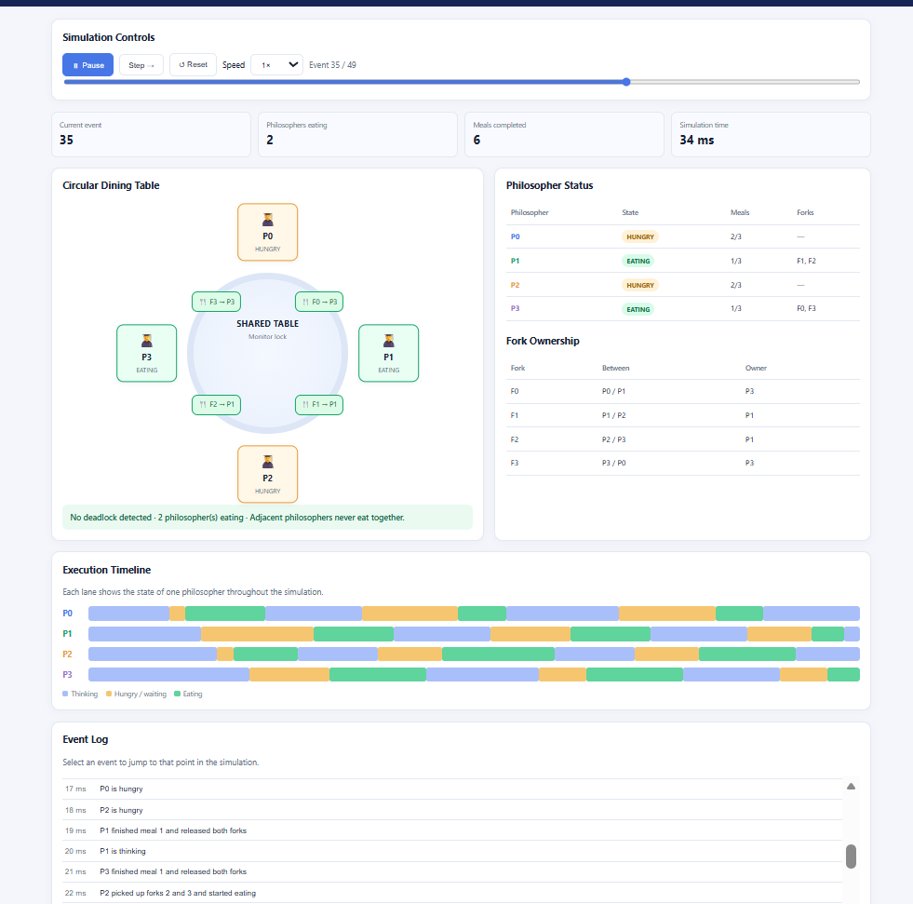
Figure 1. Dining Philosophers — Monitor Solution

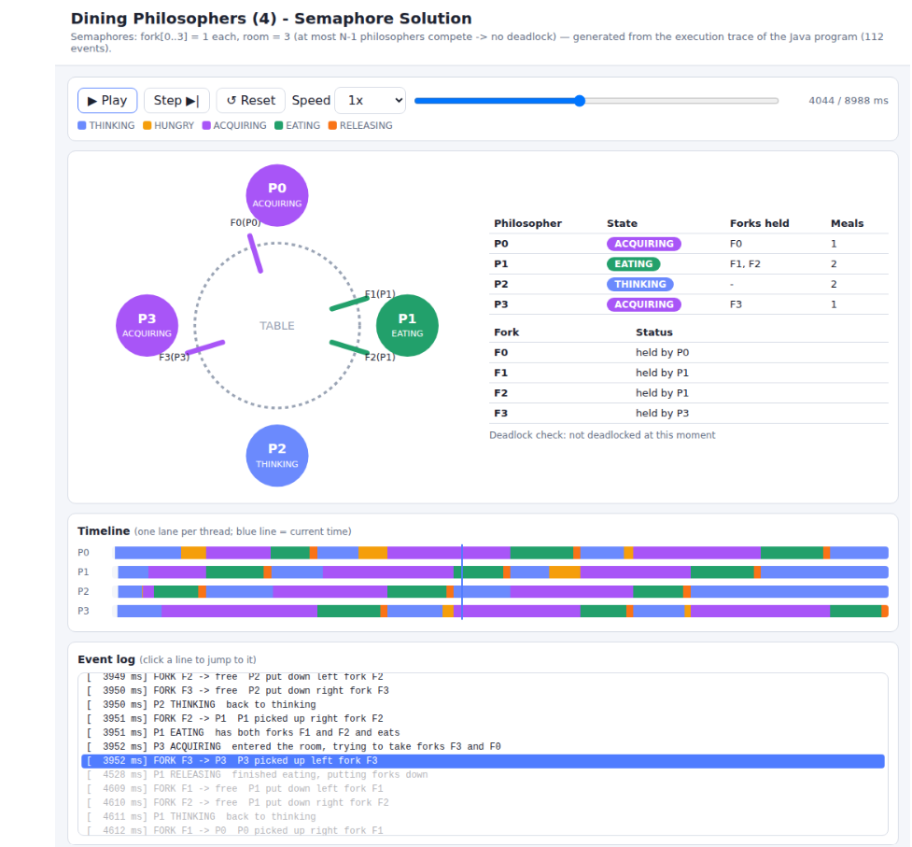
Figure 2. Dining Philosophers — Semaphore Solution

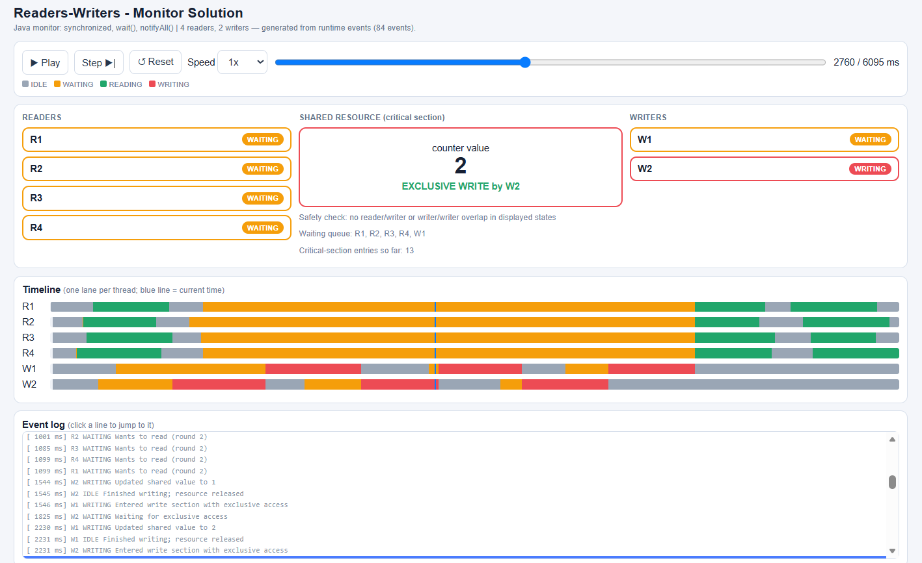
Figure 3. Readers-Writers — Monitor Solution

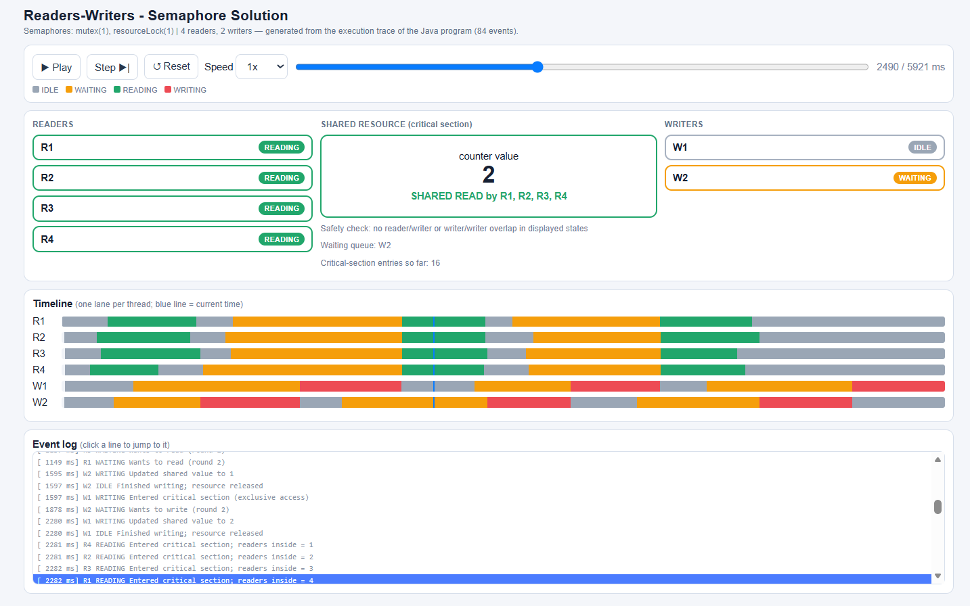
Figure 4. Readers-Writers — Semaphore Solution

