Home Office

Instructions

1. Close the agentPro on your desktop PC at work!

Try the connection already afternoon before day of your Home Office

1. Login to computer: Bitlocker and Windows login (be careful, if there is ENG keyboard)
2. ACD login: **login to Citrix** and put into the file explorer this path:

\\at-prgdfs01\DAT\ITSD\_ALL\Tools\AgentPro

And doubleclick to agentpro.exe

Login with the phone number of your emergency phone (back of the devices) including +

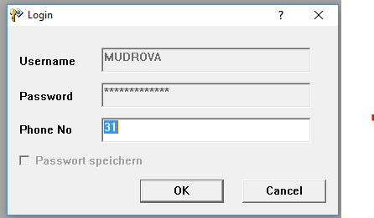

Eg**.+42070** ........

If there is an error message, please let me kmow!

1. BSD Tool is on the C: Drive
2. Work according your shipftplan. It is normal work, so the same performance is expected. Back Office agents are still available for you, just let them know via Teams, mail etc.
3. DON‘T WATCH any videos!!! It would slow the whole network!