Standby Checklist

**Check before you leave the office**:

* Standby coputer login in the office and let run the installations (first profil installation takes cca. 2 hours!)
* Disable wi-fi login and use T-Mobile USB stick for internet connection (click on the icon a use the credentials for T-Mobile) – if the connection via T-Mobile stick is not working, please restart the computer

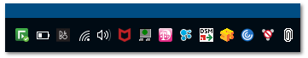

Click to Swivel icon, you will get the security string (use **your PIN** from Stonesoft e.g. 1346), click to Stonesoft VPN Client icon, click Connect and **use your Username** and security string (according your pin, in this example e.g. WNRP). Test, if you can reach Benteler intranet.

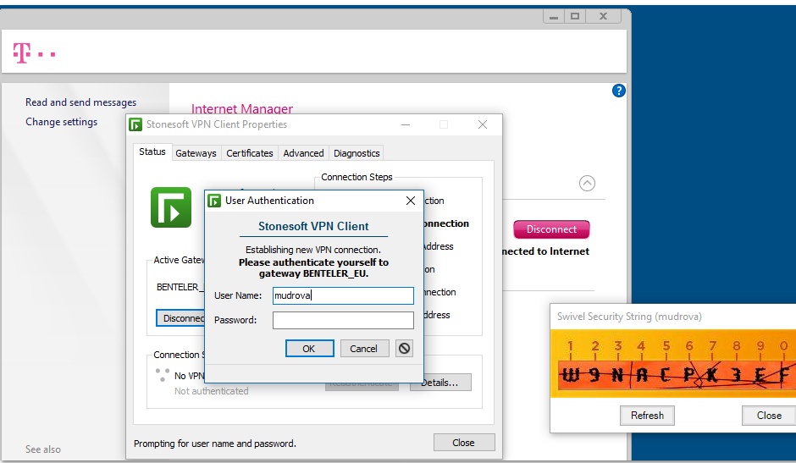

* + - * **Troubleshooting:**

**1)**

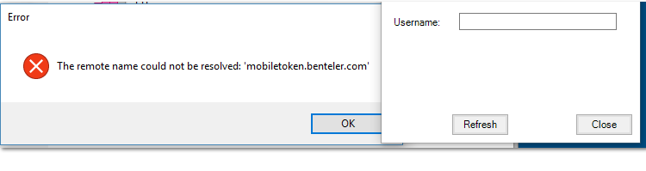

Solution: the stonesoft was opened before swivel or no internet connection > check the internet connection or/and restart computer

**2)** 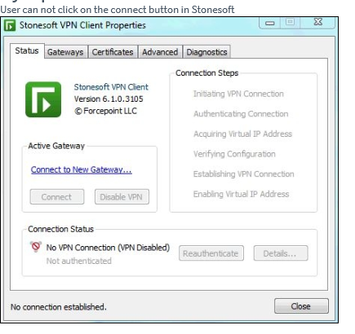

Solution: Check the gateway configuration:

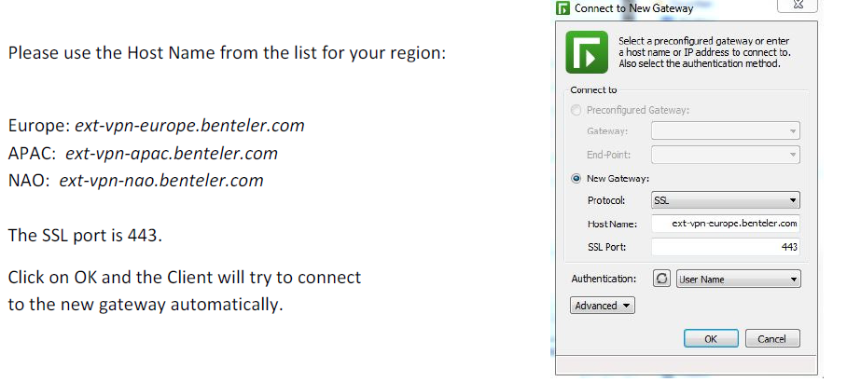

**This will help you solve also the issue, if one of the gateways is unavailable, just swich to another region (gateways available in the list of Gateways)**



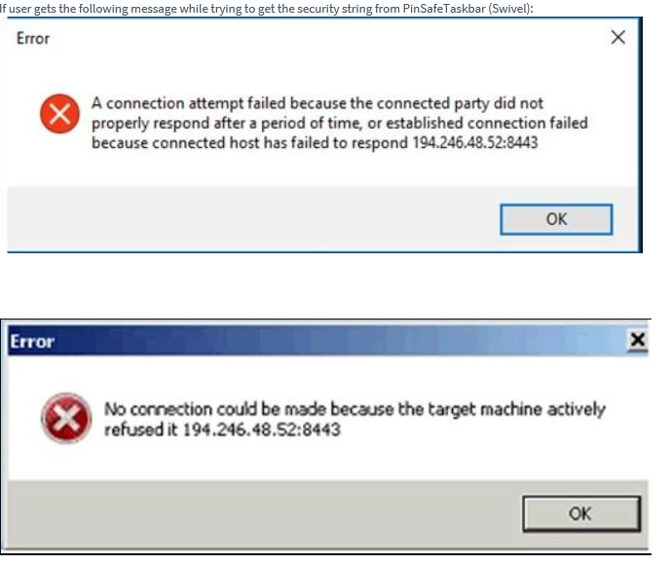**3)**

Solution: Open Forcepoint and click on „disable VPN“ and try again

**4)** If you have internet connection (just put into he address field in browser google.com and if this works, you have the internet connection), but you have Benteler network problem (page can’t be displayed) – **try external Citrix** (first login with your win credentials and then with your PIN for Swivel):

<https://workplace.ext.benteler.com/vpn/index.html>

**In the Benteler network check also:**

* Printaurus login (Citrix > Admin portal >  > login with **capital letters** and your **Printaurus passsword**. If you don’t remember your Printaurus password, ask the Print team or team leaders for reset)

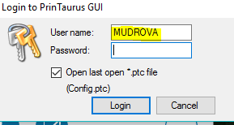)

Useful Knowledge Base : KB0011747 and KB0013140

* Check, if your win password will not expire soon
* Check, if you can call via Skype
  + - 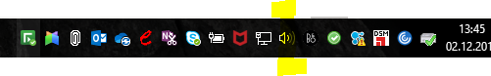Troubleshooting, if your microphone not working

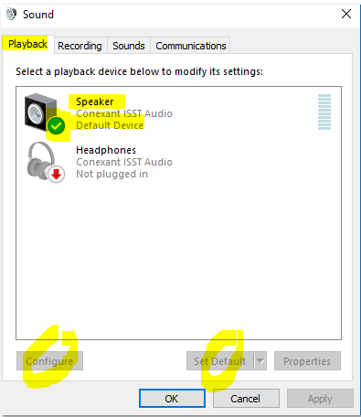Right click on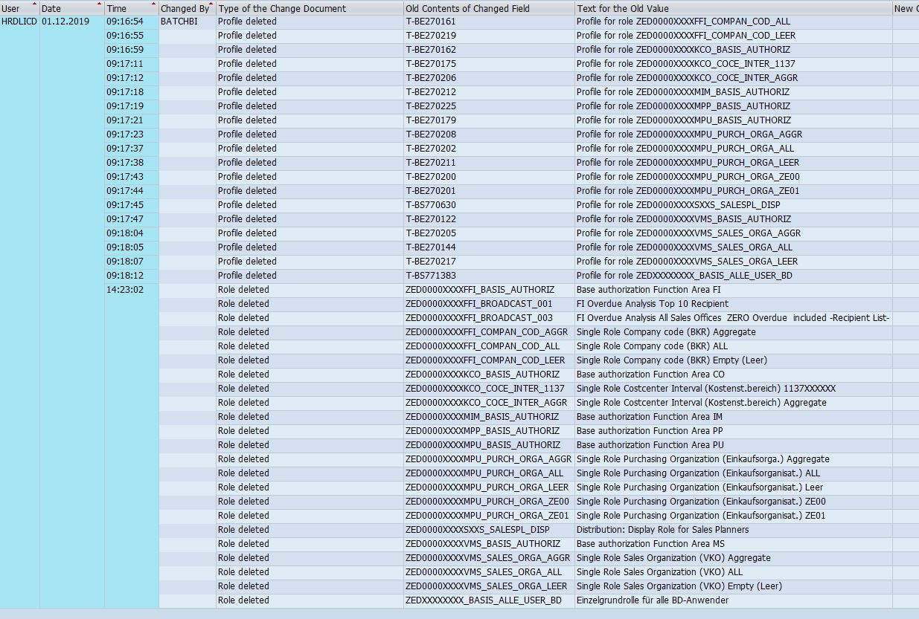 sound icon ont the taskbar > Go to Playback settings. It should look

like this:

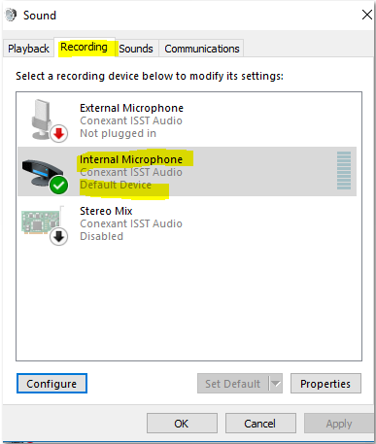 Recording tab should look like this:

Useful Knowledge base

* + - * 24 Standby KB0012404
      * EDI standby KB0012832
      * MES Nemetris KB0013165 (not supported Saturday 10 pm -Sunday 10 pm)
* 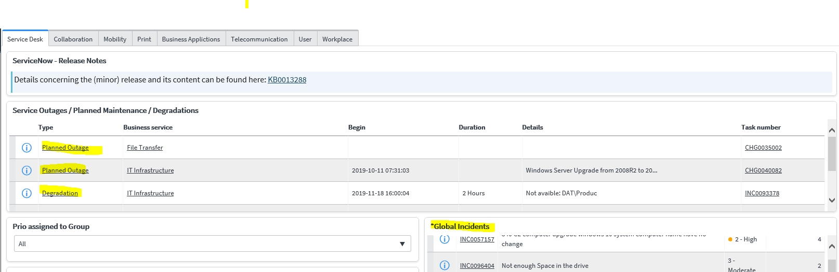Check Planned maintenance and current outages and global issues in Service Now