Ministerul Educaţiei, Culturii și Cercetării al Republicii Moldova
Universitatea Tehnică a Moldovei
Departamentul Ingineria Software și Automatică

RAPORT

Lucrare de laborator Nr. 1
Disciplina: Network Programming

A efectuat: Kushnirenko Ecaterina st.gr. FAF-223
Șoimu Ionuț st.gr. FAF-243

A verificat: assist. Univ.
Cristofor Fistic

Chișinău 2026
Objective:
Measure how the number of threads and the way work is divided among them change the running time and memory of a real workload. Determine when work is CPU-bound and when it is I/O-bound, observe a race condition and the cost of fixing it, and find where parallel speed-up stops.

Task:
Generate a file of 50 000 000 random integers. Count negative, positive, and zero values using multiple threads with different configurations: direct file partitioning (Task 1a), three synchronization approaches (Task 1b), producer-consumer pattern (Task 1c), and multi-file processing on slow storage (Task 2). Measure execution time and peak memory for each configuration.

1. Hardware Description:
CPU: AMD Ryzen AI 7 350 w/ Radeon 860M
Physical cores: 8, Logical processors: 16 (2 threads per core, SMT)
RAM: 32 GB DDR5
Disk: Micron MTFDKBA1T0QGN NVMe SSD, 953.9 GB
OS: Arch Linux, kernel 7.2.9-arch1-1
Language: C# / .NET 10.0.112
Machine 2 (Teammate):
CPU: AMD Ryzen 5 7535HS with Radeon Graphics
Physical cores: 6, Logical processors: 12 (2 threads per core, SMT)
RAM: 16 GB DDR5
Disk: SK hynix HFS512GEJ4X112N NVMe SSD, 476.9 GB / Transcend TS1TMTE115S NVMe SSD, 931.5 GB
OS: Arch Linux, kernel 7.2.9-1-cachyos
Language: C# / .NET 10.0.112

USB drive: ADATA USB Flash Drive, USB 2.0 (480 Mbps), 16 GB

2. Task 1a: Counting with Threads

Each thread reads and parses its own portion of numbers.txt. The file is divided by byte offset; each thread seeks to its starting position, skips to the next newline to avoid splitting a number, and counts until reaching its end offset. This way no line is counted twice or skipped.

Table 1. Task 1a results
Threads | Time Run 1 (ms) | Time Run 2 (ms) | Peak RAM R1 (MB) | Peak RAM R2 (MB)
1 | 1077 | 1120 | 53 | 53
2 | 628 | 627 | 53 | 53
4 | 358 | 356 | 53 | 53
8 | 285 | 223 | 53 | 53
16 | 203 | 201 | 51 | 51
32 | 220 | 225 | 57 | 54
64 | 260 | 509 | 58 | 52

Correctness check: neg=25 005 087, pos=24 994 889, zero=24, total=50 000 000. All thread configurations produced identical counts.

Table 2. Task 1a speed-up
Threads | Avg Time (ms) | Speed-up
1 | 1099 | 1.00x
2 | 628 | 1.75x
4 | 357 | 3.08x
8 | 254 | 4.33x
16 | 202 | 5.44x
32 | 223 | 4.93x
64 | 385 | 2.86x

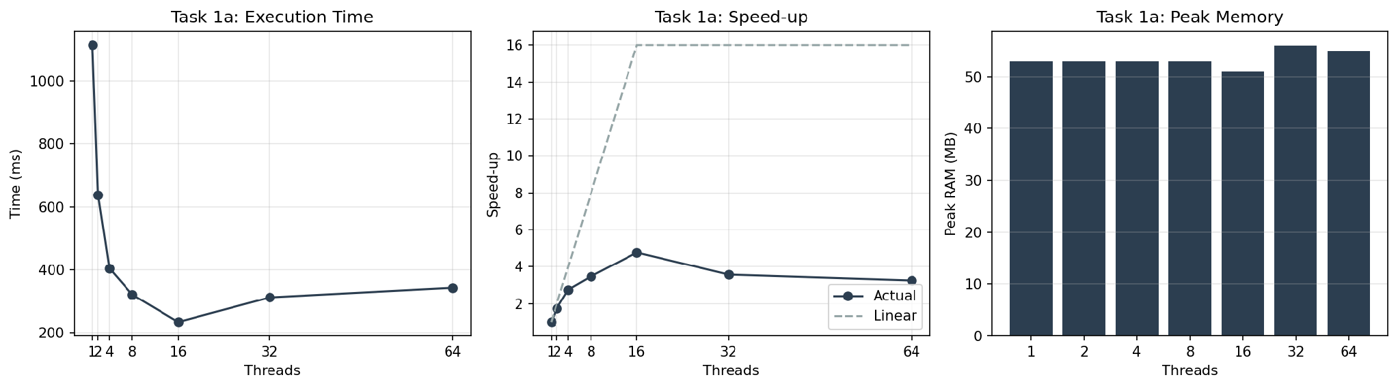
Figure 1. Task 1a: time, speed-up, and memory vs. thread count

3. Task 1b: Three Ways to Count
All 50 000 000 numbers are loaded from numbers.txt into an in-memory integer array before measuring. With as many threads as the processor has logical processors (12 on Ryzen 5 7535HS, 16 on Ryzen AI 7 350), the numbers are counted in three ways: shared counters without synchronization, shared counters protected by a lock, and separate counters per thread added together after all threads join. Version 1 was run three times to observe the non-deterministic behavior of race conditions.

Table 3. Task 1b results
Version | Time Run 1 (ms) | Time Run 2 (ms) | Time Run 3 (ms) | Avg Time (ms) | Total Counted | Correct?
1 (No sync) | 529 | 530 | 615 | 558 | 11 665 908 | No
2 (Lock) | 5027 | - | - | 5027 | 50 000 000 | Yes
3 (Per-thread) | 26 | - | - | 31 | 50 000 000 | Yes

Correctness check: Version 2 and Version 3 produced identical counts: neg=25 005 087, pos=24 994 889, zero=24, total=50 000 000. Version 1 lost over 75% of updates due to race conditions.

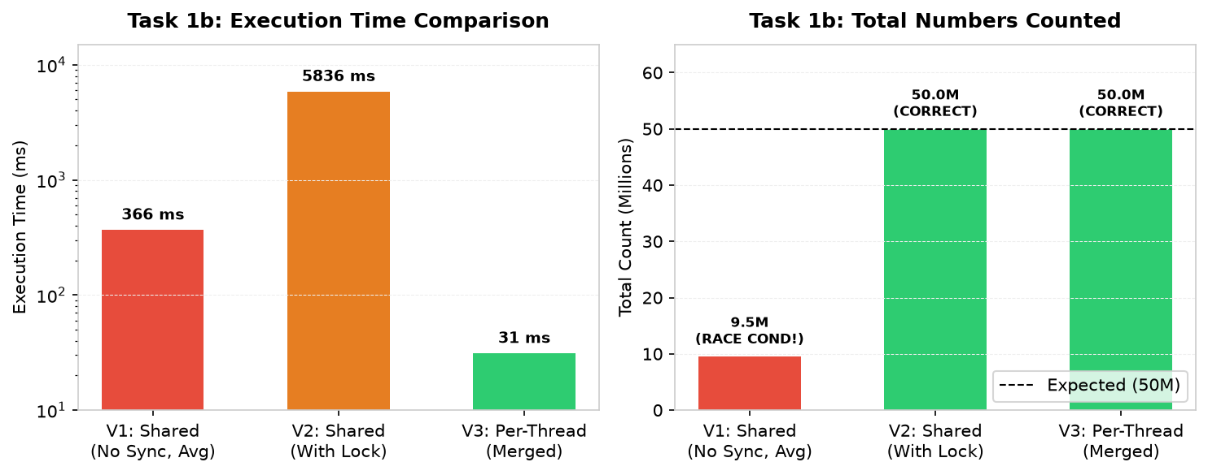
Figure 2. Task 1b: execution time and total numbers counted across the three approaches

Note: peak memory is 236 MB because the entire dataset (50 000 000 integers) is stored in memory as an int[] array (200 MB for the array plus .NET runtime overhead). Version 3 is ~193x faster than Version 2 because threads work purely in local CPU cache with no lock contention.

4. Task 1c: Producer and Consumers
One thread (the reader) reads numbers.txt line by line and puts the lines in batches of 10 000 into a thread-safe blocking queue (BlockingCollection<string[]>) with a capacity of 100 batches. Worker threads take batches from the queue, parse the integers and count signs into thread-local counters. When the queue has 100 batches, the reader waits; when the queue is empty, the workers wait. At EOF, the reader calls CompleteAdding(), and workers finish when the queue drains.

Table 4. Task 1c results
Threads | Time Run 1 (ms) | Time Run 2 (ms) | Peak RAM R1 (MB) | Peak RAM R2 (MB)
1 | 1140 | 1149 | 63 | 78
2 | 956 | 951 | 68 | 54
4 | 1075 | 1247 | 48 | 48
8 | 1419 | 1405 | 58 | 57
16 | 1871 | 1953 | 72 | 72
32 | 2401 | 2503 | 86 | 87
64 | 2640 | 2428 | 122 | 121

Correctness check: neg=25 005 087, pos=24 994 889, zero=24, total=50 000 000. All worker configurations produced identical counts.

Table 5. Task 1c speed-up
Threads | Avg Time (ms) | Speed-up
1 | 1145 | 1.00x
2 | 954 | 1.20x
4 | 1161 | 0.99x
8 | 1412 | 0.81x
16 | 1912 | 0.60x
32 | 2452 | 0.47x
64 | 2534 | 0.45x

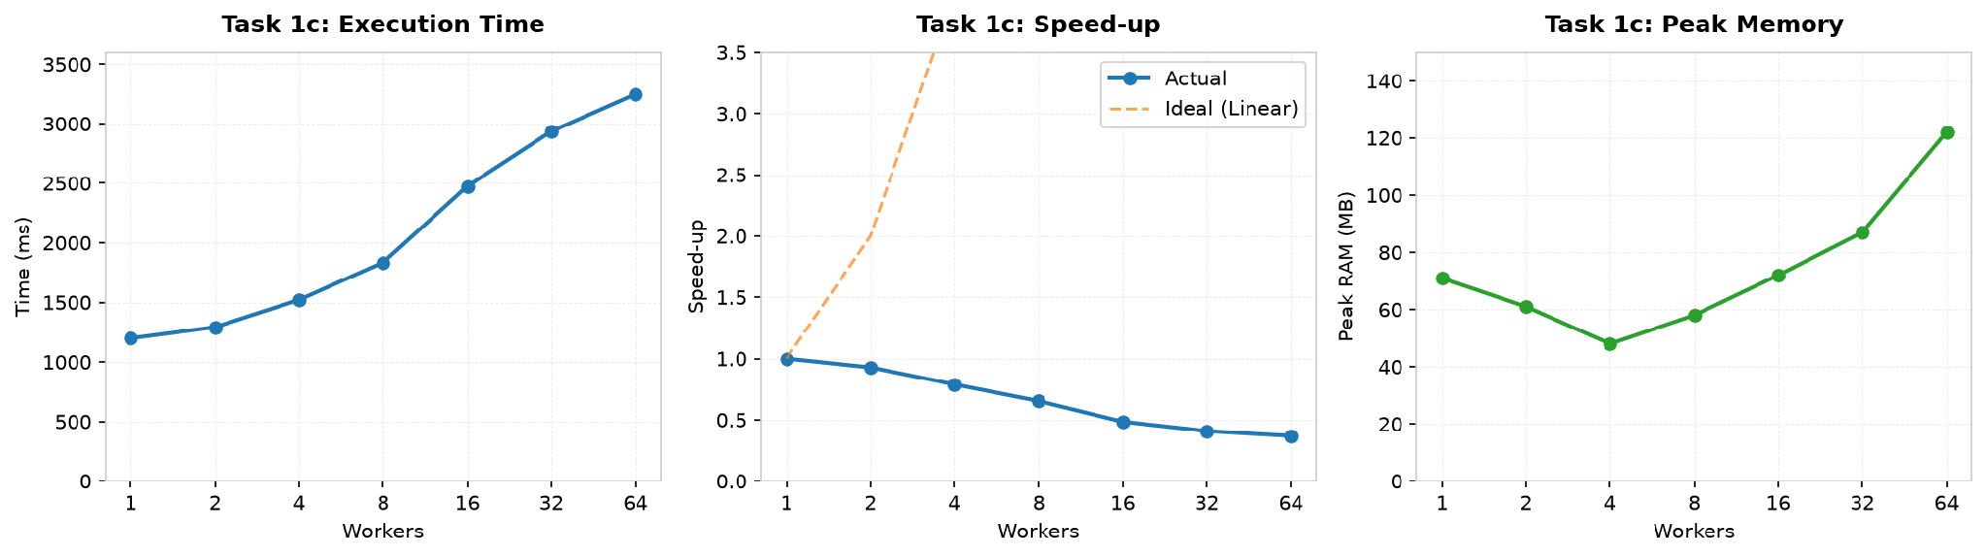
Figure 3. Task 1c: time, speed-up, and memory vs. worker count

Note: peak memory stays around 48-78 MB up to 16 workers, rising slightly to 121 MB at 64 workers due to thread stacks. Memory remains low because the queue is bounded to 100 batches (at most 1 000 000 lines in memory at once).
Questions for Task 1:

1. At which number of threads does the speed-up stop growing?
In Task 1a, speed-up grows up to 16 threads (matching the 16 logical processors on Ryzen AI 7 350, reaching 5.44x speed-up, and 12 threads on Ryzen 5 7535HS) and then drops. Up to physical cores (8 cores), speed-up is near-linear because each core has dedicated execution units. Between physical cores and logical processors (8 to 16), SMT shares execution units, giving smaller gains. In Task 1b (Version 3), thread-local counting scales similarly across all logical cores, completing in just ~26 ms. In contrast, in Task 1c, speed-up stops growing immediately at 1 worker (~1.00x) because throughput is limited by the single reader thread (Amdahl's Law).

2. Why do 32 and 64 threads not help?
With 32 or 64 threads, there are more threads than logical processors (12 or 16), so threads compete for the same CPU cores. The OS scheduler has to preemptively context-switch between them, saving and restoring registers and evicting warm L1/L2 cache lines, which adds overhead. Thread creation and join costs also become noticeable as the work per thread shrinks. In Task 1a, runtime rises from 202 ms at 16 threads to 223 ms at 32 and 385 ms at 64. In Task 1c, the slowdown is even more severe (rising from ~1.1s to ~2.5s) because 32 or 64 workers constantly compete and lock the shared queue while the reader cannot produce any faster.

3. Does the peak memory depend on the number of threads?
Across Task 1, memory behavior depends on the data architecture, not thread count: - In Task 1a, peak memory stays around 51-58 MB regardless of thread count because each thread only streams through its partition with a small StreamReader buffer (~4-8 KB). The file is never loaded into RAM. - In Task 1b, peak memory is 236 MB regardless of thread count because all 50 000 000 integers are preloaded into an int[] array in memory (~200 MB for array data plus runtime overhead). - In Task 1c, peak memory stays around 48-78 MB up to 16 workers because the queue is bounded to 100 batches (at most 1 000 000 lines buffered at once), rising slightly to 121 MB at 64 workers due to OS thread stack allocations.

4. Rank the three versions of Task 1b by time. Which are correct?
Ranking: Version 3 (~26 ms) is fastest, Version 1 (~558 ms) is second, and Version 2 (~5027 ms) is slowest (~193x slower than Version 3). Version 2 and Version 3 are correct (50 000 000 total). Version 1 is incorrect: it only counted ~11M numbers, losing over 75% of updates due to race conditions. Version 3 is fastest because each thread counts in its own local variable in CPU cache with no synchronization. Version 1 is fast because it doesn't wait for locks, but concurrent writes overwrite each other (zero was always 24 because only 24 zeros exist, so two threads rarely hit zero at the same time). Version 2 is ~193x slower than Version 3 because every single increment acquires a lock, causing extreme lock contention and cache-line bouncing across cores.

5. Compare Task 1c with Task 1a.
Task 1a is much faster than Task 1c and scales with threads. In Task 1a, time drops from 1099 ms on 1 thread to 202 ms on 16 threads (5.44x speed-up) because the file is partitioned by byte offsets in advance, allowing all threads to read and parse concurrently. In Task 1c, time starts at ~1145 ms on 1 worker and gets slower as workers are added (~1412 ms at 8 workers, ~2534 ms at 64 workers). Task 1c stops getting faster right at 1 worker. The bottleneck is the single reader thread: one thread reading 50 000 000 lines from disk sequentially cannot produce lines faster than ~1.2s. Workers cannot parse faster than the reader feeds them. Adding more workers just adds queue lock contention and context switches without any extra throughput.

6. What would happen with batches of a single line? And with a queue with no size limit?
With batches of a single line, the program would be extremely slow. Adding and removing 50 000 000 individual items from a thread-safe queue means 100 000 000 lock and signal operations. The queue overhead would dwarf the number parsing, making the run take minutes. Batches of 10 000 lines reduce queue operations to just 5 000. With a queue with no size limit, the reader would read ahead and load the entire file into memory before workers finish. Buffering 50 000 000 strings would take several gigabytes of RAM, causing garbage collector thrashing or an OutOfMemoryException. The 100-batch limit keeps memory low (~48-78 MB) by forcing the reader to wait when the queue is full.

5. Task 2: Many Files on Slow Storage

Eight part files (6 250 000 numbers each) are read from storage. Each file is read into a byte buffer in one operation, then parsed in memory. Files are distributed among threads in a round-robin fashion. Measurements below are from the NVMe SSD (local disk). USB drive measurements are in Table 7 below.

Table 6. Task 2 results (NVMe SSD)
Threads | Time (ms) | Peak RAM (MB)
1 | 398 | 394
2 | 214 | 394
4 | 121 | 394

Correctness check: neg=25 005 087, pos=24 994 889, zero=24, total=50 000 000. Same as Task 1a.

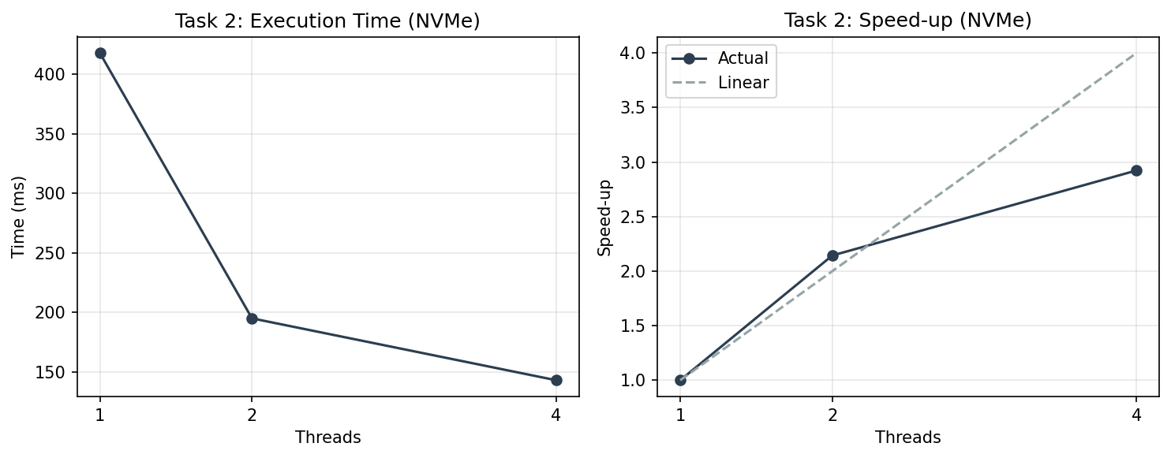
Figure 4. Task 2: time and speed-up on NVMe SSD

Note: peak memory is 394 MB because all 8 files (~45 MB each) are loaded entirely into byte buffers. Unlike Task 1a which streams through the file, Task 2 reads each file into memory with File.ReadAllBytes(). Memory does not change with thread count because all files are read regardless.
Table 7. Task 2 results (USB 2.0 drive)
Threads | Time (ms) | Peak RAM (MB)
1 | 19 562 | 394
2 | 20 169 | 394
4 | 18 969 | 394
On USB 2.0, time is ~19–20 seconds regardless of thread count (vs 121–398 ms on NVMe). Adding threads does not help because the USB bus serializes all I/O. The bottleneck is the single USB data channel, not the CPU.

Questions for Task 2:

1. Compare time on one thread with Task 1a on one thread.
Task 1a with 1 thread: ~1099 ms. Task 2 with 1 thread on NVMe: 398 ms. Task 2 is faster because it reads entire files into a byte buffer and parses bytes directly (no StreamReader, no string allocation per line, no int.Parse). On NVMe the I/O is fast, so the bottleneck is parsing — CPU-bound. On a USB drive the I/O will dominate reading time, making the work I/O-bound. On USB 2.0, the same data takes 19 562 ms on 1 thread vs 398 ms on NVMe, confirming I/O-bound behavior.

2. On the USB drive, do more threads help?
On a USB drive, more threads do not help much. A USB drive has a single data channel. Multiple threads trying to read different files from the same USB device will compete for the same physical bus. Unlike network I/O where one thread can wait for a response while another sends a request to a different server, USB I/O is serialized by the hardware. Threads waiting for I/O cannot overlap their waiting because the bottleneck is the single device, not the CPU. So adding threads does not improve throughput — it may even make it worse due to seek overhead between files.

Conclusion:
On this machine (8 cores, 16 logical processors, NVMe SSD), Task 1a and Task 2 on local disk are CPU-bound. Evidence: adding threads up to the core count reduces time proportionally, and the NVMe SSD delivers data faster than the CPU can parse it.
Task 2 on a USB drive would be I/O-bound. The USB bus bandwidth limits throughput, and adding threads cannot overlap I/O on a single device. The time on one thread with USB would be much larger than on NVMe, and more threads would not reduce it proportionally.
Speed-up stops growing at 16 threads (matching the logical processor count). Beyond that, context switching and thread management overhead increase the time. Memory stays constant in Task 1a because each thread streams through its section; memory is high in Task 2 because all files are loaded into buffers.
In Task 1b, Version 3 shows that independent thread-local counters give near-instant execution (31 ms), while Version 1 shows that unsynchronized shared counters lose most updates, and Version 2 shows that fine-grained locking is 193x slower. In Task 1c, a single reader is an inescapable bottleneck: adding consumers cannot speed up a pipeline when the producer is already at 100%.

Build and Run Instructions:
Prerequisites: .NET 10.0 SDK
Build: dotnet build -c Release
Generate data: dotnet run -c Release -- gen numbers.txt
Split for Task 2: dotnet run -c Release -- split numbers.txt
Task 1a: dotnet run -c Release -- 1a <threads> numbers.txt
Task 1b: dotnet run -c Release -- 1b [threads] numbers.txt
Task 1c: dotnet run -c Release -- 1c <threads> numbers.txt
Task 2: dotnet run -c Release -- 2 <threads> <folder>

Bibliography:
1. .NET documentation — Threading and async programming. Microsoft.
2. Lab assignment: Laboratory Work 1: Concurrency in Practice.

