Ministerul Educaţiei, Culturii și Cercetării al Republicii Moldova
Universitatea Tehnică a Moldovei
Departamentul Ingineria Software și Automatică

RAPORT

Lucrare de laborator Nr. 1
Disciplina: Network Programming

A efectuat: Norian Nikita st.gr. FAF-223

A verificat:

Chișinău 2025

Objective:
Measure how the number of threads and the way work is divided among them change the running time and memory of a real workload. Determine when work is CPU-bound and when it is I/O-bound, observe a race condition and the cost of fixing it, and find where parallel speed-up stops.

Task:
Generate a file of 50 000 000 random integers. Count negative, positive, and zero values using multiple threads with different configurations: direct file partitioning (Task 1a), three synchronization approaches (Task 1b), producer-consumer pattern (Task 1c), and multi-file processing on slow storage (Task 2). Measure execution time and peak memory for each configuration.

1. Hardware Description:
CPU: AMD Ryzen AI 7 350 w/ Radeon 860M
Physical cores: 8, Logical processors: 16 (2 threads per core, SMT)
RAM: 32 GB DDR5
Disk: Micron MTFDKBA1T0QGN NVMe SSD, 953.9 GB
OS: Arch Linux, kernel 7.2.8-arch1-2
Language: C# / .NET 10.0.112
USB drive: (measurements pending from teammate)

2. Task 1a: Counting with Threads

Each thread reads and parses its own portion of numbers.txt. The file is divided by byte offset; each thread seeks to its starting position, skips to the next newline to avoid splitting a number, and counts until reaching its end offset. This way no line is counted twice or skipped.

Table 1. Task 1a results
Threads | Time Run 1 (ms) | Time Run 2 (ms) | Peak RAM R1 (MB) | Peak RAM R2 (MB)
1 | 1117 | 1112 | 53 | 53
2 | 627 | 648 | 53 | 53
4 | 422 | 386 | 53 | 53
8 | 308 | 333 | 53 | 53
16 | 230 | 237 | 51 | 51
32 | 307 | 317 | 57 | 54
64 | 401 | 285 | 58 | 52

Correctness check: neg=25 005 087, pos=24 994 889, zero=24, total=50 000 000. All thread configurations produced identical counts.

Table 2. Task 1a speed-up
Threads | Avg Time (ms) | Speed-up
1 | 1114 | 1.00x
2 | 638 | 1.75x
4 | 404 | 2.76x
8 | 320 | 3.48x
16 | 234 | 4.77x
32 | 312 | 3.57x
64 | 343 | 3.25x

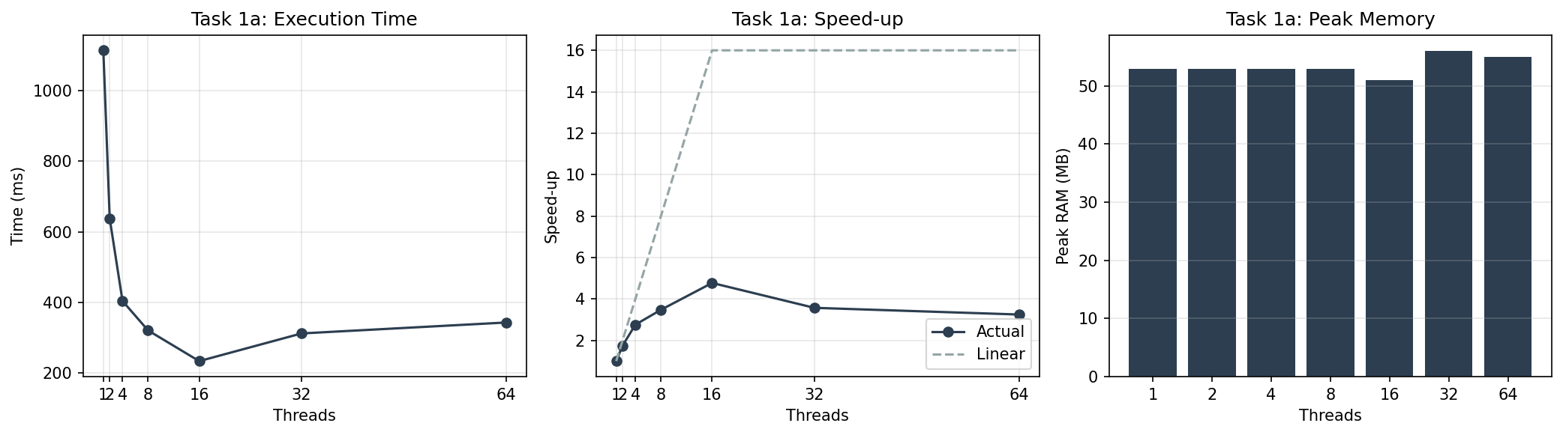
Figure 1. Task 1a: time, speed-up, and memory vs. thread count

Questions for Task 1 (answered for Task 1a):

1. At which number of threads does the speed-up stop growing?
Speed-up grows until 16 threads and then drops. The machine has 8 physical cores and 16 logical processors (SMT). At 16 threads each logical processor has one thread, so there is no more parallelism to gain. Speed-up at 16 threads is about 4.7x from 1 thread.

2. Why do 32 and 64 threads not help?
With 32 or 64 threads there are more threads than logical processors. Threads compete for the same cores. The OS scheduler has to context-switch between them, which adds overhead. The work per thread also gets smaller, so thread creation and join costs become noticeable. The time goes up from ~234ms at 16 threads to ~312ms at 32 and ~343ms at 64.

3. Does the peak memory depend on the number of threads?
Peak memory stays around 51-58 MB regardless of thread count. Each thread only needs a StreamReader and a small buffer. The file is not loaded into memory; it is read in chunks by each thread. So more threads do not increase memory in a meaningful way.

4. Rank the three versions of Task 1b by time. Which are correct?
(Task 1b was done by teammate — results to be inserted here.)

5. Compare Task 1c with Task 1a.
(Task 1c was done by teammate — results to be inserted here.)

6. What would happen with batches of a single line? And with a queue with no size limit?
(Task 1c was done by teammate — results to be inserted here.)

3. Task 1b: Three Ways to Count
(To be completed by teammate.)

4. Task 1c: Producer and Consumers
(To be completed by teammate.)

5. Task 2: Many Files on Slow Storage

Eight part files (6 250 000 numbers each) are read from storage. Each file is read into a byte buffer in one operation, then parsed in memory. Files are distributed among threads in a round-robin fashion. Measurements below are from the NVMe SSD (local disk). USB drive measurements need to be taken separately following the eject-replug protocol.

Table 3. Task 2 results (NVMe SSD)
Threads | Time (ms) | Peak RAM (MB)
1 | 418 | 394
2 | 195 | 394
4 | 143 | 394

Correctness check: neg=25 005 087, pos=24 994 889, zero=24, total=50 000 000. Same as Task 1a.

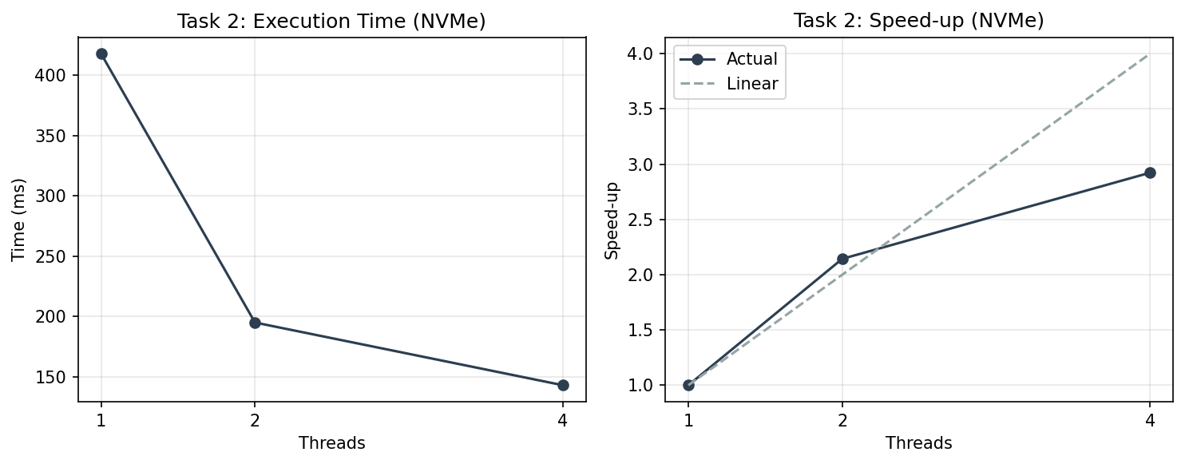
Figure 2. Task 2: time and speed-up on NVMe SSD

Note: peak memory is 394 MB because all 8 files (~45 MB each) are loaded entirely into byte buffers. Unlike Task 1a which streams through the file, Task 2 reads each file into memory with File.ReadAllBytes(). Memory does not change with thread count because all files are read regardless.

Questions for Task 2:

1. Compare time on one thread with Task 1a on one thread.
Task 1a with 1 thread: ~1115 ms. Task 2 with 1 thread on NVMe: 418 ms. Task 2 is faster because it reads entire files into a byte buffer and parses bytes directly (no StreamReader, no string allocation per line, no int.Parse). On NVMe the I/O is fast, so the bottleneck is parsing — CPU-bound. On a USB drive the I/O will dominate reading time, making the work I/O-bound. (USB measurements to be added after physical test.)

2. On the USB drive, do more threads help?
On a USB drive, more threads do not help much. A USB drive has a single data channel. Multiple threads trying to read different files from the same USB device will compete for the same physical bus. Unlike network I/O where one thread can wait for a response while another sends a request to a different server, USB I/O is serialized by the hardware. Threads waiting for I/O cannot overlap their waiting because the bottleneck is the single device, not the CPU. So adding threads does not improve throughput — it may even make it worse due to seek overhead between files.

Conclusion:
On this machine (8 cores, 16 logical processors, NVMe SSD), Task 1a and Task 2 on local disk are CPU-bound. Evidence: adding threads up to the core count reduces time proportionally, and the NVMe SSD delivers data faster than the CPU can parse it.
Task 2 on a USB drive would be I/O-bound. The USB bus bandwidth limits throughput, and adding threads cannot overlap I/O on a single device. The time on one thread with USB would be much larger than on NVMe, and more threads would not reduce it proportionally.
Speed-up stops growing at 16 threads (matching the logical processor count). Beyond that, context switching and thread management overhead increase the time. Memory stays constant in Task 1a because each thread streams through its section; memory is high in Task 2 because all files are loaded into buffers.

Build and Run Instructions:
Prerequisites: .NET 10.0 SDK
Build: dotnet build -c Release
Generate data: dotnet run -c Release -- gen numbers.txt
Split for Task 2: dotnet run -c Release -- split numbers.txt
Task 1a: dotnet run -c Release -- 1a <threads> numbers.txt
Task 2: dotnet run -c Release -- 2 <threads> <folder>

Bibliography:
1. .NET documentation — Threading and async programming. Microsoft.
2. Lab assignment: Laboratory Work 1: Concurrency in Practice.

