Ministerul Educației, Culturii și Cercetării al Republicii Moldova
Universitatea Tehnică a Moldovei
Departamentul Ingineria Software și Automatică

RAPORT

Lucrare de laborator Nr. 3-4
Disciplina: Sisteme de Operare (Operating Systems)

Elaborated: st. gr. FAF-243 | Kushnirenko Ecaterina
Verified: asist. univ. | Reițman Patricia

Chișinău 2026

INTRODUCTION
Objective:
The objective of this laboratory work is to learn the command line as the primary interface to the operating system. Laboratory work 3 covers bash itself: moving fast in the terminal, predicting what the shell does to a command line before it runs (globbing, quoting, expansions), redirecting stdout and stderr, chaining commands, running background jobs, and answering questions about data with one-liners built from small filters joined by pipes. Laboratory work 4 moves to the xv6 shell, comparing it with bash to see what a minimal shell must do and what bash adds on top.

1 THEORETICAL CONSIDERATIONS
The shell is the primary interface between the user and the operating system kernel. It reads a line of text, parses it, and carries out the described computation by creating processes, connecting them with pipes, and redirecting their standard file descriptors to files. Before a program starts, the shell does a surprising amount of work: it splits the line into words, expands wildcards (*, ?, [ ]), variables ($VAR, $(...)), brace expressions ({1..5}), and arithmetic ($((...))). It removes quotes and finds the program in the PATH directories. The program itself only receives the final list of arguments and never sees the original command line.
Every process inherits three open file descriptors from its parent: standard input (fd 0), standard output (fd 1) and standard error (fd 2). Redirection changes where these descriptors point: > connects stdout to a file, < connects stdin to a file, 2> redirects stderr, and 2>&1 makes stderr go to the same place as stdout. The order of redirections matters because each one is applied left to right. Pipes connect the stdout of one process to the stdin of the next, and the shell uses fork(), exec() and pipe() system calls to set this up [1], [2].
xv6 is a re-implementation of Unix Version 6 in about 9,000 lines of C for RISC-V. Its shell (user/sh.c, under 500 lines) supports the core features exec, redirection, pipes, sequences, background and grouping — but has no globbing, no variables, no quote handling, no PATH search, no history and no line editing. Comparing the two shells makes the boundary between "what the shell does" and "what the kernel provides" concrete [3], [4].

2 THE COMMAND LINE: SHELL, PIPES AND TEXT FILTERS
This chapter corresponds to Laboratory work 3 [1]. All exercises were performed in GNU bash 5.3 on the laptop described in the introduction.

2.1 Move fast, find help
Tab completion was tested first. After typing ls /usr/sh and pressing Tab, bash completed it to /usr/share/ (the only match); the second Tab listed all 275 entries inside that directory. cd /et completed to cd /etc/ in one Tab. Ctrl+R was used for reverse history search: after running date, whoami and uname -r, pressing Ctrl+R and typing dat found the date command.
The type and which commands identified which commands are built-in and which are external programs:
$ type cd ; type ls ; type echo ; which ls
cd is a shell builtin
ls is /usr/bin/ls
echo is a shell builtin
/usr/bin/ls
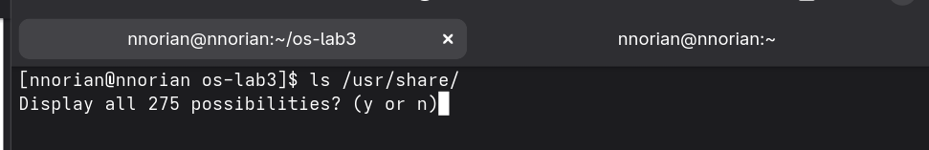
Figura 2.1 – Tab completion in bash
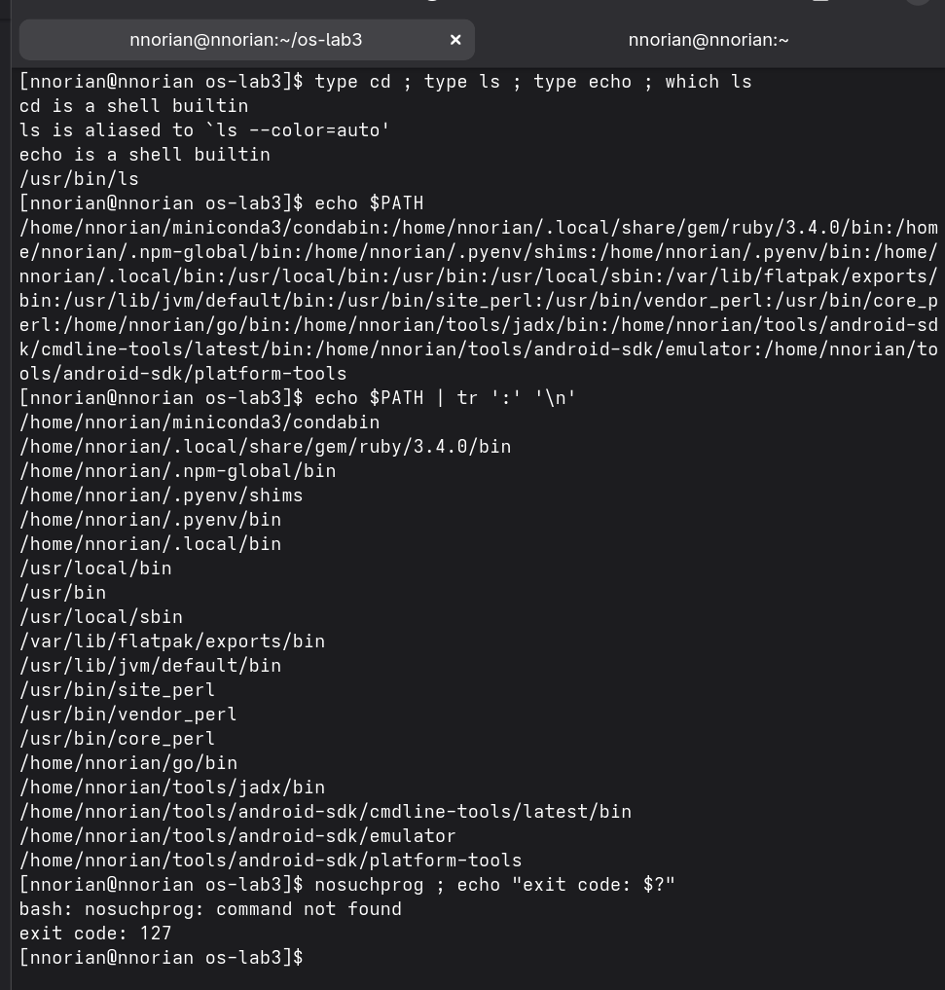
Figura 2.2 – Output of type, which, PATH directories, and exit code 127
Observations. cd and echo are built-ins; ls is an external program (/usr/bin/ls). cd must be a built-in because the current directory belongs to a process — an external cd would run in a child, call chdir(), and exit, leaving the shell's directory unchanged. The PATH has 19 directories. Exit code 127 means "command not found". The -t flag of ls sorts by modification time (newest first).

2.2 What the shell does to the command line
A directory with test files was created: a.c, alfa beta.txt, b.c, file1.txt, file2.txt, notes.txt. Several commands were predicted, then run, and the results compared:
$ echo *.c → a.c b.c
$ echo file?.txt → file1.txt file2.txt
$ echo [a-b]* → a.c alfa beta.txt b.c
$ echo *.xyz → *.xyz (no match, left unchanged)
$ ls alfa beta.txt → error (two arguments)
$ ls "alfa beta.txt" → 'alfa beta.txt' (one argument)
$ echo '$HOME' "$HOME" \$HOME → $HOME /home/nnorian $HOME
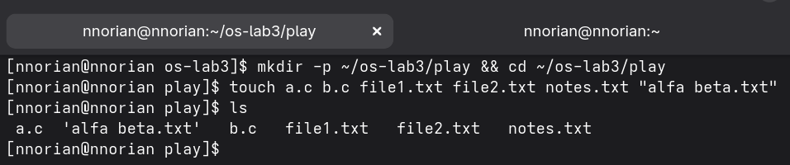
Figura 2.3 – Globbing results
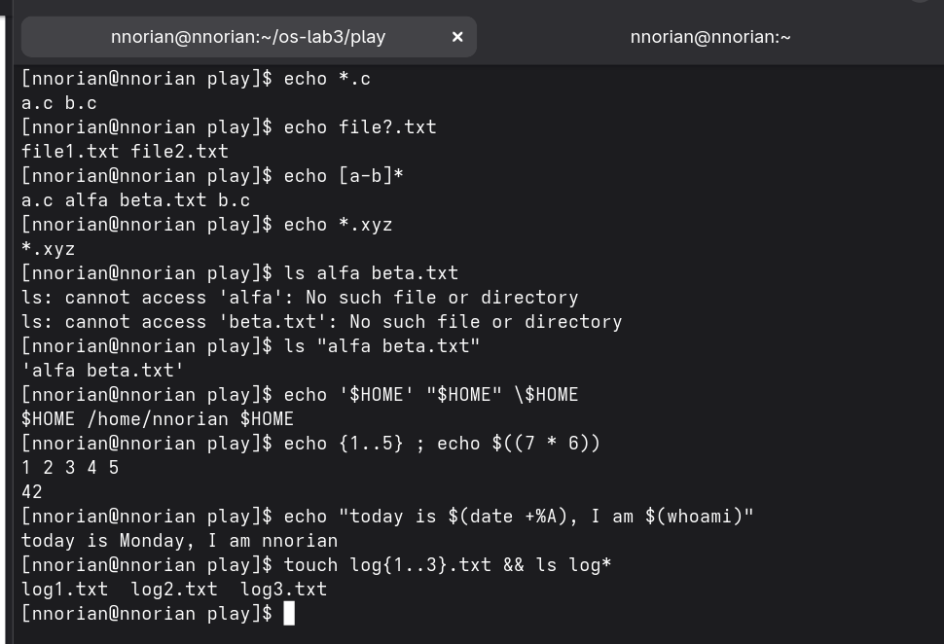
Figura 2.4 – Single quotes, double quotes, backslash, brace expansion
Observations. The shell expands *.c into matching file names before the program starts; echo never sees the *. Without quotes, the shell splits on spaces, so ls got two non-existent arguments. Single quotes keep everything literal, double quotes still expand $VAR and $(...) but stop word splitting and globbing.

2.3 Redirection, chaining and jobs
stdout and stderr were redirected to separate files. The order of redirections was compared:
$ ls /etc /nope > out.txt 2> err.txt
$ ls /etc /nope > all.txt 2>&1 → 205 lines (both streams)
$ ls /etc /nope 2>&1 > all.txt → 204 lines (error on screen)
The key insight: redirections are applied left to right. In > all.txt 2>&1, stdout goes to the file first, then stderr follows it. In 2>&1 > all.txt, stderr goes to the terminal (where stdout was before the redirect), then only stdout moves to the file.
The three chaining operators were tested: ; (always runs next), && (only on success), || (only on failure). A background job was started with sleep 100 & and stopped with kill %1.
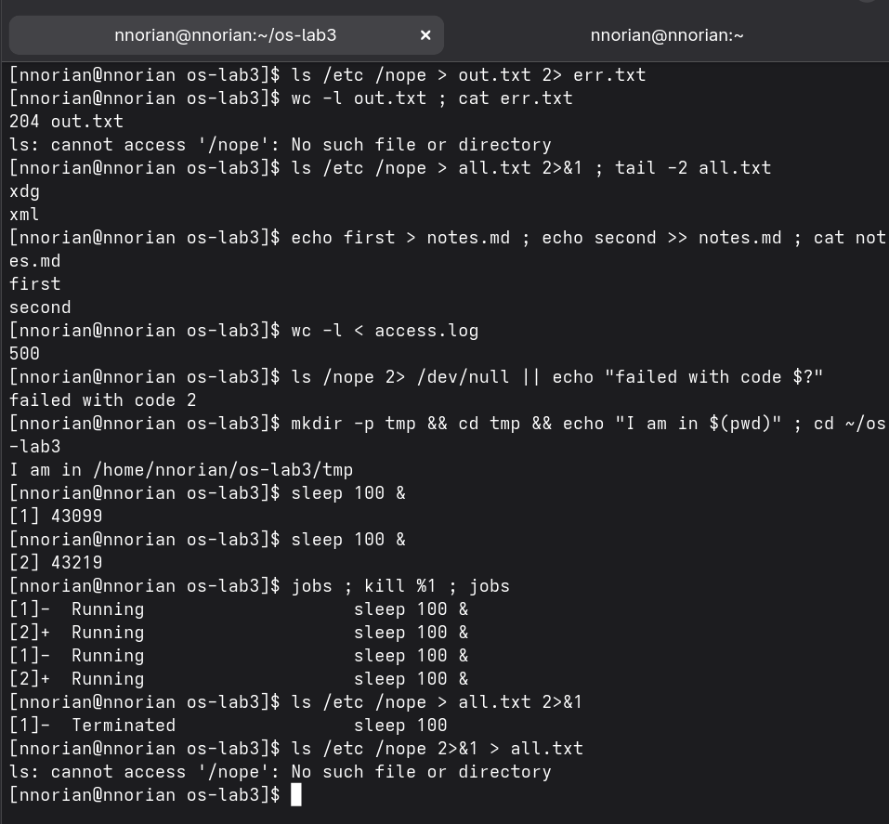
Figura 2.5 – Redirection, chaining operators, and background jobs

2.4 Answer questions with one-liners
Each line of access.log has five fields separated by spaces: date, time, user, result (OK/FAIL), page. The questions were answered with one-liners:
Q1. grep -c FAIL access.log → 100
Q2. cut -d' ' -f5 access.log | sort -u | nl → 4 pages
Q3. cut -d' ' -f5 access.log | sort | uniq -c → 125 each
Q4. grep FAIL | cut -d' ' -f3 | sort | uniq -c | sort -rn
| awk 'NR==1{max=$1} $1==max' → user3, user5 (15 each)
Q5. user3: 72 requests, 15 failed
Q6. grep FAIL | tail -3 | cut -d' ' -f2,3 → last 3 failed requests
Q7. cut -d: -f7 /etc/passwd | sort | uniq -c | sort -rn
Q8. ls /etc | wc -l → 213; ls -l /etc | wc -l → 214 (differ by 'total' line)
Cross-check: per-user failures sum to 15 + 15 + 5 × 14 = 100 = Q1. Per-page counts sum to 4 × 125 = 500 lines. Q4 needs awk to print all tied users, not just head -1, because user3 and user5 both have 15 failures.
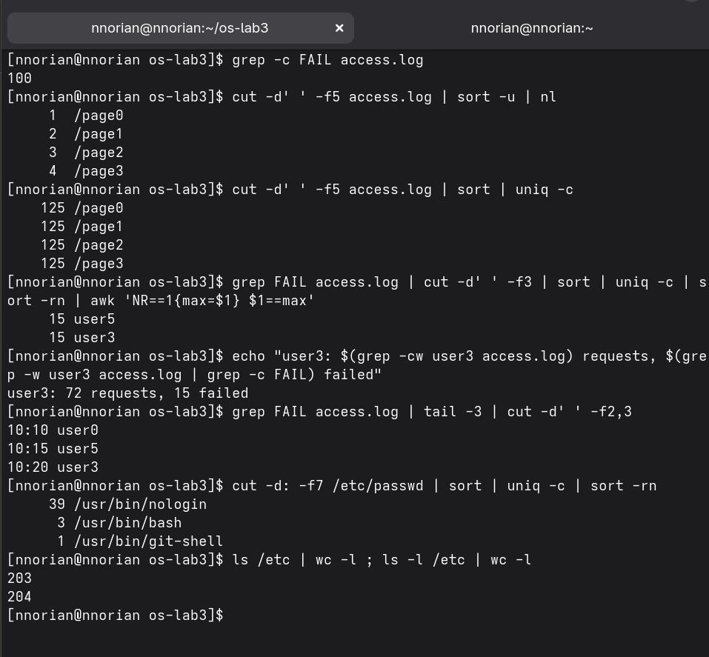
Figura 2.6 – One-liner answers (Q1–Q5)
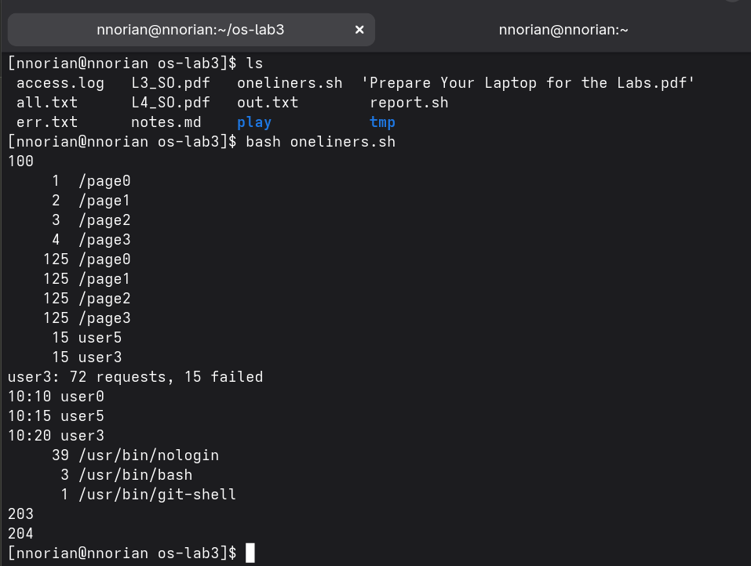
Figura 2.7 – One-liner answers (Q6–Q8)
Bonus. Lines where the minute ends in 0 and the request failed: grep -E '10:[0-5]0 user[0-9]+ FAIL' access.log returned 50 lines.
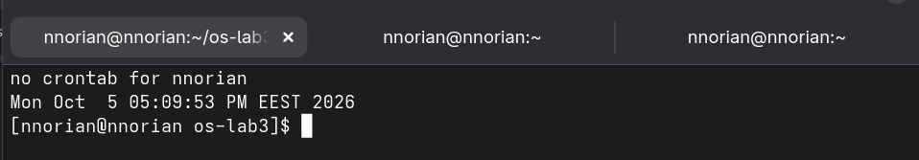
Figura 2.8 – Full run of oneliners.sh (bonus)

2.5 The report script
The one-liners were turned into a script report.sh that takes the log file as an argument, validates it, and prints a summary plus per-user failure counts:
#!/bin/bash
log=$1
if [ ! -f "$log" ]; then
echo "no such file: $log" >&2
exit 1
fi
total=$(wc -l < "$log")
fails=$(grep -c FAIL "$log")
echo "$total requests, $fails failed"
for n in 0 1 2 3 4 5 6; do
echo "user$n: $(grep -c \"user$n FAIL\" \"$log\") failures"
done
$ ./report.sh access.log
500 requests, 100 failed
user0: 14 failures ... user3: 15 failures ... user5: 15 failures
$ ./report.sh nope.log ; echo "exit code: $?"
no such file: nope.log
exit code: 1
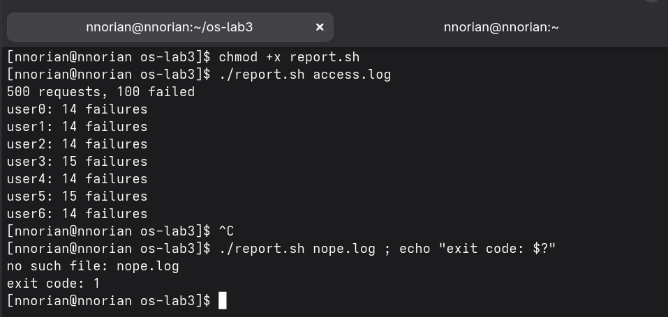
Figura 2.9 – Contents of report.sh
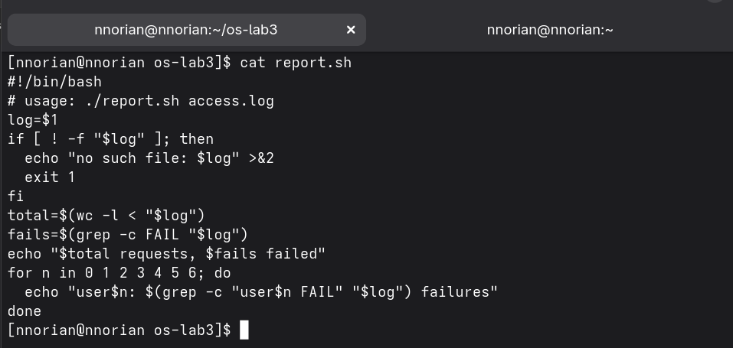
Figura 2.10 – Running the script and error handling
Observations. The shebang #!/bin/bash tells the kernel which interpreter to use. Without chmod +x the file has no execute permission (exit code 126). A name without / is looked up only in PATH, and . is not in PATH, so report.sh gives "command not found" while ./report.sh works. >&2 sends the error message to stderr so it does not mix with real output. exit 1 gives a non-zero code so callers know the script failed.
Bonus — cron. The script was scheduled with crontab: * * * * * /home/nnorian/os-lab3/report.sh ... >> report.log 2>&1. Full paths are needed because cron runs with a minimal PATH. >> appends so each run adds to the log. After two minutes, report.log had 16 lines. The job was removed with crontab -r.
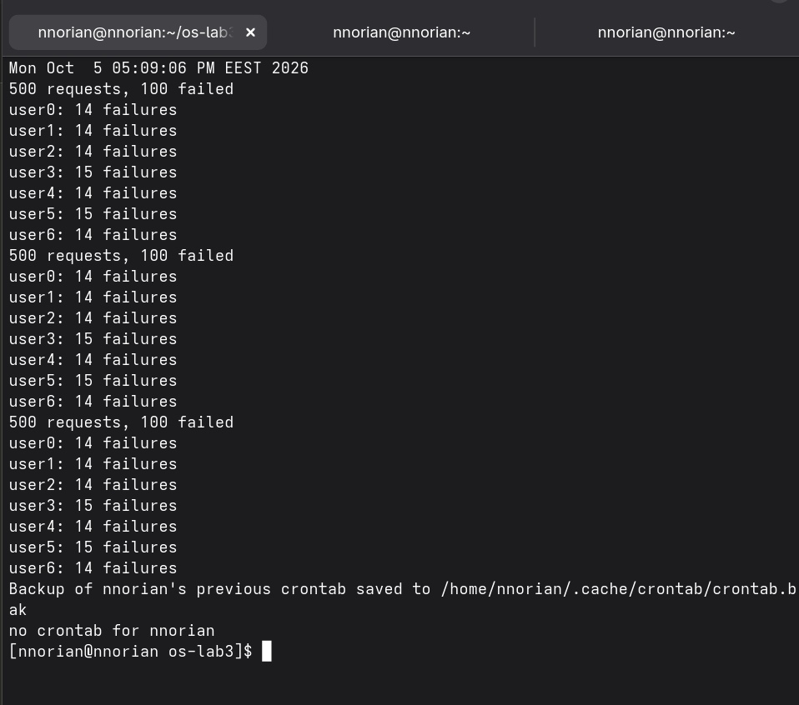
Figura 2.11 – Cron job and report.log output

3 THE XV6 SHELL FROM THE OUTSIDE
This chapter corresponds to Laboratory work 4 [1]. The xv6 operating system was booted under QEMU and its shell was compared with bash.

3.1 Fix sleep for the current xv6
The sleep system call was renamed to pause() in the current xv6. grep confirmed that user/user.h declares pause(int) on line 25 and there is no sleep. The user/sleep.c program already called pause(atoi(argv[1])) from Lab 2, so no change was needed. The Makefile already includes $U/_sleep on line 135.
$ grep -n "pause\|sleep" user/user.h
25:int pause(int);
A clean build was needed because the compiler was updated since Lab 2 and old .d files pointed to the wrong version; make clean fixed it.
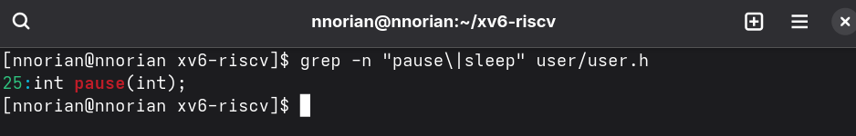
Figura 3.1 – The grep result in user/user.h
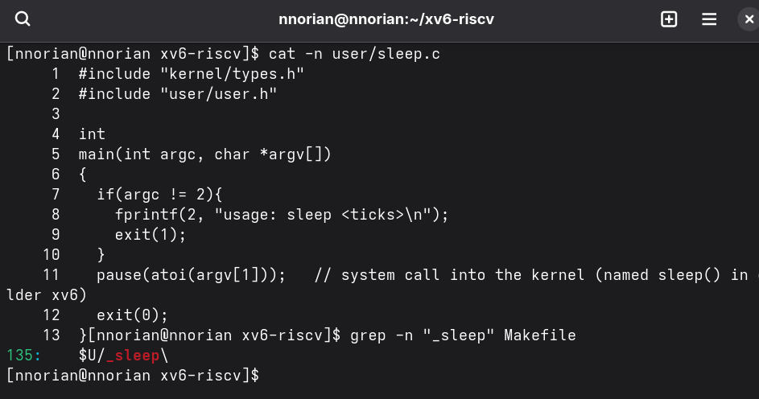
Figura 3.2 – The updated sleep.c and its Makefile entry
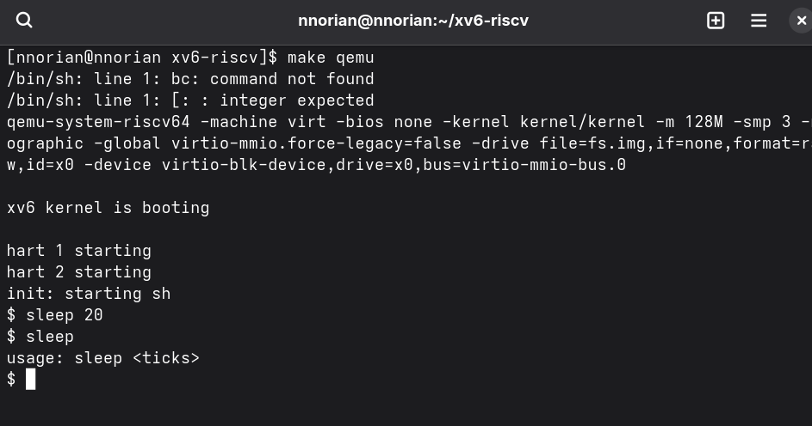
Figura 3.3 – sleep running in xv6, with and without an argument

3.2 bash versus the xv6 shell
The same set of commands was run in bash and in xv6 to compare what each shell supports:
echo hello > f ; cat < f → both: hello
ls | grep READ → both: README
(echo a; echo b) | wc → both: 2 2 4
echo one ; echo two → both: one, two
echo bg & → both run in background
ls * → bash: file listing; xv6: cannot open *
echo $HOME → bash: /home/nnorian; xv6: $HOME literal
echo "a b" → bash: a b; xv6: "a b" (quotes not removed)
mkdir d ; cd d ; ls .. → bash: lists parent; xv6: exec cd failed
The xv6 shell checks for cd only when the line starts with "cd " (sh.c line 166). In the middle of a list (mkdir d ; cd d ; ls ..), it is run as a program, exec("cd") fails, the directory stays /, and ls .. lists / again.
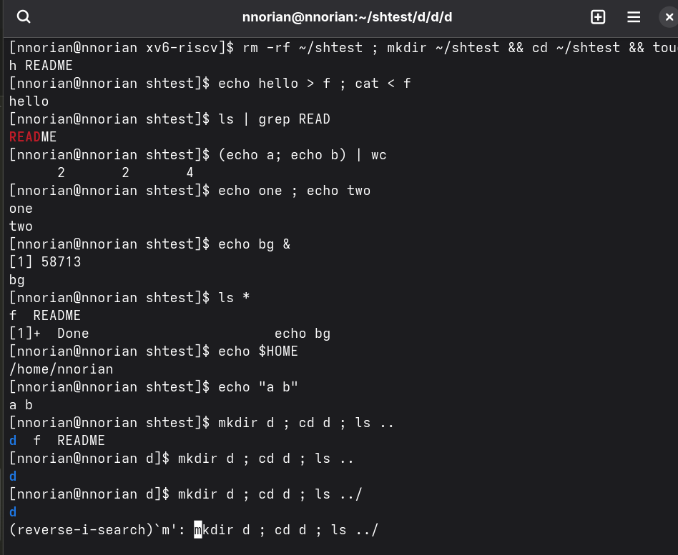
Figura 3.4 – The commands run in bash
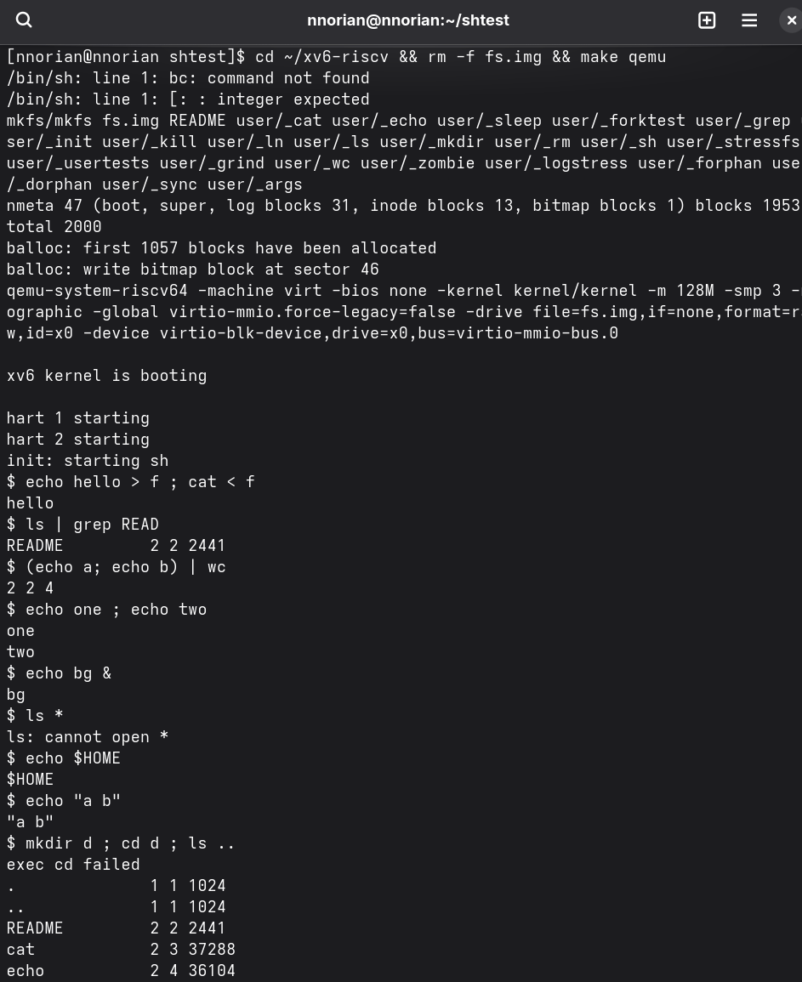
Figura 3.5 – The same commands run in xv6 (part 1)
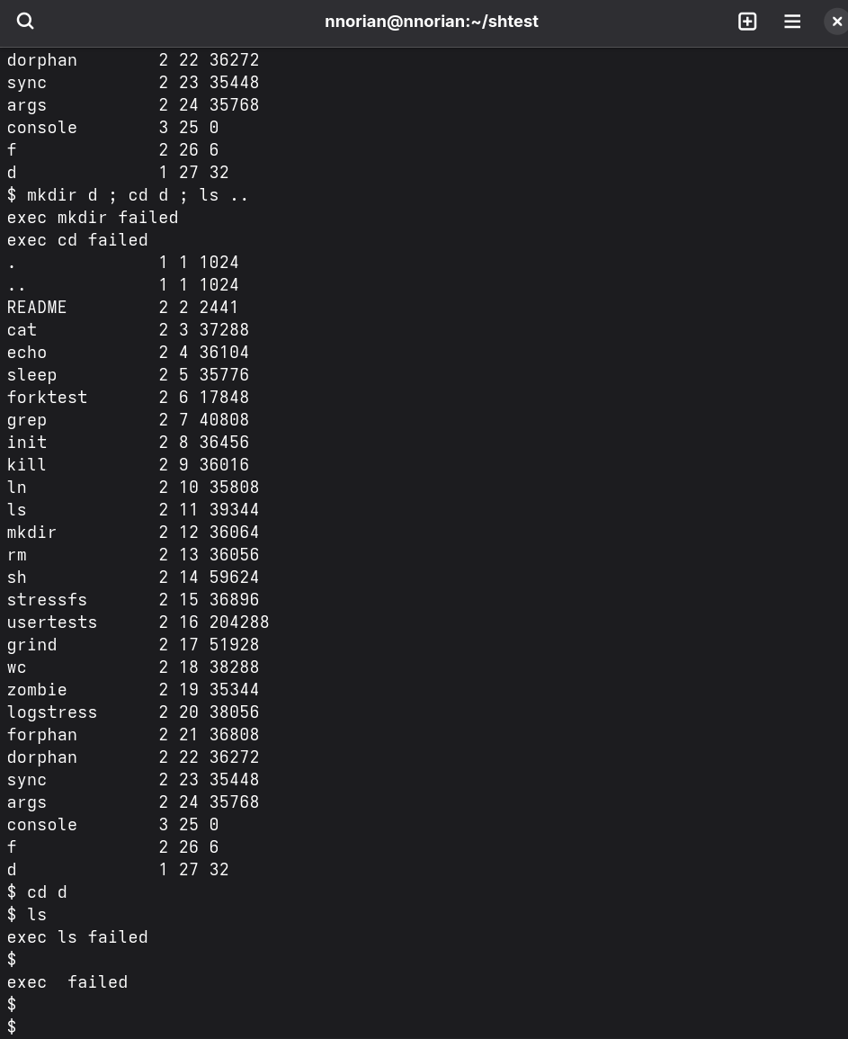
Figura 3.6 – The same commands run in xv6 (part 2)
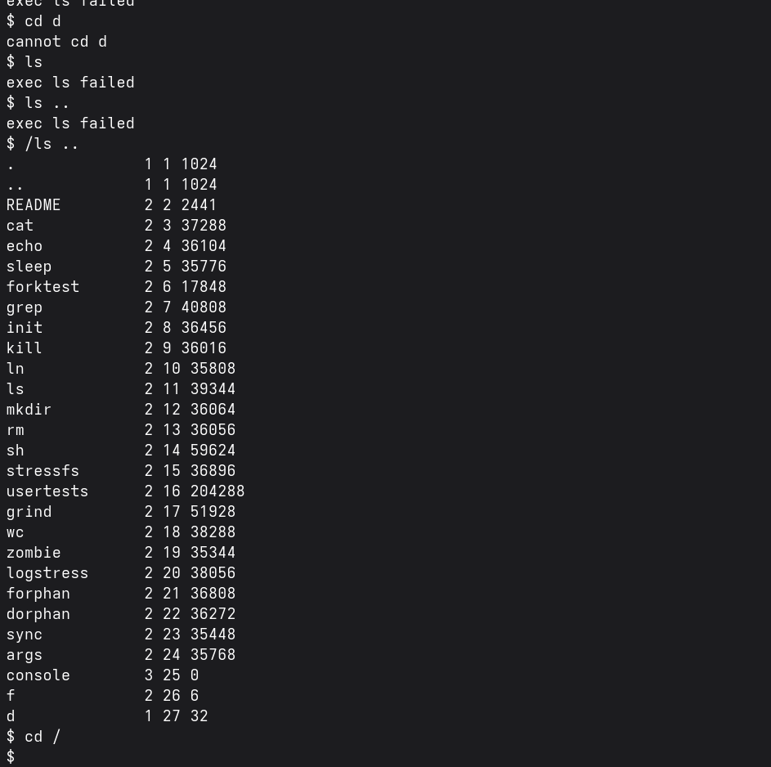
Figura 3.7 – ls failing after cd d, and the /ls workaround
Observations. Both shells support: running programs with arguments, < > >> redirection, pipes |, sequences ;, background &, grouping ( ), and built-in cd. Only bash has: globbing (* ? [ ]), variables and $(...), quote removal, PATH search, && / ||, redirection of other fds (2>, 2>&1), job control, history, line editing, Tab completion, brace expansion, arithmetic, and scripting. The xv6 shell has no PATH: it calls exec(argv[0], argv) directly (sh.c line 79). All programs live in /, so ls only works from /.

3.3 Who expands *? A program that prints its argv
A program args was written for both xv6 (args.c) and Linux (args_linux.c) that prints argc and each argv element:
#include "kernel/types.h"
#include "user/user.h"
int main(int argc, char *argv[]) {
printf("argc = %d\n", argc);
for(int i = 0; i < argc; i++)
printf("argv[%d] = [%s]\n", i, argv[i]);
exit(0);
}
Key comparison — args *.c "x y":
xv6: argc=4 argv: [args] [*.c] ["x] [y"]
bash: argc=5 argv: [./args] [args.c] [args_linux.c] [sleep.c] [x y]
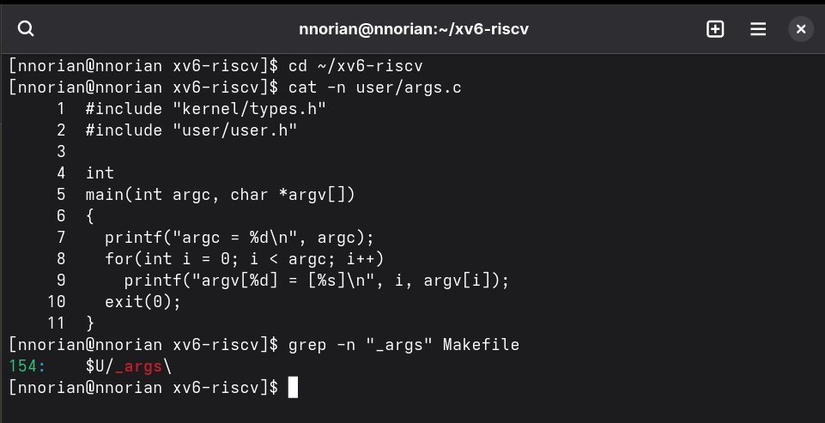
Figura 3.8 – args.c source and Makefile entry
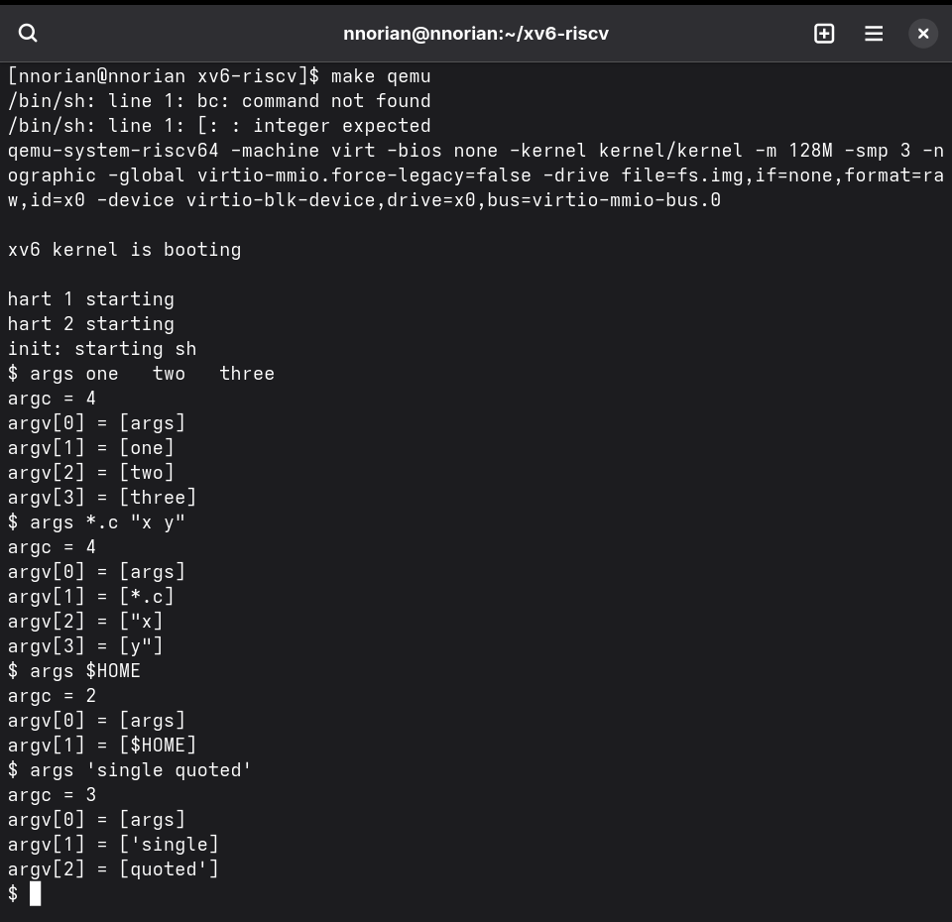
Figura 3.9 – args output in xv6
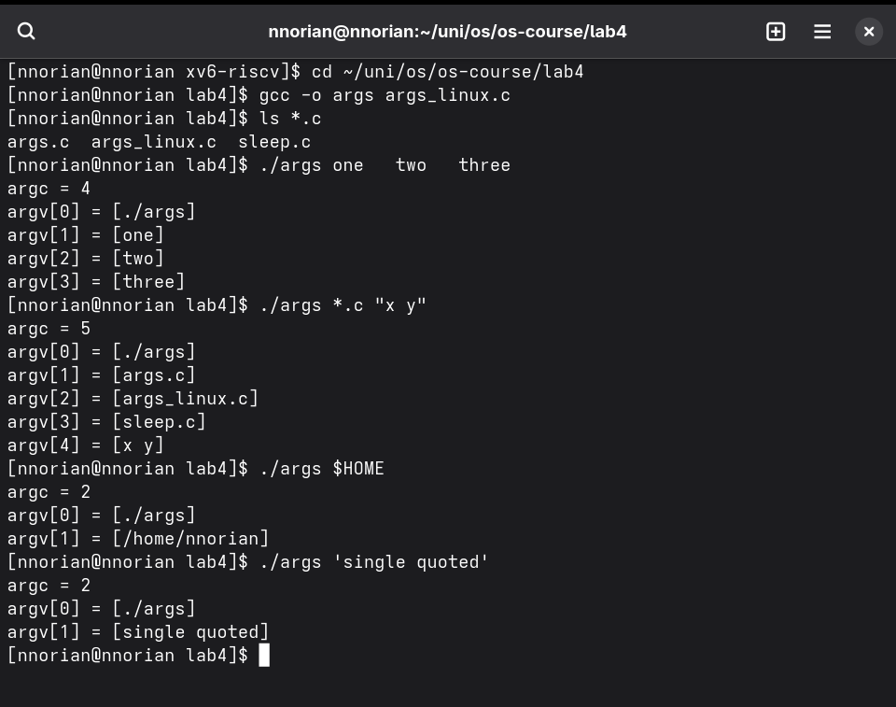
Figura 3.10 – args_linux output in bash
Observations. The program is identical on both sides and only prints what it receives. The kernel's exec copies the argv strings without inspecting them. bash replaced *.c with file names and removed quotes before calling exec; the xv6 shell does neither. Both shells split on whitespace and collapse multiple spaces into one separator. Only double quotes in bash ("x y") keep a space as part of an argument.

3.4 Read the shell
The source code of the xv6 shell (user/sh.c, 499 lines) was examined. It defines five command types: EXEC (1), REDIR (2), PIPE (3), LIST (4) and BACK (5). The runcmd() function (lines 75–129) handles each type with a switch/case. gettoken() (lines 284–297) recognises the special characters | ( ) ; & < > >>.
$ grep -n "#define" user/sh.c
8:#define EXEC 1 9:#define REDIR 2 10:#define PIPE 3
11:#define LIST 4 12:#define BACK 5 14:#define MAXARGS 10
The cd command is handled in main() (lines 166–170) before any fork: if the line starts with "cd ", the shell calls chdir(cmd + 3) directly. This must be a built-in because a child process would change only its own directory and exit.
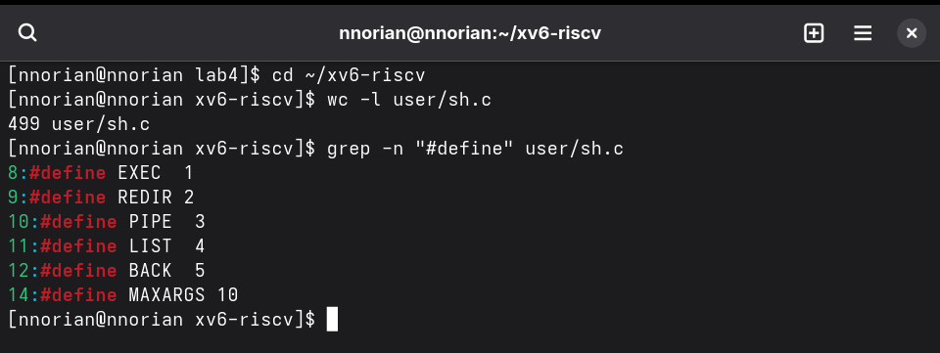
Figura 3.11 – The command kinds defined in sh.c
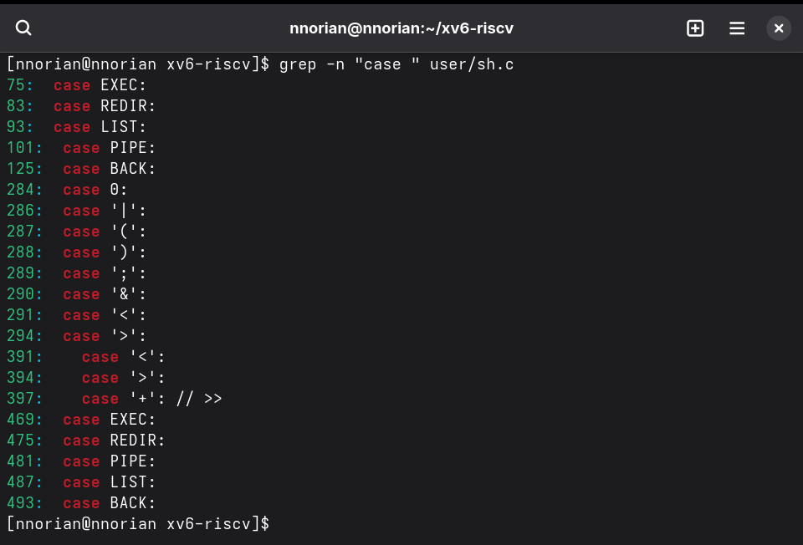
Figura 3.12 – Where each kind is run (case statements)
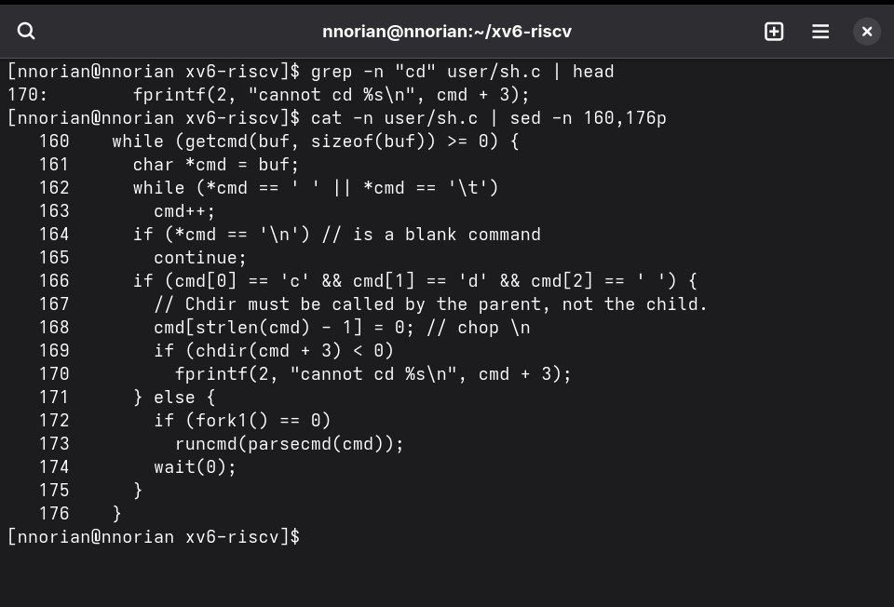
Figura 3.13 – The code that handles cd
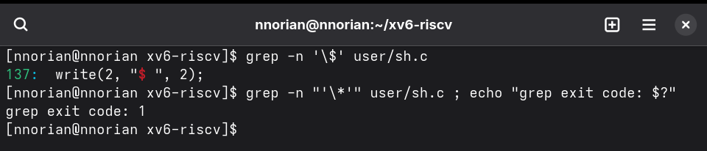
Figura 3.14 – No code for * or $ in sh.c
Observations. There is no code for * or $: grep -n '$' finds only the prompt string "$ ", and '*' is not found at all. The only special characters are whitespace and symbols "<|>&;()". Quotes are not handled either. This explains Part 2: ls *, echo $HOME and echo "a b" passed the raw text to programs unchanged.

CONCLUSIONS
This laboratory work showed the shell as the primary interface between the user and the operating system. In Laboratory work 3, bash was explored in depth: tab completion, history and help speed up daily work; the shell's expansion rules (globbing, variables, quotes, braces, arithmetic) explain every surprise from Part 2 (echo *.xyz, the file with a space, the order of redirections); redirection only changes where file descriptors point; and small filters (grep, cut, sort, uniq, wc, head, tail, awk) joined by pipes answered every question about the log in one line, then became a script with argument checks, a correct exit code and errors on stderr.
In Laboratory work 4, the xv6 shell was compared with bash. A minimal shell needs only: read a line, split it into words, recognise | ; & < > ( ), fork + exec the program and wait, and run cd inside itself because the current directory belongs to the shell process. That is all xv6's sh.c does in under 500 lines, and it is enough for redirection, pipes, lists and background jobs. Everything else — globbing, variables, quote removal, PATH search, history, completion — is done by the shell, not by the kernel or the programs. The args program proves it: the same binary receives *.c and "x in xv6, but real file names and x y in bash.

