MINISTRY OF EDUCATION AND RESEARCH OF THE REPUBLIC OF MOLDOVA
Technical University of Moldova
Faculty of Computers, Informatics and Microelectronics
Department of Software Engineering and Automatics

REPORT
Laboratory work nr. 7-8
Subject: Operating Systems
Topic: “Processes, Redirection, Pipes (Linux & xv6)”

Elaborated: st. gr. FAF-243 | Kushnirenko Ecaterina
Verified: asist. univ. | Reițman Patricia

Chișinău 2026
Contents
Introduction 3
1 Theoretical background 4
2 The shell's three steps: Linux (Laboratory 7) 5
2.1 fork + exec + wait 5
2.2 A zombie, on purpose 6
2.3 Redirection: ls -l > out.txt 7
2.4 A pipe: ls /etc | wc -l 7
3 The same calls, inside xv6 (Laboratory 8) 9
3.1 run, inside xv6 9
3.2 pingpong 10
Conclusions 12

Introduction
The objective of this laboratory work is to understand how processes are created and managed, how file descriptor redirection works, and how pipes connect processes first on a real Linux system (Laboratory 7) and then inside xv6, a small teaching Unix (Laboratory 8). The work covers fork, exec, wait, zombie processes, file descriptor manipulation, and inter-process communication through pipes.

1 Theoretical background
A process is the operating system's unit of execution: a running program with its own address space, open file descriptors, and a position in the CPU scheduler's queue. In Unix, every process except the first (init, PID 1) is created by fork(), which duplicates the calling process. The child is an almost exact copy of the parent; the only difference visible to the program is the return value of fork(): zero in the child, the child's PID in the parent.
xv6 implements the same system calls (fork, exec, wait, pipe, read, write) in about 9,000 lines of C for RISC-V. The API is intentionally similar to Unix so that programs like run.c require only minor changes (different headers, no glibc, exec instead of execlp) to run inside xv6.

2 The shell's three steps: Linux (Laboratory 7)

2.1 fork + exec + wait
The program run.c does what the shell does when the user types a command: it calls fork() to create a child process, the child calls execlp() to become the target program, and the parent calls waitpid() to wait for the child to finish.
Three variants were tested: running ls -l, running date, and running a nonexistent program (nosuchprog).
Variant 1: ls -l. The child becomes ls, which lists the files in the working directory. The parent waits and prints the child's exit status
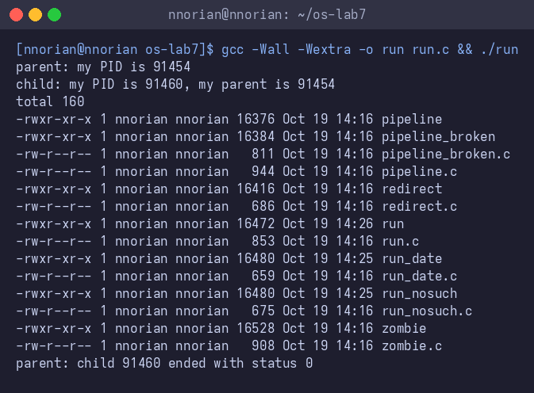
Figure 2.1 – run.c executing ls -l
Variant 2: date. The execlp line was changed to run date instead of ls
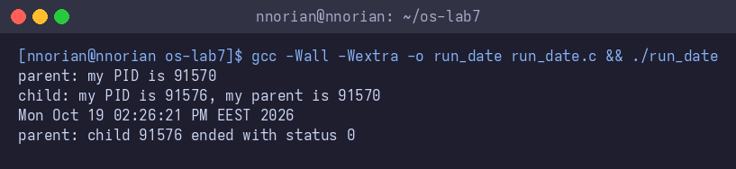
Figure 2.2 – run.c executing date
Variant 3: nosuchprog. The execlp line was changed to run a nonexistent program
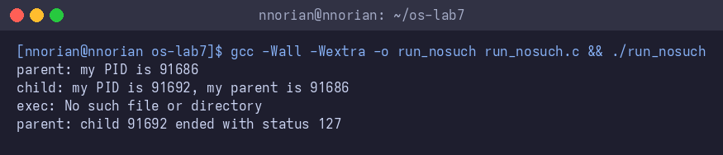
Figure 2.3 – run.c executing a nonexistent program

1. The line perror("exec") is printed only with nosuchprog because execlp() only returns when it fails. When execlp() succeeds (as with ls or date), the child's entire memory image is replaced by the new program, so the code after execlp() including perror never runs. With nosuchprog, exec fails because the program does not exist, so execution continues to the next line and perror prints the error.
2. The child prints the parent's PID as "my parent". In the screenshot, the child says "my parent is 90750", which matches the parent's "my PID is 90750". This confirms that getppid() in the child returns the PID of the process that called fork().
3. With ls, the parent sees status 0 (success). With nosuchprog, the parent sees status 127. The status 127 comes from the explicit exit(127) in the child after exec fails this is the conventional Unix exit code for "command not found".

2.2 A zombie, on purpose
A zombie is a child process that has terminated but has not been waited for by its parent. The zombie.c program adds sleep(20) before the waitpid() call, creating a 20-second window during which the child (which runs ls and exits quickly) is a zombie.
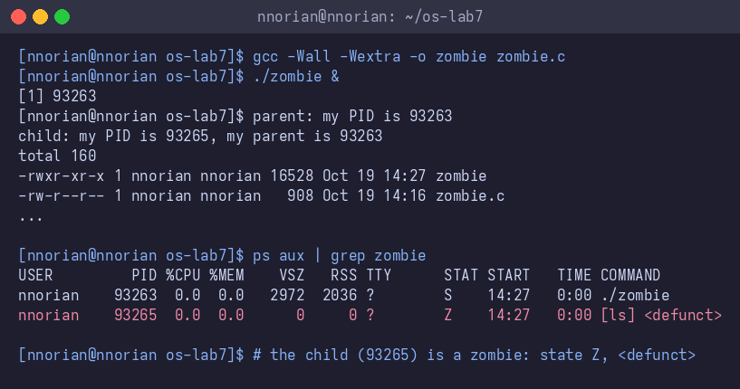
Figure 2.4 – The zombie process visible in ps output
The ps output (Figure 2.4) shows two processes. The parent (PID 93263) has state S (sleeping, in the sleep(20) call). The child (PID 93265) has state Z (zombie) and is shown as [ls] <defunct>. The child has finished executing ls and exited, but the parent has not yet called waitpid() to collect its exit status, so the kernel keeps the child's entry in the process table with zero memory (VSZ and RSS are both 0). After the parent wakes up and calls waitpid(), the zombie is reaped and disappears.

2.3 Redirection: ls -l > out.txt
The program redirect.c does what the shell does for output redirection. In the child, it closes file descriptor 1 (stdout), then opens out.txt. Because open() always returns the lowest available descriptor, it returns 1. After that, execlp("ls", ...) runs ls, which writes to descriptor 1 as always but descriptor 1 now points to out.txt instead of the terminal.
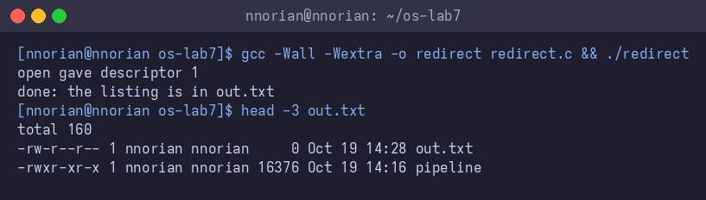
Figure 2.5 – Output redirection: ls -l > out.txt

1. open() gave descriptor 1. This is because close(1) freed descriptor 1, and open() always returns the smallest available file descriptor number. Descriptors 0 (stdin) and 2 (stderr) were still open, so 1 was the smallest free number.
2. The listing from ls does not appear on the screen because ls writes to file descriptor 1, which now points to out.txt instead of the terminal. ls itself was not modified it still calls write(1, ...) but the meaning of descriptor 1 was changed by the redirect before exec.
3. To redirect errors (like 2> err.txt), you would close descriptor 2 (stderr) before calling open. The open call would then return 2, and any output to stderr (including perror messages) would go to the file.

2.4 A pipe: ls /etc | wc -l
It creates a pipe, forks twice:
- the first child closes its stdout and dups the pipe's write end to become descriptor 1, then runs ls
- the second child closes its stdin and dups the pipe's read end to become descriptor 0, then runs wc.
- The parent closes both pipe ends and waits for both children.
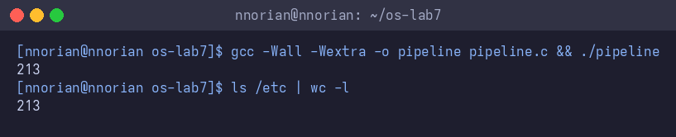
Figure 2.6 – The pipeline produces the same result as the shell
Both ./pipeline and ls /etc | wc -l printed 213, confirming the hand-built pipeline works identically to the shell's.
Breaking the pipeline. When the parent's close(p[1]) is commented out, the program hangs:
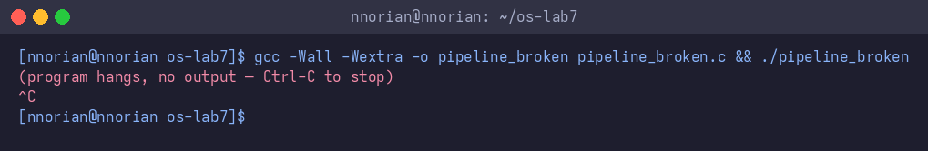
Figure 2.7 – The broken pipeline hangs and must be stopped with Ctrl-C
1. Yes, ./pipeline and ls /etc | wc -l gave the same number: 213.
2. After the change, wc is the child that never ends. ls finishes normally, it writes all filenames into the pipe and exits.
3. wc is waiting for EOF on its stdin (the read end of the pipe). EOF only arrives when all file descriptors that refer to the write end of the pipe are closed. The parent still holds p[1] open, so wc's read() never returns 0 (EOF), and wc hangs forever waiting for more input.

3 The same calls, inside xv6 (Laboratory 8)

3.1 run, inside xv6
The program user/run.c implements the same three steps as run.c from Lab 7, but uses xv6's system calls instead of glibc wrappers. The child becomes echo (instead of ls on Linux) to demonstrate exec.
Variant 1: echo hello from the child (Figure 3.1).
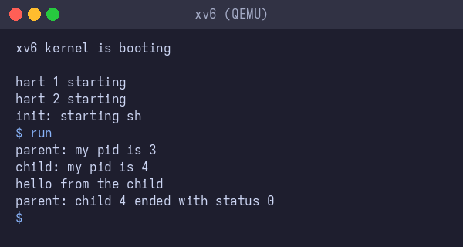
Figure 3.1 – run inside xv6 executing echo
Variant 2: ls (Figure 3.2).
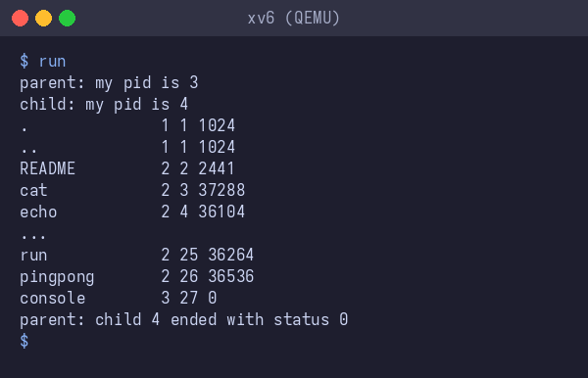
Figure 3.2 – run inside xv6 executing ls
Variant 3: nosuchprog (Figure 3.3).
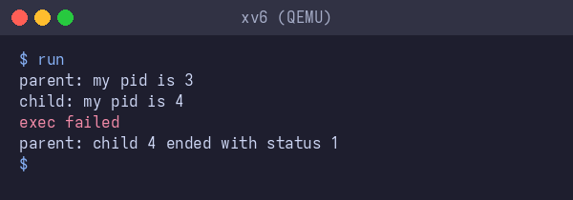
Figure 3.3 – run inside xv6 with a nonexistent program

1. In xv6, run.c uses fork(), exec(), and wait(). On Linux, run.c uses fork(), execlp(), and waitpid(). The core three-step pattern is the same: create a child (fork), replace its image (exec), and wait for it (wait). The differences are cosmetic: xv6 uses exec() with an argv array while Linux uses execlp() which searches PATH; xv6 uses wait() with a pointer to status while Linux uses waitpid() with more options.
2. echo prints "hello from the child". The code of run.c sets up the args array but does not print that text exec("echo", args) replaces the child's memory with the echo program, and it is echo's main() that iterates over its arguments and prints them.
3. The status is 1 in xv6 and 127 on Linux because the exit code after a failed exec is different in each program. In the xv6 version, the code after exec says exit(1), while in the Linux version it says exit(127). The convention of 127 for "command not found" comes from POSIX shells; xv6 has no such convention.

3.2 pingpong
The program user/pingpong.c demonstrates two-way communication between a parent and child process using two pipes: p2c (parent-to-child) and c2p (child-to-parent). The parent writes one byte into p2c[1]. The child reads it from p2c[0], prints "received ping", writes the byte into c2p[1], and exits. The parent reads the byte back from c2p[0], prints "received pong", and waits for the child.
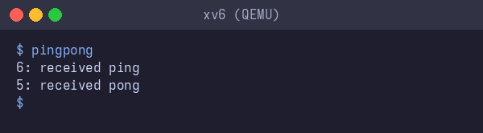
Figure 3.4 – pingpong inside xv6
The output shows PID 6 (child) received ping first, then PID 5 (parent) received pong — confirming the byte traveled parent → child → parent.
1. Two pipes are needed because a pipe is one-way: data flows from the write end to the read end. If both parent and child wrote to and read from the same pipe, the parent could read back its own byte before the child gets it, creating a race condition. With two separate pipes, each direction has its own channel: p2c carries the parent → child and c2p carries the child → parent.
2. The read(c2p[0], &b, 1) call makes the parent wait. read() on a pipe blocks until data is available. The parent calls write() to send the byte, then immediately calls read() on c2p[0]. Since the child hasn't written to c2p[1] yet, the parent's read() blocks until the child reads the byte, prints "received ping", and writes the byte back to c2p[1], at which point the parent's read() returns with the data.

Conclusions
This laboratory work demonstrated the fundamental mechanisms that every Unix shell relies on: the fork-exec-wait pattern for running programs, file descriptor manipulation for redirection, and pipes for connecting processes.
The two labs show that the core process and I/O abstractions of Unix are stable across implementations: the same small set of system calls (fork, exec, wait, pipe, read, write, close, open, dup) is sufficient to build a shell, redirect output, and compose programs through pipes.

