
Department of
Life Sciences

Fundamentals of Pharmacy / Pharmacology: The Chemistry of Drugs
SL12101 / SL12009

Structural, physical and chemical properties of amino acids: workbook
(Lecture 24)

Dr Charlotte Dodson

Name……………………………….

Introduction
Throughout this workbook I have included a number of tasks for you to complete (highlighted in blue). These are of varying difficulty, but I hope that none of them is too onerous. The point of these tasks is to encourage to you to engage in active learning and to think about the material as you work your way through the workbook. This may feel like hard work now, but there is lots of evidence that active learning makes us learn the material more deeply (better) and – in due course – makes revision much easier.

On this page there is a table with a reminder of the first few letters of the Greek alphabet. At the back I have included the structures of the proteogenic amino acids for reference. Please note that you are expected to learn the structures of these amino acids for this unit.

Reminder of the first few letters of the Greek alphabet

Letter | Pronounciation
α | alpha
b | beta
γ | gamma
δ | delta
ε | epsilon
ζ | zeta

Chemistry of amino acids

Revision of amino acids and carbon naming
In SL12100 / SL12010 and at school you covered the general structure of an amino acid. At school level, an amino acid consists of an amine group, a carboxylic acid, a central carbon linking these two moieties, and a variable sidechain or R-group (Figure 1).
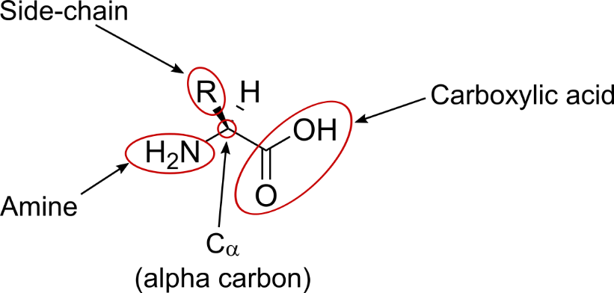
Figure 1: General structure of an amino acid.
Since school you have learnt that the carbon adjacent to a carboxylic acid is called the alpha carbon (C_{α}). This rule holds in amino acids, and so we can also label the C_{α} in Figure 1 above.
This convention of carbon numbering continues, moving away from the carboxylic acid. Therefore, depending on the amino acid side chain, we may also have a C_{β} and a C_{γ} etc. Alanine (Figure 2) has a C_{α} and a C_{β} only.
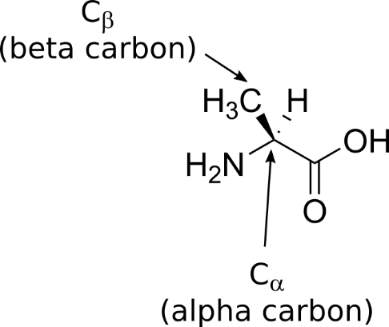
Figure 2: Structure of alanine with alpha and beta carbons labelled.

In SL12100 / SL12010 we briefly mentioned the structure of the different amino acid sidechains. You will need to learn these chemical structures for this unit. As a reminder, a copy of the chemical structures can be found inside the back cover of this booklet.

Task:
Draw the structures of aspartic acid and isoleucine below. Label the amine, the carboxylic acids and the different carbons in the sidechain (C_{α}, C_{β} etc).
Table I: Labelling the atoms in an amino acid
Aspartic acid | Isoleucine

In proteins, the carboxylic acid group of one amino acid is covalently bonded to the amine group of another. This results in the nitrogen of a NH group being covalently bound to the carbon of a C=O, ie in formation of an amide. This explains why the bond between two amino acids is called an amide bond.

Importance of the chemistry of amino acids
Biology – life itself – is a beautiful phenomenon. At a fundamental level, the way in which molecules interact with each other and in which information is stored and transferred in a biological cell underpins much of what we call life. The chemical properties of amino acids are intrinsic to the mechanisms by which much of this occurs – and to our ability to manipulate this in living organisms when the organism becomes sick.
The chemical properties of amino acids are important in:
- Maintaining protein structure
- Protein-protein interactions
- Protein location within the cell
- Channel specificity
- Information transfer (cellular signalling, gene regulation)
- Catalysis
- Small molecule drug binding and mechanism of action

Stereochemistry of amino acids
All α amino acids are chiral (except glycine).
Task:
Look up the structures of L- and D- amino acids in a textbook or online. Is the amino acid in Figure 1 an L- or D- isomer? Copy this amino acid into the correct box in Table II below, and draw the structure of the other isomer.
Table II: L- and D-isomers of α amino acids
L-amino acid | D-amino acid

Only L-amino acids (and glycine) are incorporated into peptides and proteins in biology. D-amino acids are synthesised by prokaryotes and found in peptidoglycan in the bacterial cell wall. D-amino acids (eg D-Asp and D-Ser) have recently been found in humans – these are thought to be a consequence of ageing (racemization during life).
NB all proteogenic amino acid are L-amino acids. Due to the way that naming conventions work, they are all S isomers with the exception of cysteine (which is R).
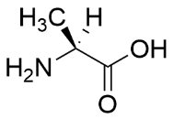 | 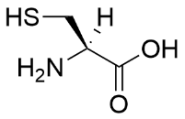
L-alanine | L-cysteine
S-alanine | R-cysteine
Figure 3: Stereochemical naming of alanine and cysteine.

Protonation state of amino acids
The amine and carboxylic acid groups of free amino acids (ie monomeric amino acids not in a protein or peptide) can both titrate. Earlier in the semester Dr Caggiano talked about the pK_{a} of common chemical groups: the pK_{a} of a primary amine is around 10.6 and that of a carboxylic acid around 2.1. This means that at pH 7 an amino acid has a positive charge on one group and a negative charge on the other. It is therefore a zwitterion (it is zwitterionic).
Question:
What is the net charge on glycine at pH 7?
Task:
Using the pK_{a} values for an amine and carboxylic acid given below (and on the previous page), complete Figure 4 by drawing the structure of a general amino acid at pH 1 and pH 13. Which one is a cation? Which one is an anion?
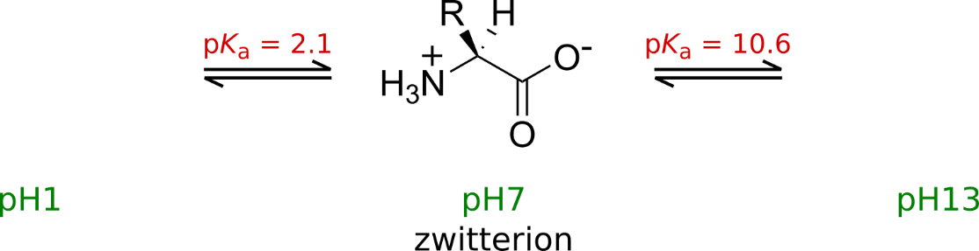
Figure 4: The protonation equilibria for a general amino acid
Remember, even though one form is predominant at each pH value, all three forms exist to some extent at all pH values.

Properties of the sidechains of amino acids
In SL12100 / SL12010 we listed the weak non-covalent interactions which stabilise protein tertiary structure. These interactions provide the free energy (ΔG) necessary to stabilise the folded protein structure. They also contribute free energy and – most importantly – the specificity which ensures that a small molecule drug binds to the correct target protein.
The two most relevant interactions for this unit are salt bridges (interactions between permanent positive and negative charges; ie an interaction between a + (plus) and a – (minus)), and hydrogen bonds.

Protonation state of amino acid sidechains
Like the amine and carboxylic acid groups of free amino acids (and the N- and C-termini of peptides), some amino acid sidechains will titrate.
Reminder: pK_{a} is related to the log of the acid constant K_{a}. K_{a} is the dissociation constant of the protonation equilibrium (think back to equilibria at school). It can also be thought about as the pH at which half of the sidechain molecules will be protonated and half will be deprotonated.

When the pH of a solution is below the pK_{a} of a titrating group, the group will be protonated. When the pH of a solution is above the pK_{a} of a titrating group, the group will be deprotonated.
The protonation state of an amino acid will determine its charge, and thus its ability to form salt bridges.
Task:
Complete Table III (on the next page) by drawing the amino acids at the indicated pH values. Remember that each titrating group has its own pK_{a}, so you will need to consider the protonation state of amine, carboxylic acid and sidechain in turn. pK_{a} values for amino acid sidechains are given on p15.
Table III: Protonation state of different amino acids at indicated pH
Aspartic acid at pH 7 | Lysine at pH 7
Glutamic acid at pH 3 | Histidine at pH 5

Hydrogen bonding between amino acids
A hydrogen bond occurs when a hydrogen atom covalently attached to one electronegative atom (often N or O) is shared with another electronegative atom that possesses a lone pair of electrons (Figure 5 below):
Figure 5: A hydrogen bond (shown in green) between a protein backbone carbonyl and a lysine sidechain
We encountered hydrogen bonds between the backbone atoms of amino acids when we looked at protein secondary structure in SL12100 / SL12010. Alpha helices and beta sheets are stabilised by hydrogen bonds between the oxygen of a backbone carbonyl and the hydrogen of a backbone amine.
Task:
In the space below, draw a backbone hydrogen bond that might be found in a beta sheet:

Hydrogen bonding of amino acid sidechains
In addition to backbone-backbone hydrogen bonds, hydrogen bonds can occur between protein sidechains or between protein sidechains and the protein backbone (eg Figure 5 above). These are the hydrogen bonds which make up protein tertiary structure.
Hydrogen bonds can also occur between protein sidechains and small molecule drugs. The hydrogen bonding potential of functional groups on a small molecule drug with amino acid sidechains (or backbone) in the binding site gives rise to much of the specificity of a drug-target interaction.
Task:
The hydrogen bonding potential of different amino acid sidechains is shown in Figure 6 below. Have a look at the different side chains and circle the groups could donate or accept a hydrogen bond.
Hydrogen bond donors
Hydrogen bond acceptors
Hydrogen bond donors or acceptors
Figure 6: Hydrogen bonding properties of amino acid sidechains at physiological pH (pH 7).

π-stacking of aromatic sidechains
Aromatic sidechains (with π-bonds) often stack on top of each other in protein structures due to attractive π-π interactions between the aromatic rings. The same interactions are used in drug design to increase the binding energy between a small molecule drug and its protein binding site (Figure 7).
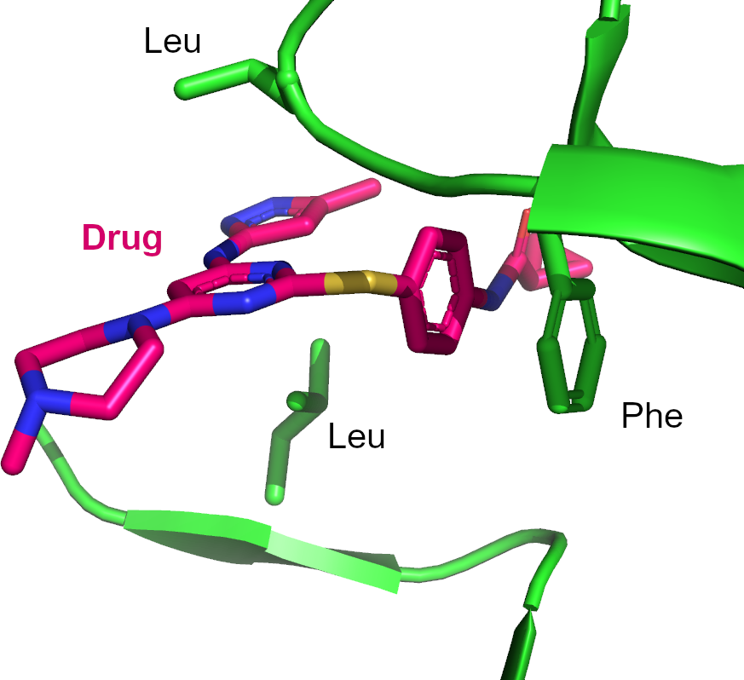
Figure 7: π-stacking between the aromatic ring of a drug molecule and a phenylalanine residue in a protein binding site. Note the two leucine residues creating an hydrophobic environment in the binding pocket. The protein is shown in green (most sidechains not drawn). Carbon atoms of the drug are shown in pink, nitrogen atoms in blue and sulphur in yellow.
Note: π-π interactions are usually less specific than hydrogen bonding interactions. In drug design, π-π interactions are often used to increase affinity (ie make the drug bind the target more tightly) and hydrogen bonds to increase specificity (ie make the drug bind to the right target in the right place).
Task:
One amino acid has been omitted from Figure 8 below. Which one do you think it is? Draw your answer in the space provided.
Figure 8: The structure of four amino acids which can engage in π-stacking

Amino acid sidechains and protein solubility
So far we have focussed on the interactions which stabilise the internal structure of a protein (secondary, tertiary etc) or which stabilise drug-protein binding. However, the chemical properties of the amino acids on a protein surface are also important!
Cytosolic proteins (proteins found in the cytosol of a cell) are in a hydrophilic environment. In order to remain stably folded in solution, cytosolic proteins must be able to interact with the charged environment created by water molecules.
Task:
Name two amino acids whose sidechains would increase the ability of the surface of a protein to interact with an aqueous environment.
Other proteins (membrane proteins) are found in the hydrophobic environment of the lipid bilayer which makes up the membranes of a cell. The surface of these proteins must be able to interact with their environment.
Task:
Name two amino acids which would increase the ability the surface of a protein to interact with the lipid bilayer.

Some transmembrane proteins form channels or pumps to enable charged species such as Na⁺ or K⁺ to cross the cellular membrane. Name an amino acid which might help a positively charge ion such as Na⁺ to cross a lipid bilayer.

Amino acid sidechains as chemical reactants
The chemistry of amino acid sidechains is not only important in drug binding and in stabilising protein structure. Amino acid sidechains can themselves react:
- in biosynthesis
- by forming covalent drug-target interactions (covalent inhibitors have a very high affinity as they are covalently attached to their target)
- in enzyme catalysis
- to form modified amino acids (for cellular signalling, to regulate gene expression, in response to O₂ levels etc)

Amino acids as nucleophiles
Four amino acids can act as nucleophiles in chemical reactions at or near physiological pH (Figure 9). The first three (cysteine, aspartic acid and glutamic acid) are frequently found, particularly on the surface of proteins. The fourth (deprotonated serine) is not normally found on the surface of proteins, but is found in the active site of serine proteases. Note the protonation state of the sidechains of all four amino acids drawn.
Figure 9: Amino acids which can act as nucleophiles in chemical reactions
The relative order of reactivity of the different nucleophilic functional groups is:

Modifications of amino acids
Amino acid sidechains may be post-translationally modified (be chemically modified by enzymes once they are fully folded and released from the ribosome) as part of normal cellular function. Common modifications are phosphorylation, acetylation, methylation and hydroxylation. Post-translational modifications can usually be reversed by a different enzyme to give a dynamic situation in which the chemistry of an amino acid reflects current conditions in the cell.

Protein phosphorylation
Amino acids may be phosphorylated on a sidechain hydroxyl. Phosphorylation is a chemical signal used to transfer and integrate information in the cell and is used in cell signalling. Threonine, serine and tyrosine all possess hydroxyl groups on their sidechains, and phosphorylation of these amino acids in proteins is common in protein kinase signalling.
Task:
Complete Table IV by drawing the phosphorylated serine and tyrosine residues in the spaces provided
Table IV: Amino acid phosphorylation
Phosphothreonine | Phosphoserine | Phosphotyrosine

Amino acid acetylation and methylation
Lysine residues in proteins can also be modified – either by acetylation or by methylation. Acetyllysine and methyllysine are important in the regulation of gene expression. While acetylation is the addition of a single chemical group, lysine can undergo mono-, di- and tri-methylation, each of which communicates different biological information.
Task:
Complete Table V on the next page

Table V: Lysine modifications
Acetyllysine | mono-methyllysine
di-methyllysine | tri-methyllysine

Proline hydroxylation
Proline residues can be hydroxylated. This may be to signal cellular oxygen levels, or to increase protein structural stability (eg in collagen). The structure of hydroxyproline is given in Figure 10 below.
Figure 10: The structure of hydroxyproline

Summary
The chemical properties of amino acids give rise to many of the macroscopic properties of biology – and life as we know it.
Amino acids have a stereocentre and may be L- or D- isomers.
Depending on their chemistry, amino acid sidechains may protonate / deprotonate or form π-stacking interactions. If the pH of the environment is known, the protonation state of an amino acid sidechain can be determined from its pK_{a}.
The chemical properties of amino acid sidechains determine the interactions made within and by a protein molecule. They also determine its reactivity, its ability to signal, and the specificity of its interaction with a small molecule drug.

The material in this booklet is © Charlotte Dodson and is published under a CC-BY-SA 4.0 licence https://creativecommons.org/licenses/by-sa/4.0/.

Reminder of amino acid structures and sidechain pK_{a} values

Amino acids with aliphatic sidechains

Amino acids with aromatic sidechains

Amino acids with acidic sidechains

sidechain pK_{a} = 3.65 | sidechain pK_{a} = 4.25 | sidechain pK_{a} = 8.18

Amino acids with basic sidechains

sidechain pK_{a} = 12.48 | sidechain pK_{a} = 6.00 | sidechain pK_{a} = 8.95

Amino acids with neutral polar sidechains

