Jsock framework

Simple java framework and server.
https://github.com/nnpa/jsock/

1. Multithreading client server (TCP/UDP)
2. Easy configuration
3. MVC like controllers (tasks)
4. Simle databese mysql usage
5. Web User rights and session
6. Modules
7. Data storage
8. Errors.

Framework diagram
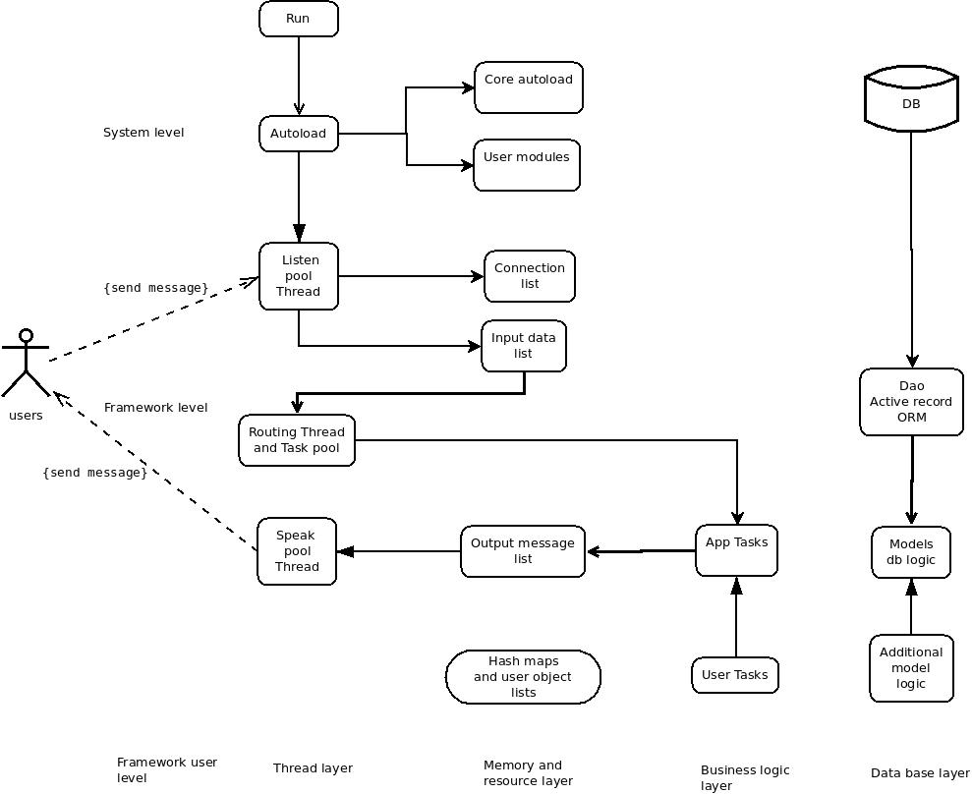

Basic working principle

Scenario

1. Startup framework and webserver daemon
2. Read configuration
3. Load modules
4. Run pool threads
5. Receive message from client
6. Run task and compute result
7. Send message to user

Thread pools

1. Receive pool
2. Sender pool
3. Routing pool
4. Connection pool

Application send and receive json messages.
byte[] buffer = "{\"task\":\"JtestTask\",\"message\":\"mymessage\",}".getBytes();
Tasks – executable java code (like controllers in our frameworks Controllers)
Models – presentation of data from mysql, execute query.

Run and Install

1. Install
Download framework and copy source files to project directory.
Install musql server.

2. Configrure
Open conf/Jconfig.java and change settings

modules – modules list
sender_pool – size of sender pool
resiver_pool – size of resiver pool
task_pool – size of resiver pool
protocol – tpc or udp sender
connection_life_time – connection time out
client_port – client port
server_port – server port
socket_buffer_size – size of socket buffer (length of message)

Database settings

mysql_user – mysql user name
mysql_password – mysql user password
mysql_url – mysql connection string for jdbc
mysql_db_name – mysql dabase name

3. Create database and tables
Load dump from dump.sql (in root directory)

5. Run application
execute main file conf/Jsock.java for test

6. Add external libraries if not exists
mysql-connector-java-5.1.39-bin.jar
json-simple-1.1.1.jar

Example Task: send message

1. Create Task
Copy file JtestTask.java from /example/JtestTask.java
Copy file JtestTask.java in directory from source file /example/JtestTask.java

2. Open lines into test file
Open jsock.tests.JclientUDPTest.java
Add lines in UDPSendThread subclass run method.

byte[] buffer = "{\"task\":\"JtestTask\",\"message\":\"mymessage\",}".getBytes();

task – executable java class (task name).
message – free data format .

3. Run application conf/Jsock.java
4. Run jsock.tests.JclientUDPTest.java
out: {"message":"mymessage"}

Task basics
1. All task extend JclientTask.
2. Rules method.
Method contains rules set, for example user message must contain field message.

@Override
public String[][] rules(){
String[][] rules = {
{"require","message"}
};
return rules;
}
Validation code located in jsock.validators and include in JclientTask.

3. User rights
Method contains string of user grands, who have access to the task. Default user privilege guest.
For example: guest,user,moderator,manager,admin

@Override
public String rights() {
//String rigths = "user,admin";
String rigths = "guest";

return rigths;
}
4. Before action
Code that runs before action. Method defined in JTask and override in JclientTask.
@Override
public void beforeAction(){
super();
//user code here
}

5. After action
Code that runs after action. Method defined in JTask and override in JclientTask.
@Override
public void afterAction(){
super();
//user code here
}

6. Action
The main method in the task
@Override
public void action(){
//System.out.println(“The task action complite”):
}

7. Receive message from client
In action method write
String message = this.message.json.get("message").toString();
Get field message from user data string.

8. Send message to client.
In the end of action method write
String outString = "{\"message\":\"some out string"}";

JOutMessages outMessage = new JOutMessages(this.message.ip,outString);
outMessage.insert();
When on the client side can receive a message.

Messages collection
jsock.message.JInMessages - Contains incoming client messages.
jsock.message.JOutMessages - Contains outgoing client messages.

Database
1. jsock.db.DBConnection
Contains jdbc connect to mysql.

2. jsock.db.DBQuery
Contains methods for execution queries to database.
delete – delete field by id
execute – execute sql string
deleteById – delete field by id
findById – find field by id
insert – insert field by id
update – update field by id
unescapeMySQLString – escape sql string

Models
Models is a user class which must be created in models folder and contains database logic.
All models must be extended from DBQuery, use models in tasks.
Examples:
models.Session.java
models.Users.java

Sutdownhook
Located in jsock.java and triggered when system shutdown.
class ShutdownHook extends Thread {
public void run() {
System.out.println("System halt");
}
}

Modules
Modules is a standalone piece of code.
Modules must be located in folder jsock.modules example TestModule
For plug in modules need add module class name to config section
public static String[] modules = { "TestModule" };

Authorization example
1. Run the jsock.tests.JClientUDPTest with command
byte[] buffer = "{\"task\":\"JLoginTask\",\"email\":\"jetananas@yandex.ru\",\"password\":\"test\"}".getBytes();
Copy receive string
7ebc5d1781c51c50c864629299e6a5d91467830206
And run next command

//byte[] buffer = "{\"task\":\"JtestTask\",\"auth_token\":\"7ebc5d1781c51c50c864629299e6a5d91476670763\",\"message\":\"authorized\"}".getBytes();

Server authorized user by token with admin rights.

Cron like commands
JCommandExecutor run user commands from directory commands.
List of first run stored in jConfig in variable executor_timeout 19 seconds by default
In variable executor_tasks stored array of executable commands
Open class commands.JsystemGarbage and you will see how it works:
In main method run you will see code:
if(condition()){
//your code here
}
condition – custom user code, which must return boolean (true/false)
You can create custom command.
1. Create class in commands directory
2. add class name to executor_tasks
Registration
External libraries:
javamail: http://www.java2s.com/Code/Jar/j/Downloadjavamail144jar.htm

/tasks/JRegistrationTask

