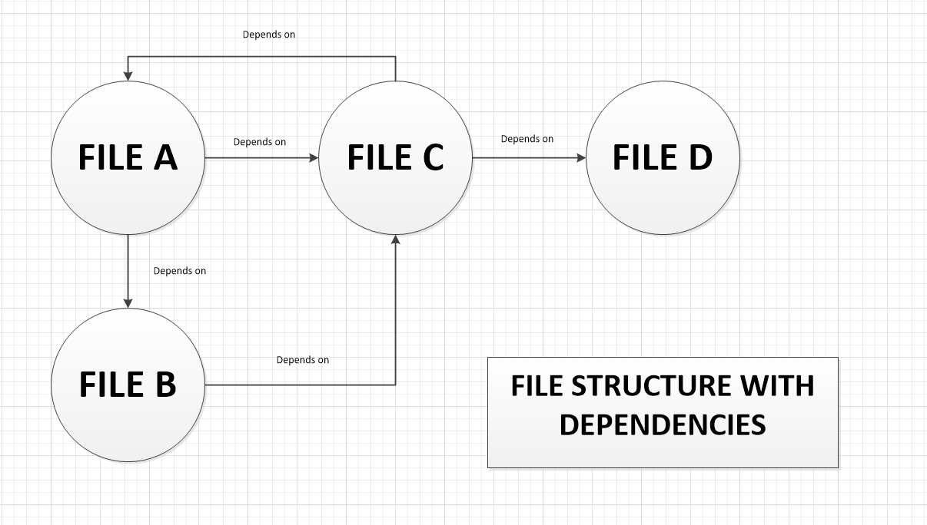  
  
  
Below is the output of the project:

=============================================================================

TYPE TABLE

=============================================================================

Type: namespace

Name of the type: Global Namespace

File Name (with absolute path): NULL

Namespace to which it belongs: Global Namespace

-----------------------------------------------------------------------------

Type: struct

Name of the type: x

File Name (with absolute path):

S:\OOD\OOD\ForProject2\CodeAnalyzer\FilesToTest\\FileA.h

Namespace to which it belongs: Global Namespace

-----------------------------------------------------------------------------

Type: class

Name of the type: FileB

File Name (with absolute path):

S:\OOD\OOD\ForProject2\CodeAnalyzer\FilesToTest\\FileB.h

Namespace to which it belongs: Global Namespace

-----------------------------------------------------------------------------

Type: Global function

Name of the type: abc

File Name (with absolute path):

S:\OOD\OOD\ForProject2\CodeAnalyzer\FilesToTest\\FileA.h

Namespace to which it belongs: Global Namespace

-----------------------------------------------------------------------------

Type: namespace

Name of the type: TestA

File Name (with absolute path):

S:\OOD\OOD\ForProject2\CodeAnalyzer\FilesToTest\\FileA.h

Namespace to which it belongs: Global Namespace

-----------------------------------------------------------------------------

Type: Global function

Name of the type: def

File Name (with absolute path):

S:\OOD\OOD\ForProject2\CodeAnalyzer\FilesToTest\\FileA.h

Namespace to which it belongs: TestA

-----------------------------------------------------------------------------

Type: class

Name of the type: FileC

File Name (with absolute path):

S:\OOD\OOD\ForProject2\CodeAnalyzer\FilesToTest\\FileC.h

Namespace to which it belongs: TestC

-----------------------------------------------------------------------------

Type: Global function

Name of the type: xyz

File Name (with absolute path):

S:\OOD\OOD\ForProject2\CodeAnalyzer\FilesToTest\\FileC.h

Namespace to which it belongs: Global Namespace

-----------------------------------------------------------------------------

Type: enum

Name of the type: Color

File Name (with absolute path):

S:\OOD\OOD\ForProject2\CodeAnalyzer\FilesToTest\\FileA.h

Namespace to which it belongs: TestA

-----------------------------------------------------------------------------

Type: class

Name of the type: FileA

File Name (with absolute path):

S:\OOD\OOD\ForProject2\CodeAnalyzer\FilesToTest\\FileA.h

Namespace to which it belongs: TestA

-----------------------------------------------------------------------------

Type: class

Name of the type: FileA

File Name (with absolute path):

S:\OOD\OOD\ForProject2\CodeAnalyzer\FilesToTest\\FileC.h

Namespace to which it belongs: TestC

-----------------------------------------------------------------------------

Type: namespace

Name of the type: TestC

File Name (with absolute path):

S:\OOD\OOD\ForProject2\CodeAnalyzer\FilesToTest\\FileC.h

Namespace to which it belongs: Global Namespace

-----------------------------------------------------------------------------

Type: Global function

Name of the type: pqr

File Name (with absolute path):

S:\OOD\OOD\ForProject2\CodeAnalyzer\FilesToTest\\FileC.h

Namespace to which it belongs: TestC

-----------------------------------------------------------------------------

Type: class

Name of the type: FileD

File Name (with absolute path):

S:\OOD\OOD\ForProject2\CodeAnalyzer\FilesToTest\\FileD.h

Namespace to which it belongs: Global Namespace

-----------------------------------------------------------------------------

=============================================================================

DEPENDENCY TABLE

=============================================================================

FileName: S:\OOD\OOD\ForProject2\CodeAnalyzer\FilesToTest\\FileA.h

Dependencies: S:\OOD\OOD\ForProject2\CodeAnalyzer\FilesToTest\\FileB.h

S:\OOD\OOD\ForProject2\CodeAnalyzer\FilesToTest\\FileC.h

-----------------------------------------------------------------------------

FileName: S:\OOD\OOD\ForProject2\CodeAnalyzer\FilesToTest\\FileB.h

Dependencies: S:\OOD\OOD\ForProject2\CodeAnalyzer\FilesToTest\\FileC.h

-----------------------------------------------------------------------------

FileName: S:\OOD\OOD\ForProject2\CodeAnalyzer\FilesToTest\\FileC.h

Dependencies: S:\OOD\OOD\ForProject2\CodeAnalyzer\FilesToTest\\FileA.h

S:\OOD\OOD\ForProject2\CodeAnalyzer\FilesToTest\\FileD.h

-----------------------------------------------------------------------------

FileName: S:\OOD\OOD\ForProject2\CodeAnalyzer\FilesToTest\\FileD.h

Dependencies: No External Dependencies!!

-----------------------------------------------------------------------------

------------------ END OF DEPENDENCY TABLE ------------------------

-->The Dependencies have been stored to the NoSqlDatabase.

The database is displayed below: (NoSqlDB Requirement defined in the purpose section is fulfilled here!!)

Key : S:\OOD\OOD\ForProject2\CodeAnalyzer\FilesToTest\\FileA.h

name : S:\OOD\OOD\ForProject2\CodeAnalyzer\FilesToTest\\FileA.h

timeDate : 2017-08-06.18:44:34

children : S:\OOD\OOD\ForProject2\CodeAnalyzer\FilesToTest\\FileB.h

S:\OOD\OOD\ForProject2\CodeAnalyzer\FilesToTest\\FileC.h

Key : S:\OOD\OOD\ForProject2\CodeAnalyzer\FilesToTest\\FileB.h

name : S:\OOD\OOD\ForProject2\CodeAnalyzer\FilesToTest\\FileB.h

timeDate : 2017-08-06.18:44:34

children : S:\OOD\OOD\ForProject2\CodeAnalyzer\FilesToTest\\FileC.h

Key : S:\OOD\OOD\ForProject2\CodeAnalyzer\FilesToTest\\FileC.h

name : S:\OOD\OOD\ForProject2\CodeAnalyzer\FilesToTest\\FileC.h

timeDate : 2017-08-06.18:44:34

children : S:\OOD\OOD\ForProject2\CodeAnalyzer\FilesToTest\\FileA.h

S:\OOD\OOD\ForProject2\CodeAnalyzer\FilesToTest\\FileD.h

Key : S:\OOD\OOD\ForProject2\CodeAnalyzer\FilesToTest\\FileD.h

name : S:\OOD\OOD\ForProject2\CodeAnalyzer\FilesToTest\\FileD.h

timeDate : 2017-08-06.18:44:34

children : NULL

=============================================================================

STRONG COMPONENTS

=============================================================================

Strong Component 1: {

S:\OOD\OOD\ForProject2\CodeAnalyzer\FilesToTest\\FileD.h

}

Strong Component 2: {

S:\OOD\OOD\ForProject2\CodeAnalyzer\FilesToTest\\FileC.h

S:\OOD\OOD\ForProject2\CodeAnalyzer\FilesToTest\\FileB.h

S:\OOD\OOD\ForProject2\CodeAnalyzer\FilesToTest\\FileA.h

}

================== END OF PROJECT DEMONSTRATION ====================