BAI702 — Machine Learning II Mini Project
Student Marks Prediction Using Linear Regression

1. Introduction
Machine Learning is a branch of Artificial Intelligence that enables computers to learn patterns from data and make predictions without being explicitly programmed. It plays an important role in education, healthcare, finance, and business analytics.
Linear Regression is a supervised machine learning algorithm used to predict continuous numeric values. This project uses Linear Regression to predict a student's final exam marks from academic factors: study hours, attendance, assignment score, and previous test score.

2. Problem Statement
Develop a Linear Regression model that predicts a student's final examination marks from academic performance data, with acceptable prediction accuracy.

3. Objectives
- Understand supervised machine learning and regression.
- Study and implement the Linear Regression algorithm.
- Preprocess and explore the student performance dataset.
- Train a model to predict final examination marks.
- Evaluate prediction performance using standard regression metrics.

4. Dataset
Dataset: Student Performance Dataset (300 student records).
Features used:
- Study Hours — average daily study hours
- Attendance (%) — class attendance percentage
- Assignment Score — average assignment score (out of 100)
- Previous Test Score — score in the previous internal test (out of 100)
Target Variable: Final Exam Marks

5. Methodology
- Data Collection
- Data Preprocessing (missing-value & duplicate check)
- Feature Selection & Correlation Analysis
- Train-Test Split (80% / 20%)
- Linear Regression Model Training
- Prediction on Test Data
- Performance Evaluation (MAE, MSE, RMSE, R²)

6. Exploratory Data Analysis
The heatmap below shows the correlation between each feature and the final exam marks. Study Hours shows the strongest positive correlation with final marks.
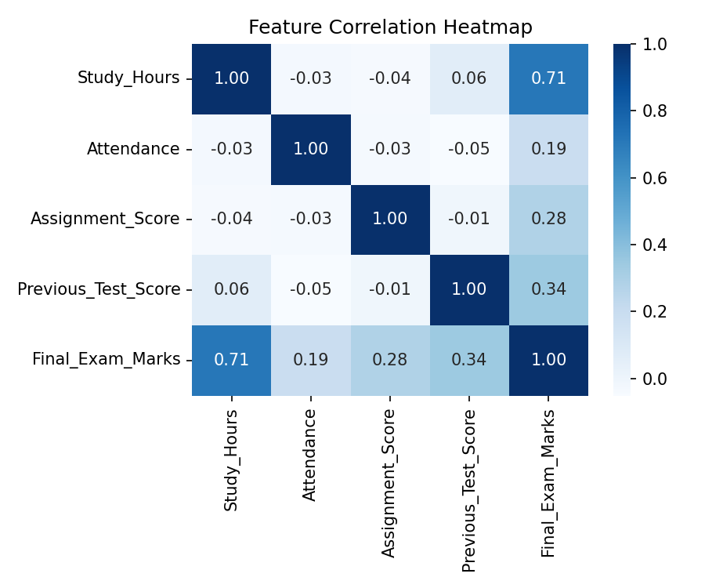
Figure 1: Feature correlation heatmap
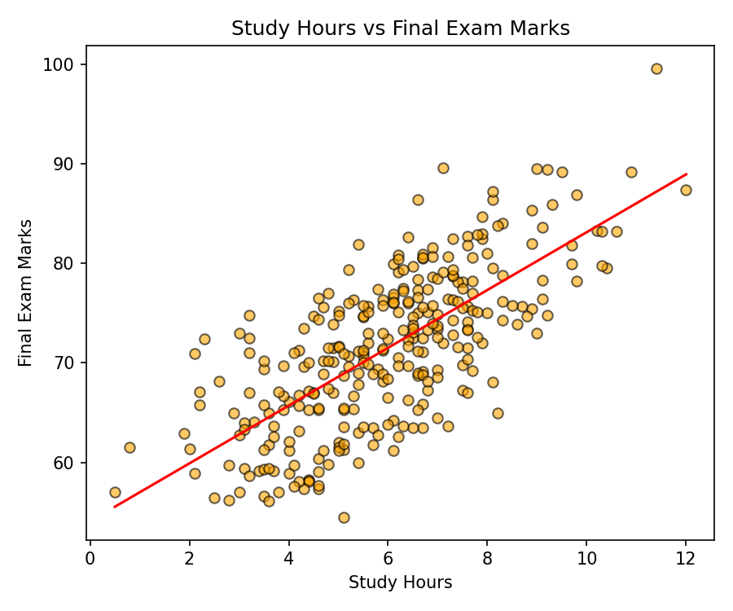
Figure 2: Study Hours vs Final Exam Marks with fitted trend line

7. Model Training & Source Code
A Linear Regression model (scikit-learn) was trained on 80% of the data and evaluated on the remaining 20%. Key code:
X = df[['Study_Hours','Attendance','Assignment_Score','Previous_Test_Score']]
y = df['Final_Exam_Marks']
X_train, X_test, y_train, y_test = train_test_split(X, y, test_size=0.2, random_state=42)
model = LinearRegression()
model.fit(X_train, y_train)
y_pred = model.predict(X_test)

8. Results & Evaluation
Model coefficients (learned weight of each feature) and performance on the held-out test set:
Feature | Coefficient
Study Hours | 2.9026
Attendance | 0.2080
Assignment Score | 0.2064
Previous Test Score | 0.1910
Intercept | 7.9471

Metric | Value
MAE (Mean Absolute Error) | 3.211
MSE (Mean Squared Error) | 16.401
RMSE (Root Mean Squared Error) | 4.050
R² Score | 0.696

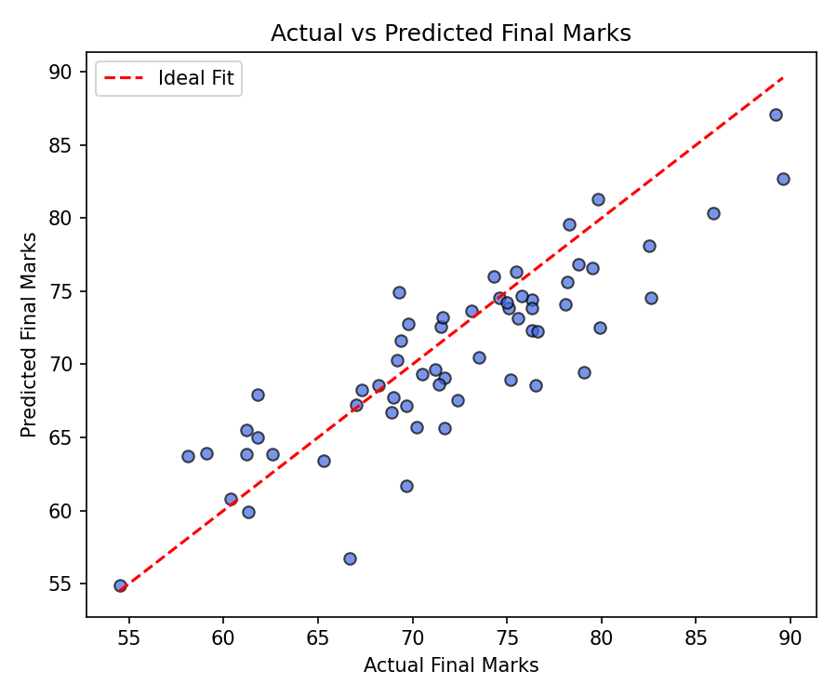
Figure 3: Actual vs Predicted final marks on the test set
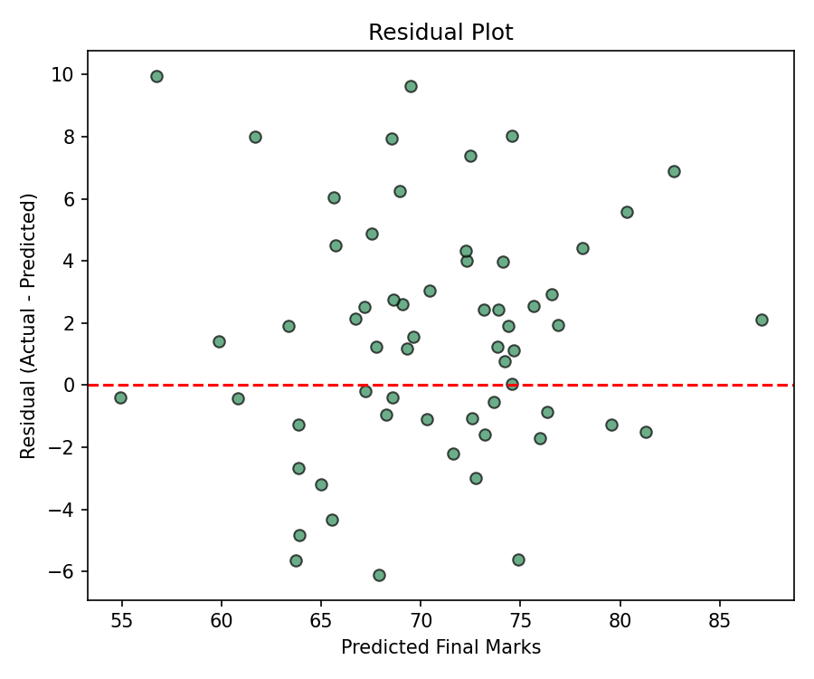
Figure 4: Residual plot — errors are centered around zero with no strong pattern

9. Sample Prediction
For a new student with the following inputs, the trained model predicts:
Input | Value
Study Hours | 7
Attendance | 90%
Assignment Score | 85
Previous Test Score | 78
Predicted Final Marks | 79.43

10. Applications
- Student performance prediction
- Academic progress analysis
- Early identification of weak students
- Educational decision support and counseling

11. Advantages & Limitations

Advantages
- Simple, fast to train and interpret
- Good baseline model for continuous value prediction

Limitations
- Assumes a linear relationship between features and target
- Sensitive to outliers
- Accuracy limited on complex, non-linear patterns

12. Conclusion
The Linear Regression model achieved an R² score of 0.696 on the test set, indicating that the four academic features explain roughly 70% of the variation in final exam marks, with a typical prediction error (RMSE) of about 4 marks. Study hours emerged as the strongest predictor. The project demonstrates a complete regression workflow — from data preprocessing to model evaluation — and confirms Linear Regression as an effective, interpretable baseline for academic performance prediction.

13. References
1. Gareth James, Daniela Witten, Trevor Hastie, Robert Tibshirani — An Introduction to Statistical Learning, Springer.
2. Aurélien Géron — Hands-On Machine Learning with Scikit-Learn, Keras & TensorFlow, O'Reilly.
3. Scikit-learn Documentation — https://scikit-learn.org

