Abdul:

Functions:

* Print(“hello”)
* Input(“ “)
* range(1,5)
* list(
* len(
* int(“25”)
* max(l1)

built in function

def print (<input parameters>):

return result (output)

def range(start,stop,step):

return result

* Function is a piece of code which performs specific tasks
* Own functions

def fun1(<parameters>):

return result

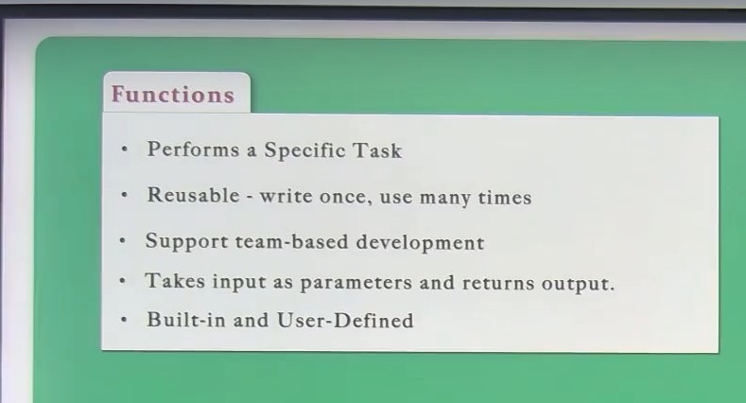

How to write a function: