Loops:

* While loop
* For Loop

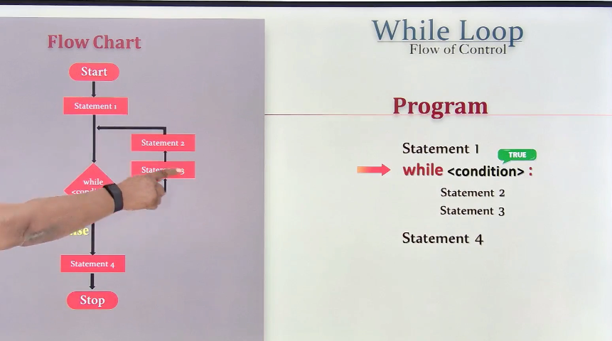

n=5

while n>0:

    print(n)

    n=n-1

#  5 4 3 2 1

Logic using while loop:

* Counter:

I=0

# digits of a number

n=2546

# r = 2546 % 10

# n = 2546 //10

sum=0

while n>0:

    r = n % 10

    # print(r)

    sum=sum+r

    n = n // 10 (inteer division)

print(sum)

##############3333

i=0

n=2546

while n>0:

    i=i+1

    n = n // 10  # (inteer division)

print(i)

######### sum of digits

# Reverse a number

# n = 1257

# r = 7521

n=1257

rev=0

while n>0:

    r= n%10

    rev=rev*10+r

    n=n//10

print(rev)  # Output: 7521

if (n==rev):

    print("Palindrome")

$ python Logic_3.py

7521

SUMMATION LOGIC:

First of 5 natural numbers:

i=0

sum=0

n=5

while i<n:

    i=i+1

    sum=sum+i

print(sum)

#15

SUM of given numbers:

n=5

i=1

sum=0

while i<=n:

    num=int(eval(input("Enter a number: ")))

    i=i+1

    sum=sum+num

print(sum)

Max/MIN:

n=5

i=0

max=float('-inf')  # Initialize max to the smallest possible value

min=float('inf')  # Initialize min to the largest possible value

while i<n:

    i=i+1

    num=int(eval(input("Enter a number: ")))

    if num>max:

        max=num

    if num<min:

        min=num

print(max)

print(min)

$ python Logic5.py

Enter a number: 3

Enter a number: 4

Enter a number: 5

Enter a number: 6

Enter a number: 1

6

1

Infinite Loop:🡪 Break and Continue

* Infinite Loop
* Break
* Continue

i=0

while True:

    i = i + 1

    if i > 5:

        break

    print(i)

1

2

3

4

5

i=0

while i<10:

    i=i+1

    if i%3==0:

        continue

    print(i)

1

2

4

5

7

8

10

Else suite-While:

If loop terminated unsuccessfully else will execute.

For var in sequence:

Statement

FOR Loop:

range(5)

# 0,1,2,3,4

rane(1,5)

# 1,2,3,4

range(6,11)

# 6,7,8,9,10

rane(0,10,2)

# 0,2,4,6,8

rane(-5,-1)

# -5,-4,-3,-2

rane(-2,3)

# -2,-1,0,1,2

range(10,5,-1)

# 10,9,8,7,6

for i in range(5):

    print(i)

# 0 1 2 3 4

for i in range(5):

    print(i)

# 0 1 2 3 4

s1="python"

for i in s1:

    print(i)

# python

for i in range(len(s1)):

    print(s1[i])

# python

Factorial:

Sum of natural numbers:

n=5

sum=0

for i in range(1,n+1):

    sum=sum+i

print(sum)

#15

Fact:

fact=1

n=5

for i in range(1,n+1):

    fact=fact*i

print(fact)

FInonacci series:

n1=0

n2=1

n=8

print(n1)

print(n2)

for i in range(n+1):

    n3=n1+n2

    print(n3)

    n1=n2

    n2=n3

$ python for_2.py

0

1

1

2

3

5

8

13

21

34

55

FACTORS of a number:

#factors

n=int(eval(input('Enter a number: ')))

i=1

count=0

for i in range(1,n+1):

    if n % i == 0:

        count=count+1

if(count==2):

    print('Prime number')

else:

    print('Not a prime number')

More about for loop

Break

Continue

Pass

Else suite

Continue:

Pass:

for i in range(0,10):

    pass

ELSE Suite:

NESTED LOOPS

for i in range(1,n+1):

    count=0

    for j in range(1,i+1):

        if i % j == 0:

            count=count+1

    if count==2:

        print(i,end=' ')

Patterns:

Code 1:

n=5

for i in range(1,n+1):

    for j in range(1,n+1):

        print("*",end=" ")

    print("\n")

# * * * * *

# * * * * *

# * * * * *

# * * * * *

# * * * * *

Code 2:

n=5

for i in range(1,n+1):

    for j in range(1,i+1):

        print("*",end=' ')

    print("\n")

OR

for i in range(1,n+1):

    for j in range(1,n+1):

        if i>=j:

            print("*",end=' ')

    print("\n")

OR

n=5

for i in range(1,n+1):

    print("*"*i,end=" ")

    print("\n")

# i >=j

# *

# * *

# * * *

#* * * *

#* * * * *

CODE 3:

n=5

for i in range(n,0,-1):

    print(i*"*",end=" ")

    print("\n")

for i in range(n,0,-1):

    for j in range(i):

        print("*",end=" ")

    print("\n")

# * * * * *

# * * * *

# * * *

# * *

# *

CODE 4:

n=5

for i in range(n,0,-1):

    for s in range(1,n-i+1):

        print(" ",end=" ")

    for j in range(i):

        print("*",end=" ")

    print("")

# * * * * *

#   * * * *

#     * * *

#       * *

#         *

OR

for i in range(1,n+1):

    print(" "*(i-1),end=" ")

    print("*"*(n-(i-1)))

#  *****

#   ****

#    ***

#     **

# *

Match Case:

dayNo=int(input("Enter a day number"))

if dayNo == 0:

    print("Monday")

elif dayNo == 1:

    print("Tuesday")

elif dayNo == 2:

    print("Wednesday")

elif dayNo == 3:

    print("Thrusday")

elif dayNo == 4:

    print("Friday")

elif dayNo == 5:

    print("Saturday")

elif dayNo == 6:

    print("Sunday")

else:

    print("Invalid day")

OR

day = 4

match day:

  case 1:

    print("Monday")

  case 2:

    print("Tuesday")

  case 3:

    print("Wednesday")

  case 4:

    print("Thursday")

  case 5:

    print("Friday")

  case 6:

    print("Saturday")

  case 7:

    print("Sunday")