OPERATORS:

Artihmetic operators:

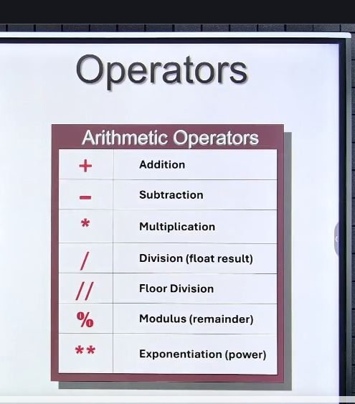

a=10

b=15

c=a+b

(a,b are operand)

+ 🡪 operator

1. Substraction

a=20

b=15

c=a-b=5

c=b-a=-5

iii.

a=4

b=7

c=a*b

c=28

iv.

floor division and modules

// and %

Integer division

a=14

b=4

c=a//b

d=a%b

c=4

d=2

v. /

c= 14/4 (Float division)

c=3.5

vi. ** (exponent)

2**5=32

Prog:

a=14

b=4

print(a+b)

#18

print(a-b)

#10

print(a*b)

#56

print(a//b)

#3

print(a%b)

#2

print(a/b)

#3.5

print(2**5)

#32

Expressions:

1. What are expressions
2. Precedence of operators
3. Associativity of operators
4. Importance of parenthesis

X=4+3+5 =🡺 12

X=2+3*5 ==🡺 25 ? 17

LR🡪 Left to right

RL🡪 Right to left

X=2+3*5 -----------🡪 RL

(10) +(11)🡪 Precedence

i.i. x=5+2*3-8/2

x= 5+ (6) –(4)==7

(3 ) ( 1) ( 2 )

1. 2**3**2

RL

2**(3 ** 2)

2**9=512

Iv/ Parantensis

5+2*6-4/2

5 + 12 + 4/2

5 + 12 -2 ===🡺 15

* (((5+2) * (6-4)) /2)
* (7*(6-4))/2
* 14/2=7

How to write a program using expression:

1. Program to find area of rectangle

breadth * length

progr:

length=eval(input("Enter length of the triangle.........."))

breadth=eval(input("Enter breadth of the triangle......."))

area=length*breadth

print("area of the triangle is .....",area)

output:

Enter length of the triangle..........6

Enter breadth of the triangle.......8

area of the triangle is ..... 48

Challenges using expression:

Triangle:

area=eval(input("Enter area of the triangle.......... "))

height=eval(input("Enter height of the triangle....... "))

base=(area*height)/2

print("Base of the triangle is ....",base)

# output:

# $ python expressions_challenge.py

# Enter area of the triangle.......... 10

# Enter height of the triangle....... 5

# Base of the triangle is .... 25.0

Ttrapezium

#Area of trapezium

# area =1/2 * (a + b) * h

a=5

b=10

h=7

area=1/2* (a+b) *h

print("Area:",area)

#Area: 52.5

AREA of Circle:

import math

radius=eval(input("Enter radius of the circle.......... "))

area=math.pi * radius * radius

print("Area of the circle is ....", area)

# $ python expressions_challenge.py

# Enter radius of the circle.......... 1-

# Area of the circle is .... 314.1592653589793

KMS to MILES

# kms to miles

# 1 km = 0.621371 miles

kilometers = 15

miles = kilometers * 0.621371

print("Miles:", miles)

# Miles: 9.320565

DISPLACEMENT:

# displacement

#d=( v * v  -  u * u ) / (2 * a)

u=4

v=6

a=3

d=(v*v - u*u) / (2 * a)  # assuming a = -5 for deceleration

print("Displacement:", d)

# Displacement: 3.3333333333333335

Surface of a Cubiod:

Total Area=2*( l*h + l*b + b* h)

# Surace area of cubiod

# surface_area = 2 * (length * breadth + breadth * height + height * length)

length  = 10

breadth = 5

height  = 7

surface_area = 2 * (length * breadth + breadth * height + height * length)

print("Surface area of the cuboid is:", surface_area)

# 310

Finding roots of Quadratic Equation:

import math

a=1

b=-5

c=6

# x1=  (-b-(b*b - 4 * a * c))/(2 * a)

# x2=  (-b+(b*b - 4 * a * c))/(2 * a)

x1= (-b - math.sqrt(b*b - 4*a*c))/(2*a)

x2= (-b + math.sqrt(b*b - 4*a*c))/(2*a)

print(x1,x2)

#2.0,3.0

Arithmetic Assignment:

String concatenation and repetition:

Revising arithmetic operator : +,-,*,/,//,%

String concatenation and Repetition

String : +,*

Integer

Float

Boolean

Complex

Artithmetic with all datatypes

Resultnat datatype of expressions

Datatypes:

Integer

Float: all operators are works

* // , %

Boolean:

All operators are works here

Complex:

Except // , % all operators will works

RESULTANT Datatype of expression

* The resultant ill be highest datatype

print(True+True)

#2

print(True+5)

#6

print(True+2.4)

#3.4

print(3+(2+3j))

#5+3j

print(True+3+4.5+(2+3j))

#(10.5+3j)

# bool << int << float << complex