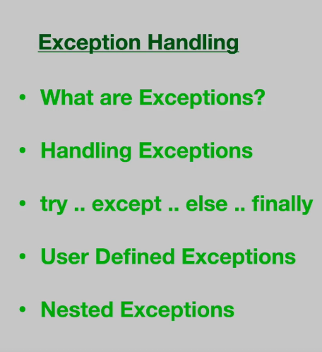

Types of Errors:

- Syntax Error
- Logical Errors
- Runtime Errors
# Syntax Error
a=input("Enter A:")
b=input("Enter B)

# Output: b=input("Enter B) ^
# SyntaxError: unterminated string literal (detected at line 6)

b. Logical Errors

a=input("Enter A:")
b=input("Enter B:")

if a>b:
print(a)
else:
print(a)

# Output:
# a=10
# b=20

#Output:
# 10 (But the answer should be 20)

# else:
# print(a)

3. Run time Error:
# Runtime Error:
# Type Error
# Zero Division Error

a=input("Enter A:")
b=input("Enter B:")

c=a//b

print(c)

#output:
# Enter A:5
# Enter B:ERROR!
# 10
# Traceback (most recent call last):
# File "<main.py>", line 7, in <module>
# TypeError: unsupported operand type(s) for //: 'str' and 'str'

a=input("Enter A:")
b=input("Enter B:")

c=a//b

print(c)

#output 1:
# Enter A:10
# Enter B:5
# 2

#output 2:
# Enter A:10
# Enter B:0
# ERROR!
# Traceback (most recent call last):
# File "<main.py>", line 7, in <module>
# ZeroDivisionError: integer division or modulo by zero

Whom should handle Errors:
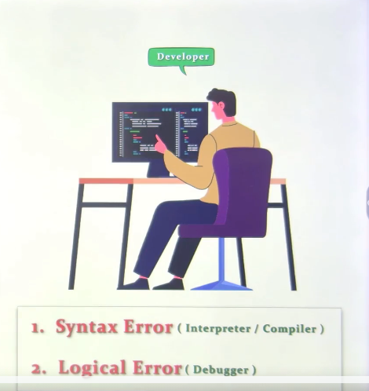

3. Runtime error

a. User input
b. File Access (File not found)
c. Data base connection
d. Internet connection
e. Peripherals

Examples of Exceptions:
Runtime errors:

a=10
b=2
c=a//b
print(c)

ZERO DIVISION ERROR:

#5
a=10
b=0
c=a//b
print(c)
# File "<main.py>", line 12, in <module>
# ZeroDivisionError: integer division or modulo by zero

################ 2 TypeError
a=10
b='x'

c=a//b

print(c)

# TypeError: unsupported operand type(s) for //: 'int' and 'str'

######### 3 Index Error

L1=[3,6,9,12,15]
print(L1[0])
# 3

print(L1[6])

#IndexError: list index out of range

############### 4
d={1:"one",2:"two",3:"three"}

print(d[5])

# KeyError: 5

############## 5

int('xyz')
# ValueError: invalid literal for int() with base 10: 'xyz'

######################### Syntax Error

int('xyz)
# SyntaxError: unterminated string literal (detected at line 67)

Exception Handling:
-----------------------------
Try
Except
else
Finally

Prog 1:
# try / Except / Else / Finally
### Prog 1
a,b=10,0
try:
c=a//b
print(c)
except:
print("Error")
print("end")

# a,b=10,2
# 5
# end

Output 2:
# a=10,b=0
# error
# end

# Prog 2

L=[10,20,30,40,50]

try:
index=int(input("Enter Index"))
print(L[index])
except:
print("Index Error")

print("End of program")

# Enter Index: 8
# Index Error
# End of program

Multiple Exception:
--------------------------------

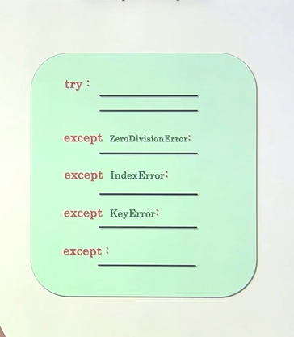

L=[10,20,30,40,50]
try:
index=int('abc')
print(L[index])
except (IndexError,TypeError,ValueError) as msg:
print(msg)
print("End of program")

Output:
invalid literal for int() with base 10: 'abc'
End of program

