**Neha Shet**

**UTA ID - 1001417919**

1) Programming Language used - Python

2) Environment - Linux machine (Omega sever).

3) IDE:Brackets

3) Steps to run the application:

(a) Enter the path in the command prompt

(b) For server, type this: python filename.py

In this case, python serverThread.py

(c) For client, type this: python filename.py

In this case, python client.py

4) Explanation:

This chat application can have multiple users. The document contains the screenshot of 2 clients and 4 clients chatting flawlessly.

First, run the serverThread program followed by the client program.

After executing the client program, a message will pop up stating to enter the username and the peername.

When you run the client program in the second command prompt and enter the name, it will display that with which user you are currently connected.

The chatting will continue till any of the client stops to respond. If there is no response then, the program will automatically close.

quit command is used, which is used to terminate the communication between the users.

References:

<http://www.bogotobogo.com/python/python_network_programming_tcp_server_client_chat_server_chat_client_select.php>

https://docs.python.org/2/library/socket.html

https://www.tutorialspoint.com/python/

http://www.bogotobogo.com/python/python_network_programming_server_client_file_transfer.php

6) Screen shots:

(a) ServerThread Compilation –

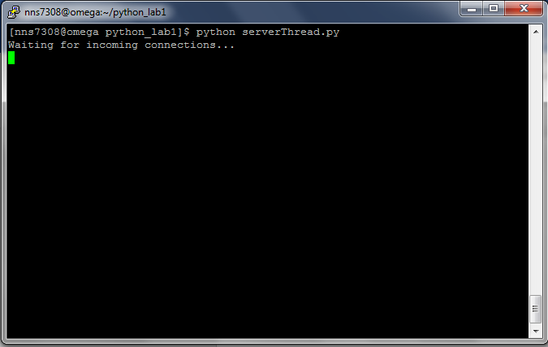

(b) Client compilation-

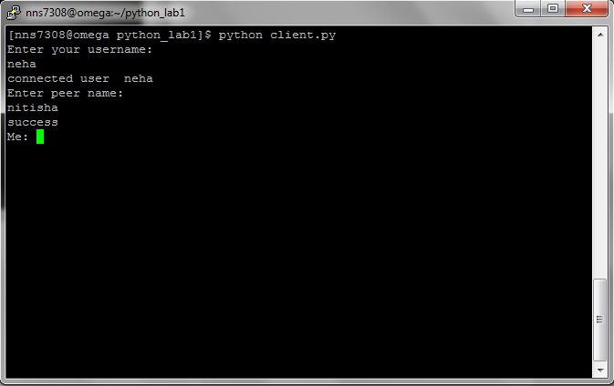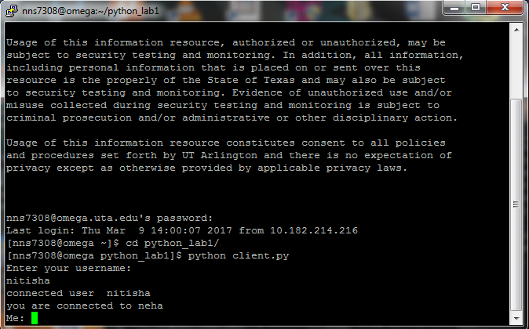

(c) 4 Clients chat:

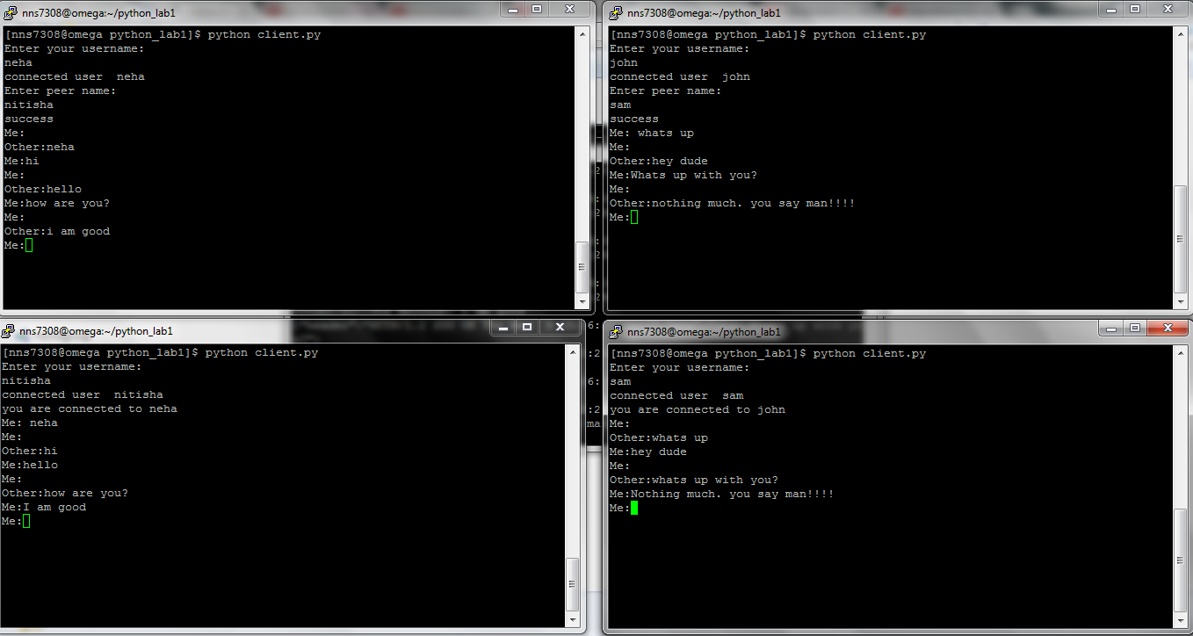

(d) 2 clients chat:

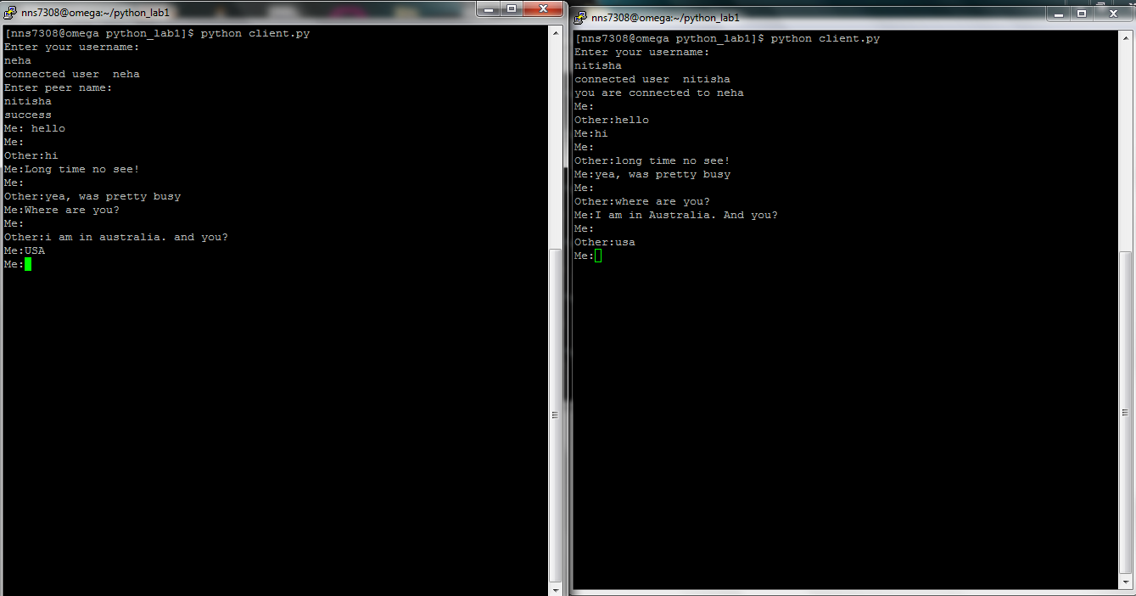

(e) Timeout:

