Design

1. General class diagram

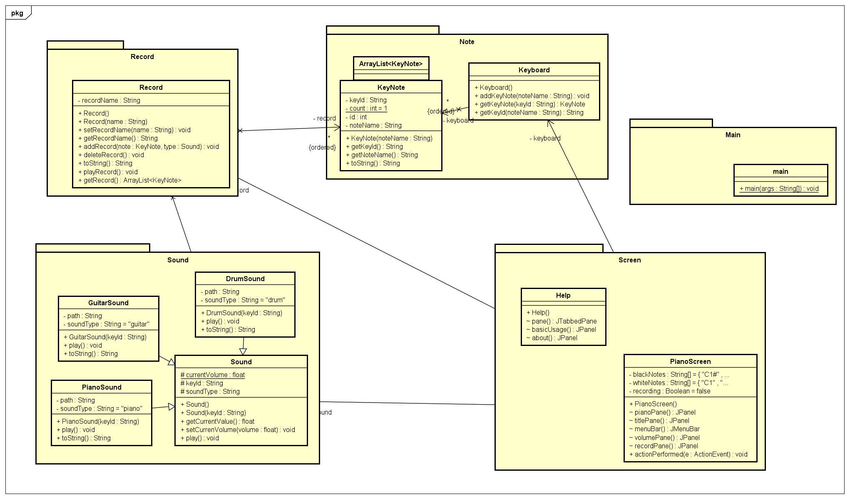

1. Several class diagram

1. Explanation of design

* Class Help and PianoScreen implements JFrame to represent java swingx.

