HỌ VÀ TÊN: NGUYỄN NGỌC THIÊN PHÚC

MSSV: N21DCCN066

LỚP D21CQCNPM01-N

Môn: Xử lý ảnh

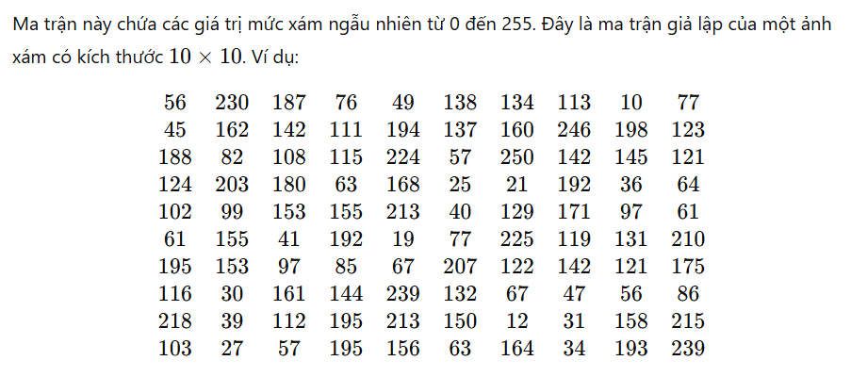

**Bài làm:**

|  |  |  |  |
| --- | --- | --- | --- |
| I | h(i) | CDF(k) | Round |
| 10 | 1 | 0.01 | 3 |
| 12 | 1 | 0.02 | 5 |
| 19 | 1 | 0.03 | 8 |
| 21 | 1 | 0.04 | 10 |
| 25 | 1 | 0.05 | 13 |
| 27 | 1 | 0.06 | 15 |
| 30 | 1 | 0.07 | 18 |
| 31 | 1 | 0.08 | 20 |
| 34 | 1 | 0.09 | 23 |
| 36 | 1 | 0.1 | 26 |
| 39 | 1 | 0.11 | 28 |
| 40 | 1 | 0.12 | 31 |
| 41 | 1 | 0.13 | 33 |
| 45 | 1 | 0.14 | 36 |
| 47 | 1 | 0.15 | 38 |
| 49 | 1 | 0.16 | 41 |
| 56 | 2 | 0.2 | 51 |
| 57 | 2 | 0.22 | 56 |
| 61 | 2 | 0.24 | 61 |
| 63 | 2 | 0.26 | 66 |
| 64 | 1 | 0.27 | 69 |
| 67 | 2 | 0.29 | 74 |
| 76 | 1 | 0.3 | 77 |
| 77 | 2 | 0.32 | 82 |
| 82 | 1 | 0.33 | 84 |
| 85 | 1 | 0.34 | 87 |
| 86 | 1 | 0.35 | 89 |
| 97 | 2 | 0.37 | 94 |
| 99 | 1 | 0.38 | 97 |
| 102 | 1 | 0.39 | 99 |
| 103 | 1 | 0.4 | 102 |
| 108 | 1 | 0.41 | 105 |
| 111 | 1 | 0.42 | 107 |
| 112 | 1 | 0.43 | 110 |
| 113 | 1 | 0.44 | 112 |
| 115 | 1 | 0.45 | 115 |
| 116 | 1 | 0.46 | 117 |
| 119 | 1 | 0.47 | 120 |
| 121 | 2 | 0.49 | 125 |
| 122 | 1 | 0.5 | 128 |
| 123 | 1 | 0.51 | 130 |
| 124 | 1 | 0.52 | 133 |
| 129 | 1 | 0.53 | 135 |
| 131 | 1 | 0.54 | 138 |
| 132 | 1 | 0.55 | 140 |
| 134 | 1 | 0.56 | 143 |
| 137 | 1 | 0.57 | 145 |
| 138 | 1 | 0.58 | 148 |
| 142 | 3 | 0.61 | 156 |
| 144 | 1 | 0.62 | 158 |
| 145 | 1 | 0.63 | 161 |
| 150 | 1 | 0.64 | 163 |
| 155 | 2 | 0.66 | 168 |
| 156 | 1 | 0.67 | 171 |
| 158 | 1 | 0.68 | 173 |
| 160 | 1 | 0.69 | 176 |
| 161 | 1 | 0.7 | 179 |
| 162 | 1 | 0.71 | 181 |
| 164 | 1 | 0.72 | 184 |
| 168 | 1 | 0.73 | 186 |
| 171 | 1 | 0.74 | 189 |
| 175 | 1 | 0.75 | 191 |
| 180 | 1 | 0.76 | 194 |
| 187 | 1 | 0.77 | 196 |
| 188 | 1 | 0.78 | 199 |
| 192 | 2 | 0.8 | 204 |
| 193 | 1 | 0.81 | 207 |
| 194 | 1 | 0.82 | 209 |
| 195 | 3 | 0.85 | 217 |
| 198 | 1 | 0.86 | 219 |
| 203 | 1 | 0.87 | 222 |
| 207 | 1 | 0.88 | 224 |
| 210 | 1 | 0.89 | 227 |
| 213 | 2 | 0.91 | 232 |
| 215 | 1 | 0.92 | 235 |
| 218 | 1 | 0.93 | 237 |
| 224 | 1 | 0.94 | 240 |
| 225 | 1 | 0.95 | 242 |
| 230 | 1 | 0.96 | 245 |
| 239 | 2 | 0.98 | 250 |
| 246 | 1 | 0.99 | 252 |
| 250 | 1 | 1 | 255 |

**Ma trận cũ:**

|  |  |  |  |  |  |  |  |  |  |
| --- | --- | --- | --- | --- | --- | --- | --- | --- | --- |
| 56 | 230 | 187 | 76 | 49 | 138 | 134 | 113 | 10 | 77 |
| 45 | 162 | 142 | 111 | 194 | 137 | 160 | 246 | 198 | 123 |
| 188 | 82 | 108 | 115 | 224 | 57 | 250 | 142 | 145 | 121 |
| 124 | 203 | 180 | 63 | 168 | 25 | 21 | 192 | 36 | 64 |
| 102 | 99 | 153 | 155 | 213 | 40 | 129 | 171 | 97 | 61 |
| 61 | 155 | 41 | 192 | 19 | 77 | 225 | 119 | 131 | 210 |
| 195 | 153 | 97 | 85 | 67 | 207 | 122 | 142 | 121 | 175 |
| 116 | 30 | 161 | 144 | 239 | 132 | 67 | 47 | 56 | 86 |
| 218 | 39 | 112 | 195 | 213 | 150 | 12 | 31 | 158 | 215 |
| 103 | 27 | 57 | 195 | 156 | 63 | 164 | 34 | 193 | 239 |

**Ma trận mới:**

|  |  |  |  |  |  |  |  |  |  |
| --- | --- | --- | --- | --- | --- | --- | --- | --- | --- |
| 45 | 244 | 196 | 71 | 40 | 142 | 137 | 107 | 2 | 76 |
| 35 | 181 | 150 | 102 | 209 | 140 | 175 | 252 | 219 | 124 |
| 198 | 79 | 99 | 109 | 239 | 51 | 255 | 150 | 155 | 119 |
| 127 | 121 | 193 | 61 | 186 | 12 | 10 | 204 | 25 | 63 |
| 94 | 91 | 163 | 168 | 232 | 30 | 130 | 188 | 89 | 56 |
| 56 | 168 | 33 | 204 | 7 | 76 | 242 | 114 | 132 | 226 |
| 216 | 163 | 89 | 81 | 68 | 224 | 122 | 150 | 119 | 191 |
| 112 | 17 | 178 | 153 | 249 | 135 | 68 | 38 | 45 | 84 |
| 237 | 28 | 104 | 216 | 232 | 158 | 5 | 20 | 173 | 234 |
| 96 | 15 | 51 | 216 | 170 | 61 | 183 | 22 | 206 | 249 |