Vietnam DOOH Advertiser Spending Analysis
Who's Paying the Most Money into Digital Out-of-Home Advertising

Report Date: December 2, 2025
Market Focus: Vietnam DOOH Advertising Buyers & Spending Patterns
Time Period: 2024-2025 Market Intelligence

KEY MARKET METRICS
Total Market Size (2025): USD $129.58 Million
Market Growth Rate: 5.74% - 12.54% CAGR
Top Spending Category: Retail & Consumer Goods (44.49%)
Fastest Growing Sector: Telecom & Technology (7.04% CAGR)
Geographic Concentration: HCMC + Hanoi (60-70% of spend)

Executive Summary
This report provides detailed intelligence on advertiser spending in Vietnam's Digital Out-of-Home (DOOH) advertising market, identifying top spenders, budget allocations, and buyer behavior patterns.

Key Findings
- Retail & Consumer Goods dominate with 44.49% market share
- FMCG commands 33.71% of digital advertising spend
- 91 of Vietnam's top 100 companies actively invest in DOOH
- Total market size: USD $129.58M (2025) growing to $171.29M (2030)
- Geographic concentration: HCMC and Hanoi capture majority of spending
- Digital DOOH growing at 12.54% CAGR, significantly outpacing static formats
- Programmatic adoption driving 61.8% revenue uplift for major operators

1. Industry Spending Analysis
The Vietnam DOOH market shows clear industry concentration, with Retail and FMCG sectors accounting for nearly 78% of total advertising spending. This dominance reflects the strategic importance of physical presence and point-of-sale marketing in Vietnam's evolving retail landscape.

Figure 1: Industry Market Share Distribution
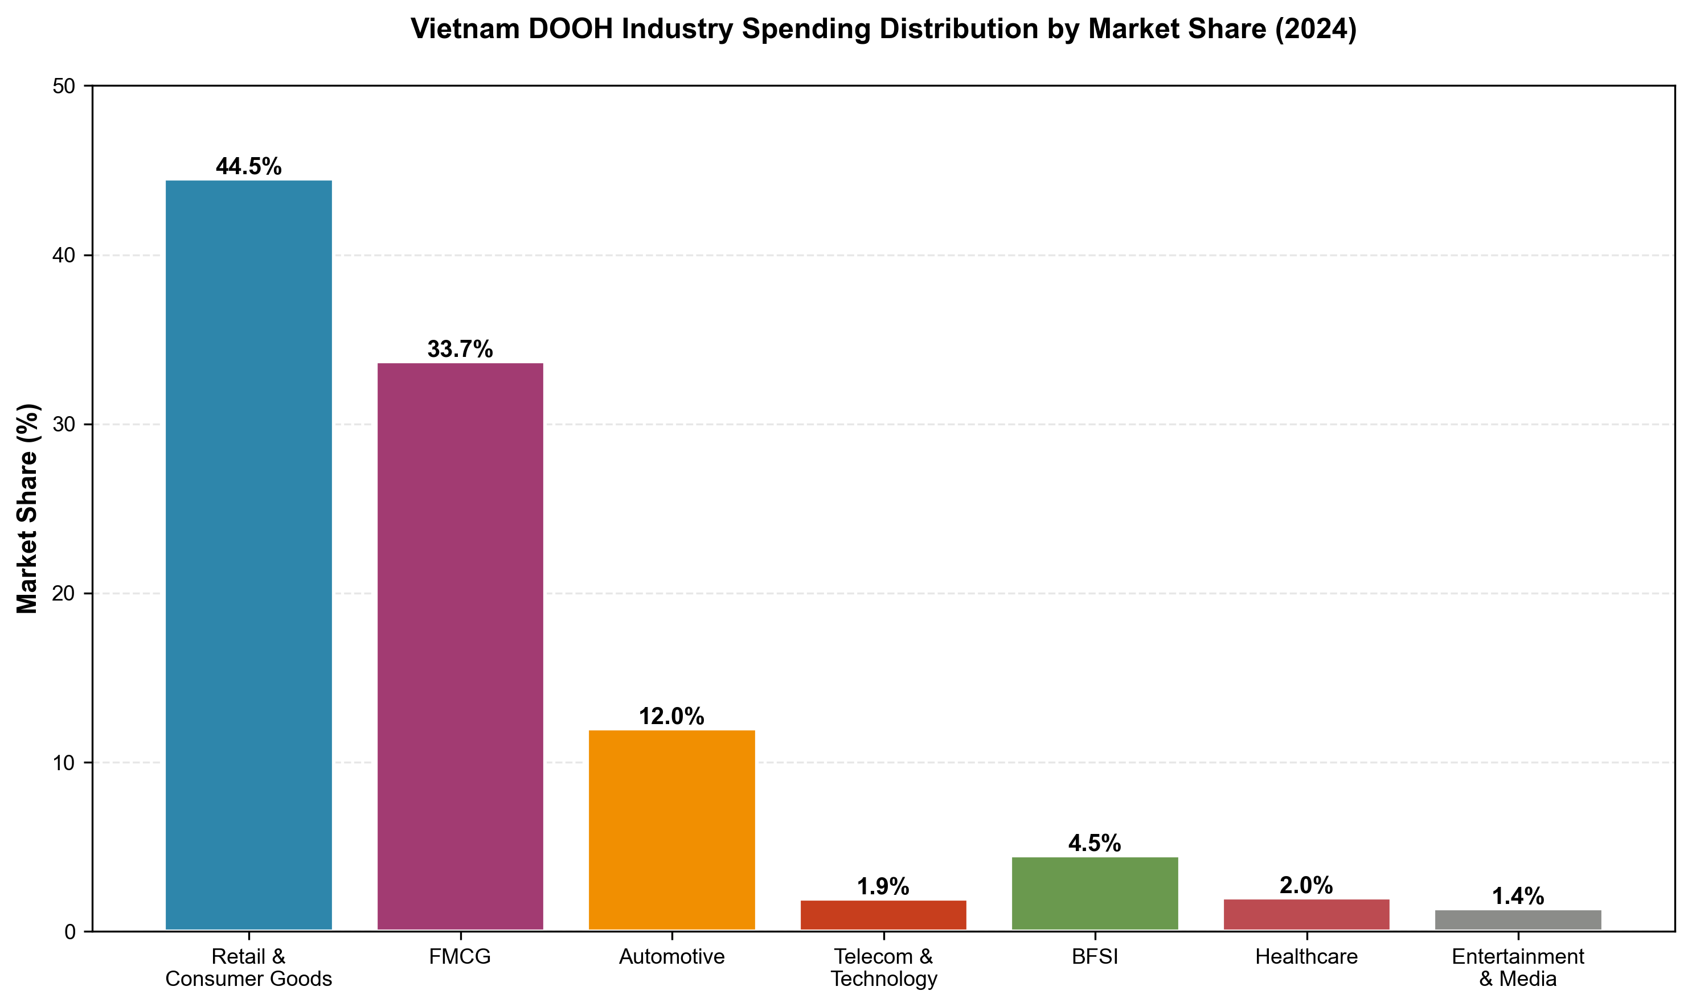
Figure 1: Industry spending distribution showing Retail & Consumer Goods dominance at 44.49%, followed by FMCG at 33.71%. These two sectors represent the majority of DOOH investment.

Key Insights: Industry Concentration
- Retail & Consumer Goods (44.49%): Largest spender, driven by e-commerce competition and need for physical store traffic
- FMCG (33.71%): Heavy programmatic adoption enabling same-day creative optimization and audience retargeting
- Automotive (12%): Recording fastest budget increases, fueled by VinFast's domestic EV surge
- Combined Retail + FMCG: Control 78.2% of market, creating significant volume buying power

Figure 2: Annual Budget Allocation by Industry
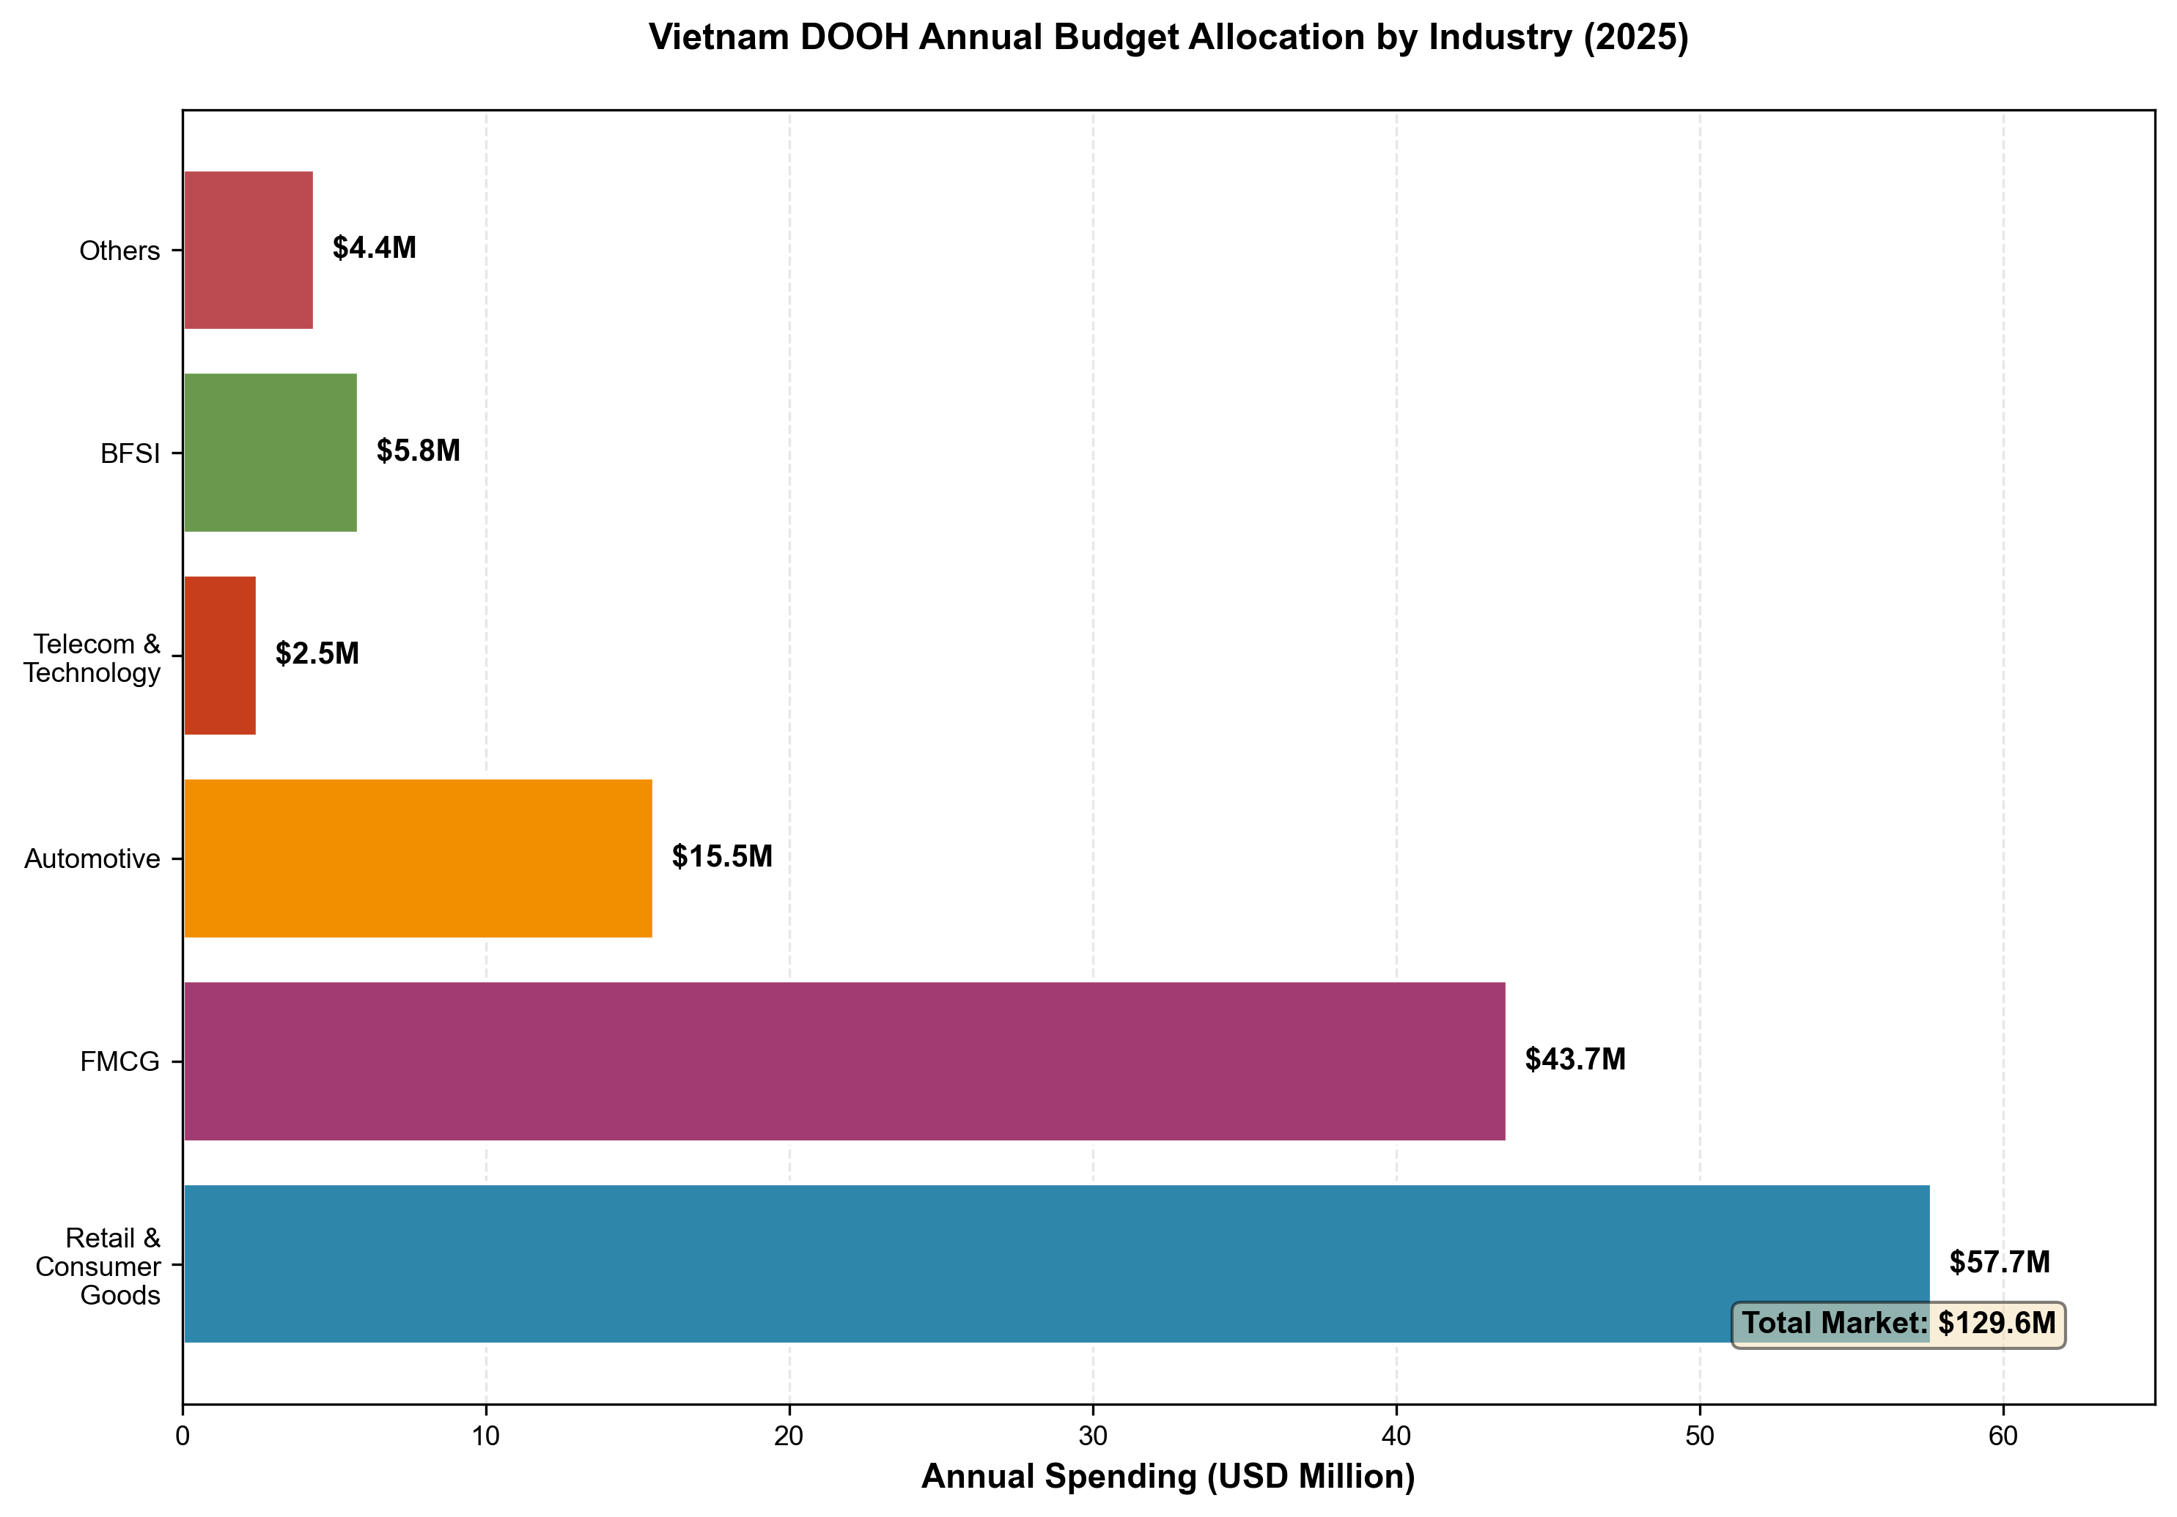
Figure 2: Absolute spending by industry in USD millions, illustrating the significant investment gap between top-tier and emerging sectors.

2. Growth Dynamics and Market Projections
Vietnam's DOOH market demonstrates strong growth momentum across all segments, with digital formats significantly outpacing traditional static billboards. The market is experiencing a fundamental shift toward programmatic buying and data-driven optimization.

Figure 3: Sector Growth Rates Comparison
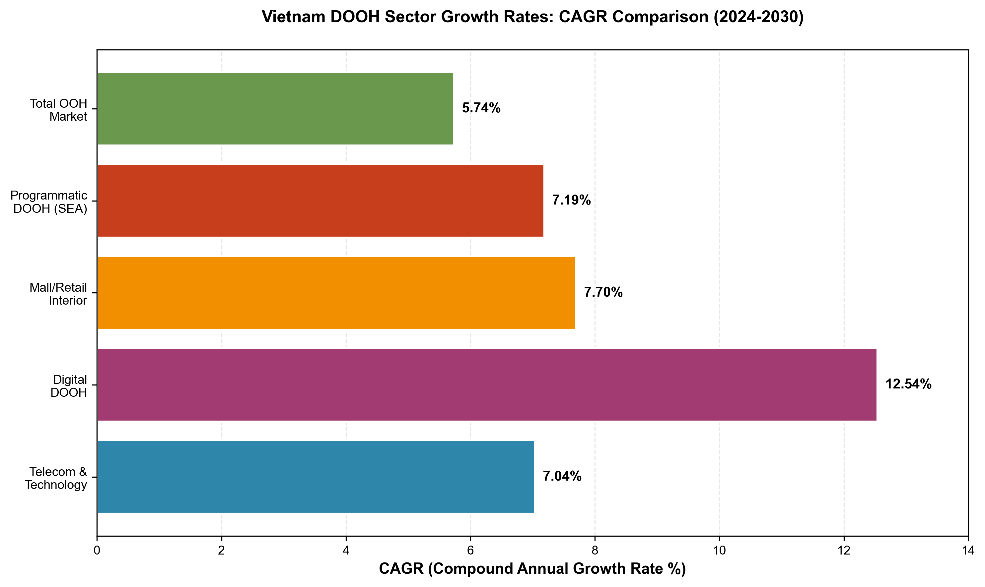
Figure 3: CAGR comparison showing Digital DOOH leading at 12.54%, followed by Mall/Retail Interior and Telecom sectors. All segments outperform the total market average.

Growth Rate Analysis
- Digital DOOH: 12.54% CAGR represents fastest growth trajectory, driven by programmatic capabilities
- Telecom & Technology: 7.04% CAGR fueled by 5G rollout and competitive wars among major operators
- Mall/Retail Interior: 7.70% CAGR reflects growing importance of point-of-sale proximity marketing
- Growth Differential: Digital formats growing 2.5x faster than static, signaling market transformation

Figure 4: Market Size Projections (2024-2030)
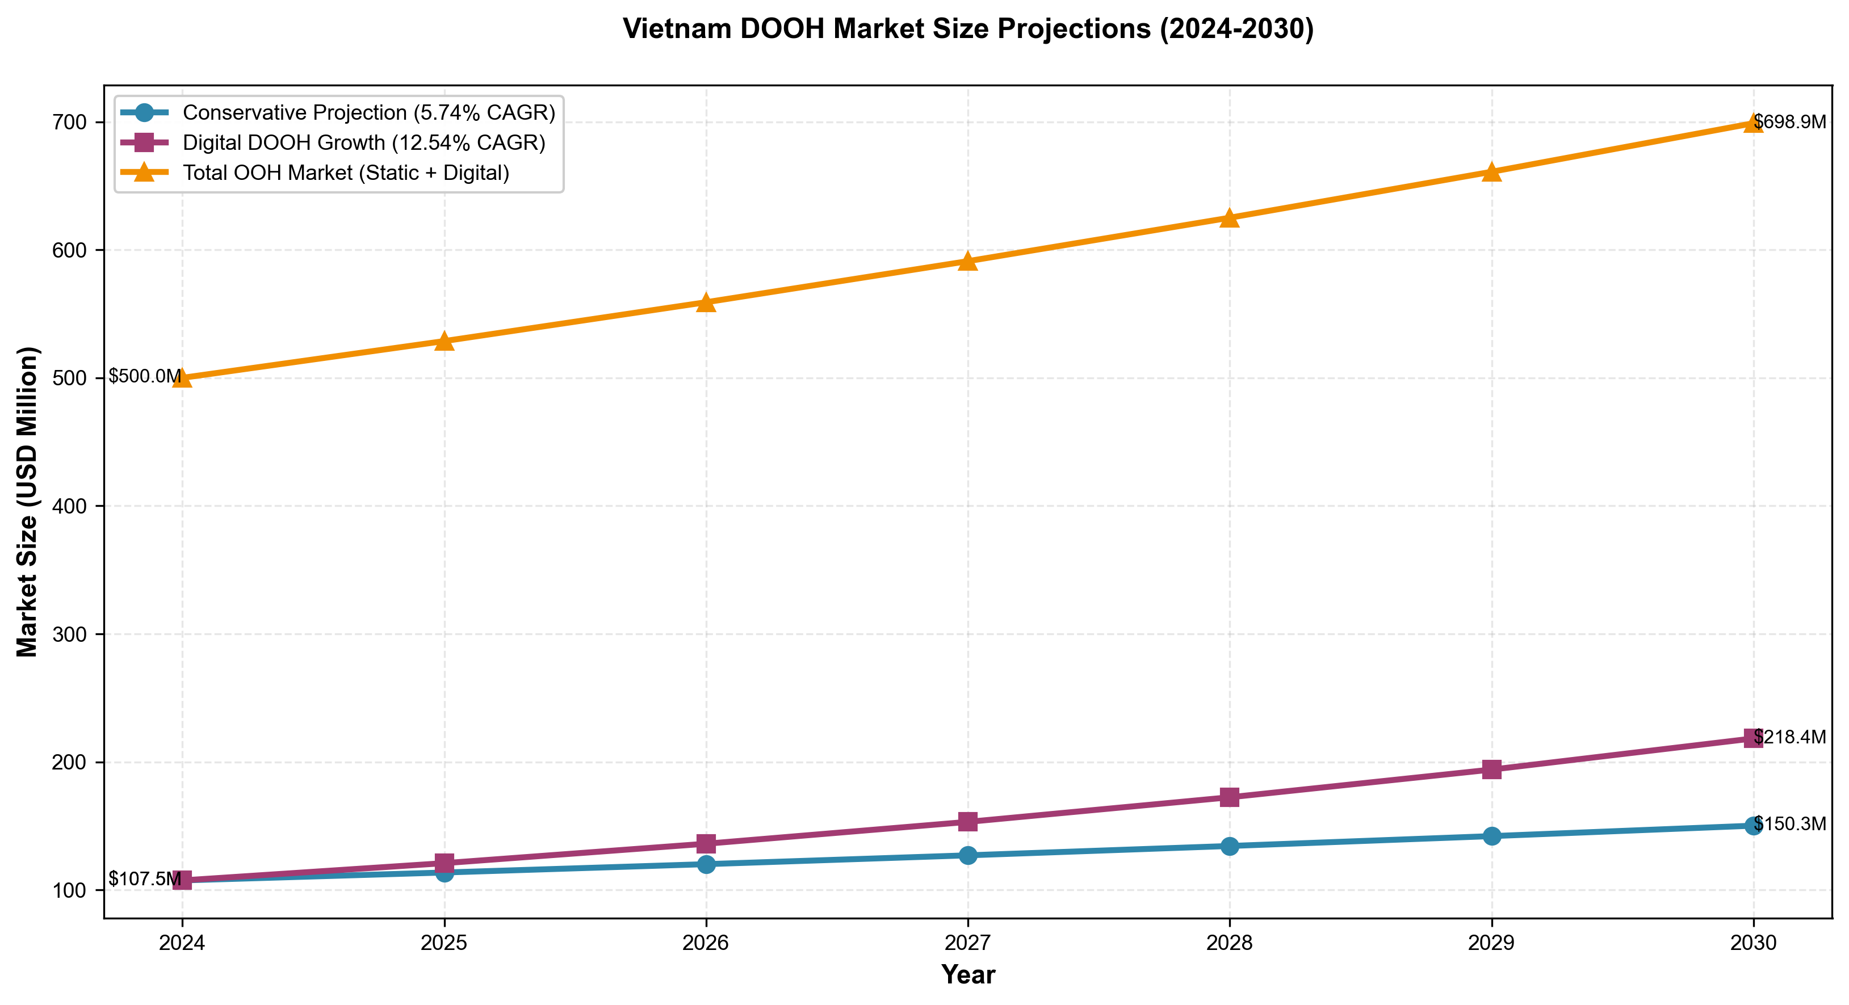
Figure 4: Three projection scenarios showing market evolution. Digital DOOH (12.54% CAGR) demonstrates steepest growth curve, while total market includes both static and digital segments.

Market Evolution 2024-2030
Conservative projections suggest the market will reach $171M by 2030, while more aggressive digital-focused projections indicate potential for $282M if digital adoption accelerates. The most likely scenario places 2030 market size between $200-220M, representing a doubling of current market value.

3. Geographic Spending Patterns
DOOH spending in Vietnam shows pronounced geographic concentration, with Ho Chi Minh City and Hanoi capturing the majority of investment. This concentration reflects infrastructure advantages, population density, and advertiser targeting strategies focused on urban affluent consumers.

Figure 5: Geographic Spending Distribution
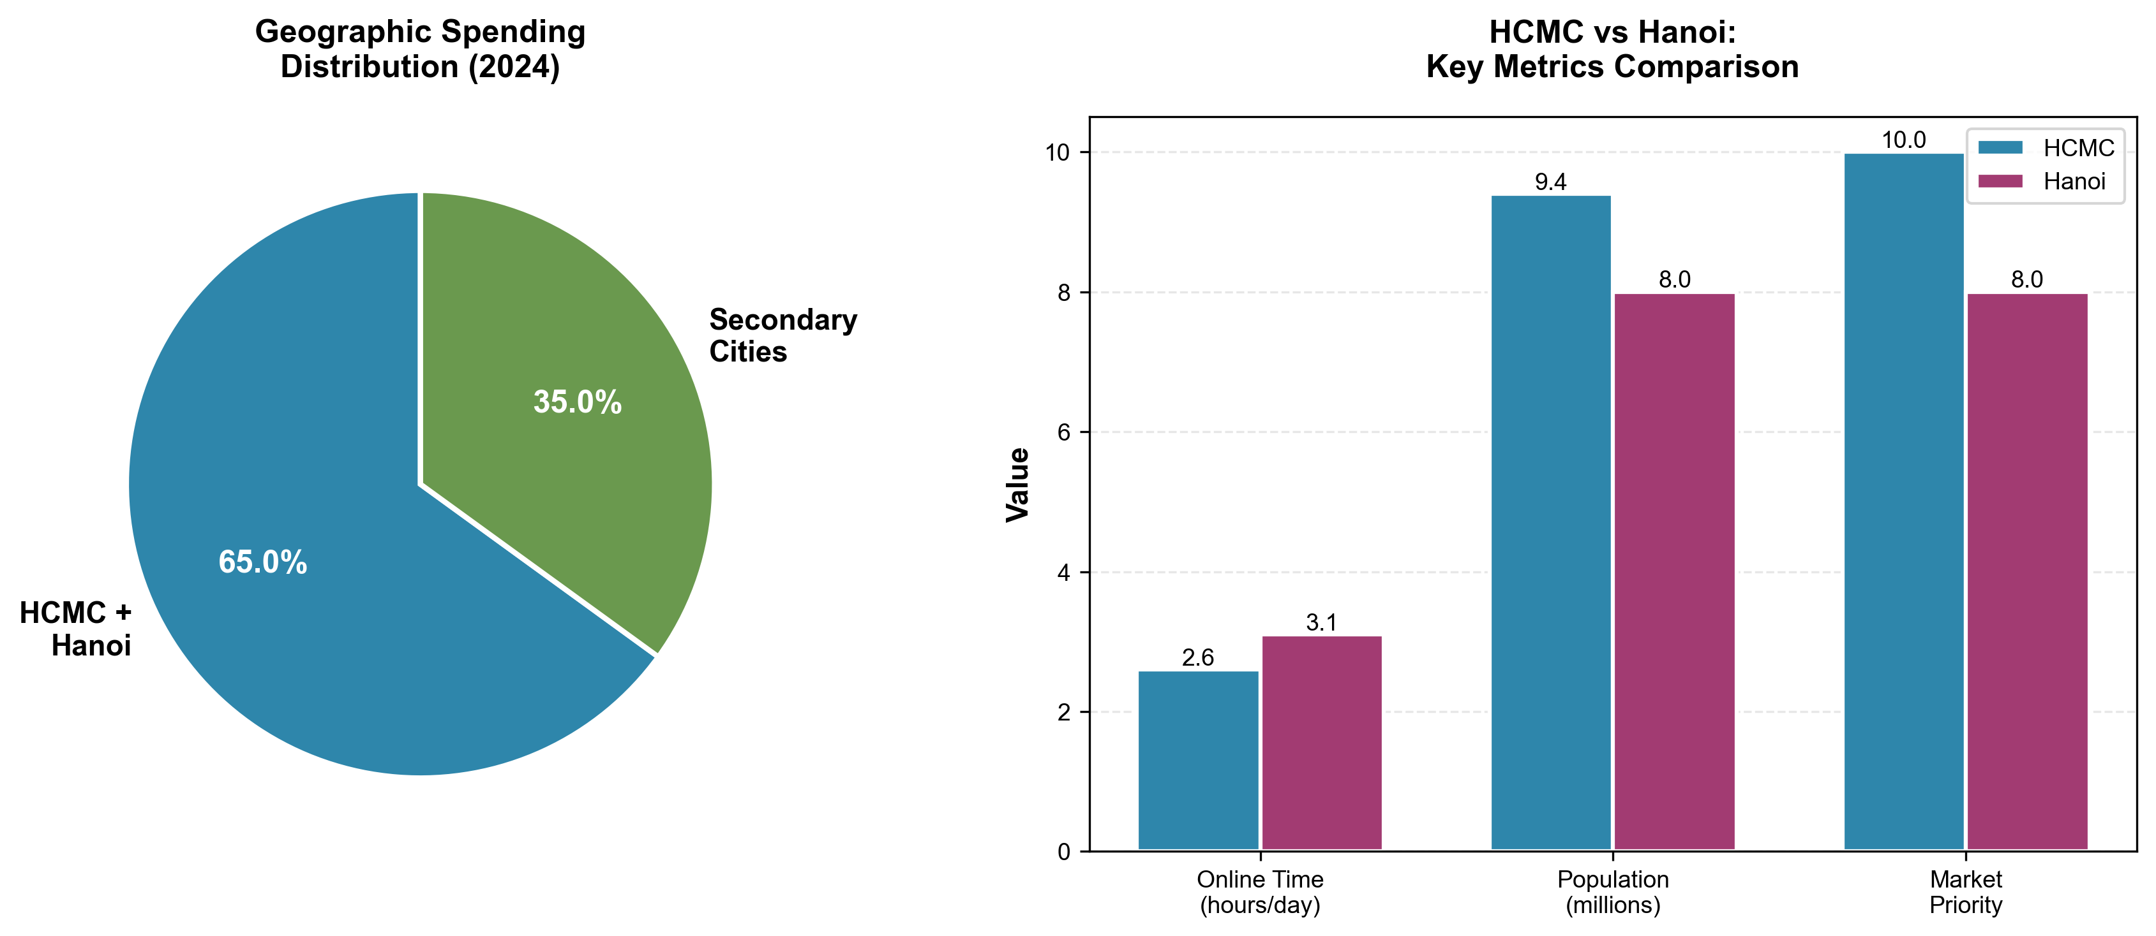
Figure 5: Left panel shows spending concentration in Tier 1 cities (HCMC + Hanoi) at 65%. Right panel compares key metrics between the two primary markets.

HCMC vs. Hanoi: Comparative Analysis
- Spending Volume: HCMC generates higher absolute spending due to larger population (9.4M vs 8.0M) and more developed infrastructure
- Digital Consumption: Hanoi residents spend MORE time online (3.1 hrs/day vs 2.6 hrs/day), showing stronger digital format preference
- Infrastructure: HCMC metro expansion creating hundreds of interior screens; Hanoi's smart city mandates driving municipal building displays
- Advertiser Focus: HCMC favors retail/FMCG campaigns; Hanoi over-indexes on tech/fintech programmatic buying

Secondary Cities: Emerging Opportunities
Da Nang and other Tier 2 cities represent 30-40% of total spending, with lower CPMs enabling volume-based strategies. Static formats retain stronger presence in these markets, though urbanization (6.29% CAGR) is driving gradual digital adoption.

4. Format Preferences: Static vs. Digital
Vietnam's DOOH market remains predominantly static (75.24% share) but is experiencing rapid digital transformation. Digital formats offer programmatic capabilities, real-time optimization, and superior attribution, driving accelerated adoption among sophisticated advertisers.

Figure 6: Static vs. Digital Format Analysis
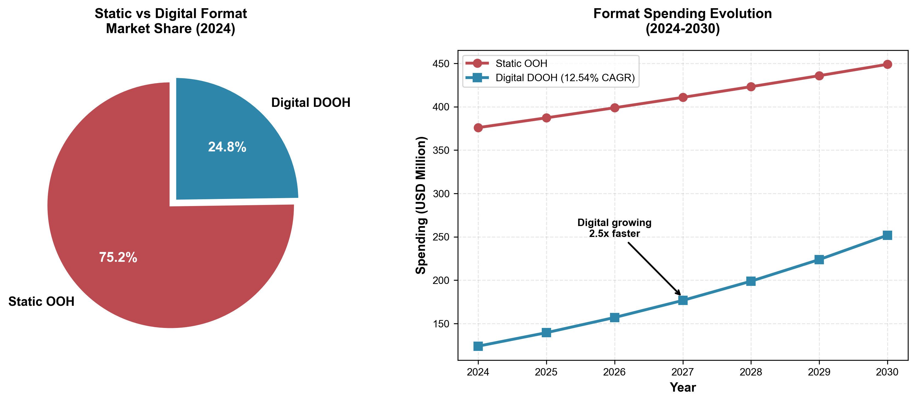
Figure 6: Left panel shows current market share (2024) with static formats dominant. Right panel projects spending evolution, highlighting digital's 2.5x faster growth rate.

Format Transition Dynamics
- Current State: Static OOH maintains 75.24% share, concentrated in highway corridors and suburban locations
- Digital Growth: 12.54% CAGR represents 2.5x faster growth than static, driven by urban concentration and programmatic adoption
- Programmatic Impact: JCDecaux reported 61.8% platform revenue uplift via VIOOH SSP, demonstrating ROI of digital investment
- Investment Shift: Advertisers increasingly gravitating toward "data-rich digital screens" in HCMC and Hanoi

Format Preferences by Advertiser Type
- FMCG Brands: Programmatic-enabled screens for day-of creative optimization and audience retargeting
- Automotive: Highway megaboards (static and digital) for large-format brand building and test-drive promotions
- Retail: Mall interior screens near point-of-sale; complemented by mass-reach roadside billboards
- Telecom/Tech: Interactive metro screens driving app downloads and mobile actions
- Luxury Brands: Premium inventory with sophisticated 3D/CGI capabilities in affluent areas

5. Seasonal Spending Patterns and Evolution
Vietnam's DOOH spending historically concentrated around Tet (Lunar New Year), with spirits brands generating 60% of yearly sales in the 6-week period. However, 2024 marked a significant shift, with traditional Tet campaigns showing 47% year-over-year decline in consumer engagement.

Figure 7: Seasonal Spending Pattern Evolution
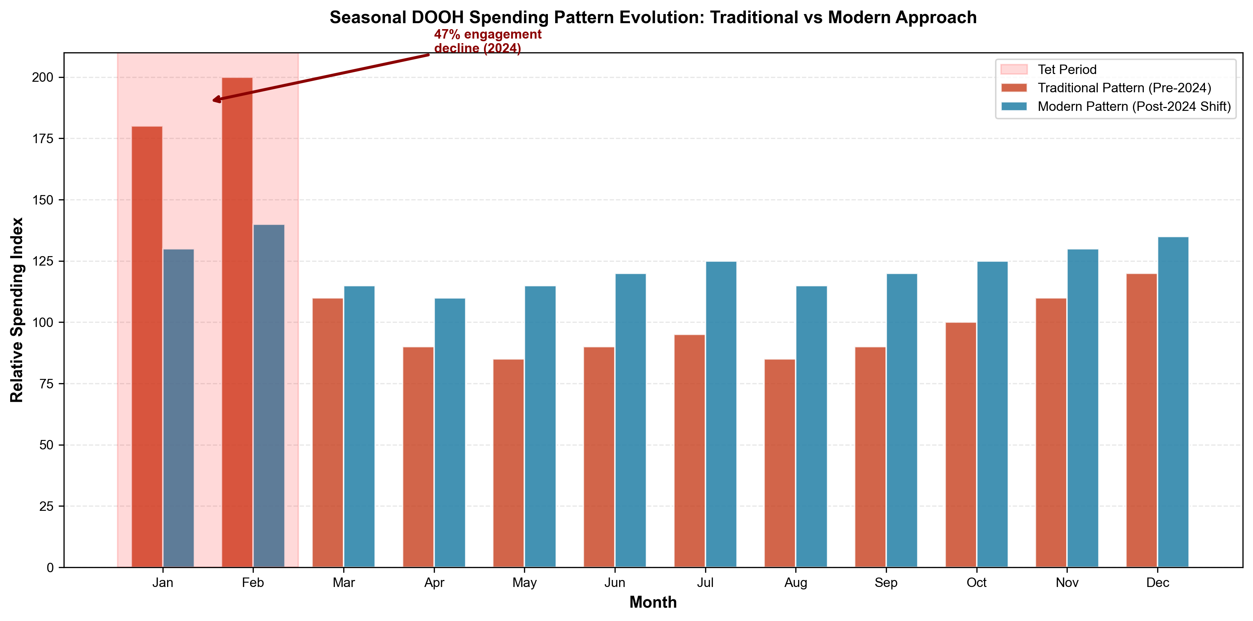
Figure 7: Comparison of traditional Tet-concentrated spending vs. modern year-round optimization. The 2024 shift reflects 47% engagement decline in traditional Tet campaigns.

Strategic Shift: From Seasonal to Continuous
- Traditional Peak: Tet period historically drove 200+ relative spending index, with spirits/beer dominating
- 2024 Disruption: 47% YoY decline in consumer engagement; family reunion discussions down 77.5% on social media
- Modern Approach: Shift to year-round programmatic optimization with real-time creative adaptation
- New Drivers: Weather patterns, local events, traffic patterns, competitive activity, and sales data

Category-Specific Seasonal Patterns
- FMCG: Weather-driven peaks (beverages in hot season), holiday promotional calendars, product launch windows
- Automotive: Model year launches (Q4-Q1), test-drive season coordination, auto show tie-ins
- Retail: Back-to-school, Black Friday (growing adoption), year-end shopping, e-commerce coordination
- Entertainment: Film release calendar synchronization, event-based shorter cycles, tactical high-impact bursts

6. Major Advertisers and Campaign Strategies
91 of Vietnam's top 100 companies by revenue actively invest in DOOH, with over 700 major domestic and foreign brands using the channel. This elite adoption demonstrates DOOH's strategic importance for reaching Vietnam's urban affluent consumers.

Confirmed Heavy DOOH Spenders

Consumer Electronics
OPPO: Ran large-scale elevator advertising campaigns achieving breakthrough success surpassing Samsung in market share. Strategic DOOH deployment credited for market leadership shift.

FMCG & Beverage
- Suntory PepsiCo Vietnam: Active Chicilon Media client with creative elevator media campaigns and programmatic adoption
- Nestle: Major participant in Vietnam DOOH ecosystem, featured in MMA Global forums, multi-format presence
- Heineken: Integrated billboard advertising with Tet seasonal campaigns, +30% beer sales driving seasonal investment

Automotive
VinFast: Nationwide test-drive promotions via highway megaboards, historic Times Square presence (1,000 m² LED display), domestic EV surge fueling massive DOOH investment.

Luxury & Fashion
Calvin Klein: 27-day programmatic DOOH campaign with Moving Walls across 230 screens at 39 sites, generating 1.56 million billable impressions and 713K ad plays. Demonstrates luxury brand adoption of programmatic DOOH capabilities.

Campaign Strategies by Advertiser Type

FMCG Brands
- Tactical Approach: Programmatic buying for agility and day-of creative optimization
- Budget Allocation: Year-round presence with seasonal peaks, programmatic efficiency driving ROI
- Format Focus: Point-of-sale proximity targeting in malls, brand-safe environments for launches

Luxury Brands
- Tactical Approach: Data-driven location targeting, premium inventory in affluent areas, sophisticated 3D/CGI creative
- Budget Characteristics: Willing to pay premium CPMs, longer campaign durations, international coordination

Automotive
- Tactical Approach: Nationwide highway megaboard takeovers, test-drive event coordination, geographic conquest
- Budget Characteristics: Large format investments, model launch spikes, sustained brand presence

7. Key Growth Drivers and Market Dynamics

Primary Growth Catalysts
- Urbanization: Rapid metro expansion in HCMC and Hanoi creating new premium inventory in transit environments
- Smart City Infrastructure: Municipal buildings mandating digital signage, government-driven digital transformation
- Programmatic Adoption: Platforms (ANTS, VIOOH/JCDecaux, Moving Walls) enabling efficiency and real-time buying
- 5G Rollout: Telecom competition fueling ad spend, enhanced interactive capabilities, mobile-to-DOOH integration
- E-commerce Pressure: Retailers fighting back with physical store traffic drivers, omnichannel strategies
- Measurement Improvement: Data-rich screens enabling attribution, programmatic analytics, improved ROI demonstration

DOOH Unique Advantages
- Cannot be blocked (vs. digital ad blockers)
- Contextual relevance during commute/shopping moments
- Premium attention in urban environments
- Programmatic capabilities bridging digital and physical
- Brand safety in controlled environments
- Large format impact impossible in other channels

Market Challenges
- Tet Effectiveness Declining: 47% engagement drop requiring creative innovation beyond traditional messaging
- Measurement Standards Gap: Limited industry-standard metrics, attribution capabilities vary by vendor
- Programmatic Adoption Pace: Ongoing transition from traditional buying, learning curve for stakeholders
- Static to Digital Transition: 75% still static creates inventory risk, capital intensive to convert

8. Actionable Intelligence for Stakeholders

For Media Buyers
- Category Leverage: Retail/FMCG representing 78% of market creates volume discount opportunities
- Programmatic Access Required: Demand ANTS, VIOOH, or Moving Walls connectivity for optimization
- Seasonal Strategy Shift: Don't over-concentrate on Tet; year-round optimization preferred
- Geographic Arbitrage: Balance secondary city reach (lower CPMs) vs. Tier 1 precision (attribution data)
- Measurement Requirements: Demand attribution data, QR integration, store visit tracking, mobile retargeting

For Media Sellers
- Retail Sales Strategy: 44.49% share demands dedicated retail teams with POS attribution capabilities
- Programmatic Imperative: JCDecaux's 61.8% revenue uplift proves ROI; SSP connectivity critical
- Geographic Focus: HCMC + Hanoi = majority revenue; premium pricing justified in Tier 1 cities
- Format Transition: Digital growing 2.5x faster but don't abandon static too quickly; gradual conversion strategy

For Investors/Strategists
- Growth Vector Priority: Digital DOOH at 12.54% CAGR; technology/platform plays preferred over traditional inventory
- Consolidation Opportunity: Fragmented market creates M&A potential for scale building
- Telecom Surge Preparation: 7.04% CAGR highest among sectors; 5G wars = ad spending wars
- Measurement Gap = Opportunity: Limited attribution creates opportunity for measurement tech platforms
- Retail Partnership Strategy: 44.49% market share makes retail media network co-development priority

9. Methodology and Data Reliability

Data Sources
This analysis synthesizes data from multiple market research firms (Mordor Intelligence, Statista, IMARC Group, Ken Research), industry case studies, company reports, and campaign data. Research reflects 2024 actual data and 2025 projections based on market intelligence through December 2024.

Source Discrepancies and Limitations
- Market Size Range: Total Vietnam DOOH estimates vary from $32.6M to $500M due to different methodologies (digital-only vs. total OOH, geographic scope, format classification)
- Growth Projections: Conservative projections show 5.74% CAGR; aggressive projections show 10.14% CAGR depending on market definition
- Proprietary Data Gaps: Specific brand-level spending, detailed CPM/rate cards, programmatic platform market shares, and campaign-level ROI metrics not publicly available

Recommended Further Research
For deeper insights, direct engagement recommended with: JCDecaux Vietnam, Chicilon Media, VCCorp, GroupM Vietnam, Dentsu Vietnam, Nielsen Vietnam ad spend tracking, and Vietnam Advertising Association reports.

10. Conclusions and Market Outlook
Vietnam's DOOH market stands at a transformative inflection point. With 91 of the country's top 100 companies actively investing, elite adoption is established. The market is experiencing three simultaneous shifts that will define its trajectory through 2030:
Digital Acceleration: 12.54% CAGR for digital formats vs. slower static growth signals inevitable format transition. Programmatic capabilities (61.8% revenue uplift for JCDecaux) demonstrate clear ROI advantage.
Geographic Concentration with Secondary Growth: HCMC and Hanoi capture 60-70% of spending but secondary cities growing at 6.29% CAGR create geographic diversification opportunities.
Seasonal to Continuous: The 47% Tet engagement decline marks the end of seasonal "spray and pray" strategies. Year-round programmatic optimization with real-time adaptation is the new standard.
Category Evolution: While Retail (44.49%) and FMCG (33.71%) dominate today, Telecom's 7.04% CAGR signals emerging category shifts driven by 5G competition.
Infrastructure Expansion: Metro development, smart city mandates, and airport LED installations are creating premium inventory that commands higher CPMs and attracts sophisticated programmatic buyers.

The market will likely reach $200-220M by 2030, representing a near-doubling from current levels. Success will favor players who embrace programmatic technology, develop measurement capabilities, cultivate retail partnerships, and maintain presence in both Tier 1 premium locations and emerging secondary cities.

Appendix: Key Data Tables

Market Size Data
Metric | 2024 | 2025
Digital OOH | $107.50M | $129.58M
Static OOH | $376M (75.24%) | $395M (est.)
Total Market | $500M | $530M (est.)

Industry Spending Breakdown (2025)
Industry | Market Share | Annual Spending (USD)
Retail & Consumer Goods | 44.49% | $57.6M
FMCG | 33.71% | $43.7M
Automotive | ~12% | $15.5M
BFSI | ~4.5% | $5.8M
Telecom & Technology | 1.93% | $2.5M
Others | ~3.37% | $4.4M

Sources:
- [Vietnam Digital OOH Advertising Market Size and Report 2033](https://www.imarcgroup.com/vietnam-digital-ooh-advertising-market)
- [Vietnam OOH And DOOH Market Comprehensive Market Study: Trends and Predictions 2025-2033](https://www.marketreportanalytics.com/reports/vietnam-ooh-and-dooh-market-89845)
- [Vietnam OOH And DOOH Market Size, Share, Trends & Industry Report, 2030](https://www.mordorintelligence.com/industry-reports/vietnam-ooh-and-dooh-market)
- [The Future of OOH & DOOH in Vietnam: Trends, Innovation, and Market Predictions for 2025](https://www.movingwalls.com/ebooks/the-future-of-ooh-dooh-in-vietnam/)
- [Vietnam Digital Out of Home Advertising Market Size and Forecasts 2031](https://mobilityforesights.com/product/vietnam-digital-out-of-home-advertising-market)
- [Top 32 Billboard Companies in Vietnam (2025)](https://ensun.io/search/billboard/vietnam)
- [Vietnam's Advertising Industry 2025: Censorship, Trends, and Key Players](https://the-shiv.com/vietnams-advertising-industry/)

Company Information
- [Shojiki Vietnam](https://shojiki.vn/en)
- [Shojiki Tax Information](https://trangvangvietnam.org/thong-tin-doanh-nghiep/0314717888-cong-ty-co-phan-quang-cao-shojiki)
- [Goldsun Media Group](https://goldsungroup.com.vn/en/)
- [Goldsun Tax Information](https://masothue.com/0103047271-cong-ty-co-phan-goldsun-viet-nam)
- [DatVietVAC Group Tax Information](https://thuvienphapluat.vn/ma-so-thue/cong-ty-co-phan-datviet-vac-group-holdings-mst-0315744468.html)
- [DatVietVAC Website](https://datvietvac.vn/)
- [Bizman Media Website](https://bizmanmedia.vn)
- [Bizman Tax Information](https://thuvienphapluat.vn/ma-so-thue/cong-ty-tnhh-truyen-thong-bizman-media-mst-0318379189.html)
- [NSG Ads Vietnam](http://nsgads.com/)
- [NSG Ads Tax Information](https://thuvienphapluat.vn/ma-so-thue/cong-ty-tnhh-nsg-ads-mst-0108608393.html)
- [Golden Communication Group](https://goldenadgroup.vn/)
- [Golden Communication Tax Information](https://masothue.com/0309343725-cong-ty-tnhh-truyen-thong-golden-public-relations)
- [Chicilon Media](https://chicilonmedia.com/en)
- [Chicilon Media Tax Information](https://masothue.com/0302229420-cong-ty-co-phan-cong-nghe-thong-tin-truyen-thong-thien-hy-long-viet-nam)
- [Focus Media Vietnam Tax Information](https://thuvienphapluat.vn/ma-so-thue/cong-ty-tnhh-focus-media-viet-nam-mst-0317774884.html)
- [Goldsun Focus Media](https://goldsunfocusmedia.com.vn/?lang=en)
- [Unique Media Group](https://uniquevietnam.vn/)
- [Unique Media Tax Information](https://masothue.com/0106470492-cong-ty-co-phan-tap-doan-quang-cao-unique)
- [Vie BOARD NTT Docomo Press Release](https://www.docomo.ne.jp/english/info/media_center/pr/2024/0729_00.html)
- [Vie BOARD Tax Information](https://thuvienphapluat.vn/ma-so-thue/cong-ty-co-phan-vie-board-mst-0318635530.html)

### Tax Database Sources
- [MaSoThue.com - Vietnamese Tax ID Database](https://masothue.com/)
- [ThuVienPhapLuat.vn - Legal Library Tax Database](https://thuvienphapluat.vn/ma-so-thue)

