Vietnam DOOH Advertiser Spending Analysis
Visual Intelligence Report

Report Date: December 2, 2025
Market Focus: Vietnam DOOH Advertising Buyers & Spending Patterns

1. Industry Spending Distribution
Top industries investing in DOOH advertising in Vietnam:
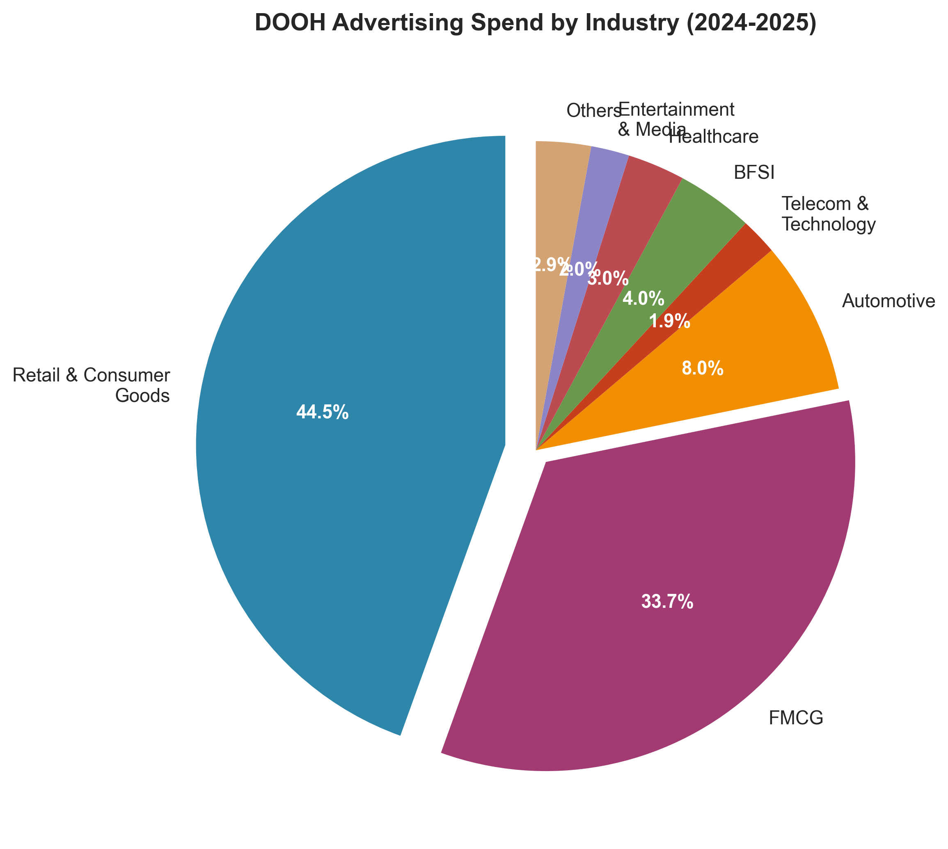
• Retail & Consumer Goods dominate with 44.49% market share (~$47-58M annually)
• FMCG commands 33.71% of digital advertising spend
• Combined, these two sectors represent 78.2% of total DOOH spending

2. Sector Growth Rates Comparison
Annual growth rates (CAGR) by industry sector through 2030:
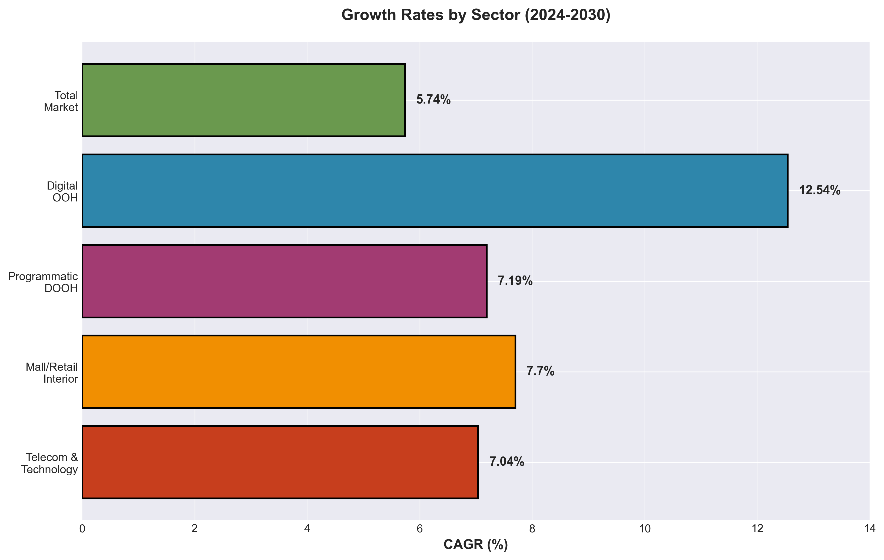
• Digital DOOH growing at 12.54% CAGR - fastest overall growth
• Telecom & Technology: highest sector-specific growth at 7.04%
• Mall/Retail Interior screens: 7.70% CAGR, reaching $15.4M by 2030

3. Market Size Projections (2024-2030)
Vietnam DOOH market growth trajectory:
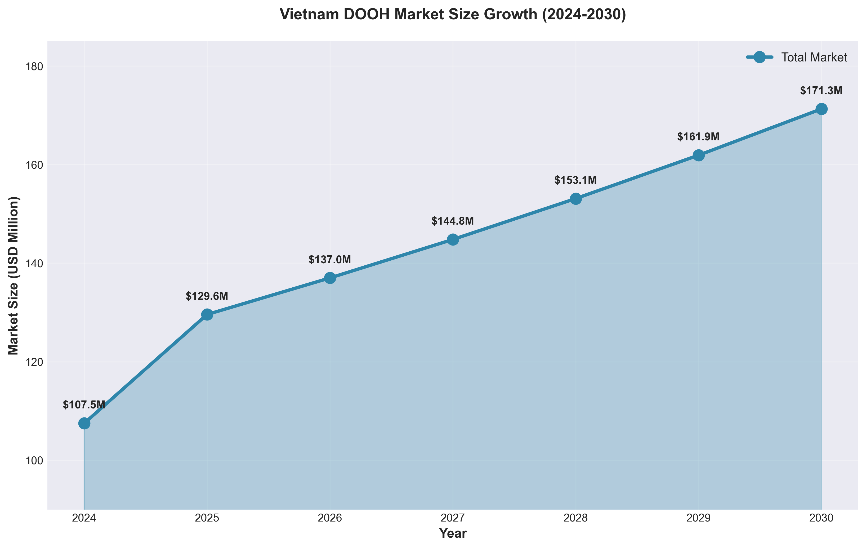
• 2024: $107.5M → 2030: $171.29M
• 5.74% CAGR (conservative estimate)
• Total growth of $63.79M over 6-year period

4. Static vs Digital OOH Format Split
Current market composition and future trajectory:
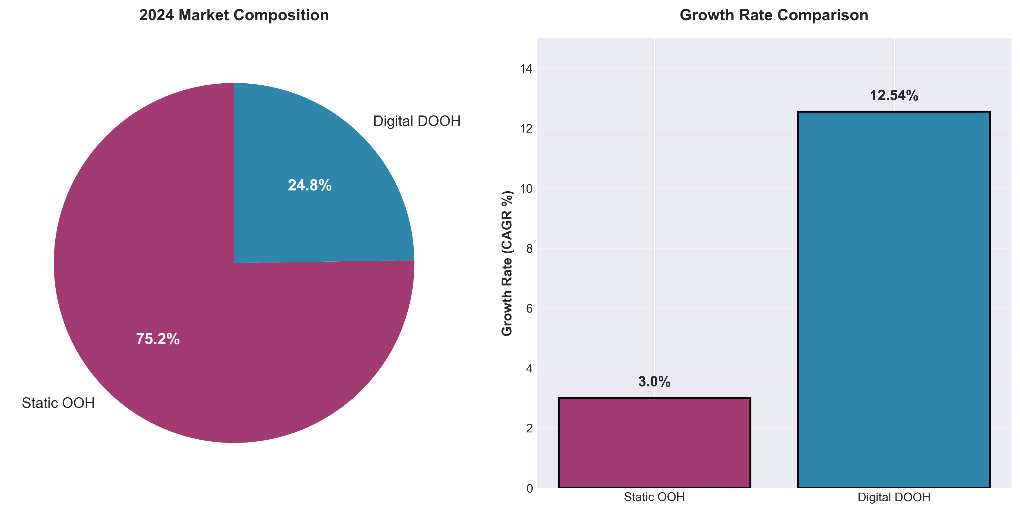
• Static OOH still dominates at 75.24% but growing slowly
• Digital DOOH at 24.76% but growing 4x faster (12.54% vs ~3% CAGR)
• Digital format expected to gain market share steadily through 2030

5. Geographic Spending Distribution
DOOH advertising spend concentration by region:
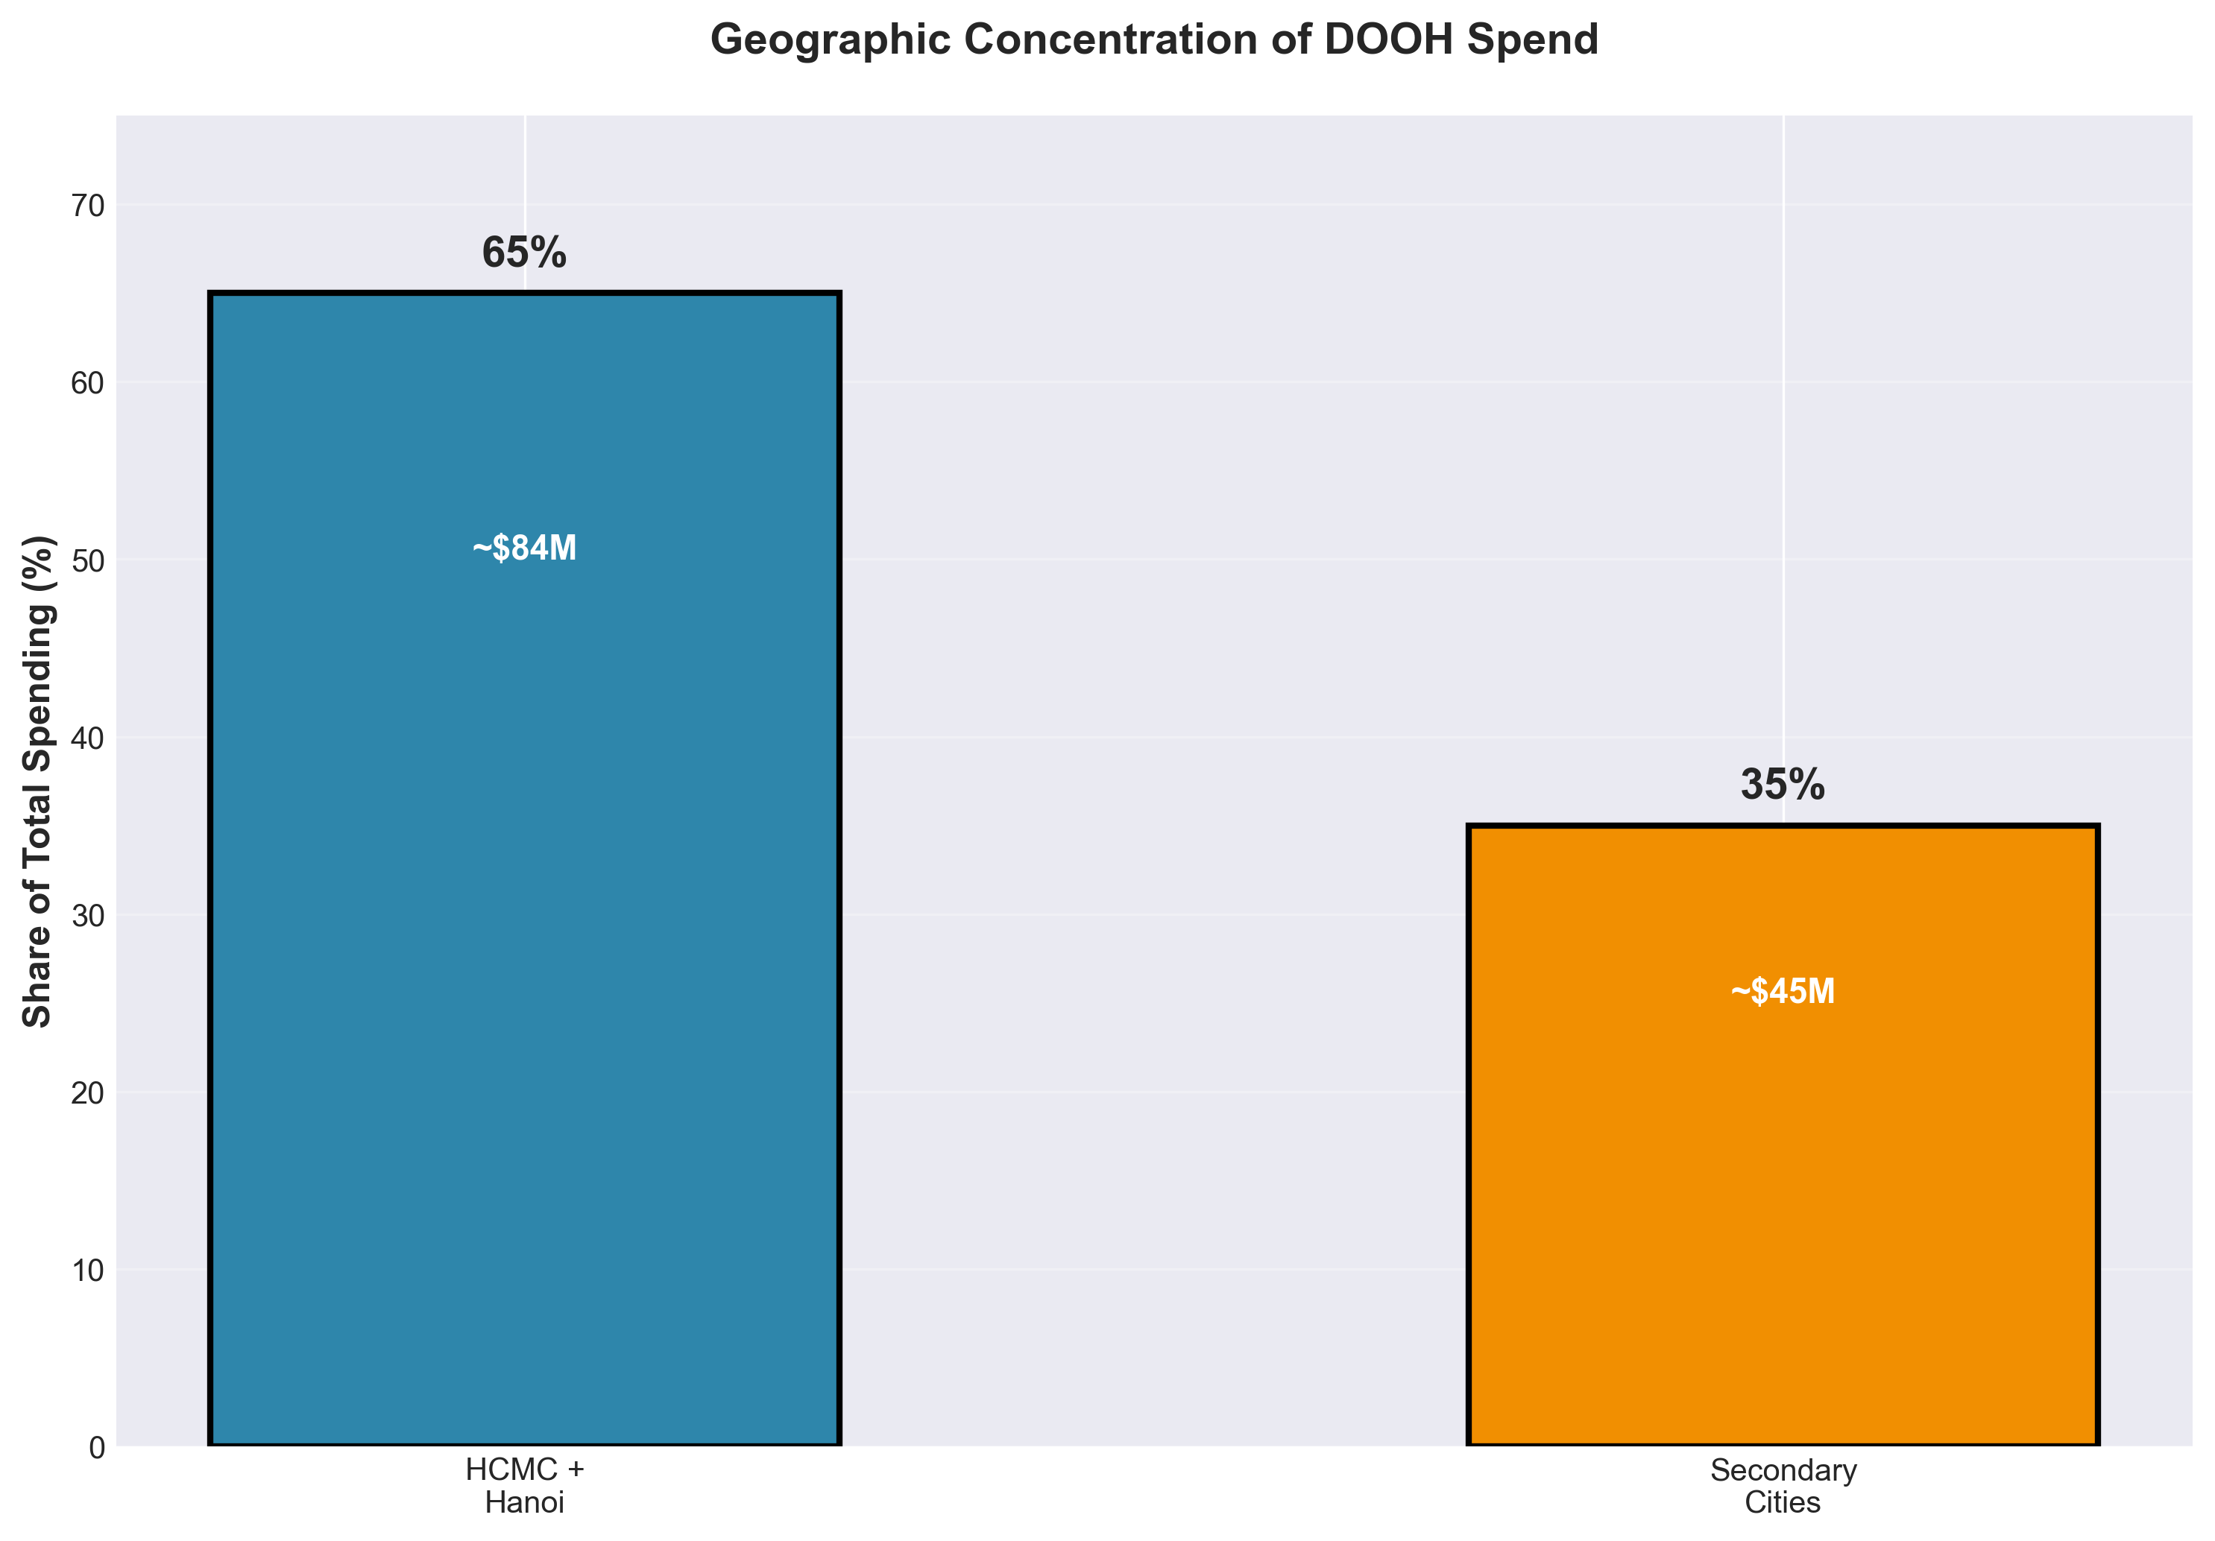
• HCMC and Hanoi capture 60-70% of total DOOH spending
• Secondary cities (Da Nang, Can Tho, etc.): 30-40% of spending
• Tier 1 cities command premium CPMs with better attribution data

6. Telecom Sector Market Share
Mobile network operators driving 5G advertising wars:
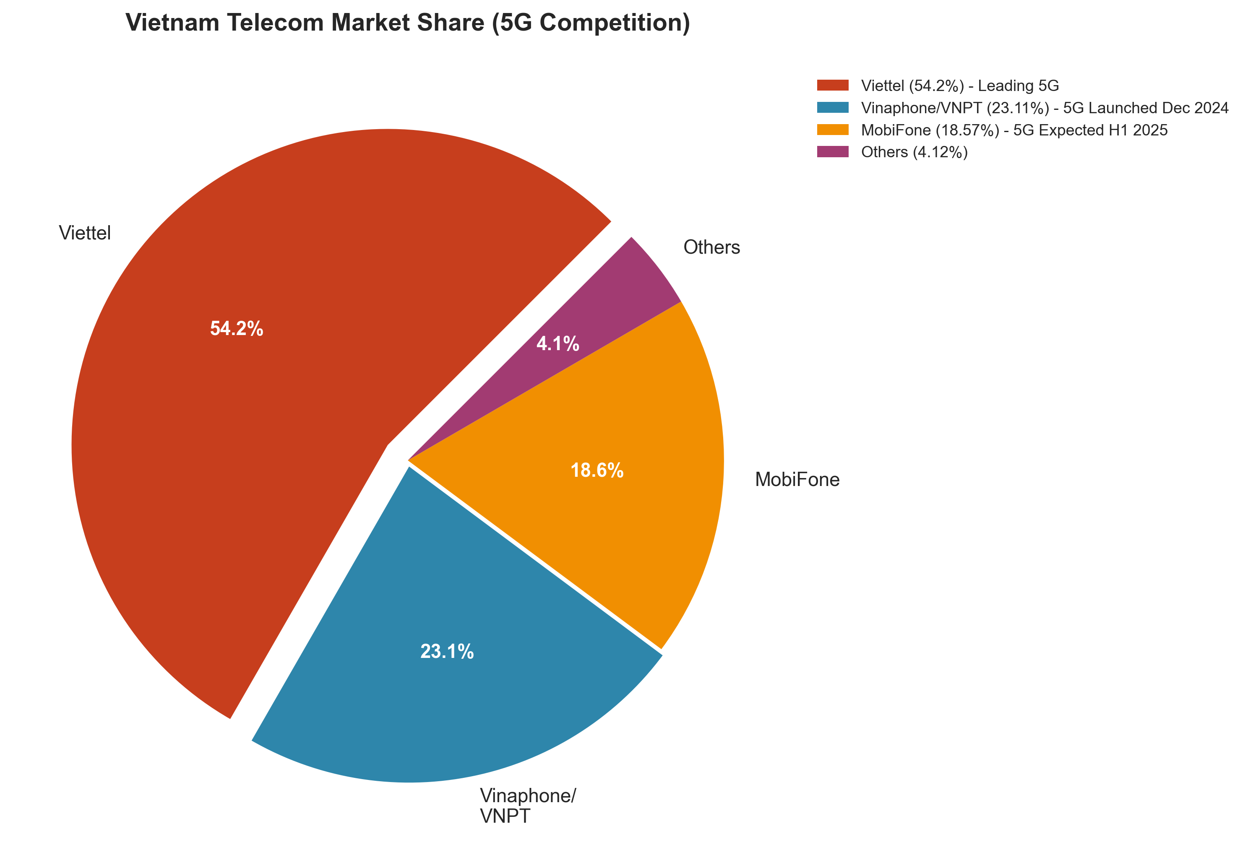
• Telecom sector expected to grow at 7.04% CAGR (highest among sectors)
• 5G rollout intensifying competition and driving ad spend increases
• Interactive metro screens and app install campaigns primary formats

7. Estimated Budget Allocation by Industry
Annual spending estimates by major industry sectors:
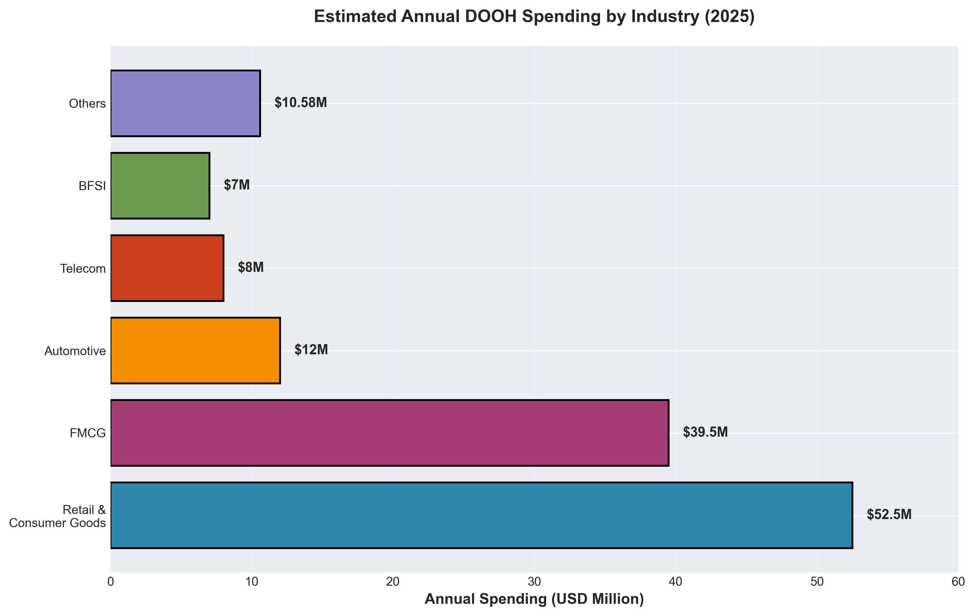
• Retail & Consumer Goods: ~$47-58M annually (44.49% share)
• FMCG: ~$35-44M annually (33.71% share)
• Combined top 2 sectors: ~$82-102M (78% of total market)

Key Insights Summary
- Market Dominance: Retail (44.49%) and FMCG (33.71%) control 78% of DOOH spending
- Growth Leaders: Digital DOOH growing at 12.54% CAGR, 4x faster than static formats
- Sector Opportunity: Telecom & Technology poised for 7.04% CAGR growth driven by 5G wars
- Geographic Focus: HCMC + Hanoi capture 60-70% of spending with premium CPMs
- Market Size: $129.58M (2025) → $171.29M (2030), +32% growth over 5 years
- Format Shift: Static 75.24% → Digital 24.76%, but digital gaining share rapidly
- Elite Adoption: 91 of Vietnam's top 100 companies actively invest in DOOH
- Programmatic Impact: JCDecaux reported 61.8% revenue uplift via programmatic buying

Methodology & Data Sources
This visual analysis is based on comprehensive research of Vietnam's DOOH advertising market, synthesizing data from industry reports, market research firms, and company disclosures. All figures represent 2024 actual data and 2025 projections.

Key sources include:
- • Mordor Intelligence Vietnam OOH & DOOH Market Reports
- • Statista Digital Out-of-Home Advertising Vietnam Forecasts
- • NielsenIQ Vietnam Advertising Intelligence
- • Company-specific data (JCDecaux, Chicilon Media, Moving Walls)
- • Industry case studies and press releases

Note: Market size estimates vary across sources due to different methodologies (digital-only vs. total OOH, geographic scope). Conservative estimates used where discrepancies exist.

