1. 设置JDialog屏幕居中

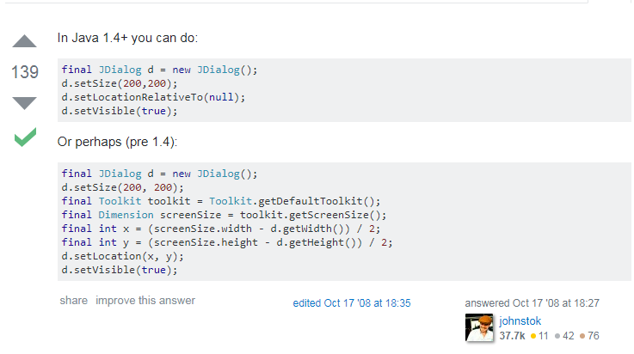

注意方法调用顺序

https://stackoverflow.com/questions/213266/how-do-i-center-a-jdialog-on-screen

1. Eclipse的Watch窗口

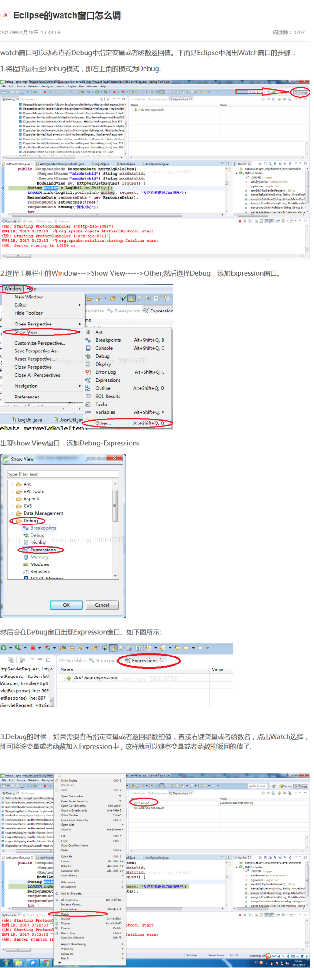

1. 设置JDialog窗口图标

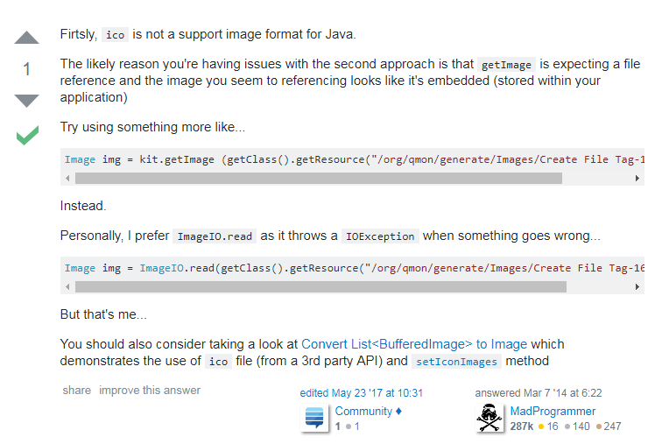

https://stackoverflow.com/questions/22242955/jdialog-box-title-bar-icon-change