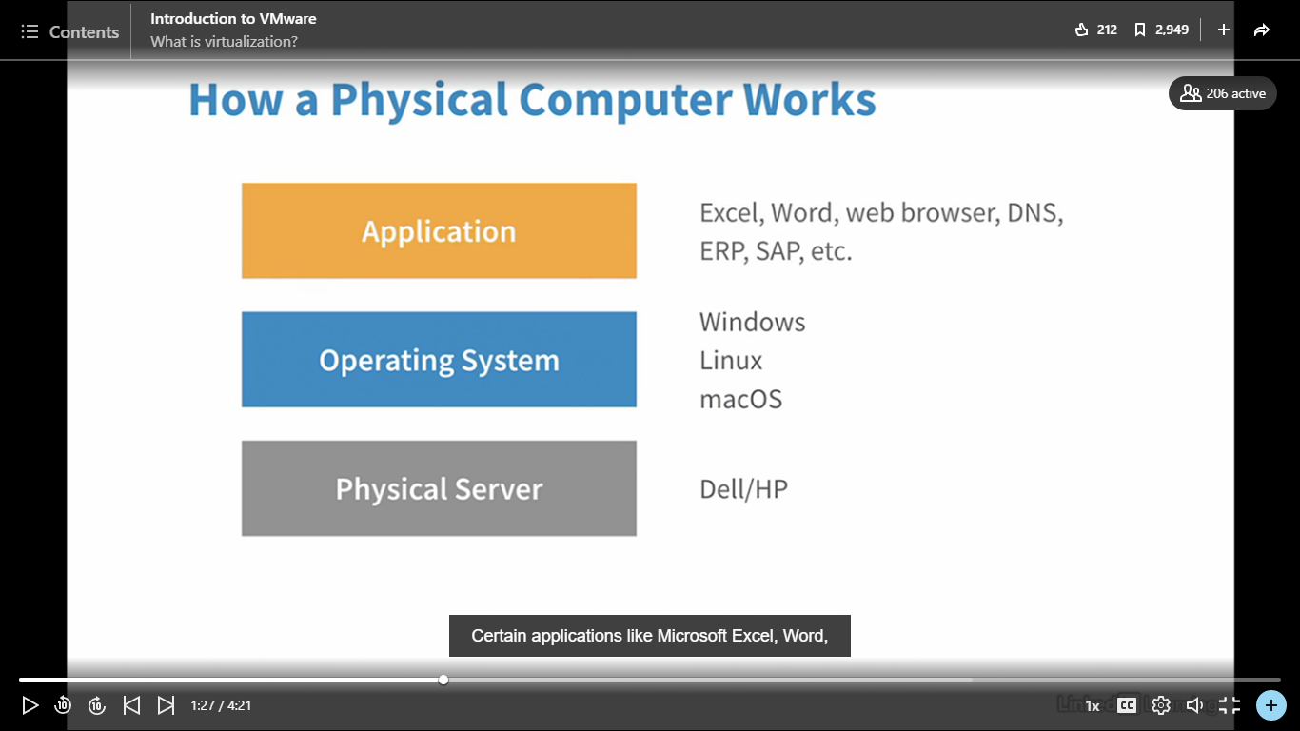

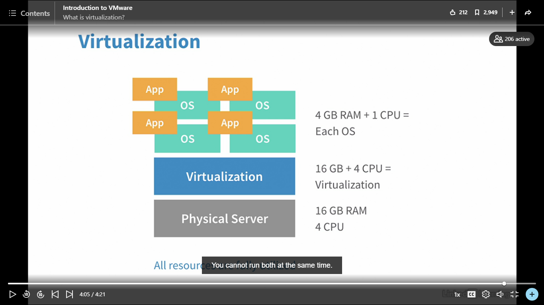

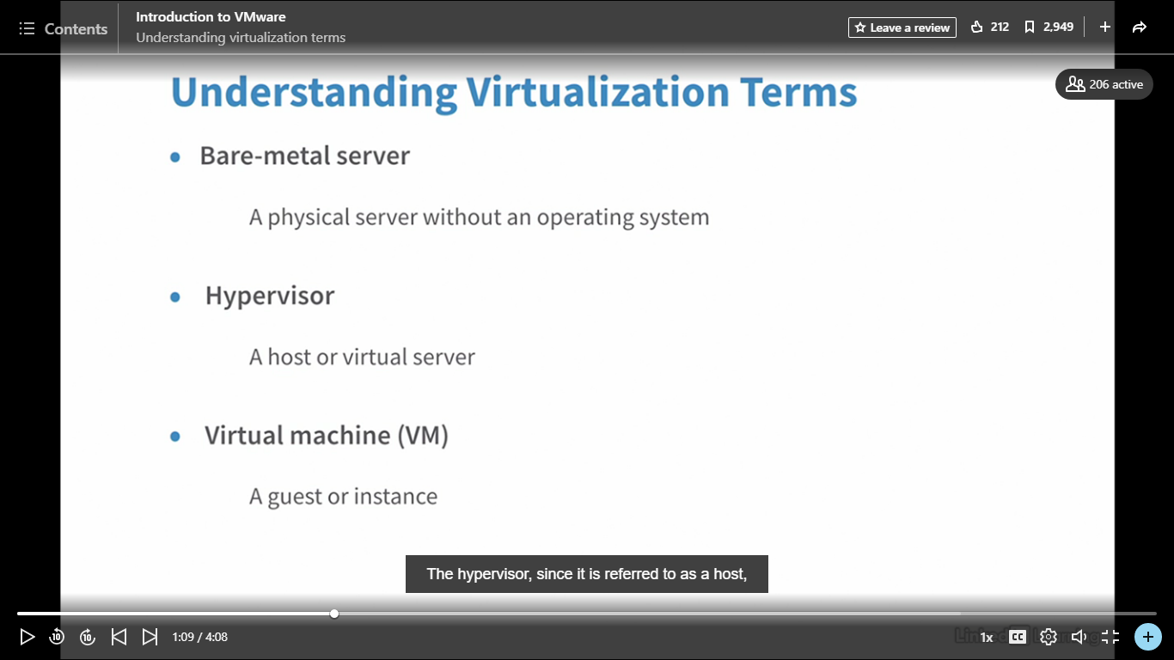

Selecting transcript lines in this section will navigate to timestamp in the video

- [Instructor] In this video, we are going to learn some of the virtualization terminologies that are used in today's IT world. And before you get into virtualization, it is very important that you should get yourself familiar with these terminologies. The very first one that you will often hear is the bare-metal server. A bare-metal server is a physical server that you could touch and it has no operating system. So you probably going to get a physical server, which you will have to rack and stack in your data center, and then you will install operating system on it. Then you have a hypervisor. Hypervisor is a virtualization software which is installed on that bare-metal server to make it a virtual server. That hypervisor server also referred to as a host or a virtual server. In VMware, that hypervisor is referred to as an ESXi server. Then you have a virtual machine, a virtual machine in short a VM. It is also referred to a guest or an instance. A virtual machine is a machine that runs on top of that hypervisor. The hypervisor, since it is referred to as a host, it is hosting the virtual guest. Then we have a virtualization manager. The virtualization manager is the console or a managing tool that manages the hypervisor and virtual machine. In VMware, it is called a vCenter. In Oracle world, it is called OVM Manager or Oracle Virtual Manager. Then you have a virtual desktop, which in short is a VDI. You're going to hear that a lot because a lot of corporate employees are nowadays using a virtual desktop, which is given to them by their IT team, which they could access from anywhere. So if you have a laptop and you need to work on something, you have to carry that laptop, right? But in virtual desktop, you could go on any laptop. And if you have your access to your corporate environment, then you could access your VDI session. And that will look exactly the same every time you access it. It is your own given environment. Then, moving on, you will hear the word P2V, which is physical to virtual. A physical to virtual is something that you could take the physical server and you virtualize it. Now, a lot of companies are moving from physical to virtual. They have a lot of their operating system or applications running on physical system. So what they are doing is they are virtualizing it. So you probably going to hear a data center migration. In data center migration, one of the things that you would have to do is physical to virtual migration. Then you have a V2V, virtual to virtual migration. How does it happen is if you have an older version of virtualization software running on your virtual machine, you can upgrade it by going through V2V. Then you have VM template. One of the greatest feature of a virtualization is VM template. When you create a VM template, you could actually create or spin a lot of other virtualization machines from VM template because you have a template built on it now. Then you have a snapshot is just like a backup but it's not exactly a backup but it takes a snapshot of your virtual machine right at the moment if you're taking it right now. And for example, a month from now, if you wanted to come back and revert back to that same snapshot, you could do that with a few clicks. Then the last one you have, clone or cloning. Clone is if you have a virtual machine, you could simply copy and paste the exact same virtual machine you have running, which is very, very hard to do in a physical system. So it becomes a lot easier when you have a virtual machine. So these are the few virtualization terms. I'm sure there are a lot more but the basic ones that you should really need to know before you get into virtualizations are these.