Student ID: 892083

Name: Wai Yan WONG

1. How many usernames contain the letter A?

SELECT COUNT(username)

FROM customer

WHERE username LIKE '%A%'

 1 Row Returned

2. What is the average journey length, in seconds?

SELECT AVG(TIMESTAMPDIFF(second,startTime,endTime)) AS avg_length

FROM journey

 1 Row Returned

3. List the stations on the Eastern line (excluding City), in outbound order.

SELECT station.name

FROM station INNER JOIN line

ON station.line = line.id

WHERE line.name = 'Eastern'

ORDER BY line.id

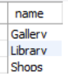 3 Rows Returned

4. On which day of the week (Monday, Tuesday etc.) are the most journeys made?

SELECT dayname(journey.startTime) AS MostJourneys

FROM journey

GROUP BY DATE_FORMAT(startTime, "%Y-%m-%d" )

ORDER BY COUNT(*) DESC

LIMIT 1

Student ID: 892083

 1 Row Returned

5. List any stations at which no passenger has started or ended a journey. Show the station id and name.

SELECT station.id, station.name

FROM station

WHERE station.id NOT IN

(SELECT startStation

FROM journey INNER JOIN station

ON station.id = journey.startStation)

AND station.id NOT IN

(SELECT endStation

FROM journey INNER JOIN station

ON station.id = journey.endStation)

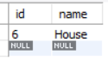 1 Row Returned

6. List the details of each journey, along with its cost.

SELECT journey.id, customer, startStation, startTime, endStation, endTime, CASE

WHEN str.zone = ed.zone

AND str.zone = 1

THEN 1

WHEN str.zone = ed.zone

AND str.zone = 2

AND str.line = ed.line

THEN 1

WHEN str.zone != ed.zone

THEN 2

WHEN str.zone = ed.zone

AND str.zone = 2

AND str.line != ed.line

THEN 3

END 'cost/$'

FROM journey INNER JOIN station str INNER JOIN station ed

Student ID: 892083

ON str.id = journey.startStation

AND ed.id = journey.endStation

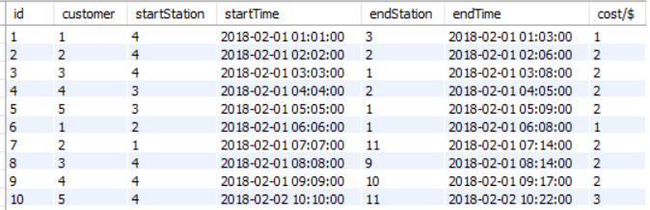

20 Rows Returned

7. List the station ids, along with the number of journeys that started or stopped at each station.

SELECT station.id, COUNT(journey.id)

FROM station

LEFT JOIN journey

ON station.id = journey.startStation

OR station.id = journey.endStation

GROUP BY station.id

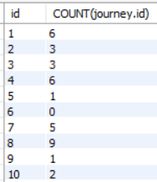 11 Rows Returned

8. List the journeys that ended at the last station on the line. (the station with the highest sequence number for a line)

SELECT id, endstation

FROM journey

WHERE endStation in

Student ID: 892083

(SELECT id

FROM

(SELECT line,MAX(sequence) AS seq

FROM station

GROUP BY line

) AS maxseq INNER JOIN station

ON maxseq.seq = station.sequence

AND maxseq.line = station.line

WHERE id != 1)

ORDER BY id

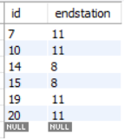 6 Rows Returned

9. For each journey, show how many stations it passed through. (Count the end station but not the start station.)

SELECT journey.id, startStation, endStation, CASE

WHEN str.line = ed.line

THEN ABS(CAST(str.id AS SIGNED)-CAST(ed.id AS SIGNED))

WHEN str.line != ed.line

THEN str.sequence + ed.sequence

END 'pass through/stations'

FROM journey INNER JOIN station str INNER JOIN station ed

ON str.id = journey.startStation

AND ed.id = journey.endStation

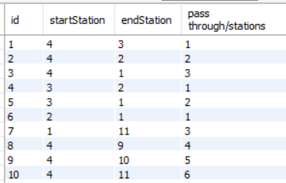 20 Rows Returned

Student ID: 892083

10. List the usernames of customers who have travelled on all lines.

SELECT username

FROM

(SELECT username, station.line AS line

FROM station INNER JOIN journey INNER JOIN customer

ON station.id = journey.startStation

AND journey.customer = customer.id

WHERE line != 0

UNION ALL

SELECT username, station.line AS line

FROM station INNER JOIN journey INNER JOIN customer

ON station.id = journey.endStation

AND journey.customer = customer.id

WHERE line != 0

) AS travel1

GROUP BY username

HAVING COUNT(DISTINCT(line)) = 3

ORDER BY username

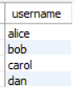 4 Rows Returned