**TEST reference guide for the reviewer.**

**Windows Solution**

The tool has been compiled under Windows 8.0/8.1  
the supplied files are the following:

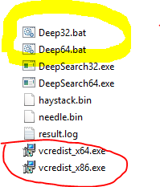

There are two .batch files which allow running immediately the application either 32 or 64 bit.  
Editing the bat file it is possible to change the input parameters which are haystack file name, needle file name and threshold.  
The sample run in windows 8.0/8.1 and it might be necessary to install the corresponding redistributables.  
For example on a64 bit machine it is appropriate to install both redistributable so that both versions can be tested.  
Once the application has finished the result can be seen in the log file.  
The Tool has been compiled in Visual Studio 2013 Ultimate and the solution is available on GitHub at the following address:  
<https://github.com/diegomary/deepSearchBF>

**Linux Solution**The tool has been compiled Under Linux



The supplied files:

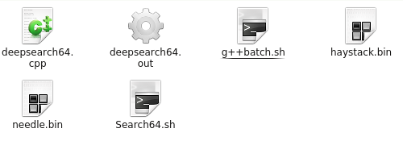

g++batch.sh must be given permission of execution and build the binary using g++ compiler.  
Search64.sh is the batch file that launches the tool.

**Example of creation of haystack.bin and needle.bin.**The Example is based on two files which I have manually created as follows:  
Haystack.bin and needle.bin

The Haystack.bin has random byte values inside:

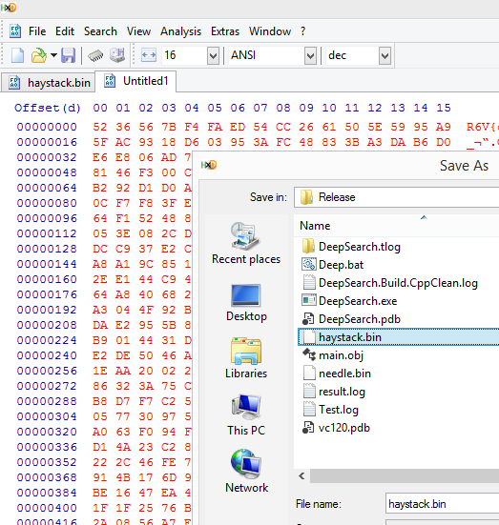

The needle.bin file is a file of 1000 random bytes :

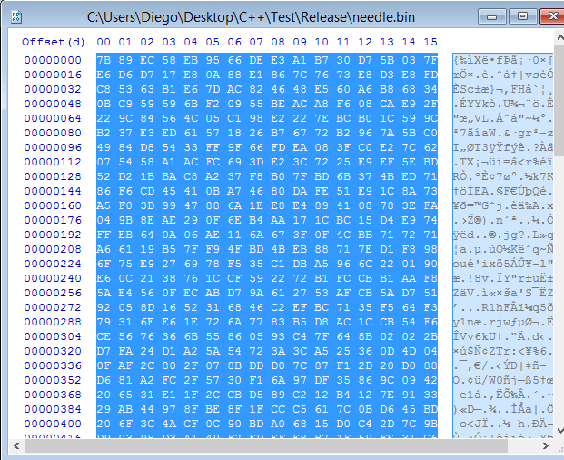

In order to test the application I have written the pattern of 1000 bytes of needle into haystack at different position leaving unaltered the file size (past write) at the following locations:

1. Offset 64 from origin 1000 bytes

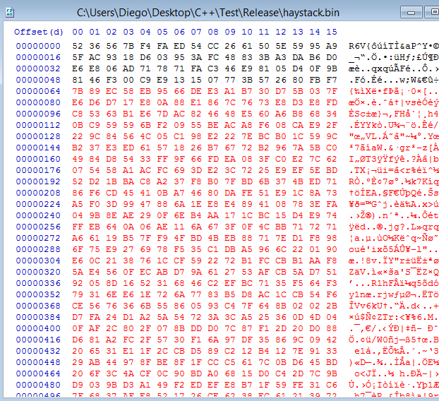

1. **Offset 6672 from origin 1000 bytes**

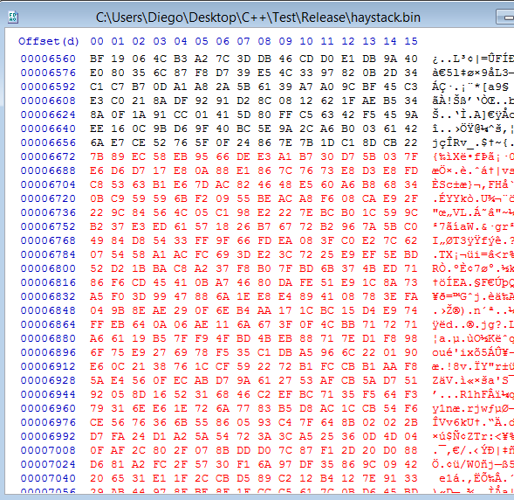

1. **Offset 74192 from origin 1000 bytes**

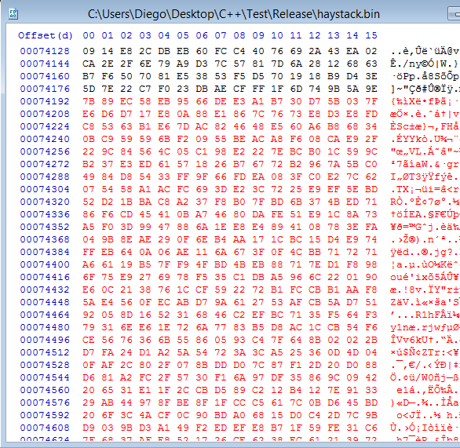

After the tool has run we are prompted to inspect the file result.log which has been created in the same folder where the tool and the data files reside.

An example of result log content can be:

Reading File......  
Reading File......  
Threshold: 1000  
Offset of needle: 0  
Element of Size 1000 found at position 64  
Element of Size 1000 found at position 6672  
Element of Size 1000 found at position 74192

***************** Search terminated **************************

Time elapsed in seconds: 0.0001

If the threshold is modified to a value that is inferior to the length of the needle multiple results will be written in the log file accordingly.

**Implementation of multiple strategies for different trade-offs between speed and memory requirements.**

The Algorithm of search is implemented with pointers in memory.  
In this way only a limited amount of data can be inspected and the amount itself is limited to the memory installed on the machine.  
A better solution in terms of space optimization saving is certainly to create a view of the Haystack file on disk and use memory mapped files, and using state solid hard drive.   
Since I wanted to grant full portability of the code between UNIX and Windows and vice versa I decided at this stage not to implement memory mapped files which requires a different approach on different platforms.

I want to give a simple route here of the Mapping in Windows and I want also to indicate that file mapping has its corresponding methods in Linux with different function names and slightly a different procedural approach.

* Windows Approach

HANDLE HN = CreateFile(FileName,GENERIC_ALL ,0,NULL,OPEN_EXISTING,FILE_ATTRIBUTE_NORMAL,NULL);  
HANDLE HP = CreateFileMapping(HN,NULL,PAGE_READWRITE,0,0,NULL);   
HANDLE HX =MapViewOfFile(HP,FILE_MAP_ALL_ACCESS,0,0,0);  
**unsigned char * pt = (unsigned char *)HX;**DWORD fileSize = GetFileSize(HN, NULL);  
 // Here goes file manipulation for example  
**for(int j =0; j< fileSize; j++)  
pt[j] = pt[j] ^ 100;**// then to deallocate  
UnmapViewOfFile(HX);  
CloseHandle(HP);  
CloseHandle(HN);

**Performance test.**

The tool has been tested with an haystack of 512,000,000 bytes and a needle of 1,000,000 bytes with the following report reading result.log:  
**tool compiled 32 bit. Machine Laptop HP DV6 I5  
only one occurrence of needle placed in haystack manually using Hxd editor**

Reading File......  
Reading File......  
Threshold: 1000000

Offset of needle: 0  
Element of Size 1000000 found at position 427653376

***************** Search terminated **************************

Time elapsed in seconds: 1.9850 sec.

The application has been tested with the same data but with a threshold of (1,000,000 -10). This implies multiples occurrences at different threshold levels. The following results:

***************** Search terminated **************************

Time elapsed in seconds: 129.3960

**More on performance:**

It is worth mentioning that in multiprocessor machines like the common laptops the power of calculus is divided among its processors, and every processor manages one thread in an application.  
The tool developed is using only one thread at present and on a machine with 4 processors only roughly 20% of the cpu will work to search in the haystack.

If required it is possible to use the power of other processors and divide among them the workload.

For example we can fill a queue of possible thresholds using one thread and at the same time inquire the queue for the threshold in order to perform the search in another thread.

A step further can be to assign to each processor a range of thresholds which is a very performing solution because doing so every thread can work without synchronization.  
The cost of a multithreaded choice can be important and it must be devised wisely taking into consideration the target, the amount of data to be searched and the time at disposal.

**Search Algorithm**.

The choice to compare the needle to portions of haystack using **memcmp** crt function is justified by its high speed and by its portability in Linux and Unix.  
It is possible also to implement the **Boyer Moore** algorithm which start the search from the last character of the pattern and does pre-processing .With such algorithm It is possible to reach time complexity at worst O(m + n) but generally sub linear.  
The application source code can be compiled either in Windows and Linux because I wanted not to use third part libraries which can prevent portability.  
I chose to check the first and last char of the needle and this could be beneficial for long needles.

inline void coreSearchTurbo(byte* haystack, int lenHaystack, byte * elementTosearch, int sizeOfelement, FILE * logger)

{

int limit = (lenHaystack - sizeOfelement);

for (int q = 0; q <= limit; q++)

{

if ((haystack[q] == elementTosearch[0]) &&  
(haystack[q + sizeOfelement - 1] == elementTosearch[sizeOfelement - 1]))

{

if (memcmp(elementTosearch, &haystack[q], sizeOfelement) == 0)

{

fprintf(logger, "Element of Size %d found at position %d\n",  
zeOfelement, q);

q += sizeOfelement;

}

}

}

}

It is worth noting that the IO operations in the loop by means of the logger are very expensive and they should be moved at the end of the search. In order to do so, two are the ways that we can choose:  
the first solution takes into consideration a forecast of the number of probable occurrences and it allocates an array of strings of fixed size and such array is fed at every occurrence. At last only one IO operation will be done.  
The second solution is to create a dynamic array of string like the following: vector<string> occurences;  
When an occurrence is found the vector grows and only at the end of the search the vector will be serialized on the log file. This solution however is not thread safe.

**Test on 32bit and 64bit Architecture**

Using the same machine it has been noted a conspicuous difference in terms of performance using the 32 bit version of the tool or the 64 version of the tool.

The result.log for both 32 and 64 implementations gives the following results:

**64 bit version of the tool:**

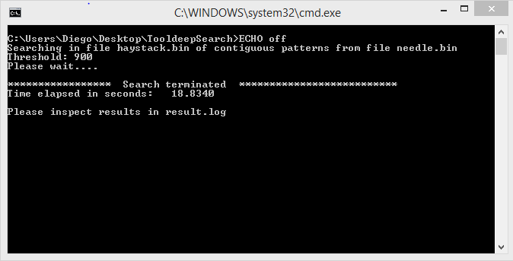

And its corresponding usage in terms of resources



**32 bit version of the tool:**

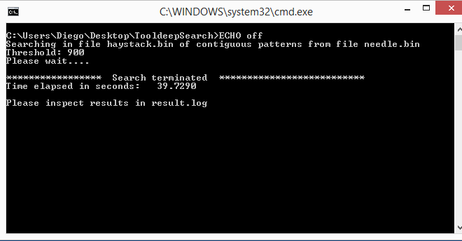

And its corresponding usage of resources



**Using the tool to benchmark Amazon AWS Micro Instances:**

The following screenshot demonstrates that the application has been tested on an Amazon AWS Micro instance with architecture 64 bit.

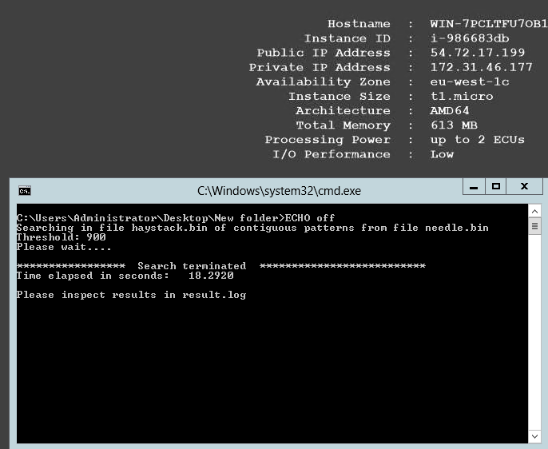

**Conclusions**

The test contains many interesting points that if developed with care can lead to a very proficient solution in terms of performance and memory containment.   
I have enjoyed the analysis and I am looking forward to extending my knowledge on such topic which I consider fascinating and constructive.  
My personal self is looking for optimization and love for details. Algorithms are a beautiful part of the challenge for a developer.