To secure applications it is often necessary to verify the identity of the user, this process is called authentication. There are several methods to authenticate a user, with passwords being the most common one. Passwords are usually chosen by the user. Those user passwords are often not strong enough and can be easily found out by brute forcing or simple deduction (e.g. pet names etc.).

Password generators utilize pseudo random numbers to create passwords that are not prone to those attacks. Programs like KeePass2[0] have built-in password generators that can be parameterized to create passwords with different length and characters. Although available for free, it is still necessary to download and install KeePass2 before it can be used. Better available are online password generators, which only require you to browse to a specific website.

The problem with online password generators is that they are often not secure. Most of them generate the passwords on the server, which makes it impossible to check the password generation process and also allows the operator of the website to see the password and save it. Examples for this kind of generator are the ones from Codepad[1], Norton[2] and Dinopass[3]. The Passwordsgenerator website[3] allows to generate a password locally using JavaScript. Even though the password cannot be seen by the operator of the website it is still not secure, because it uses the Math.random() function as only source for randomness. Math.random() **does not** return good cryptographic pseudo random numbers, which makes the generator prone to statistics attacks. The XKCD password generator[4] utilizes a combined approach by combining Math.random(), a server generated SHA-1 Hash and some window properties to create a random number. Although better than only using Math.random() it is still not secure, because none of these sources provides good randomness.

With the release of the crypto JavaScript API [5] it is no longer necessary to use tricks and server side methods to generate a secure password. All mayor browsers support this API. The following example code shows a simple password generator.

function generateRandomPassword(length, chars) {

var password = '';

for (var i = 0; i < length; i++) {

var index = getRandomNumber() % chars.length;

password += chars.charAt(index);

}

return password;

}

function getRandomNumber() {

var array = new Uint32Array(1);

window.crypto.getRandomValues(array);

return array[0];

}

Although this password is secure, under the assumption that the length and charset are big enough, it most likely will difficult to type. The lack of ergonomics in password generators was the motivation for “Reduktion von Fehlerraten mittels ergonomischer Passwörter”[6] by Weich , Herres and Knorr. The authors discuss password generation and identify security, memorability and ergonomics as main criteria. They continue by studying writing behavior on the German “qwertz” keyboard layout and derive an ergonomic password generation algorithm (shown in fig. 1) from their observations. An implementation of the algorithm was given in EPT (Ergonomic Password Tool) a Java command line tool.

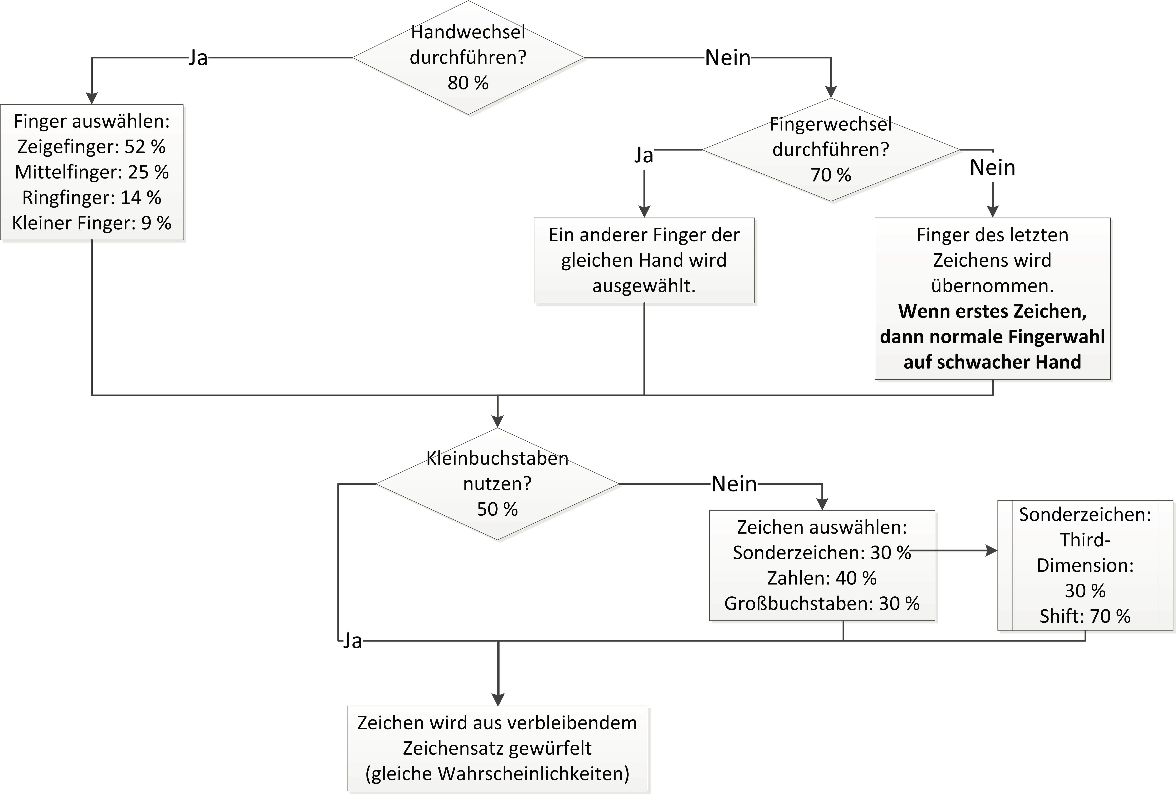

The lack of secure and ergonomic password generators in the web was the motivation for implementing my own version of EPT. The entire application works locally and no server communication is required after the initial page request. The random values are delivered by the browser via the JavaScript Crypto API and the application can be exported as single file. Through a minimal options field the length and used character set can be specified, as well as the used algorithm for the password generation (ergonomic or random).

To verify their approach Weich , Herres and Knorr calculated the entropy[7] of 4 character ergonomic passwords, which was 25% lower than the entropy of random passwords. The entropy is a measure for information and is maximized if the values are evenly distributed. I made my own calculations and experiments with the password generator and found that the calculations seem to be correct. The author suggest that by increasing the length of the password by 20% a nearly equal level of security can be reached, than using random passwords.

Even though the entropy for small password lengths is high enough, it is not clear if the entropy scales well with increased length. Since it is challenging to calculate the entropy for longer passwords a better measure for password strength is still required. Even though I still consider the ergonomic password generator secure.

[0] <http://keepass.info/>

[1] <http://www.codepad.de/en/software/online-tools/password-generator.html>

[2] <https://identitysafe.norton.com/de/password-generator>

[3] <http://www.dinopass.com/>

[4] <http://preshing.com/20110811/xkcd-password-generator/>

[5] <https://developer.mozilla.org/en-US/docs/Web/API/Window/crypto>

[6] <http://www.hochschule-trier.de/fileadmin/users/229/DACH_Herres_Weich-1.8.pdf>

[7] <https://en.wikipedia.org/wiki/Entropy_(information_theory)>