Name: Đặng Thịnh Tường Minh

Student ID: 20235528

1. Use case diagramA diagram of a company

   Description automatically generated
2. Class diagram

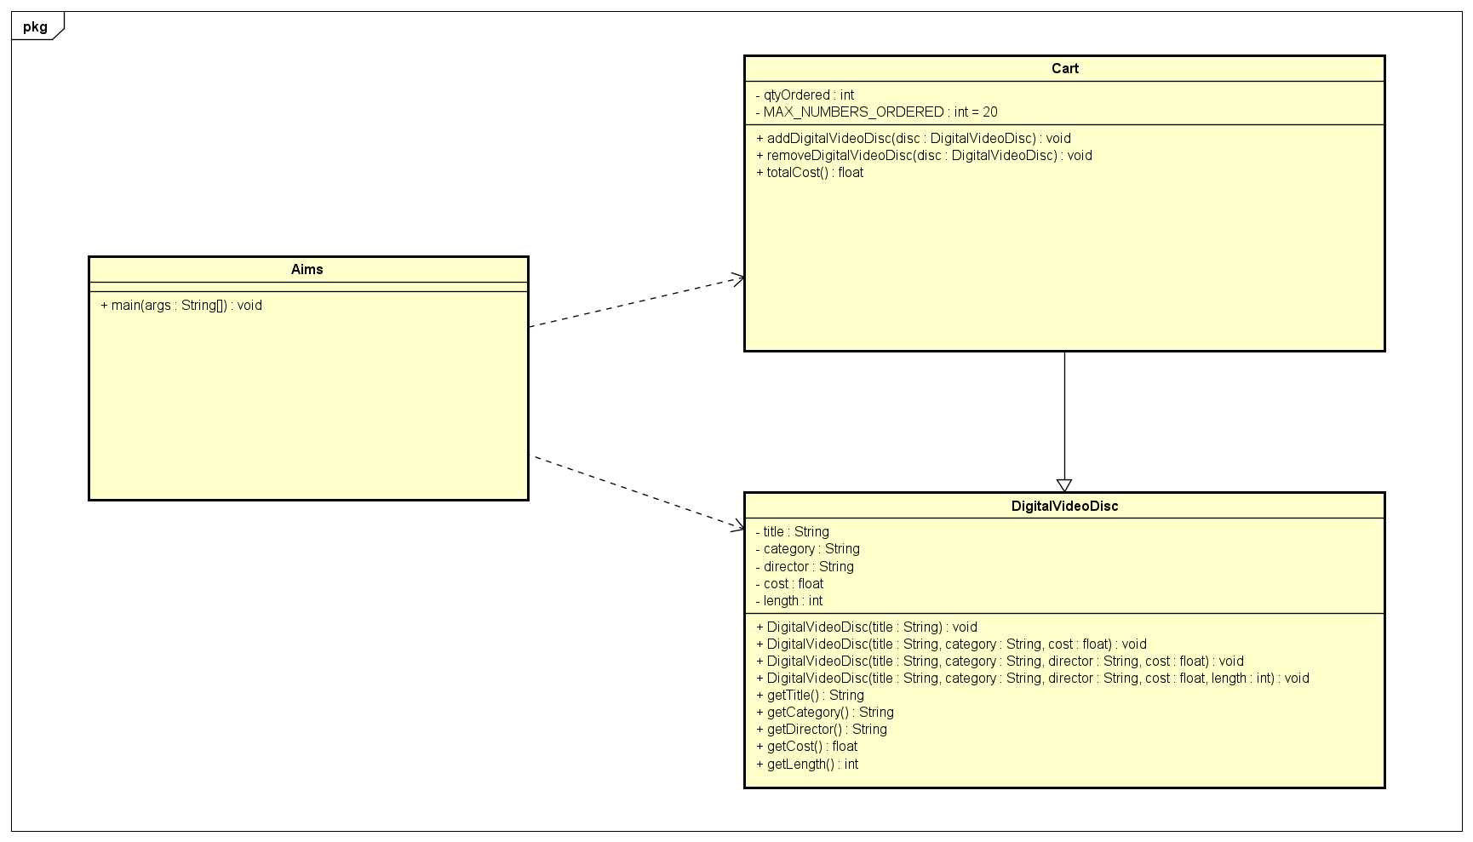

1. Reading assignment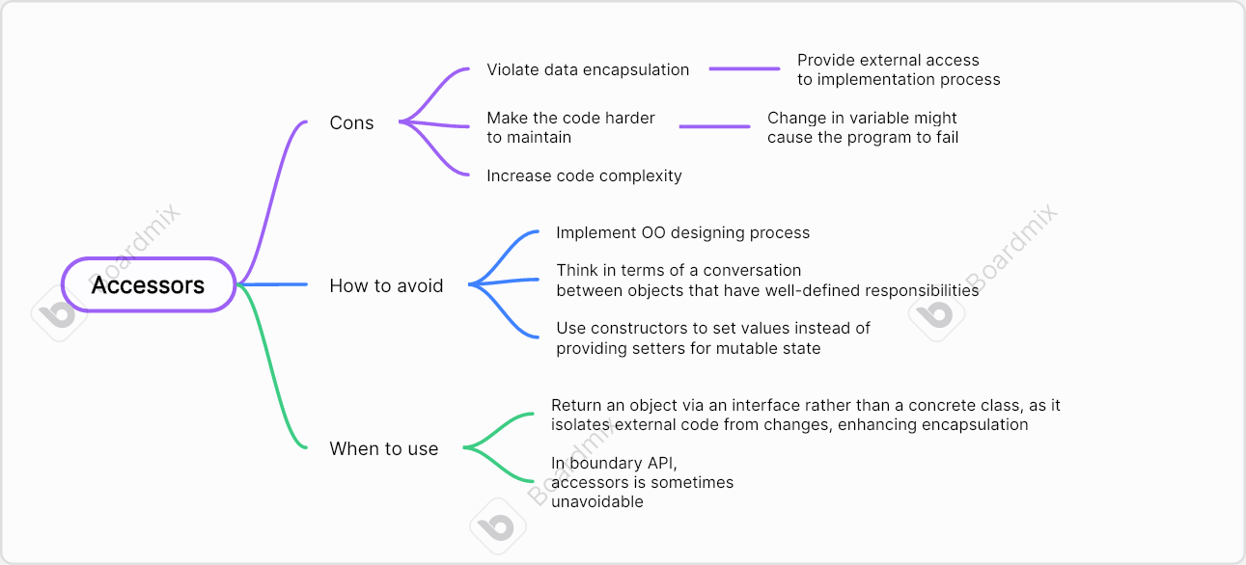
2. Question

If you create a constructor method to build a **DVD** by title then create a constructor method to build a **DVD** by category. Does JAVA allow you to do this?

Ans: JAVA doesn’t allow you to this because they have same amount and type of parameter.