MIDI DRIVEN GRAPHICS

1. Introduction
The main objective of this program is to create real-time animations that respond to the notes being played on a midi channel. At this time the midi channel that drives the animations is channel 10. This is known to be the channel for the drum kit.
The animations do run in real-time, that is, every time we play a key on the keyboard it will be displayed on the screen. This makes it useful for live concerts, or live events. The user can also load and save as many different "Sets" as wanted. A "Set" is a file that has all the information of the scene.
A user interface is provided so that we can have full control of all the program parameters. Through the user interface we can translate, animate and (texture) map every single midi note.

2. Technical Requirements
- Any computer running Linux (kernel 2.4.+)
- 3D capable videocard.
- MIDI interface or a Soundcard with a MIDI / GAME port.

3. Software Requirements
In order to make the program work, it must be successfully compiled under Linux. To do so we must have installed certain specific libraries, which can be downloaded freely on the internet. These libraries are:
- OpenGL (www.opengl.org)
- ALSA (www.alsa-project.org)
- GLUI (www.cs.unc.edu/~rademach/glui/)

To compile it, a simple 'make' will do it.

4. Running the program for the first time.
After successful compilation we should have a new file called 'midi'.
To run the program we need to type: ./midi hw:x1,x2
Where x1 is the soundcard number, and x2 is the midi Interface number. Both numbers are provided once the ALSA installation is successful.
Generally we type: ./midi hw:0,0. Which specifies the first soundcard in the system, and the first midi device in the system.

5. 3D MIDI
Once inside the program the first thing we will see is a blank screen with a menu on the right side. Now, everytime a note is pressed it will appear on the screen.
Below is a screenshot of the C-1 note being pressed. (Velocity = 127)
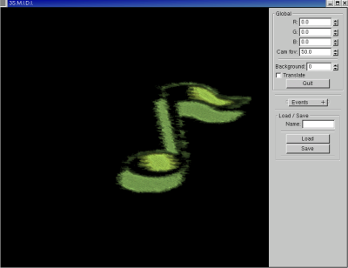

Notes respond to velocity. That is, depending on the velocity of the note (how hard it is pressed) it will be scaled accordingly.

Pressing '1' or '2' on the keyboard will make the menu to show or hide.

So far, so good. But know, what else can we do?

5.1 The Global Menu

The first thing we see at the top of the menu is the global parameters. Through this menu we will have control over the background effects.

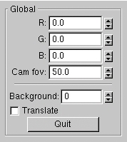

The labels R,G,B define the intensity of each color channel. The first time we run the program they are all set to zero. If we change their values a background image will be seen. The range for all colors is from 0 to 1.

The 'Cam fov' parameter stands for the Camera Field of View, we can change the field of view, creating interesting visual effects. It ranges from 20 to 200.

The Background field let us choose between four different background textures. This textures are stored in the 'Data' subdirectory. They are 256x256 textures saved in BMP format, and can be replaced with any paint program. (Photoshop, GIMP).

The Translate check box is unchecked by default. Once it is checked it will scroll the background.

5.2 The event roll-out

Below the Global menu is a roll-out menu. When we click on it the Events menu appear.
Every event is associated with a midi note. Each midi note have his own parameters (position, texture, etc). This menu let us change this parameters for each midi note.

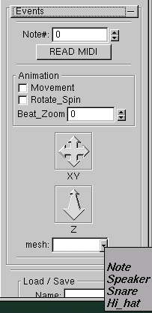

The Note# field let us choose the note we want to 'edit'. The range of midi notes goes from 0 to 127. In this case 36 will represent a C-2, 48 will be middle C in a piano keyboard, and so on.

The READ MIDI box, is a useful tool when we don't know which key is being play. Just click it and the last note being played will appear in the note field.

In the animation panel we find 3 different items.

The movement check-box will animate the current note being 'edited'. If the movement check box is pressed the current note will move each time it is pressed. If we keep a note pressed for a long time it will scroll through the screen.

The rotate check-box will make the current note rotate along its X axis, imitating the movement of a wheel.

The Beat Zoom field, is a special option. It is only useful for one note at a time. Once we enter the value of the note we want to 'zoom' every time that note is played the background screen and the selected note will zoom towards the camera. Quite an interesting effect!

The translation icons are shown behind the Animation menu. It is with this tools that we can translate each midi note to where we want on the screen. XY translation comes together. For the depth we use the Z icon.

The Mesh field, will show once clicked a list of different objects. This list represent the Event texture. We can choose from 4 different textures. As with the backgrounds, this are also bitmaps that can be edited with our favorite paint program.

5.3 Load & Save

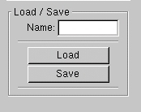
This part of the menu will let us load and save the current configurations, so they can be retrieved at any time.
Once the user is happy with the configuration, it can be saved. Just type the desired name and press the Save button. To load, use the same mechanism, type the appropriate name, and hit the Load button.

