How to run Langevin molecular dynamics simulation using LAMMPS.

1. How to make input particle position data?

In Matlab, type

write_lammps_data_file('loc_test.data');

2. How to run simulation?

Answer: In Matlab, type

batch_md_hardsphere_run(1,1);

If you want to increase the effective particle diameter, try

batch_md_hardsphere_run(1,1.1);

3. Note

Pair potential

Example: U(x)=epsilon*(x/r0-1)^(2)*(r0/x)^(24);

I can define arbitary potential in lammps by making tabular text file (pair_style table)

I use $ε=1$, $r_{0}=rcut$

*unit: lj -> all dimensionless number. ($k_{B}=1)$

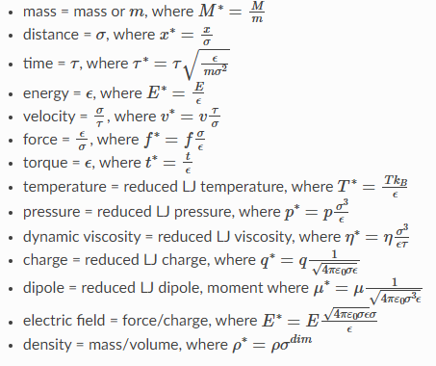

Below is the typical input script.

|  |
| --- |
| # ---------- Initialize simulation ---------------------  units lj %Set the unit convention of the systems.  atom_style atomic %Set number of attributes per atom. See <https://docs.lammps.org/atom_style.html>  dimension 3 %Simulation is in 3 dimensions  boundary p p p %periodic boundary conditions  read_data G:\24-05-28-Ilya\lammps/test/input/loc_sample.data %input particle locations.  mass * 1.0 %mass of all particles are set to 1  pair_style table linear 1000 %set pair potential.  pair_coeff * * potential.table power_law 1  velocity all create 1 87287 dist gaussian %initial velocity. Random. Gaussian distribution.  compute displ all displace/atom  fix 1 all nve  fix 2 all langevin 1 1 1.0 3213 %integrator. https://docs.lammps.org/fix_langevin.html  #--------- Dump file ------------------  thermo_style custom step pe ke temp press  thermo 10000  dump 1 all custom 10000 dump.* id type x y z  # --------- Run -------------  timestep 0.001  run 100000 |