Resolution Bias and Cross-Generator Detection of AI-Generated Images
Noa Keter · Ido Josephsberg
Deep Learning, Tel Aviv University, 2026b · Dr. Shay Maymon
Code and run instructions: https://github.com/noa-keter/deep-learning
1 Motivation and problem definition
A convolutional detector separates real photographs from generated ones almost perfectly when the test images come from the generator it trained on. On generators it has never seen, accuracy falls sharply. We ask how much of that in-distribution success reflects the generative process and how much reflects the way the benchmark was built.
The concern is concrete. Each generator emits images at a single fixed resolution, while real photographs vary, so the dimensions alone identify both the class and the generator. A detector can therefore score well without ever examining pixel content. On our data a rule with zero parameters, predicting “synthetic” whenever the image is square, reaches 0.977 accuracy on every source-target pair. That is higher than the cross-generator accuracy of every trained detector we report below.
Removing the cue is not a neutral act. The generative fingerprint is a high-frequency property, and every correction damages it differently: cropping discards context, rescaling attenuates the frequencies carrying the signal, and padding introduces a border of its own. Prior work applies one correction and reports the corrected number. We make the correction itself the experimental variable, holding architecture, data and protocol fixed, and ask whether the conclusions survive that choice. They do not.
2 Related work
Wang et al. [1] established the pattern this project examines: a classifier trained on a single generator detects generated images easily in-distribution, yet transfers unevenly to unseen architectures. GenImage [2] scaled the question to a million images and formalized the cross-generator protocol, training on one generator and evaluating on all others, which is the protocol we adopt. Grommelt et al. [3] then showed that GenImage carries two construction artifacts, JPEG compression and image size, and that removing both raises cross-generator accuracy by more than eleven percentage points for ResNet50 and Swin-T detectors.
We take [3] as established and begin where it stops. That work demonstrates that the bias exists and corrects it once, by a single mechanism. It does not ask whether the choice of mechanism changes the answer. Ours is a different claim: the correction is itself a free parameter, and it reorders published results.
3 Data
We use Tiny-GenImage (Hugging Face TheKernel01/Tiny-GenImage, CC BY-NC-SA 4.0), a 35,000-image, 8.4 GB subset of GenImage [2]. It holds 17,500 real ImageNet photographs and 2,500 images from each of seven generators: ADM, BigGAN, GLIDE, Midjourney, SD 1.5, VQDM and Wukong. Every row carries its generator label, and splits are stratified by generator. Inspecting the files directly, we confirmed that each generator emits a single native resolution, with one 512² Midjourney outlier in 2,500 (Table 1), while real images vary, and that all images are JPEG except ADM, which is PNG. GenImage's format bias is therefore largely absent here, which is what makes this subset suitable for our purpose: size is the only substantial surviving confound.
 | BigGAN | ADM · GLIDE · VQDM | SD 1.5 · Wukong | Midjourney | Real (ImageNet)
Native resolution | 128² | 256² | 512² | 1024² | variable
Table 1. Native resolution of each class. Every generator emits one fixed size, so both the class and the generator can be read off the dimensions alone; this is the confound the project is about. The real class is the only one with variable aspect ratio, which is what makes the pad strategy behave the way it does in §5.
Splits. The dataset ships a train split of 28,000 and a validation split of 7,000. We use the shipped validation split as our test set and carve our own validation set from 10% of train, giving 3,600 training, 400 validation and 4,000 test images per run. Model selection uses the internal validation set only, so no reported number ever influenced training. Each matrix cell pairs the target generator's 500 test fakes with the same fixed 500 real images, so every cell is exactly balanced at n = 1,000 and accuracy is directly interpretable. The binomial standard error is ±1.6 pp at p = 0.5.
4 Models and hyperparameters
Architecture. A compact CNN trained from scratch in PyTorch, 1,173,473 parameters: four blocks of [Conv 3×3, BatchNorm, ReLU] ×2 followed by 2×2 max-pooling, with widths 32/64/128/256 taking the 128×128 input down to 8×8, then global average pooling, dropout 0.3 and a single linear unit. Training from scratch is required here: the real class is ImageNet, so an ImageNet-pretrained backbone would arrive having already seen the negative class. Two further choices follow from the nature of the signal. Nothing downsamples before the end of the first block, because the cue is high-frequency and early pooling would destroy it. The head is global average pooling, because the evidence is a location-free texture statistic. The receptive field at the final block is 76×76, 59% of the image width. Table 2 gives the training configuration.
Optimizer | AdamW | Learning rate | 3×10⁻⁴ | Weight decay | 1×10⁻⁴
Scheduler | Cosine to 0 | Batch size | 128 | Epochs | 40
Loss | BCE-with-logits | Precision | AMP float16 | Augmentation | h-flip p = 0.5
Normalization | (x/255 − 0.5)/0.5 | Selection | best internal val | Hardware | Colab T4, torch 2.11
Table 2. Training configuration, identical across all 56 runs. Horizontal flip is the only augmentation, and deliberately so: random resized cropping, JPEG jitter and blur all resample or re-encode the image, injecting the very artifact under study.
The four size-equalization strategies. Each maps a native-resolution image to 128×128. center_crop takes the central window; random_crop takes a window at a random offset, drawn once per image from an index-seeded RNG; rescale resizes the whole image bilinearly; pad scales the long side to 128 preserving aspect ratio and zero-pads to square. The first two preserve native pixel statistics and discard content; the last two resample, and pad adds a border. Two structural properties matter later. First, all seven generators emit square images, so pad and rescale are identical on every generated image and differ only on the real class, which makes that pair a clean intervention on real photographs alone. Second, BigGAN is natively 128², so all four strategies are the identity on BigGAN images, so any variation in its training distribution comes purely from the real class.
Baselines and protocol. Two zero-parameter rules fix how much size alone explains. The square rule predicts synthetic if the image is square. The size-lookup rule predicts synthetic if the test resolution is among those the training generator emits. The full design is 4 strategies × 7 source generators × 2 seeds = 56 training runs, each evaluated on all seven targets, yielding four 7×7 transfer matrices. Total compute was roughly 2 GPU-hours (127 s per run) on a free-tier T4.
5 Results
The confound is real, and it is resolution. Each panel title in Figure 1 gives that arm's diagonal, off-diagonal and gap. Against them, the square rule scores 0.977 on every one of its 49 cells, diagonal and off-diagonal alike (TPR 1.000, TNR 0.954), because every generated image in this dataset is square and 95.4% of real photographs are not. The size-lookup rule is sharper still and exposes the mechanism exactly: it scores 1.000 whenever the source and target generators share a native resolution and exactly 0.500 whenever they do not, in 47 of 49 cells; the two exceptions trace to the single 512² Midjourney row, which widens the lookup set. Neither rule measures anything about the generative process; this is the shortcut every trained detector competes against.
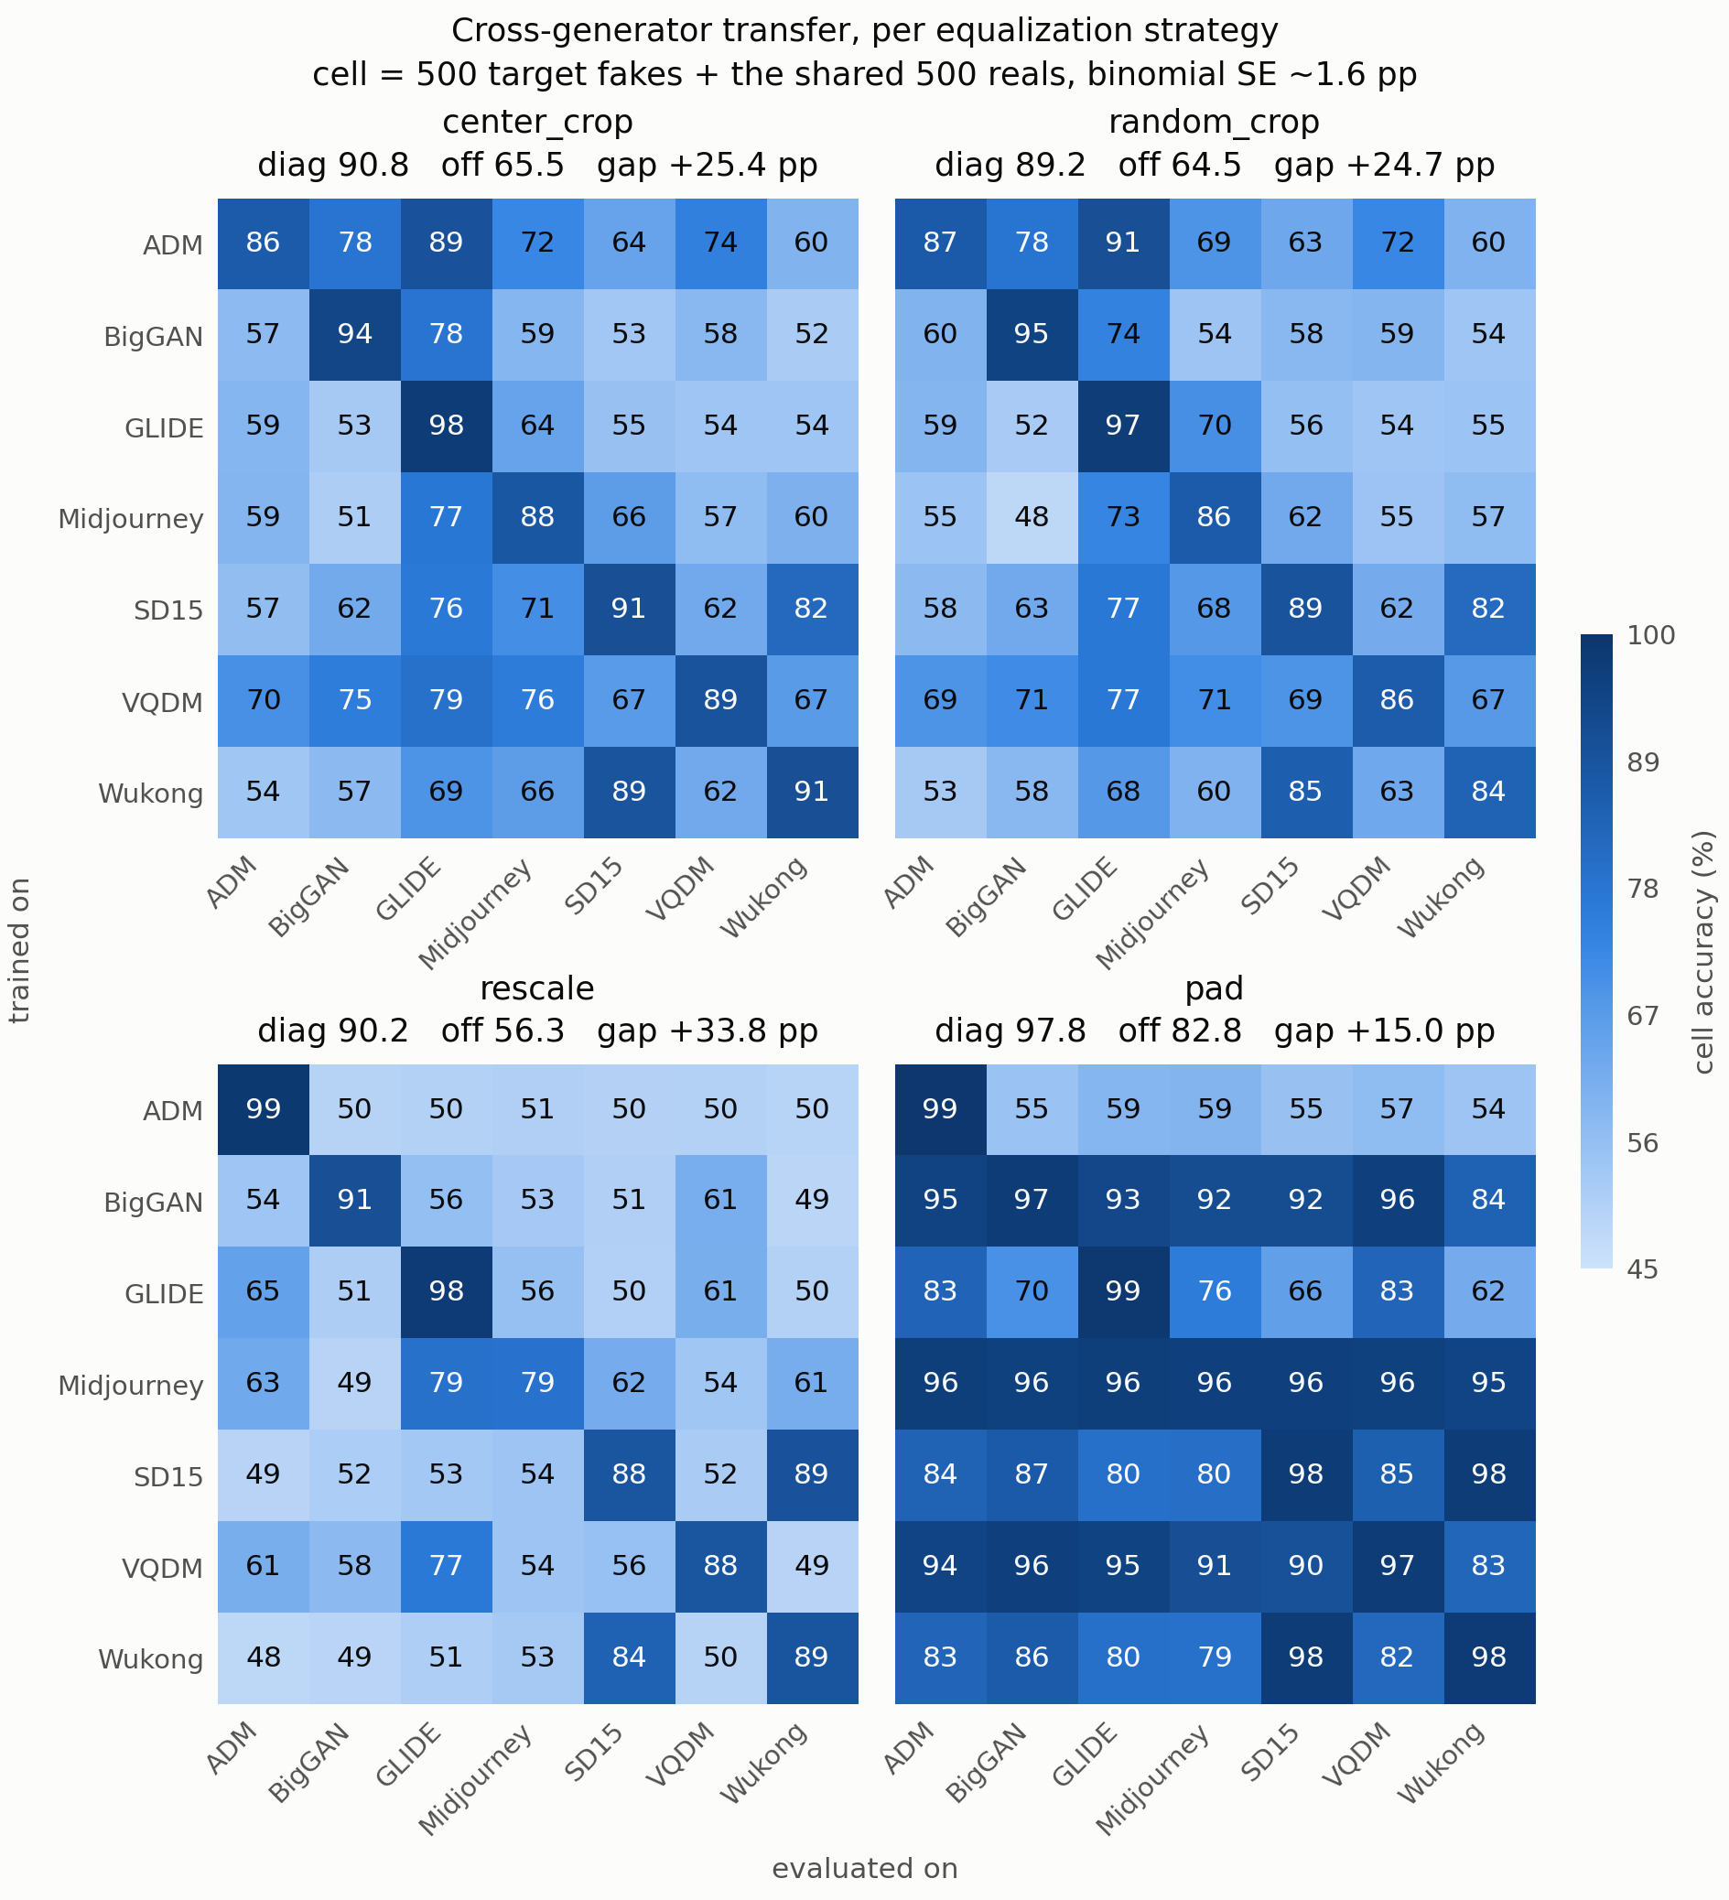
Figure 1. Cross-generator transfer accuracy under each size-equalization strategy. Rows are the generator a detector trained on, columns the generator it was evaluated on; each cell is the mean of two seeds over n = 1,000 balanced images, and all four panels share one color scale. The diagonals are broadly similar; the off-diagonal structure is not, and that difference is the result. ADM's row is the clearest case: strong under center_crop and random_crop, at chance under rescale.
The ranking does not survive the correction. This is the main result, and Figure 2 shows it. The two strategies that do not resample, center_crop and random_crop, agree almost perfectly on which generators yield transferable detectors (ρ = +0.964, p = 0.003). That agreement is the anchor: it shows the ranking is a stable, reproducible property of the data. Measured against it, rescale produces a ranking that retains none of the same structure (ρ = 0.000), and the movement is not a mild reshuffle. ADM is the best source generator under both cropping strategies and the worst under rescaling, a first-to-last inversion across seven positions. Two papers using the same data, architecture and protocol would disagree about which generator is hardest, purely because one rescaled and the other cropped. Ranked by target generator instead, the same comparison gives ρ = +0.286; we report the source axis because the claim concerns which training generator yields a transferable detector.
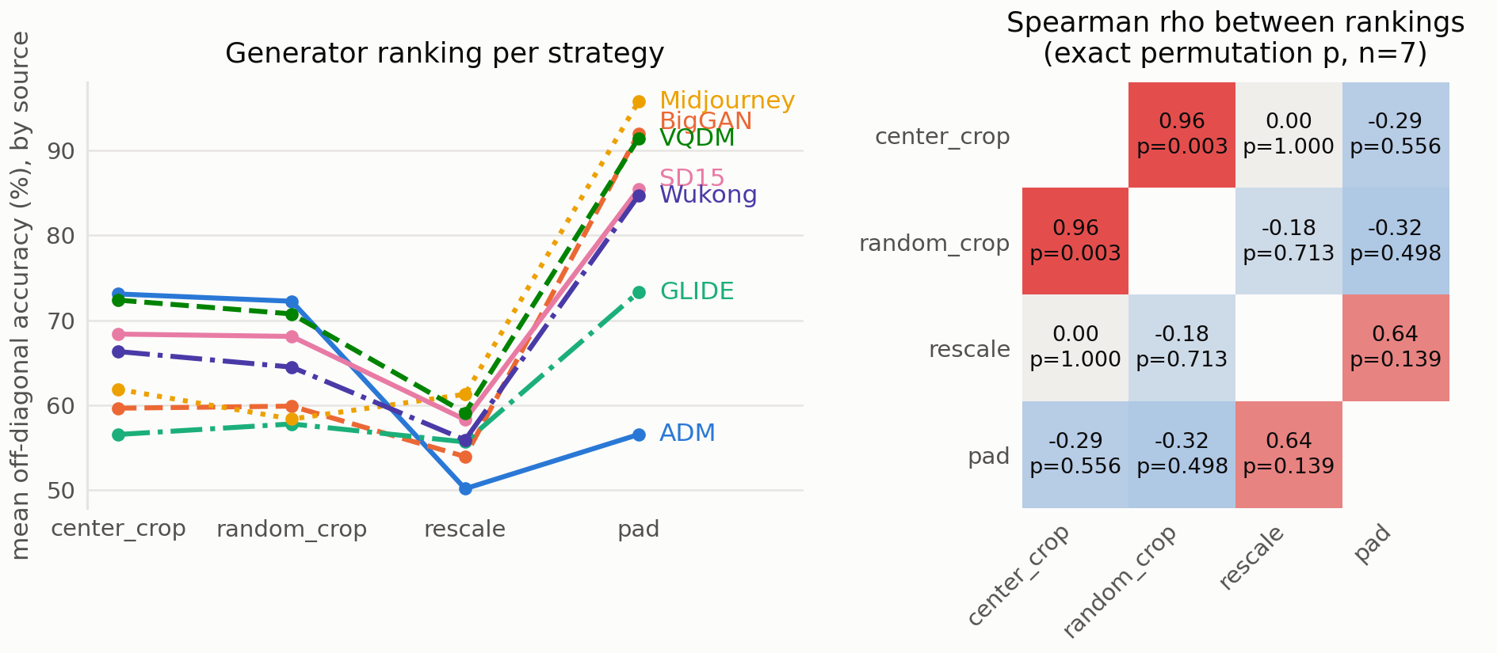
Figure 2. Left: mean off-diagonal accuracy of each generator used as a training source, under each strategy; the vertical order of the lines is the ranking. Right: Spearman ρ between the four rankings, with exact permutation p-values. The two strategies that do not resample almost coincide (ρ = +0.964), which shows the ranking is a stable property of the data. Rescaling reorders it, and ADM in particular falls from first place to last.
We are careful about what ρ = 0.000 supports. At n = 7 it is absence of evidence for an association, not evidence of independence. The claim rests on the positive finding, the +0.964 agreement between the two non-resampling arms, and on the size of the movement: per-cell disagreement between seeds averages 0.012 to 0.024 and never exceeds 0.076, so a seven-position inversion sits far outside seed noise.
pad does not remove the confound; it re-encodes it. Figure 1 shows pad with by far the best transfer (0.828), and reporting that as the best correction would be the central mistake this project exists to catch. Because every generator is square and only real photographs have variable aspect ratio, padding adds a black border to real images and to nothing else, so the border is a perfect proxy for the real class. A detector reading only the border would ceiling at (1.000 + 0.954)/2 = 0.977, and pad's measured diagonal is 0.978. Two further observations agree. Transfer between generators sharing a native resolution exceeds transfer between those that do not by +0.113, +0.113 and +0.135 for the other three strategies, but by only +0.007 for pad, whose transfer is therefore indifferent to generator similarity, exactly as a border-reader would be. Pad also converges fastest, at a mean best epoch of 26.6 against 32.6 to 33.6. Higher accuracy here marks a worse experiment, not a better detector. Attribution confirms this directly in §6.
6 Analysis
Is the weak transfer simply an undertrained small CNN? No. Scoring each saved checkpoint on its own training set separates the three regimes (Table 3) and rules out a capacity explanation.
 | Train | In-domain test | Cross-generator
center_crop | 0.967 | 0.908 | 0.655
rescale | 0.982 | 0.902 | 0.563
Table 3. Three-level decomposition for the two arms that differ only by resampling, 14 runs each. Rescale fits its training set better than center_crop, matches it on held-out images of the same generator, and collapses only when the generator changes. The middle column is the in-domain diagonal of Figure 1. Train accuracy is recomputed from the saved checkpoints; as a guard, recomputed validation accuracy reproduced the value recorded during training exactly in all 28 runs.
At 96.7% to 98.2% training accuracy the network is close to memorizing its 3,600 images, so the modest in-domain accuracy is a variance limit rather than a bias limit. We did not run a width sweep, so the epoch-budget control below is our only capacity-adjacent evidence, but it rules out an undertrained network as the explanation for the low diagonal. The decomposition also sharpens the headline: resampling does no measurable in-distribution damage. The two arms separate by 0.092 only in the cross-generator column. A practitioner validating in-distribution would see no reason for concern. The per-generator spread is uneven: Midjourney under rescale carries the widest train/val gap anywhere (0.152 and 0.159 across the two seeds), while ADM under rescale has essentially none. An epoch-budget control agrees: doubling training from 40 to 80 epochs on three generators raised in-domain accuracy by 0.020 while cross-generator accuracy moved by −0.007. More training buys in-distribution fit and nothing in transfer.
An open observation. ADM behaves inconsistently in a way we can measure but cannot explain. Under center_crop it is the hardest generator in the study (in-domain 0.863); under rescale it is nearly trivial (0.986) while its transfer falls to chance (0.501, the lowest anywhere). ADM is the only PNG generator in an otherwise JPEG dataset, but that asymmetry predicts ADM should be easiest under center_crop, where native pixels and real-image JPEG blocking both survive, and we observe the opposite. Since ADM's row feeds the ranking, we report this as unresolved rather than offer a mechanism we have not tested.
Cue-level evidence: the pad model is reading its border. Input-gradient attribution tests the §5 argument against the model's internals rather than its behavior. For each test image we take saliency = max-channel |∂f(x)/∂x|, normalize each map to sum to one and average 200 images per tag; border mass is the fraction of that mean map falling in the outer 16-pixel ring, against a uniform null of 0.4375. Table 4 reports all four arms at seed 0.
Strategy | Real | Generators | Real ranked first
center_crop | 0.4345 | 0.4243 | 0 of 7
random_crop | 0.4310 | 0.4175 | 1 of 7
rescale | 0.3793 | 0.3721 | 2 of 7
pad | 0.5613 | 0.4113 | 7 of 7
Table 4. Mean border mass by strategy, over the seven detectors trained in each arm. The last column counts runs in which the real class ranked above all seven generators. Pad's separation is an order of magnitude larger than any other arm's, and it is the only one present in every run.
The separation is consistent, not an average over a few strong runs: every pad run exceeds +0.11, and no run in any other arm reaches +0.04, so the two groups do not overlap. Pad's generator border mass, 0.411, is in line with the other arms, so padding does not raise saliency at the edges in general; only the class that receives a border is affected. Under pad the outer ring of a real image is mostly constant zero, so gradient mass concentrated there is evidence about the border itself. This confirms from inside the model what §5 inferred from accuracy alone. Rescale also draws on the most centrally concentrated evidence of the four arms, 0.373 against 0.419 to 0.430.
Radially averaged spectra close the loop. The motivation in §1 assumed that resampling attenuates the frequencies carrying the generative signal. The spectra confirm it. Averaged over frequencies above 0.35 cycles per pixel, the real-minus-fake gap in log power is +0.256 for center_crop and +0.253 for random_crop, but only +0.075 for rescale and +0.058 for pad. Both resampling arms lose roughly two thirds of the high-frequency separation the crops retain, which is the mechanism behind the transfer collapse in Figure 1.
7 Discussion: insights, limitations and future directions
Insights. Three findings survive our controls. First, a zero-parameter size rule transfers better than all four trained detectors, so cross-generator numbers reported without an explicit size correction are largely uninterpretable. Second, the correction is not a neutral preprocessing detail: strategies preserving native pixels agree on generator difficulty (ρ = +0.964) while resampling gives an unrelated ordering, so a published ranking depends partly on a choice that is rarely reported. Third, a correction can raise accuracy while making the experiment worse, as pad does by trading the size cue for a border cue that attribution finds in all seven of its runs and in none elsewhere. Cross-generator work should treat size equalization as a first-class methodological choice and report more than one.
Limitations. We test one architecture at one input resolution; a larger or pretrained backbone might rank generators differently, though pretraining is unavailable here because the real class is ImageNet. Two seeds per cell place the inversion outside noise but do not give tight per-cell intervals. The rank correlations rest on n = 7 generators, the full width of the benchmark. We use a 35,000-image subset rather than full GenImage, and the attribution of §6 covers seed 0 only. The ADM anomaly is unexplained.
Future directions. Re-encoding ADM as JPEG and re-running its row would separate format from resolution, and repeating the comparison on full GenImage with a ResNet50 would test whether the reordering persists at scale.
8 References
[1] S.-Y. Wang, O. Wang, R. Zhang, A. Owens and A. A. Efros. CNN-generated images are surprisingly easy to spot... for now. CVPR 2020. arXiv:1912.11035.
[2] M. Zhu, H. Chen, Q. Yan, X. Huang, G. Lin, W. Li, Z. Tu, H. Hu, J. Hu and Y. Wang. GenImage: A Million-Scale Benchmark for Detecting AI-Generated Image. NeurIPS 2023, Datasets and Benchmarks Track. arXiv:2306.08571.
[3] P. Grommelt, L. Weiss, F.-J. Pfreundt and J. Keuper. Fake or JPEG? Revealing Common Biases in Generated Image Detection Datasets. 2024. arXiv:2403.17608.
[4] K. Simonyan, A. Vedaldi and A. Zisserman. Deep Inside Convolutional Networks: Visualising Image Classification Models and Saliency Maps. ICLR Workshop 2014. arXiv:1312.6034.
[5] Tiny-GenImage dataset. Hugging Face, TheKernel01/Tiny-GenImage. License CC BY-NC-SA 4.0.
9 Contribution of each team member
Ido Josephsberg | Noa Keter
Data pipeline and cache build (data.py); training loop and checkpointing (train.py); 28 of the 56 runs (center_crop, rescale); train/validation diagnostic (trainval.py); transfer-matrix and ranking analysis (analyze.py); the ensemble ablation (ensemble.py, logits.py); run notebooks; README. Report: motivation, models and hyperparameters, results. | Model architecture (model.py); the two zero-parameter baselines (baseline.py); 28 of the 56 runs (pad, random_crop); the cue-level analysis (04_cues.ipynb), input-gradient attribution across all four arms; publication-scale figures; project presentation. Report: related work, data, analysis, discussion, references and assembly.
Code and reproducibility. All code, the exact run commands, the split definitions and every metrics.json produced by the 56 runs are in the public repository at https://github.com/noa-keter/deep-learning. The cache build is deterministic and seeds are fixed, so each reported cell reproduces from a clean clone. The README gives the exact commands.

