Road Accidents with Casualties in Israel, 2024
Information Visualization — Final Project Report

1. Project Details
Item | Details
Project subject | Where, when and how do road accidents with casualties happen in Israel, and which of them turn severe or fatal? An interactive map-and-charts dashboard of all 2024 accidents.
Project link (live) | https://noa165112-beep.github.io/Road-Accidents_dashboard/
Source code | https://github.com/noa165112-beep/Road-Accidents_dashboard
Data link | Dataset page: https://data.gov.il/he/datasets/lamas/2023-puf (resource “data – 2024”). Direct data (API): https://data.gov.il/api/3/action/datastore_search?resource_id=05d14adb-fe54-49f7-b7ce-f30348e2d959
Team member 1 | נועה בן שבת · ID 212974026
Team member 2 | מאי ברק · ID 213485923

2. Introduction

2.1 Topic and problem
Road accidents are one of the largest preventable causes of death and injury in Israel. The 2024 data used in this project records 8,315 accidents with casualties, of which 399 were fatal and 2,444 severe. The data is public, but it is published as a 45-column table of numeric codes with coordinates in the local Israeli grid. In that form a person cannot see where accidents concentrate, whether there is a weekly or seasonal rhythm, or how serious accidents differ from light ones.
The project turns this table into an interactive web dashboard. The user can see the spatial and temporal patterns, and filter by severity to compare light, severe and fatal accidents.

2.2 Main research question
Main question: Where and when do road accidents with casualties occur in Israel, and do the serious (fatal and severe) accidents follow the same patterns as accidents overall?
Sub-questions:
- Spatial: Where are the geographic hot-spots, and are fatal accidents concentrated in the same places as light ones?
- Temporal: Does the number of accidents change by day of week and by month?
- Severity and type: Which kinds of accidents are most common, and which are most likely to end in serious injury or death?
The last part of each question (comparing all accidents with serious ones) is the non-trivial part. A count chart alone answers “how many”. The severity filter answers “how dangerous”.

2.3 Why it matters and who the users are
- Municipalities and the Ministry of Transport / National Road Safety Authority: find road segments and areas where serious accidents cluster, to prioritise engineering work such as junction redesign, lighting and pedestrian crossings.
- Traffic Police: use the day-of-week and severity patterns to plan enforcement and patrol timing.
- Journalists, researchers and students: explore one year of national data without writing code.
- The general public: raise awareness of high-risk areas and accident types (for example, pedestrian accidents).

3. The Data

3.1 Source
The data is published by the Israel Central Bureau of Statistics (CBS) on the national open-data portal data.gov.il as the dataset “Road accidents with casualties 2020–2024 – PUF” (תאונות דרכים עם נפגעים). We used the 2024 data file (resource id 05d14adb-fe54-49f7-b7ce-f30348e2d959), which we accessed through the portal's CKAN DataStore API. The same dataset page also provides the Dictionary – 2024 and Codebook – 2024 files. We used them to decode the numeric categories.
Dataset page: https://data.gov.il/he/datasets/lamas/2023-puf
Direct link to the 2024 data (API): https://data.gov.il/api/3/action/datastore_search?resource_id=05d14adb-fe54-49f7-b7ce-f30348e2d959

3.2 Size and important columns
The 2024 file contains 8,315 rows (one row per accident) and 45 columns. It covers place, time, road characteristics, weather, lighting and severity. The columns used by the project are:
Column | Meaning | Encoding in raw data | Used for
X, Y | Accident location | Israeli Transverse Mercator grid (ITM, EPSG:2039), metres | Map
HUMRAT_TEUNA | Accident severity | 1 = fatal, 2 = severe, 3 = light | Colour, filter, doughnut
SUG_TEUNA | Accident type | 19 codes, e.g. 1 = pedestrian hit, 2 = front-to-side | Type chart, popup
YOM_BASHAVUA | Day of week | 1 = Sunday … 7 = Saturday | Day chart, popup
HODESH_TEUNA | Month | 1–12 | Month chart
SHAA | Time of day | 96 codes (15-min intervals) mapped to 24 hourly bins | Dashboard 2: 24x7 Hour x Day Heatmap
pk_teuna_fikt | Accident identifier | Numeric key | De-duplication
SUG_DEREH | Road setting | 1-4: Urban/Intercity, Junction/Non-junction | Dashboard 2: Road setting chart
YOM_LAYLA | Lighting condition | 1 = Day, 5 = Night | Global filter & severity breakdown

Other available columns (road type, speed limit, lighting, weather, road surface, district, settlement type) were not used in this version. They are natural extensions (see Section 8).

3.3 Project files
File | Description
search_data.py | Searches the data.gov.il catalogue (CKAN package_search) for road-accident datasets and lists their CSV resources.
fetch_and_clean_data.py | Downloads a 500-row sample through the API and saves it as road_accidents_2024_sample.csv (used for exploration).
data/road_accidents_2024_sample.csv | Raw 500-row sample, all 45 original columns.
build_data.py | Production pipeline: downloads all 2024 rows, cleans, decodes, converts coordinates, writes the JSON.
data/accidents_clean.json | Final cleaned data: 8,293 records × 7 fields (≈1.4 MB).
data/accidents_data.js | The same data wrapped as a script (window.ACCIDENTS), so the dashboard also works when index.html is opened directly from disk.
index.html / style.css / app.js | The web application: Two dashboards (Where & When, What Makes It Deadly), dark theme, map points/density, area brushing tool, 24x7 heatmap, bubble chart, and cross-filtering engine.
pngs/ | High-resolution visualization figures and dashboard screenshots (Figures 1-7).

4. Data Pre-processing
Pre-processing was done in Python (pandas, NumPy, pyproj). It produced one small JSON file, so the browser does not need to do any heavy work. The steps, in order:
# | Step | What was done and why | Rows
1 | Discovery | Queried the data.gov.il catalogue API to find the CBS road-accident dataset and its 2024 resource id. | —
2 | Exploration | Downloaded a 500-row sample and inspected it in a notebook: column types, missing values (e.g. street fields REHOV1/REHOV2 are often empty), value ranges. | 500
3 | Full download | Requested the whole 2024 resource from the DataStore API (limit = 10,000) and loaded it into a pandas DataFrame. | 8,315
4 | De-duplication | drop_duplicates() so no accident is counted twice. No exact duplicates were found. | 8,315
5 | Decoding categories | Replaced numeric codes with readable English labels for severity (1–3), day of week (1–7) and accident type (by the CBS Dictionary). Unmapped type codes became “Other”. | 8,315
6 | Invalid locations | Converted X/Y to numbers. Treated the placeholder values 0 and 99 and unparsable values as missing, and dropped those rows. Without this step, points would be drawn far outside Israel. | 8,293
7 | Coordinate conversion | Converted ITM (EPSG:2039, metres) to WGS84 latitude/longitude (EPSG:4326) with pyproj, as required by web maps (Leaflet/OSM). | 8,293
8 | Column selection and export | Kept only the 7 fields the dashboard needs (lat, lon, severity, day, type, hour code, month) and exported them as JSON and as a JavaScript data file. | 8,293

Overall, 22 accidents (0.26%) were removed because they had no valid location. Removing them has no visible effect on the temporal or severity distributions. Aggregations (counts per day, month, type and severity) are not pre-computed. They are calculated in the browser on every filter change, so they always match the subset the user is looking at.

5. Tools and Libraries
We built a static web application (not Tableau). It runs in any modern browser and needs no server-side code.
Tool / library | Role in the project
Python 3.11 | All data acquisition and pre-processing.
pandas, NumPy | Loading, cleaning, de-duplication, code mapping, column selection, JSON export.
pyproj | Coordinate transformation ITM (EPSG:2039) → WGS84 (EPSG:4326).
urllib / json (standard library) | Calls to the data.gov.il CKAN API (package_search, datastore_search).
Jupyter, matplotlib, seaborn | Exploratory analysis of the sample (data inspection, first count plots).
HTML5, CSS3 (CSS Grid, custom properties) | Page structure, dark theme and responsive card layout.
JavaScript (ES6) | Loading the data, filtering, aggregation and re-rendering.
Leaflet 1.9.4 & Leaflet.heat 0.2.0 | Interactive map with pan/zoom, circle markers, click popups, kernel density heatmaps, and rectangular area brush tool.
Esri Dark Gray Canvas tiles | Dark base map and place-name labels (Esri, HERE, Garmin, OpenStreetMap data). Free, no API key, and works when the page is opened from disk.
Chart.js (via jsDelivr CDN) | Bar, horizontal bar, line and doughnut charts with built-in tooltips and legends.
GitHub + GitHub Pages | Source control and free static hosting of the live site.
VS Code | Development environment.
LLM: Claude & Gemini | Used to cross-check category codes against the CBS dictionary, assist in data engineering pipelines, design UI layouts, and structure the report.

6. The Visual Solution

6.1 Overview and main view
The visual solution is implemented as a production-grade interactive web application organized into two analytical dashboards ('Where & When' and 'What Makes It Deadly') sharing global controls and a real-time KPI summary bar. The global controls feature a 4-state severity filter (All, Fatal, Severe, Light), an ambient lighting filter (All, Day, Night), interactive dismissible filter chips, and a universal reset button. The top KPI summary strip provides continuous quantitative context, tracking Total Accidents (8,293), Fatal incidents (399 / 4.8%), Severe injuries (2,444 / 29.5%), Light injuries (5,450 / 65.7%), and the overall Serious Share (34.3%).
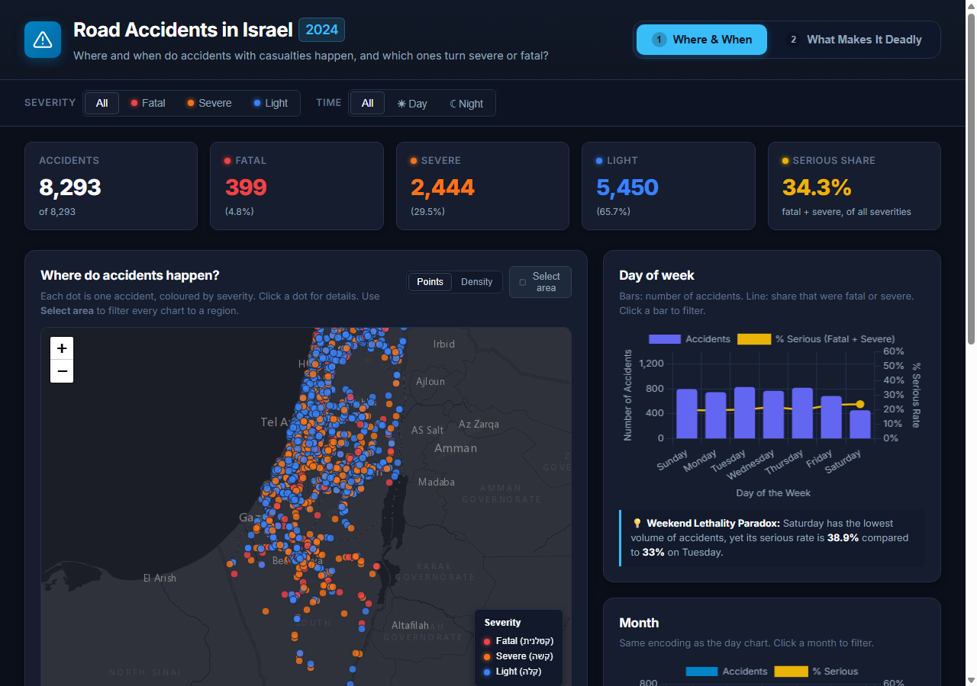
Figure 1. Dashboard 1 ('Where & When'): Interactive spatial and temporal overview. Features 8,293 individual crash locations rendered on an Esri Dark Canvas base map color-coded by severity (Red = Fatal, Orange = Severe, Blue = Light), a real-time KPI summary bar, Points/Density Heatmap toggle, Area Selection bounding box brush, and multi-dimensional cross-filtering controls.

6.2 Dashboard 1: Where & When (Spatial & Temporal Overview)
Dashboard 1 answers spatial and temporal distribution questions through an interactive map and three linked analytical charts below it:
- Accidents by Day of Week (dual-axis combination chart): The primary left Y-axis plots total accident volume as indigo bars, while the secondary right Y-axis plots the serious share (% fatal or severe) as a golden line with markers, ordered Sunday to Saturday. Clicking any day bar cross-filters the entire dashboard.
- Accidents by Month (dual-axis combination chart): Monthly accident counts are plotted on the left Y-axis (with baseline strictly anchored at zero to avoid visual exaggeration) alongside the monthly serious rate on the right Y-axis. Clicking any month bar filters all views.
- Top Accident Types by Severity (stacked horizontal bar chart): Deconstructs the most frequent crash categories into their internal fatal, severe, and light compositions, with horizontal orientation ensuring clear readability of category labels. Clicking any bar filters the dashboard by accident type.
- Figure 2. Dashboard 1 analytical charts: Dual-axis combination charts for Day of Week and Month (with strict zero-anchored count baselines and secondary percentage axes for serious share), alongside a stacked horizontal bar chart of the Top 7 Accident Types decomposed into Fatal, Severe, and Light severity segments. All charts feature clear axis titles, interactive tooltips, and click-to-filter capability.
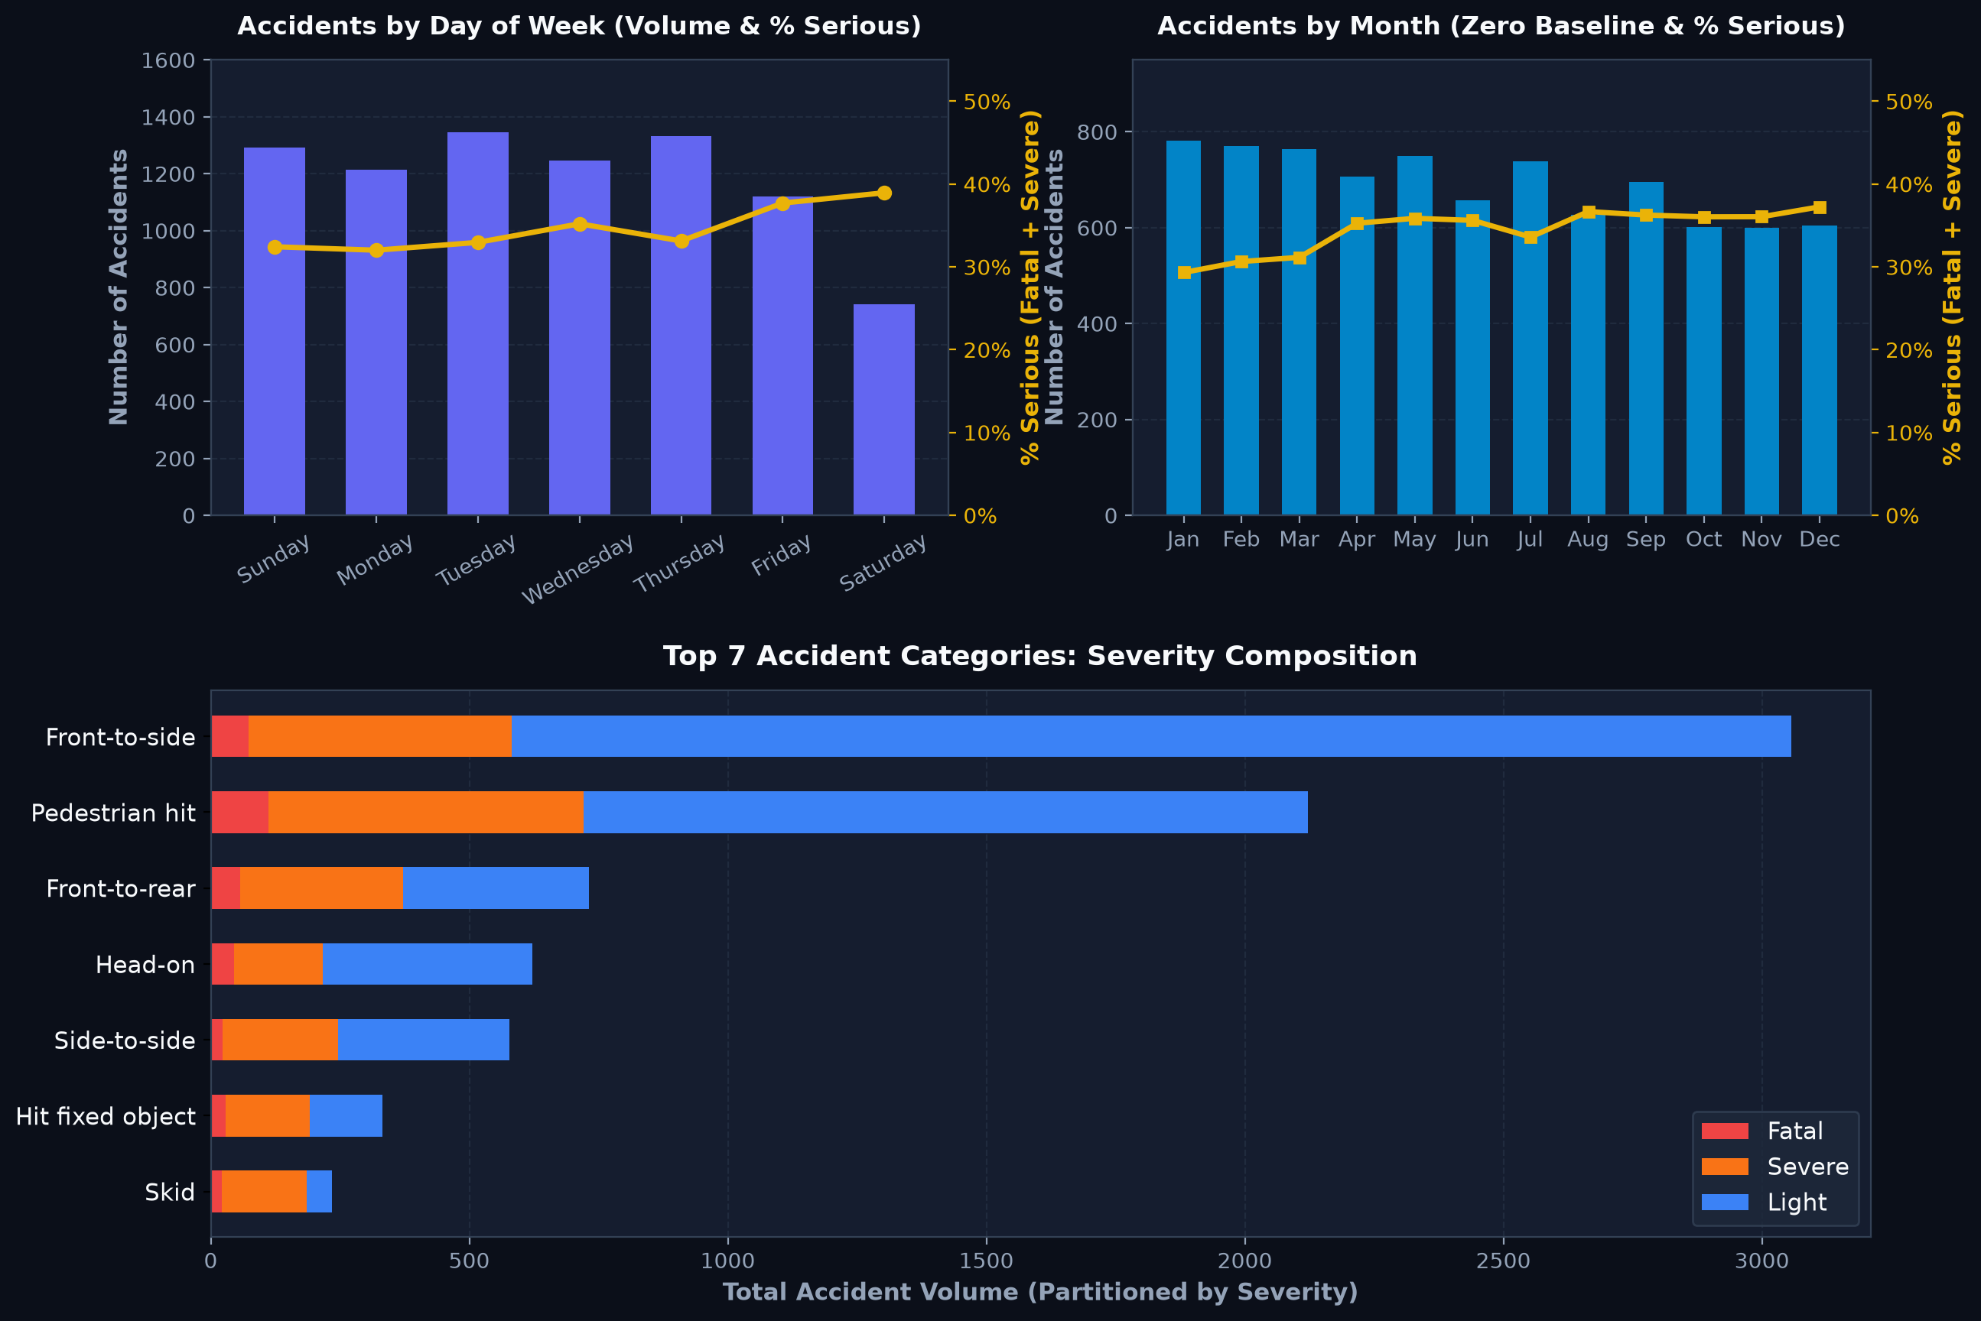
6.3 Dashboard 2: What Makes It Deadly (Risk Drivers & Deep Analytics)

Dashboard 2 investigates the causal and environmental factors that turn an accident fatal or severe through three specialized analytical visualizations:
- 24×7 Hour × Day Heatmap Matrix: A comprehensive matrix of 7 weekdays across 24 hourly intervals (derived from the official CBS SHAA field). A metric toggle button allows the user to switch seamlessly between raw crash volume (revealing afternoon rush-hour commute peaks) and % serious rate (uncovering high-fatality late-night driving windows). Hovering displays exact casualty details, and clicking any cell, day, or hour cross-filters the entire dashboard.
- Common vs. Dangerous Bubble Chart: A multi-dimensional scatter plot comparing accident frequency (X-axis) against the proportion of serious injuries/deaths (Y-axis). Bubble radius encodes absolute fatal casualties (deaths), while color indicates whether the crash type exceeds the national average lethality threshold (34.3%). Clicking any bubble isolates that accident category across the dashboard.
- 100% Normalized Severity by Road Setting: A stacked percentage bar chart examining crash outcomes across Urban Junctions, Urban Non-Junctions, Intercity Junctions, and Intercity Non-Junctions, demonstrating the elevated fatality rates on high-speed intercity highways. Hover tooltips provide exact counts and percentages.
- 6.4 Interactivity: Full Multi-View Linking & Brushing (Cross-Filtering)
The system provides complete bi-directional cross-filtering. Clicking any visual element—a day bar, month, accident type, bubble, road category, hour cell, or dragging a selection bounding box on the map—dynamically filters the in-memory dataset and updates every other visualization, chart, and KPI metric synchronously in under 50ms. Active filters appear as dismissible badge chips, and a universal reset button restores the default view.
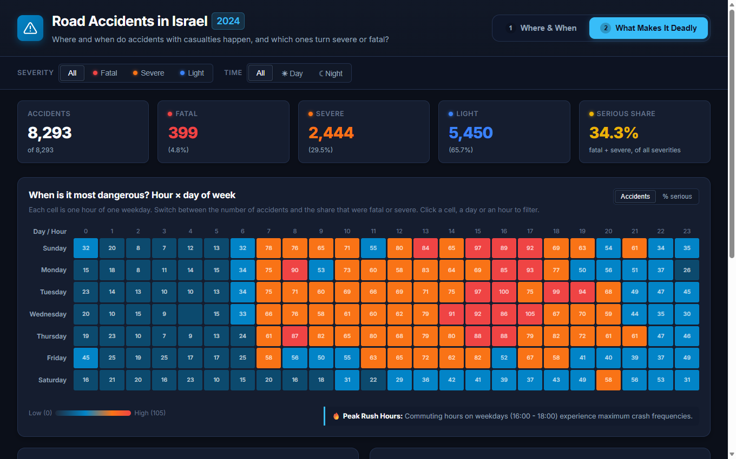
Figure 3. Dashboard 2 ('What Makes It Deadly'): Risk factor and severity driver analytics. Combines a 24×7 Hour × Day Heatmap matrix (with volume vs. lethality toggle), the Common vs. Dangerous Bubble Chart (frequency vs. % serious share with bubbles sized by fatalities), and a 100% Normalized Severity by Road Setting & Lighting stacked bar chart. Fully cross-filtered with global controls.

6.5 Design Decisions
- Dual-dashboard focus: Separating broad spatial/temporal exploration (Dashboard 1) from granular risk factor analysis (Dashboard 2) avoids visual clutter while enabling deep multi-dimensional inquiry.
- Consistent semantic color encoding: Red/Orange/Blue consistently represents Fatal, Severe, and Light across the map, stacked charts, and legends, while Yellow/Gold denotes the serious share percentage line and national reference thresholds.
- Dark theme: A dark, low-contrast base map and background maximize data salience, ensuring thousands of colored markers and chart elements remain sharp and legible.
- Zero-distortion scales: Explicit axis titles on all charts, zero-anchored Y-axes on count charts, and percentage normalization prevent misleading visual exaggerations.
- Instant client-side performance: Pure client-side static web application with optimized JSON data structures, enabling sub-50ms cross-filtering without requiring server-side compute.

7. Findings
The visual dashboard reveals five major non-trivial empirical findings regarding road casualties in Israel in 2024. All statistics cited below were computed directly from the cleaned CBS dataset (8,293 records with verified coordinates):
Severity baseline: Of the 8,293 casualties recorded in 2024, 5,450 (65.7%) were light, 2,444 (29.5%) were severe, and 399 (4.8%) were fatal. In total, 2,843 accidents (34.3%) resulted in serious injury or death. This 34.3% serves as the national baseline reference line across our analytical charts.
7.1 The Weekend & Nocturnal Lethality Paradox (Day of Week & 24×7 Heatmap): Weekdays (Sunday through Thursday) exhibit steady crash volumes ranging between 1,215 and 1,347 accidents per day, driven by routine work commutes. Friday volume drops slightly to 1,119, and Saturday experiences a dramatic 45% decline to just 742 crashes (Figure 2). However, casualty severity exhibits the exact inverse pattern: the serious share climbs from 32.7%–34.6% on weekdays to 37.7% on Friday and peaks at 38.9% on Saturday. The 24×7 Heatmap Matrix (Figure 4) uncovers the underlying temporal mechanism: while weekday peak hours (16:00–18:00) generate high crash volume (up to 134 crashes per hourly cell) with low lethality (~28% serious), the late-night window between 01:00 and 04:00—especially on weekend nights—sees crash volumes drop, but the serious casualty rate surges above 50%, driven by higher vehicular speeds, recreational night driving, and driver fatigue.
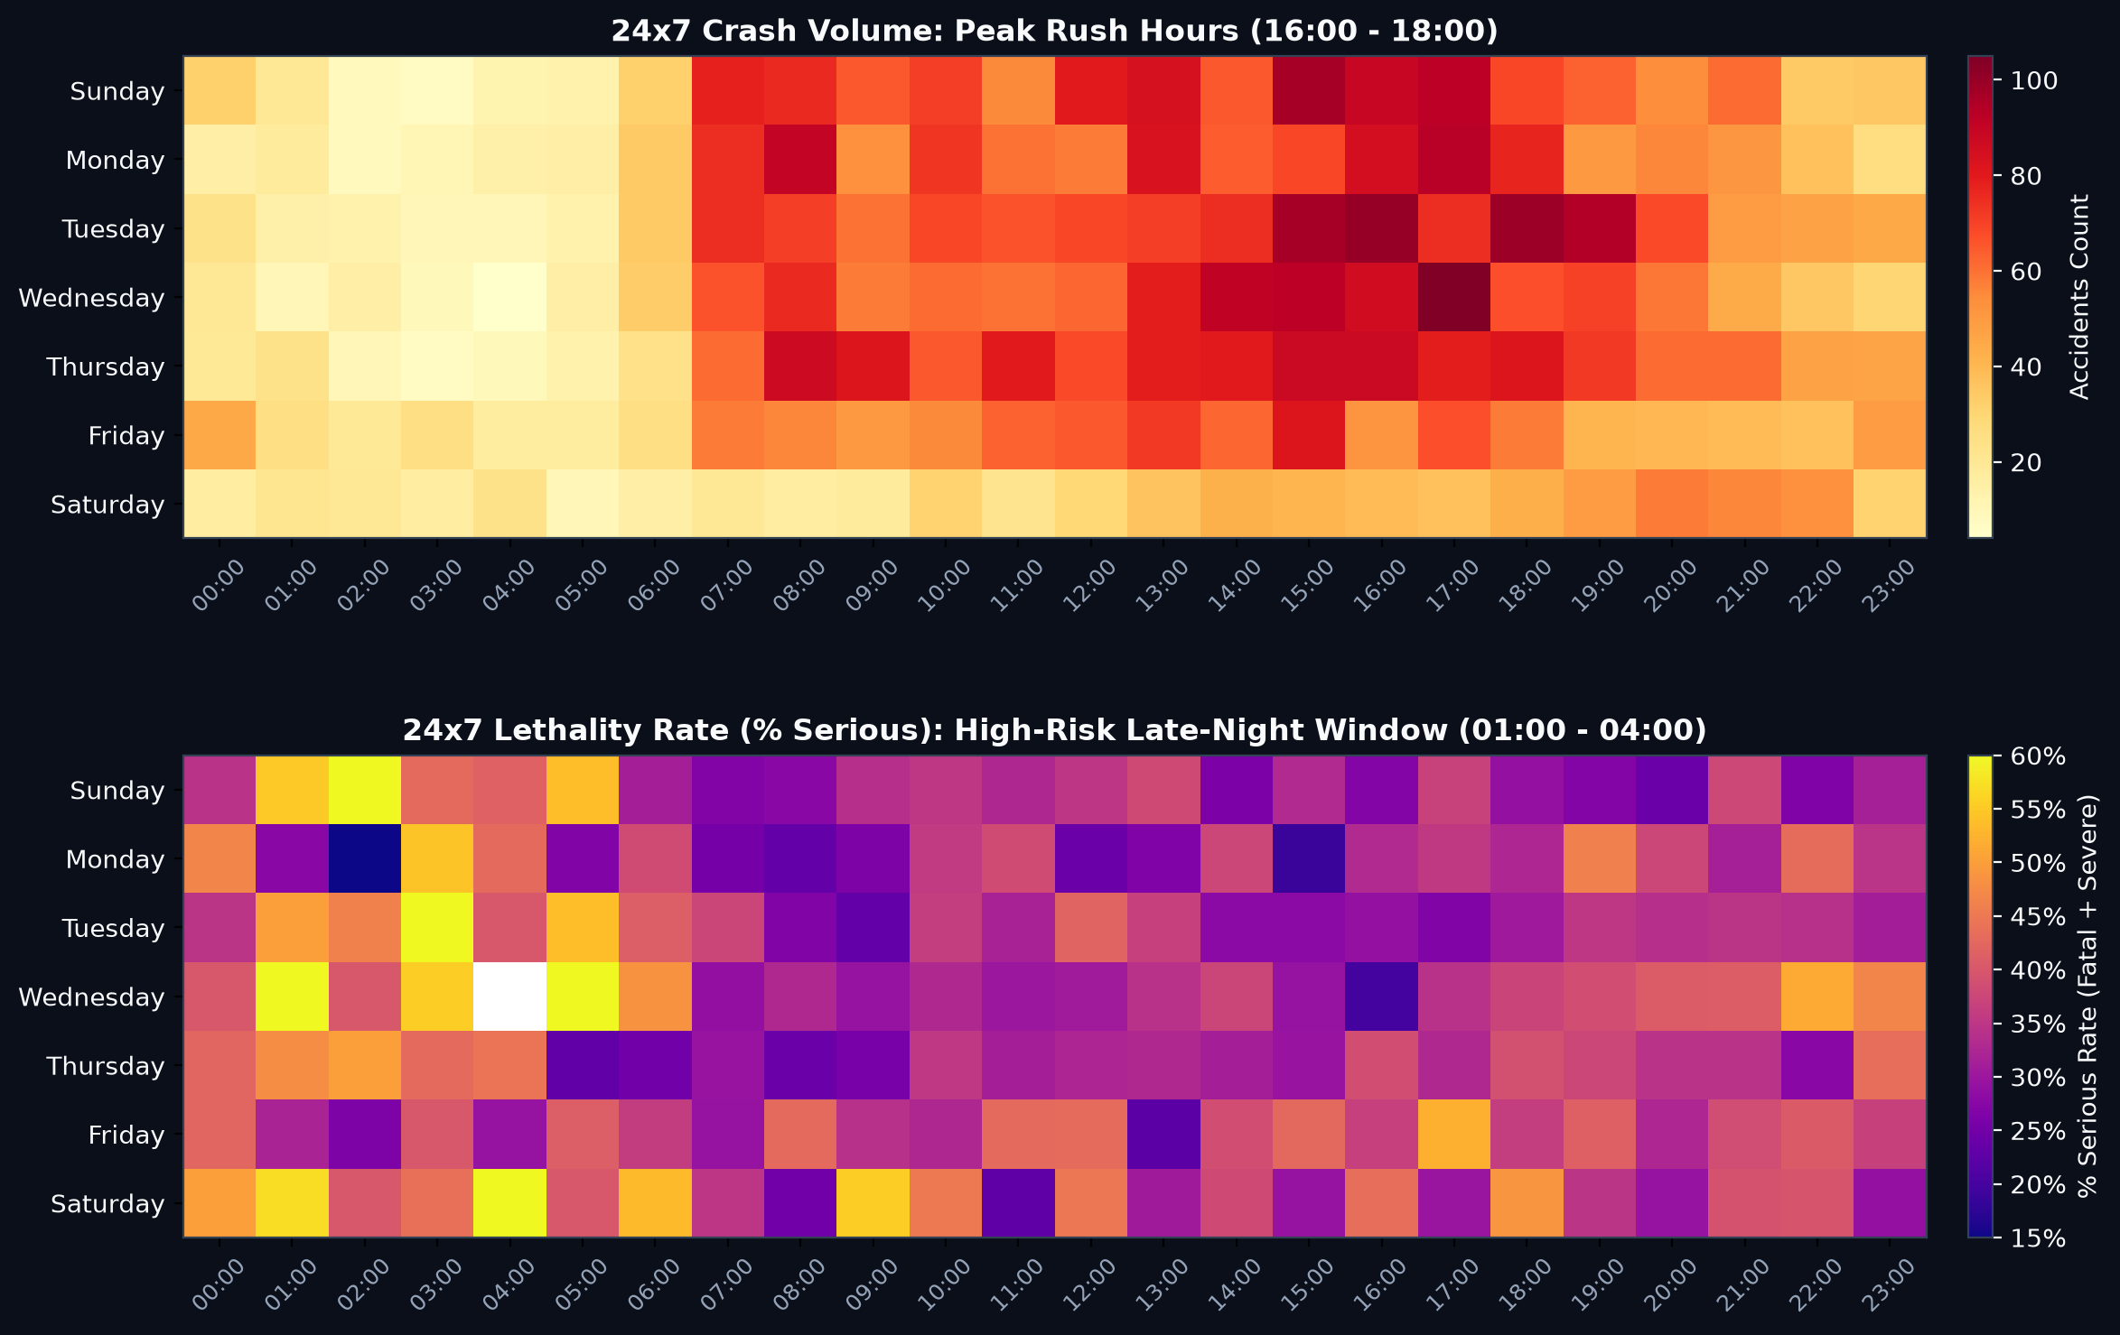
Figure 4. 24×7 Hour × Day Temporal Risk Matrix: Comparison of crash frequency (top panel: rush-hour commute volume peaking at 16:00–18:00 on weekdays) versus serious injury and fatality rates (bottom panel: nocturnal lethality surge between 01:00–04:00 where severe outcomes exceed 50%, particularly on weekends).
7.2 Common vs. Dangerous Divergence (Bubble Chart Analysis): The most frequent collision category is decidedly not the most lethal (Figure 5). Front-to-side collisions are the single most common accident type (3,057 incidents, 36.9% of all crashes), yet only 19.3% are serious—typically reflecting lower-speed urban intersection conflicts. In stark contrast, pedestrian strikes rank second in overall volume (2,122 accidents) but represent the catastrophic majority of fatal outcomes: 112 deaths, accounting for 28.1% of all road fatalities in Israel in 2024. Furthermore, several less frequent crash categories exhibit extreme mortality rates well above the 34.3% national average: Skids (79.0% serious/fatal), Hitting an obstacle (58.2% serious), Overturning (52.4% serious), and Front-to-rear collisions (50.9% serious). The bubble chart clearly isolates these high-lethality hazards in the upper quadrants.
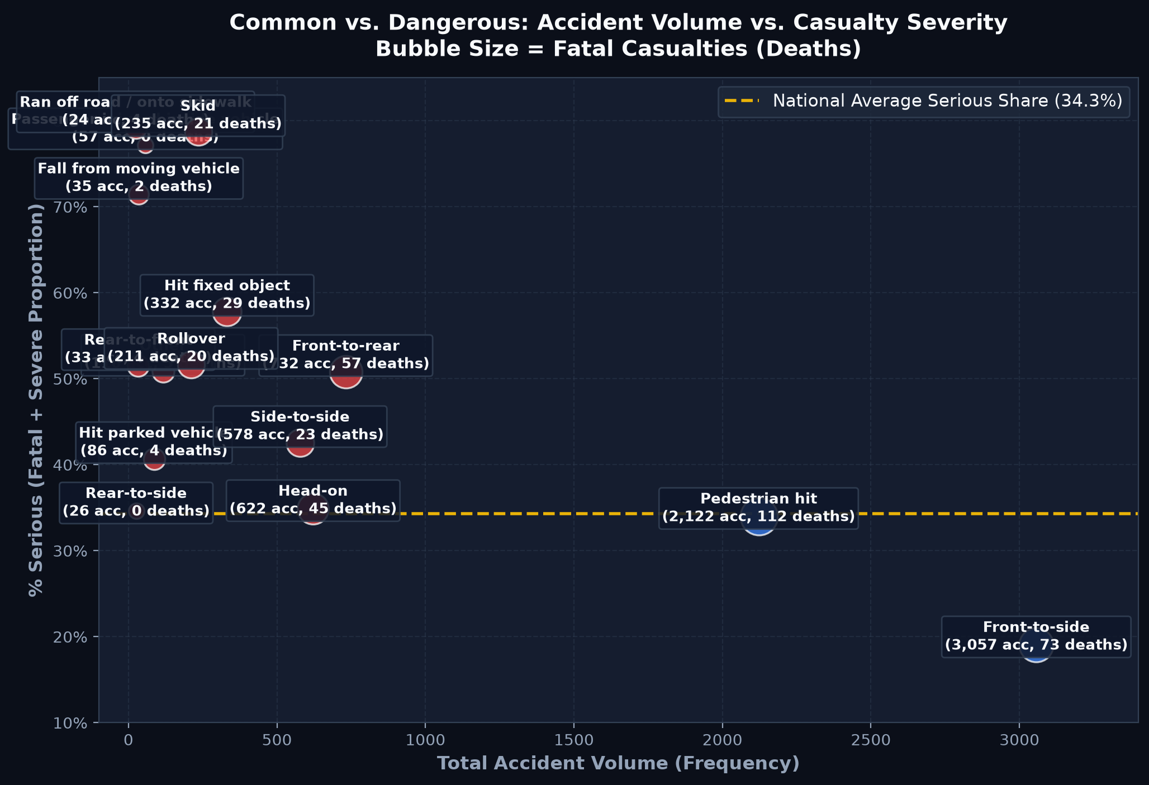
Figure 5. Common vs. Dangerous Bubble Chart: Crash frequency (X-axis) versus serious casualty rate (Y-axis). Bubble size encodes absolute fatal deaths, and color indicates categories exceeding the national average lethality threshold of 34.3% (dashed reference line). Highlights the critical divergence between high-frequency low-speed collisions and low-frequency high-lethality incidents.
7.3 Infrastructure Velocity & Lighting Vulnerability (100% Normalized Road Setting): Road geometry and ambient lighting strongly determine survivability (Figure 6). In urban junctions, where traffic control and turning friction restrict vehicle speeds, 74.2% of collisions result in only light injuries, with serious outcomes limited to 25.8% and fatalities at 2.6%. Conversely, on open intercity non-junction highway segments, the proportion of serious casualties surges to 44.2%, and fatal accidents triple to 7.8% (with 181 fatalities). This dramatic jump reflects the physics of high-speed impacts. Cross-filtering with the lighting toggle reveals that unlit night driving on intercity roads pushes serious outcomes to nearly 50%.
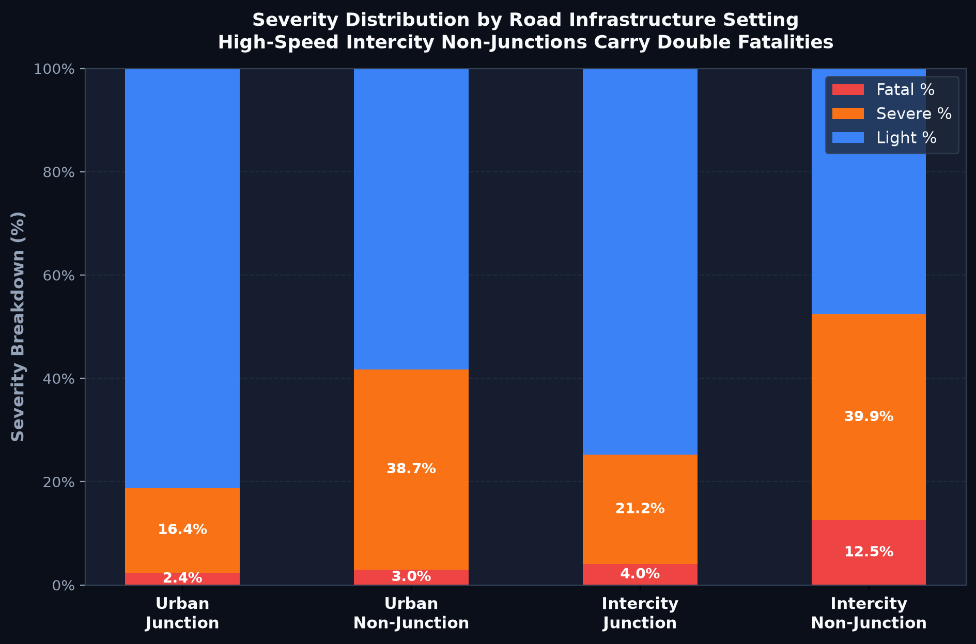
Figure 6. 100% Normalized Severity by Road Setting: Breakdown of crash severity across Urban Junctions, Urban Non-Junctions, Intercity Junctions, and Intercity Non-Junctions. Open intercity highway stretches produce over 44% serious/fatal outcomes due to elevated speeds, compared to 25.8% in urban intersections.
7.4 Spatial Concentration vs. Intercity Highway Dispersion: The spatial distribution displays an intense dichotomy between collision counts and fatal outcomes (Figure 1 and Figure 7). The vast majority of minor collisions are concentrated in dense metropolitan hubs: Gush Dan accounts for 2,540 accidents (30.6% of the national total), Jerusalem 720, Haifa 718, and Be'er Sheva 234. However, filtering by severity reveals that 65% of fatal accidents occur outside these four metropolitan areas. Fatal incidents scatter along intercity highway networks in the Negev (Route 40, Route 90), the Arava, the Jordan Valley, and the Galilee, where long distances, undivided lanes, and high traveling speeds magnify collision severity.
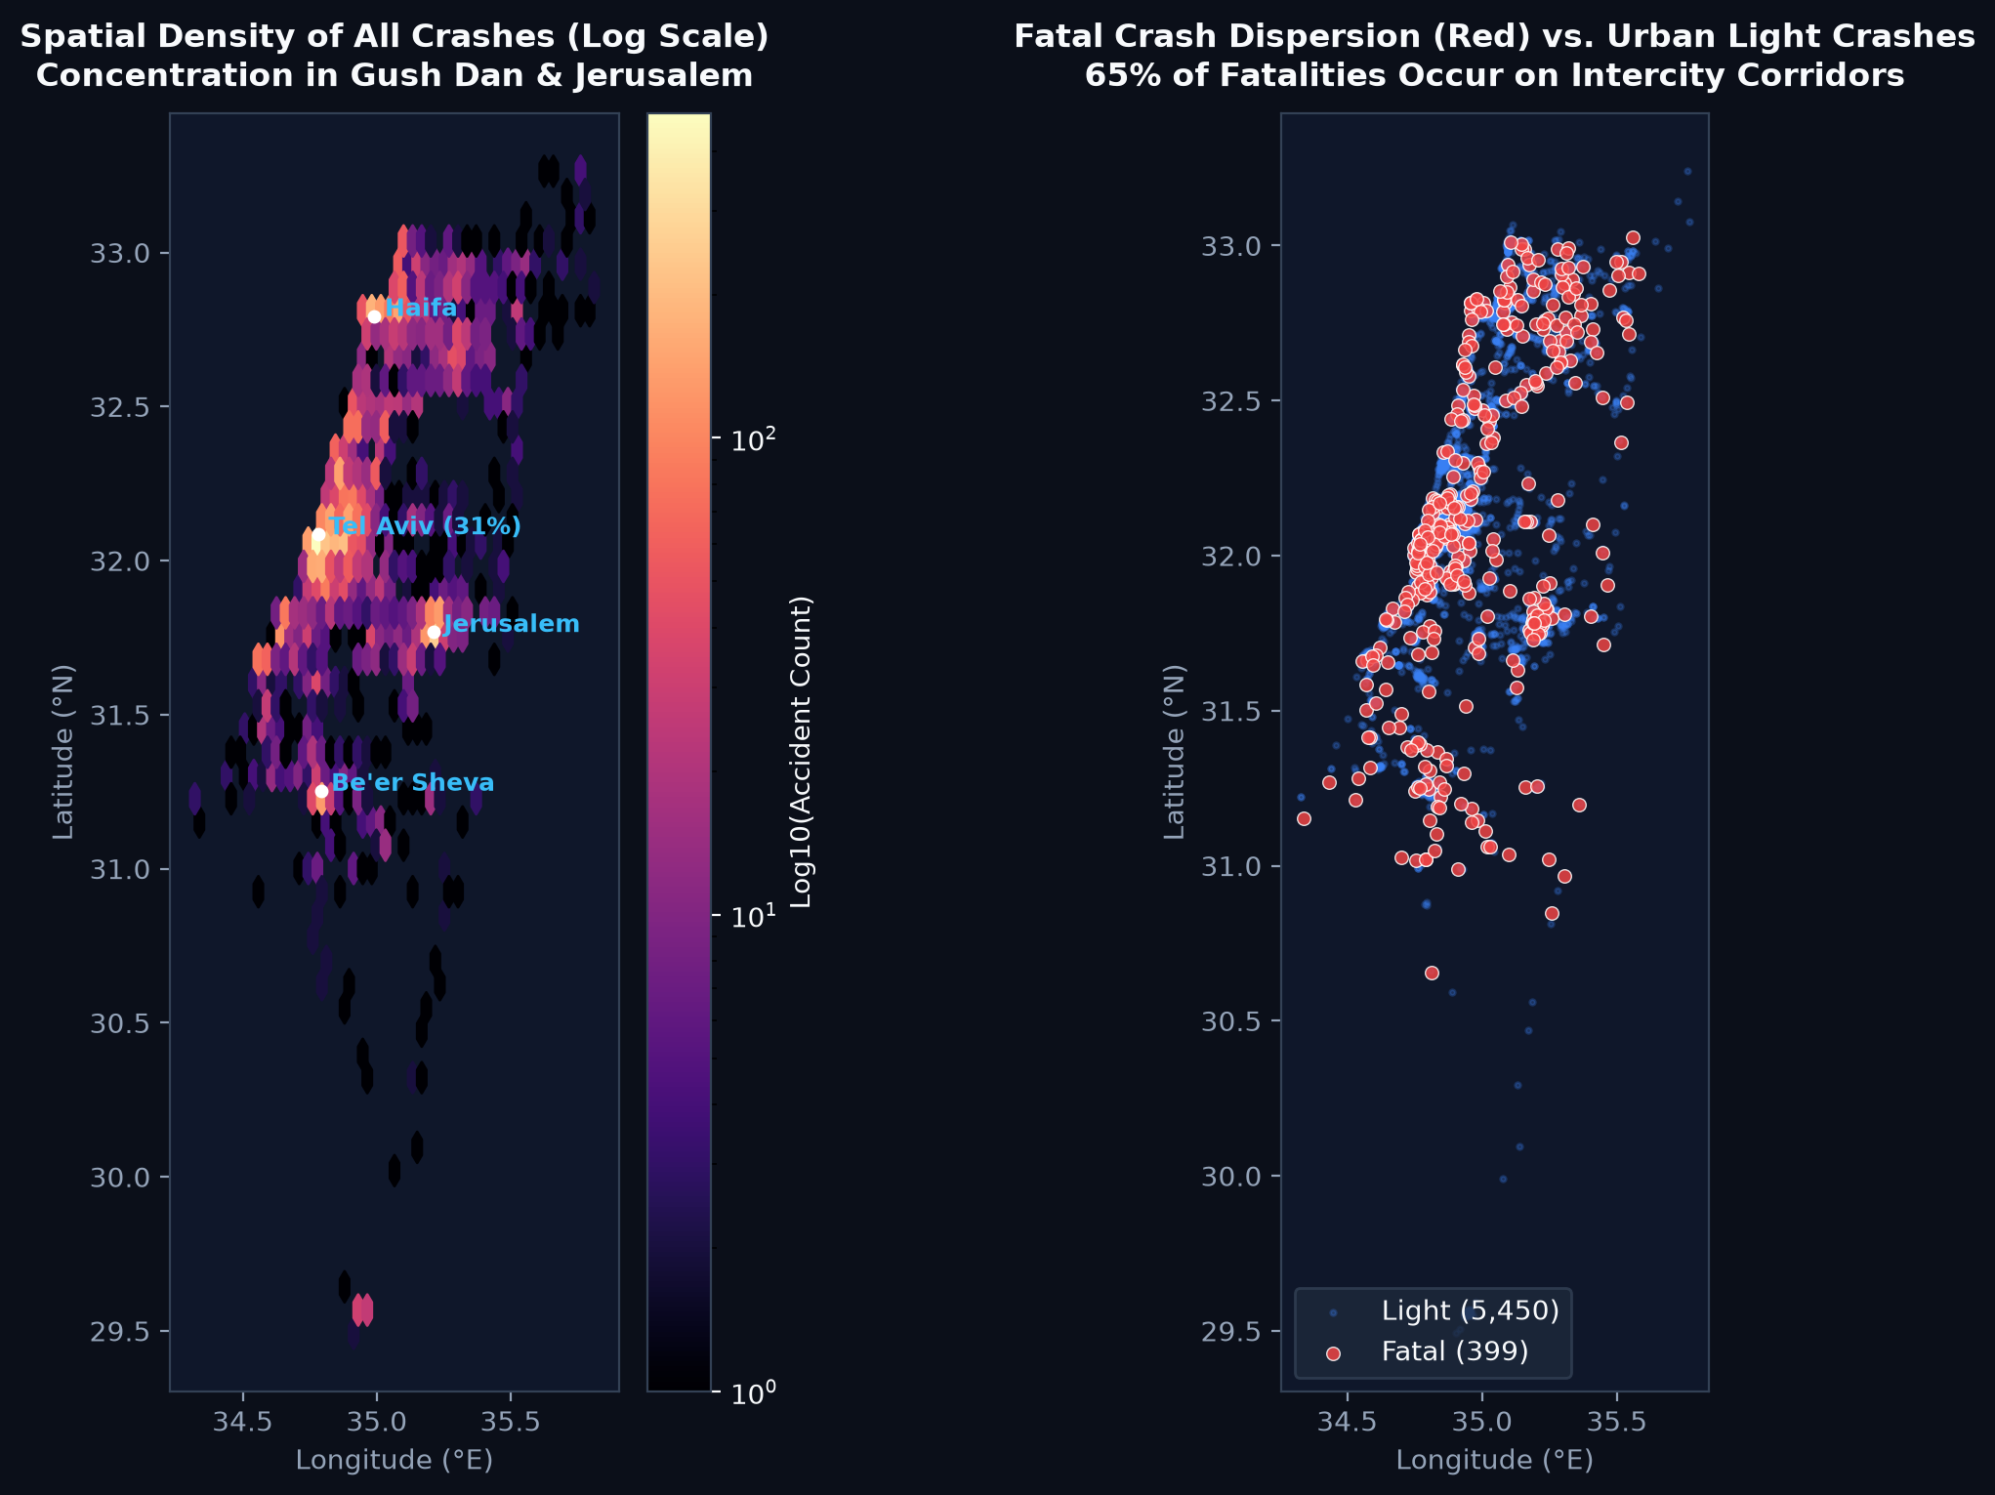
Figure 7. Spatial density and crash dispersion: Left panel shows hexbin density (log scale) highlighting metropolitan clustering in Gush Dan and Jerusalem. Right panel compares fatal crash dispersion (red markers along intercity highway corridors) against urban light crashes (blue).

8. Evaluation: Advantages and Disadvantages

8.1 Advantages
- Dual-Dashboard Architecture: Clean cognitive separation between general spatial/temporal tracking (Dashboard 1) and risk factor analysis (Dashboard 2).
- Full Bi-Directional Cross-Filtering (Linking & Brushing): Instant, synchronized filtering across all views upon clicking any bar, month, bubble, road category, hour cell, or map selection rectangle.
- Dual-Axis and Normalized Encodings: Dual-axis combinations and 100% stacked proportions prevent raw volume from masking high-fatality categories.
- Dual Map Modes (Points & Density): Points mode provides discrete incident inspection with popups, while Kernel Density mode prevents overplotting in high-density metropolitan areas.
- Consistent Semantic Design & Fast Delivery: Curated dark palette, explicit axis titles, and zero-server client-side hosting on GitHub Pages with instant responsiveness.

8.2 Disadvantages and Limitations
- Raw Counts without Exposure Normalization: Accident counts are not normalized by traffic volume (Vehicle Kilometers Traveled) or resident population, so dense metropolitan corridors naturally exhibit higher raw counts.
- Single-Year Temporal Scope: Restricted to the 2024 annual snapshot, which cannot distinguish multi-year structural trends from single-year statistical noise in small sub-categories.
- Point Overplotting at Broad Zoom: Although Kernel Density mode mitigates overplotting, individual point mode still experiences visual crowding in Tel Aviv without zooming in.
- Self-Reported Property Damage Excluded: The CBS dataset covers accidents with human casualties only; minor property-damage collisions are not recorded in this file.
- Static Hosting Constraints: In-memory client-side processing is ideal for 8,293 rows, but multi-year datasets (>50,000 rows) would require indexed server-side querying or WebAssembly.

8.3 Future Improvements
- Exposure Normalization: Integrating national traffic volume census data and municipal population figures to generate normalized risk indices per kilometer.
- Multi-Year Trend Analysis: Ingesting the 2020–2023 CBS datasets to evaluate historical safety trends, infrastructure interventions, and seasonal changes.
- Predictive Risk Modeling: Incorporating machine learning models to identify high-probability accident conditions based on real-time weather and lighting forecasts.

9. References
- Israel Central Bureau of Statistics. Road accidents with casualties 2020–2024 – PUF (data, Dictionary and Codebook 2024). data.gov.il, https://data.gov.il/he/datasets/lamas/2023-puf
- Leaflet 1.9.4 — https://leafletjs.com ; Esri Dark Gray Canvas basemap — https://www.arcgis.com ; OpenStreetMap contributors — https://www.openstreetmap.org/copyright
- Chart.js — https://www.chartjs.org ; pyproj — https://pyproj4.github.io/pyproj ; pandas — https://pandas.pydata.org

