**Software Requirements Specification**

Prepared by:

Yaniv Shahar

Tal Rabinovich

Gal Tzfati

Noa Malka Manzur

Shiraz Yom Tov

1.Introduction:

Autonomous cars, also known as self-driving cars, are vehicles that can operate without human intervention or with minimal human input.

By using a combination of sensors, cameras, and machine learning algorithms it can detect and interpret their surroundings, navigate roads, and make decisions.

There are several levels of autonomous driving, ranging from Level 0 (no automation) to Level 5 (full automation).

At Level 0, the driver is responsible for all aspects of driving.

At Level 5, the car can handle all driving tasks in all conditions without any human input.

Autonomous cars have the potential to significantly reduce traffic accidents, as they eliminate the potential for human error.

They can also make driving more efficient, as they can optimize speed, routing, and traffic flow.

Additionally, autonomous cars can improve accessibility for people who are unable to drive, such as the elderly or disabled.

However, there are also concerns about the safety and reliability of autonomous cars, as well as the potential for job loss in the transportation industry. There are also ethical considerations surrounding decision-making algorithms, such as how the car should respond in the event of an unavoidable accident.

One of the technologies we will use is Image processing.

Image processing is a field of computer science that involves analyzing, manipulating, and enhancing digital images using algorithms and techniques.

some common image processing techniques include:

1. Filtering: This involves applying a mathematical operation to the pixels in an image to enhance or suppress certain features.

For example, a low-pass filter can be used to remove high-frequency noise, while a high-pass filter can be used to enhance edges.

1. Segmentation: This involves dividing an image into regions or segments based on properties such as color or texture.

This can be used for tasks such as object recognition or tracking.

1. Feature extraction: This involves identifying specific features in an image, such as edges or corners, that can be used for further analysis or recognition.
2. Compression: This involves reducing the size of an image file without significantly reducing the quality of the image.

This is important for applications such as storing or transmitting large amounts of image data.

1.2 The purpose:

Our project involves using an existing kit car to perform several advanced driving functions using computer vision and artificial intelligence. By equipping the car with sensors and cameras that can identify road signs and traffic lights, as well as detect objects at a crosswalk, the car will be able to navigate the road more safely and intelligently. The car will also be programmed to slow down and accelerate according to the rules of the road and use its headlights for overtaking. These modifications will make the kit car more autonomous and safer to operate, and they have the potential to revolutionize the automotive industry.

1.3 Product:

The product is an autonomous car system that is designed to drive alone using computer vision and machine learning techniques.

The system can identify road signs, traffic lights, and objects at a crosswalk.

It is also capable of slowing down and accelerating according to the rules of the road and using the car's headlights for overtaking.

The system is implemented using an Arduino kit.

System Features:

1. Identification of road signs and traffic lights: The system shall be able to identify road signs and traffic lights using computer vision and machine learning techniques.
2. Identifying objects at a crosswalk.
3. Slowing down and accelerating according to the rules of the road.
4. Using the car's headlights for overtaking.

Diagrams of the project using two different technologies:

Local -

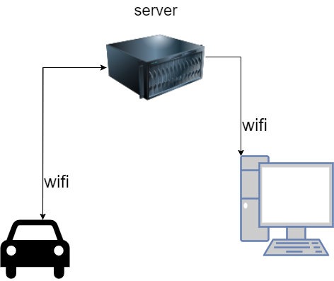

Remote –

