This paragraph is here just to set the font size and spacing for the reference doc.The Shumagin Islands (Figure 2; Figure A3a) was surveyed between 9 June and 12 June. The survey area encompassed 3,179.3 km2 (927.0 nmi2). Acoustic backscatter was measured along 390.5 km (210.8 nmi) of trackline on 26 transects spaced mainly 5.6km (3.0 nmi) apart and ranging from 3.4 km (1.9 nmi) to 11.1 km (6.0 nmi) apart (Figure 2; Figure A3b). Bottom depths in the Shumagin Islands area ranged from 53.0 to 234.5 m and averaged 143.0 m.

This paragraph is here just to set the font size and spacing for the caption.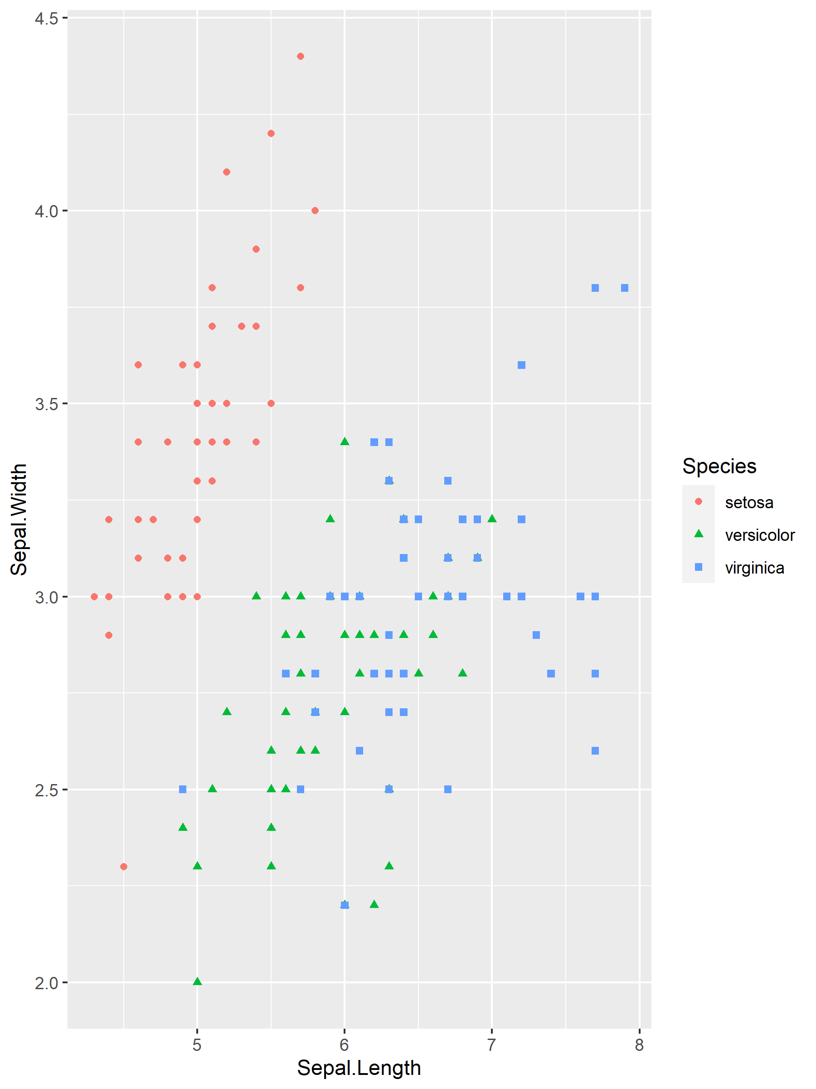

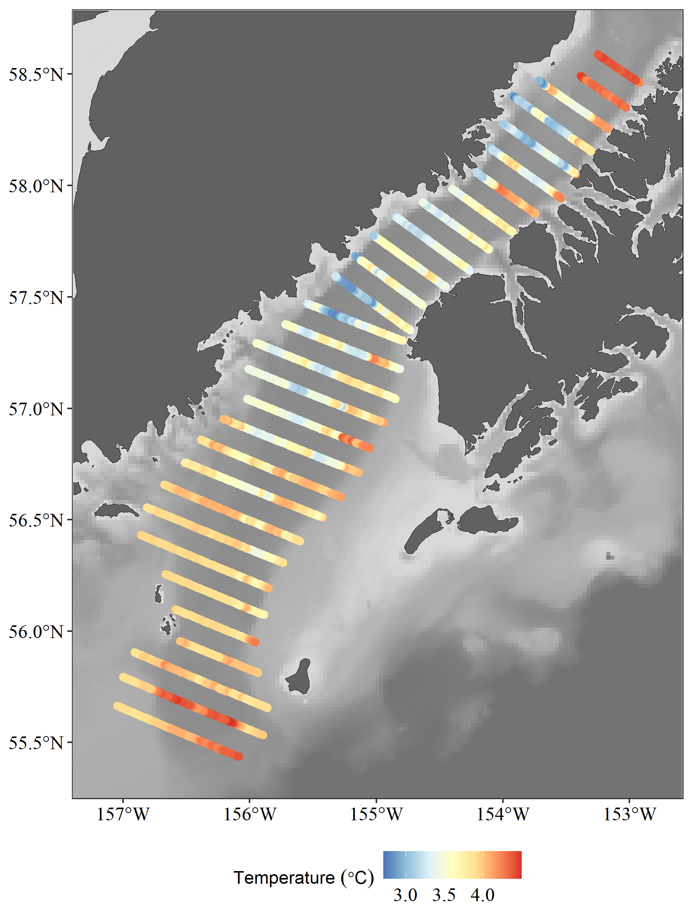

Figure 1. -- Transect lines and trawl haul locations during the 2023 winter pre-spawning acoustic-trawl surveys. The survey region associated with each transect is indicated by the transect color. The location of trawl events are indicated with purple markers. NMFS reporting areas are noted in white text. Bottom depths are indicated in greyscale.

And this is a landscape

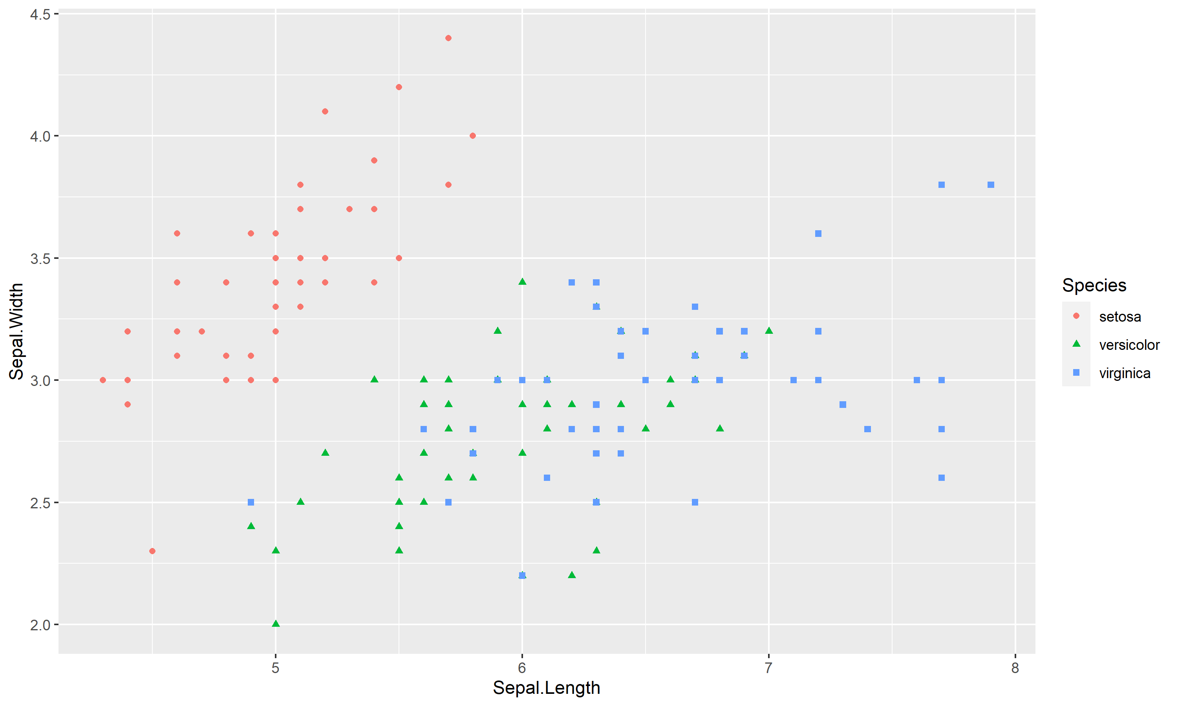

## References

Barbeaux SJ, Hollowed AB (2018) Ontogeny Matters: Climate Variability and Effects on Fish Distribution in the Eastern Bering Sea. Fisheries Oceanography 27:1–15.

# Heading (should be portrait)

## Subheading

##### Results of the Acoustic-Trawl Survey

##### of Walleye Pollock (Gadus chalcogrammus) in the

##### Shumagin Islands and Shelikof Strait

##### February and March 2023

##### (DY2023-03 and DY2023-04)

#### by

#### Denise McKelvey, Abigail McCarthy, and Darin Jones

#### Resource Assessment and Conservation Engineering Division

#### Alaska Fisheries Science Center

#### National Marine Fisheries Service

#### National Oceanic and Atmospheric Administration

#### 7600 Sand Point Way, NE

#### Seattle, WA 98115

Table 1. -- Trawl stations and catch data summary from the 2021 acoustic-trawl survey of walleye pollock in the GOA Shelf, Shumagin Islands, Barnabas Trough, Sh

elikof Strait, and Chiniak Trough regions.

| Year | Shelikof Strait | |  | Chirikof Shelfbreak | |  | Marmot Region | |
| --- | --- | --- | --- | --- | --- | --- | --- | --- |
|  | Biomass | Est. error |  | Biomass | Est. error |  | Biomass | Est. error |
| 1981 | 2,785.7 |  |  |  |  |  |  |  |
| 1982 |  |  |  |  |  |  |  |  |
| 1983 | 2,278.1 |  |  |  |  |  |  |  |
| 1984 | 1,757.1 |  |  |  |  |  |  |  |
| 1985 | 1,175.2 |  |  |  |  |  |  |  |
| 1986 | 585.7 |  |  |  |  |  |  |  |
| 1987 |  |  |  |  |  |  |  |  |
| 1988 | 301.7 |  |  |  |  |  |  |  |
| 1989 | 290.5 |  |  |  |  |  | 2.4 |  |
| 1990 | 374.7 |  |  |  |  |  |  |  |
| 1991 | 380.3 |  |  |  |  |  |  |  |
| 1992 | 713.4 | 3.6% |  |  |  |  |  |  |
| 1993 | 435.8 | 4.6% |  |  |  |  |  |  |
| 1994 | 492.6 | 4.5% |  |  |  |  |  |  |
| 1995 | 763.6 | 4.5% |  |  |  |  |  |  |
| 1996 | 777.2 | 3.7% |  |  |  |  |  |  |
| 1997 | 583.0 | 3.7% |  |  |  |  |  |  |
| 1998 | 504.8 | 3.8% |  |  |  |  |  |  |
| 1999 |  |  |  |  |  |  |  |  |
| 2000 | 448.6 | 4.6% |  |  |  |  |  |  |
| 2001 | 432.7 | 4.5% |  |  |  |  |  |  |
| 2002 | 256.7 | 6.9% |  | 82.1 | 12.2% |  |  |  |
| 2003 | 317.3 | 5.2% |  | 31.0 | 20.7% |  |  |  |
| 2004 | 330.8 | 9.2% |  | 30.0 | 20.4% |  |  |  |
| 2005 | 356.1 | 4.1% |  | 77.0 | 20.7% |  |  |  |
| 2006 | 293.6 | 4.0% |  | 69.0 | 11.0% |  |  |  |
| 2007 | 180.9 | 5.8% |  | 37.0 | 6.7% |  | 3.6 | 5.0% |
| 2008 | 197.7 | 5.6% |  | 22.0 | 9.6% |  |  |  |
| 2009 | 257.2 | 5.9% |  | 0.4 | 32.3% |  | 19.9 |  |
| 2010 | 421.4 | 2.6% |  | 9.4 | 15.0% |  | 5.6 |  |
| 2011 |  |  |  |  |  |  |  |  |
| 2012 | 333.9 | 7.9% |  | 21.2 | 16.4% |  |  |  |
| 2013 | 866.0 | 5.3% |  | 63.2 | 31.4% |  | 19.9 | 4.1% |
| 2014 | 827.1 | 4.7% |  |  |  |  | 14.4 | 9.4% |
| 2015 | 847.8 | 4.3% |  | 12.7 | 14.2% |  | 22.5 | 3.1% |

National Marine Fisheries Service (NMFS) 2014. NOAA protocols for fisheries acoustics surveys and related sampling (Alaska Fisheries Science Center), 26 p. Prepared by Midwater Assessment and Conservation Engineering Program, Alaska Fish. Sci. Center, Natl. Mar. Fish. Serv., NOAA.

##### CONTENTS

References 5

Heading (should be portrait) 5

Subheading 5