# APPENDIX II. SCIENTIFIC PERSONNEL

| Shumagin Islands | | |
| --- | --- | --- |
| Name | Position | Organization |
| Denise McKelvey | Chief Scientist | AFSC |
| David Bryan | Fishery Biologist | AFSC |
| Alex De Robertis | Fishery Biologist | AFSC |
| Scott Furnish | Computer Spec. | AFSC |
| James Gossom | Fishery Biologist | AIS |
| Dave McGowan | Fishery Biologist | AFSC |
| Matthew Phillips | Fishery Biologist | AFSC |
| 1AFSC = Alaska Fisheries Science Center, National Marine Fisheries Service, Seattle, WA; AIS Scientific and Environmental Services, Inc. | | |

| Shelikof Strait | | |
| --- | --- | --- |
| Name | Position | Organization |
| Taina Honkalehto | Chief Scientist | AFSC |
| Scott Furnish | Computer Spec. | AFSC |
| James Gossom | Fishery Biologist | AIS |
| Darin Jones | Fishery Biologist | AFSC |
| Mike Levine | Fishery Biologist | AFSC |
| Sandi Neidetcher | Fishery Biologist | AFSC |
| Matthew Phillips | Fishery Biologist | AFSC |
| Sam Urmy | Fishery Biologist | AFSC |
| 1AFSC = Alaska Fisheries Science Center, National Marine Fisheries Service, Seattle, WA; AIS Scientific and Environmental Services, Inc. | | |

# APPENDIX III. REGIONAL SUMMARIES

## Shumagin Islands

*Survey timing and extent*

The 2023 winter AT survey of pre-spawning pollock in Shumagin Islands was conducted between 15 February and 21 February. The entire survey area encompassed 6,448 km2 (1,880 nmi2). Acoustic backscatter was measured along 861.5 km (465.2 nmi) of transects spaced mainly 9.3 km (5 nmi) apart with spacing varying from 2.8 km to 9.3 km (1.5 to 5 nmi) in the survey area (Fig. ). Bottom depths in the survey area ranged from 58 m to 221 m.

*Environmental conditions*

Sea surface temperatures (SST) measured in the Shumagin Islands in 2023 indicate relatively average thermal conditions during the survey. SST ranged from 3.4°C to 4.5°C as measured by the ship’s flow-through instrumentation along acoustic transects and averaged 4.1°C (Fig. ). The along-transect mean SST was 0.6°C warmer than observed during 2020 and 0.2°C warmer than the 2006–2020 historical mean (3.9°C). The average SST measured by the SBE 39 at all haul locations was 3.9°C (Table ), which was 0.4°C warmer than the haul-based mean SST in 2020, 0.2°C warmer than the 2006–2020 historical mean, and 0.2°C warmer than the long-term 1995–2020 historical mean. Mean SST anomalies from both sources in 2023 were less than ± 0.5, indicating average conditions relative to the 2006–2020 period (Fig. ). Mean temperature between the surface and deepest trawl (i.e. headrope) depth at all haul locations varied by approximately 1.2°C (Fig. ).

*Trawl catch summary*

Biological data and specimens were collected in the Shumagin Islands from 8 LFS1421 hauls (Fig. , Table ) targeted on backscatter attributed to pollock. The lengths of an average of 257 randomly selected pollock were measured from each haul, with an average of 39 individuals more extensively sampled for at least one of the following: body weight, maturity, and age (Table ). A total of 305 otoliths used to estimate pollock ages were collected in the Shumagin Islands (Table ).

Pollock and salmon shark were the most abundant species by weight in the LFS1421 hauls, contributing 98.2% and 1% of the catch by weight respectively (Table A3.). Pollock and Pacific capelin were the most abundant species by numbers with 95.2% and 3.6% of total catch by numbers, respectively.

*Pollock maturity*

Pollock observed in the Shumagin Islands were generally in prespawning (females) or spawning (males) maturity stages. The abundance weighted maturity composition for males > 40 cm FL (n = 147) in the Shumagin Islands was 1% immature, 4% developing, 27% pre-spawning, 68% spawning, and 0% spent, and for females > 40 cm FL (n = 182) the abundance weighted maturity composition was 0% immature, 2% developing, 89% pre-spawning, 8% spawning, and 0% spent (Fig. a). The length at which 50% of female pollock were determined to be reproductively mature (i.e., pre-spawning, spawning, or spent) is 43 cm FL (Fig. b).

*Distribution and Abundance*

**Describe your distribution**(Fig. ). **Describe any interesting adult vs juvenile distributions**. Most adult pollock (defined as 75% of the biomass) were detected between depths of 75-155 m (Fig. a). Most juvenile pollock were detected between depths of 95-175 m (Fig. b). Most adult pollock were observed within 75 m of the bottom with, most juveniles found within 55 and ranging up to 85 m (includes 95% of the biomass) off the bottom (Fig. c and d), computed from bottom-referenced analysis. About 14% of the adult pollock biomass was observed within 10m of the seafloor, and 66% percent of biomass within 50 m of the seafloor (Fig. c).

Pollock with lengths 10-16 cm FL, indicative of age-1 pollock, accounted for 70.5% of the numbers and 9% of the biomass of all pollock observed in the Shumagin Islands (Fig. ). Pollock 17-24 cm FL, indicative of age-2s, accounted for 1.5% by numbers and 1.4% by biomass. Pollock 30 cm FL accounted for 26.2% and 86.8% of the numbers and biomass, respectively.

A total of 550.1 million pollock weighing 48,867.9 t were estimated to be in the Shumagin Islands at the time of the survey. The 2023 biomass was 999.5% of that observed in 2020 (4,889 t) and 151.9 % of the historic mean of 32.2 thousand tons (Table ; Fig. ). The 2023 survey biomass estimate is the largest in the Shumagin survey time series since 2015 (Table ; Fig. ). The relative estimation error of the 2023 biomass estimate based on the 1-D geostatistical analysis was 8.7%.

Table A3.. -- Catch by species and numbers of length and weight measurements taken from 8 LFS1421 hauls during the 2023 acoustic-trawl survey of walleye pollock in Shumagin Islands.

|  |  | Catch | | | |  | Measurements | |
| --- | --- | --- | --- | --- | --- | --- | --- | --- |
| Species name | Scientific name | Weight (kg) | % | Number | % |  | Length | Weight |
| walleye pollock | *Gadus chalcogrammus* | 10,287.3 | 98.2 | 65,272 | 95.2 |  | 2,053 | 410 |
| salmon shark | *Lamna ditropis* | 106.0 | 1.0 | 1 | <0.1 |  | 1 | 1 |
| big skate | *Beringraja binoculata* | 25.6 | 0.2 | 1 | <0.1 |  | 1 | 1 |
| Pacific capelin | *Mallotus catervarius* | 22.3 | 0.2 | 2,494 | 3.6 |  | 116 | 42 |
| Pacific cod | *Gadus macrocephalus* | 10.5 | 0.1 | 4 | <0.1 |  | 4 | 4 |
| chinook salmon | *Oncorhynchus tshawytscha* | 7.7 | <0.1 | 6 | <0.1 |  | 5 | 5 |
| eulachon | *Thaleichthys pacificus* | 4.7 | <0.1 | 157 | 0.2 |  | 48 | 26 |
| arrowtooth flounder | *Atheresthes stomias* | 3.8 | <0.1 | 8 | <0.1 |  | 8 | 8 |
| squid unid. | Cephalopoda (class) | 2.3 | <0.1 | 335 | 0.5 |  | 46 | 23 |
| Alaskan pink shrimp | *Pandalus eous* | 0.2 | <0.1 | 106 | 0.2 |  | 11 | - |
| Pacific herring | *Clupea pallasii* | 0.2 | <0.1 | 6 | <0.1 |  | 4 | 4 |
| isopod unid. | Isopoda (order) | <0.1 | <0.1 | 90 | 0.1 |  | - | - |
| smelt unid. | Osmeridae (family) | <0.1 | <0.1 | 55 | <0.1 |  | 14 | - |
| Total |  | 10,470.6 |  | 68,535 |  |  | 2,311 | 524 |

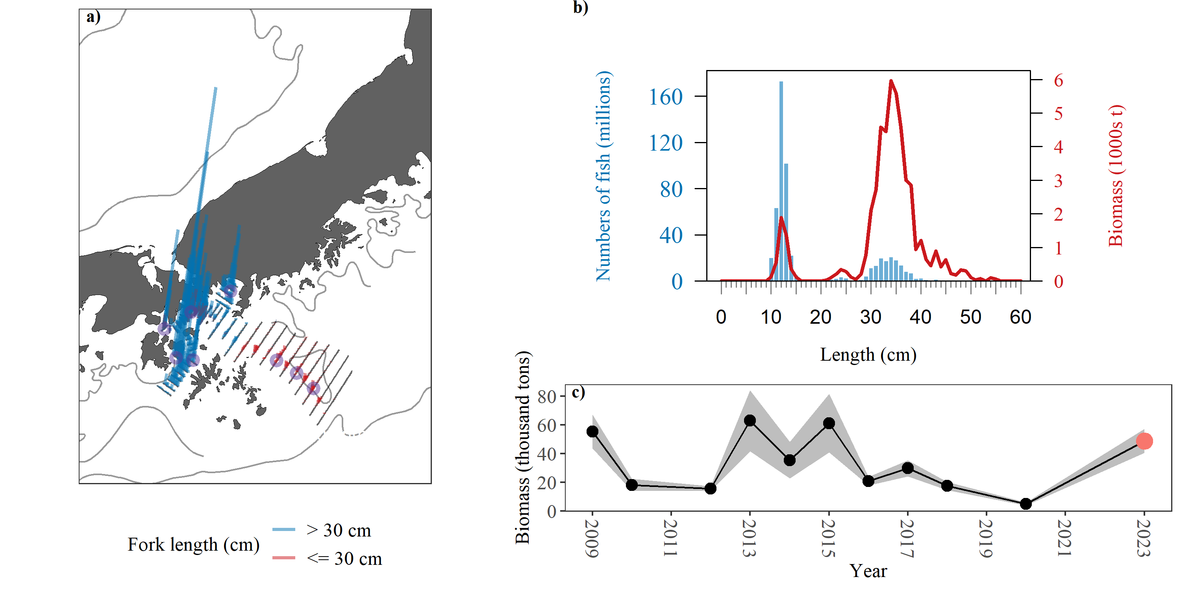

Figure A3.. -- 2023 Shumagin Islands sampling summary. a) Density (t/nmi^2^) attributed to pollock (vertical lines) along tracklines. Biomass densities are categorized based on haul catches comprised of mostly adult (>30 FL, blue) or juvenile (≤ 30 FL, red) pollock. Trawl locations are indicated with purple circles. b) Numbers- (blue bars) and biomass- (red line) at-length estimates of pollock. c) Summary of age-1+ pollock biomass estimates (thousands of metric tons) from 2009 to 2023. Current survey estimate in red, and shaded area indicates 1-D geostatistical 95% confidence intervals

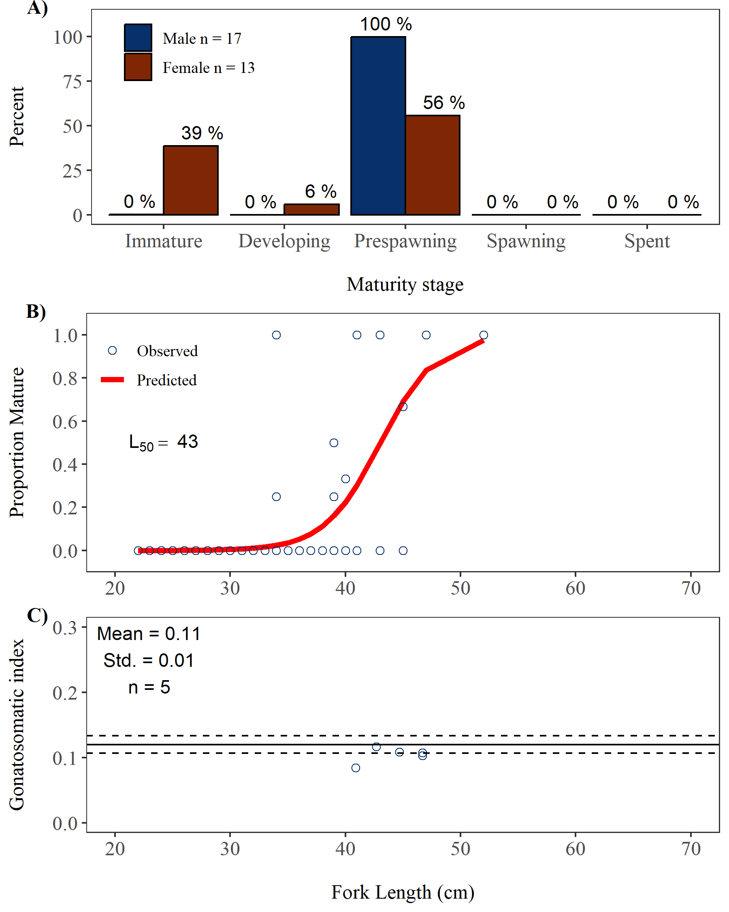

## Pavlof Bay

*Survey timing and extent*

The 2023 winter AT survey of pre-spawning pollock in Pavlof Bay was conducted between 17 February and 17 February. The entire survey area encompassed 294 km2 (86 nmi2). Acoustic backscatter was measured along 72.2 km (39 nmi) of transects spaced mainly 3.7 km (2 nmi) apart with spacing varying from 3.7 km to 6.1 km (2 to 3.3 nmi) in the survey area (Fig. ). Bottom depths in the survey area ranged from 62 m to 137 m.

*Environmental conditions*

Sea surface temperatures (SST) measured in the Shumagin Islands in 2023 indicate relatively average thermal conditions during the survey. SST ranged from 3.1°C to 3.4°C as measured by the ship’s flow-through instrumentation along acoustic transects and averaged 3.3°C (Fig. ). The along-transect mean SST was 0.1°C cooler than observed during 2018 and 0.1°C cooler than the 2006–2018 historical mean (3.4°C). The average SST measured by the SBE 39 at all haul locations was 3.3°C (Table ), which was 0.1°C cooler than the haul-based mean SST in 2018, 0.4°C cooler than the 2006–2018 historical mean, and 0.4°C cooler than the long-term 1995–2018 historical mean. Mean SST anomalies from both sources in 2023 were less than ± 0.5, indicating average conditions relative to the 2006–2018 period (Fig. ). Mean temperature between the surface and deepest trawl (i.e. headrope) depth at all haul locations varied by approximately 0.3°C (Fig. ).

*Trawl catch summary*

Biological data and specimens were collected in the Pavlof Bay from 1 LFS1421 hauls (Fig. , Table ) targeted on backscatter attributed to pollock. The lengths of an average of 430 randomly selected pollock were measured from each haul, with an average of 63 individuals more extensively sampled for at least one of the following: body weight, maturity, and age (Table ). A total of 55 otoliths used to estimate pollock ages were collected in the Pavlof Bay (Table ).

Pollock and NA were the most abundant species by weight in the LFS1421 hauls, contributing 100% and NA% of the catch by weight respectively (Table A3.). Pollock and NA were the most abundant species by numbers with 100% and NA% of total catch by numbers, respectively.

*Pollock maturity*

Pollock observed in the Pavlof Bay were generally in prespawning (females) or spawning (males) maturity stages. The abundance weighted maturity composition for males > 40 cm FL (n = 44) in the Pavlof Bay was 0% immature, 0% developing, 11% pre-spawning, 89% spawning, and 0% spent, and for females > 40 cm FL (n = 3) the abundance weighted maturity composition was 0% immature, 0% developing, 100% pre-spawning, 0% spawning, and 0% spent (Fig. a). The length at which 50% of female pollock were determined to be reproductively mature (i.e., pre-spawning, spawning, or spent) is 48.8 cm FL (Fig. b).

*Distribution and Abundance*

**Describe your distribution**(Fig. ). **Describe any interesting adult vs juvenile distributions**. Most adult pollock (defined as 75% of the biomass) were detected between depths of 65-105 m (Fig. a). Most juvenile pollock were detected between depths of 65-105 m (Fig. b). Most adult pollock were observed within 45 m of the bottom with, most juveniles found within 45 and ranging up to 55 m (includes 95% of the biomass) off the bottom (Fig. c and d), computed from bottom-referenced analysis. About 34% of the adult pollock biomass was observed within 10m of the seafloor, and 93% percent of biomass within 50 m of the seafloor (Fig. c).

Pollock with lengths 10-16 cm FL, indicative of age-1 pollock, accounted for 2.5% of the numbers and 0.1% of the biomass of all pollock observed in the Shumagin Islands (Fig. ). Pollock 17-24 cm FL, indicative of age-2s, accounted for 0.8% by numbers and 0.2% by biomass. Pollock 30 cm FL accounted for 89.9% and 96.6% of the numbers and biomass, respectively.

A total of 18.1 million pollock weighing 5,536.9 t were estimated to be in the Shumagin Islands at the time of the survey. The 2023 biomass was 120.1% of that observed in 2020 (4,610 t) and 243.7 % of the historic mean of 2.3 thousand tons (Table ; Fig. ). The 2023 survey biomass estimate is the largest in the Shumagin survey time series since 2015 (Table ; Fig. ). The relative estimation error of the 2023 biomass estimate based on the 1-D geostatistical analysis was 8.7%.

Table A3.. -- Catch by species and numbers of length and weight measurements taken from 1 LFS1421 hauls during the 2023 acoustic-trawl survey of walleye pollock in Pavlof Bay.

|  |  | Catch | | | |  | Measurements | |
| --- | --- | --- | --- | --- | --- | --- | --- | --- |
| Species name | Scientific name | Weight (kg) | % | Number | % |  | Length | Weight |
| walleye pollock | *Gadus chalcogrammus* | 3,600.0 | 100.0 | 10,727 | 100.0 |  | 430 | 77 |
| Total |  | 3,600.0 |  | 10,727 |  |  | 430 | 77 |

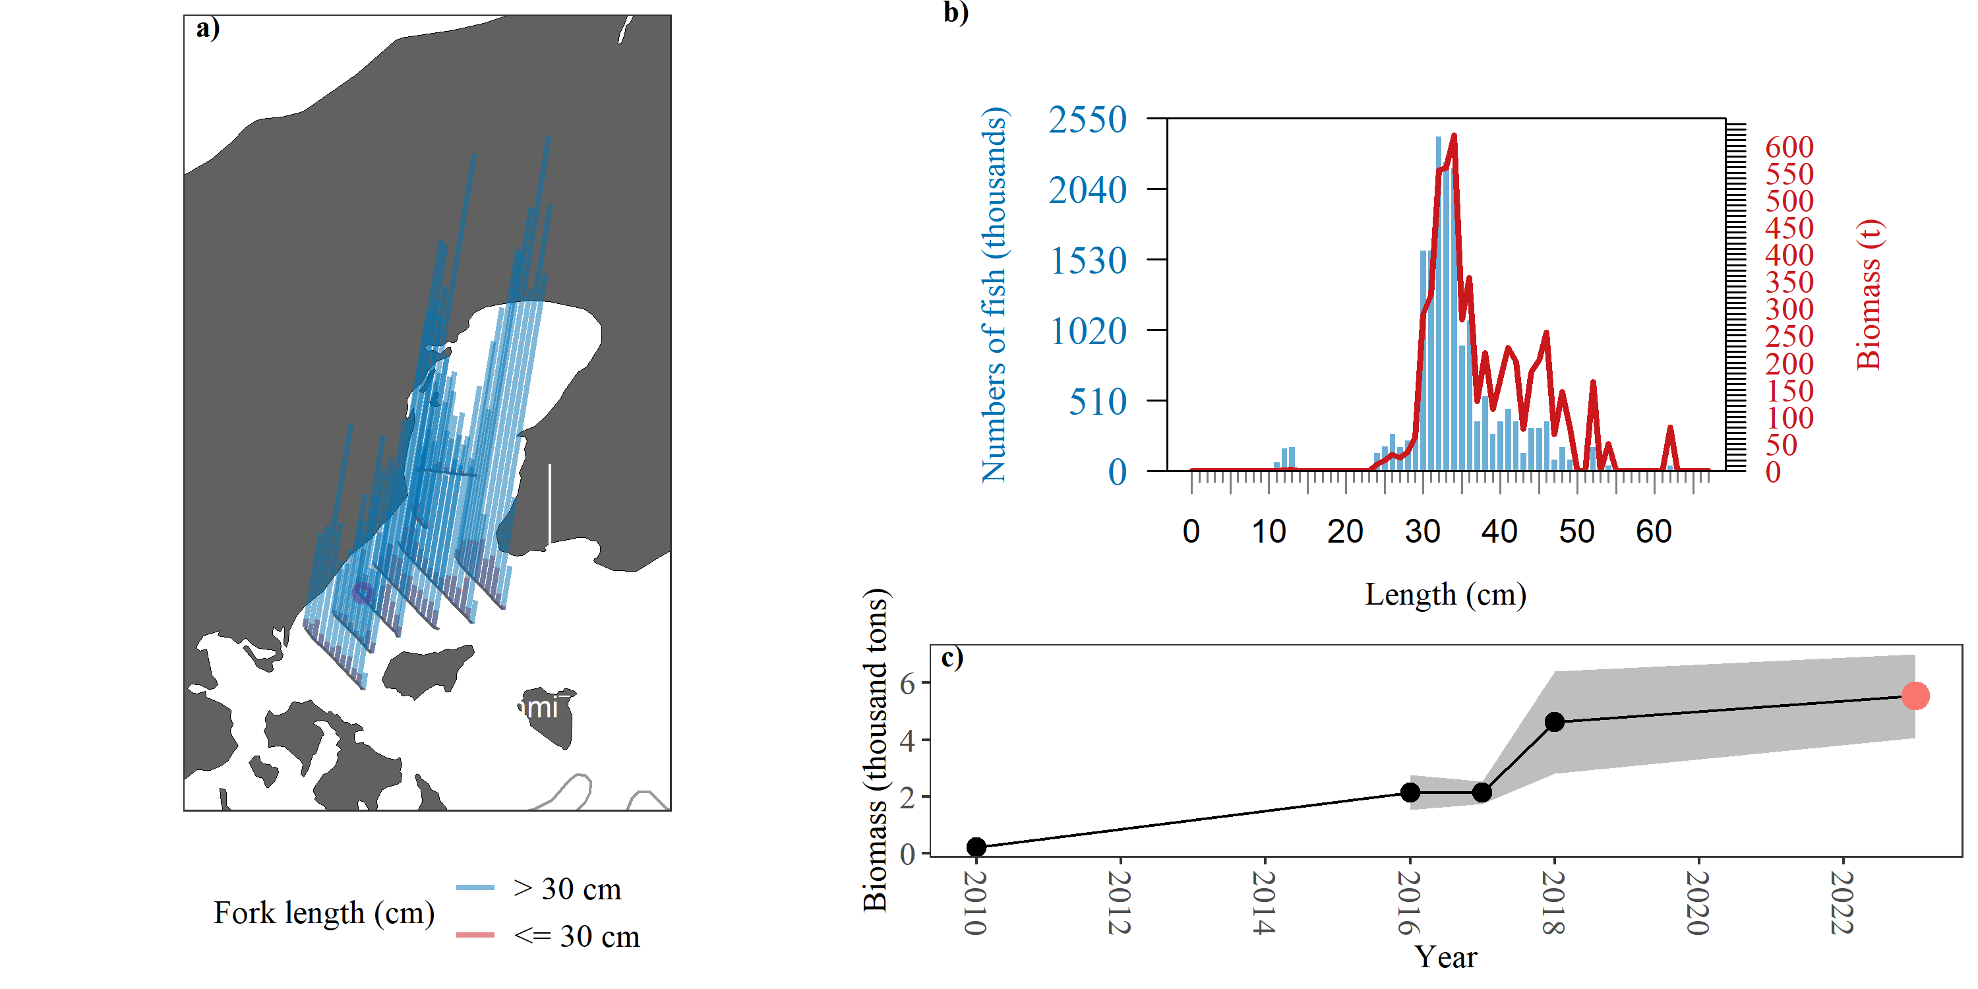

Figure A3.. -- 2023 Pavlof Bay sampling summary. a) Density (t/nmi^2^) attributed to pollock (vertical lines) along tracklines. Biomass densities are categorized based on haul catches comprised of mostly adult (>30 FL, blue) or juvenile (≤ 30 FL, red) pollock. Trawl locations are indicated with purple circles. b) Numbers- (blue bars) and biomass- (red line) at-length estimates of pollock. c) Summary of age-1+ pollock biomass estimates (thousands of metric tons) from 2010 to 2023. Current survey estimate in red, and shaded area indicates 1-D geostatistical 95% confidence intervals

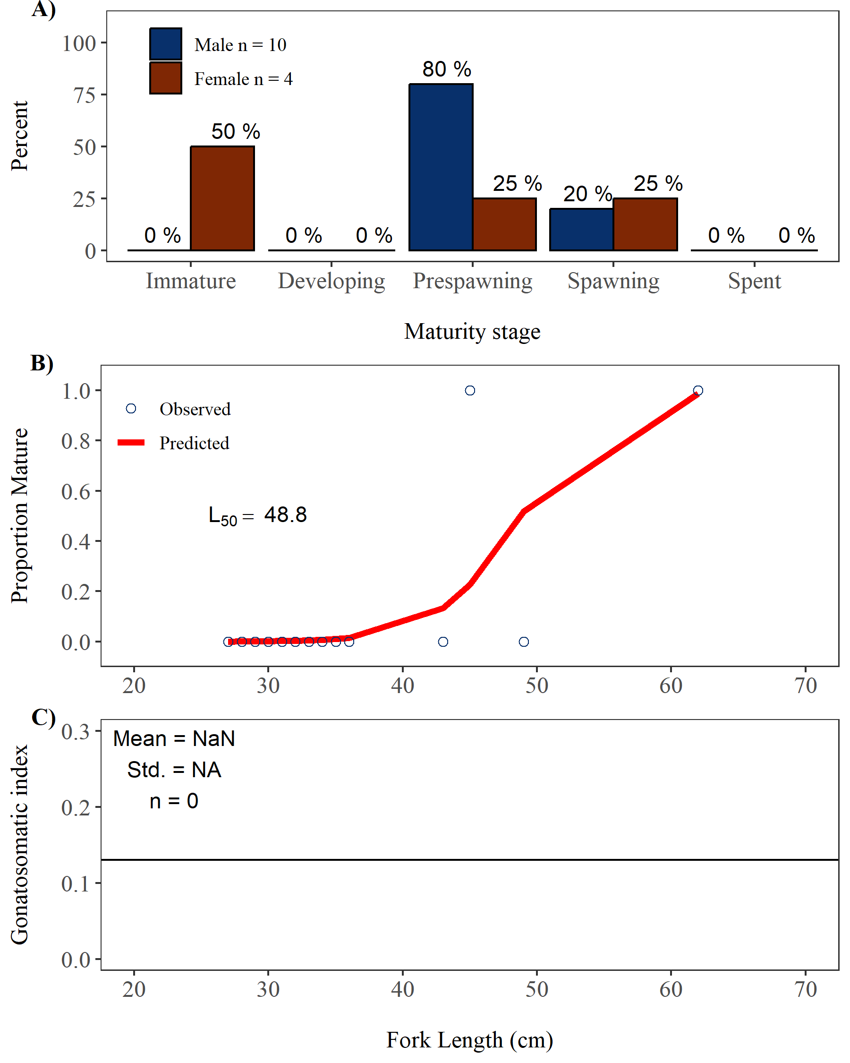

## Morzhovoi Bay

*Survey timing and extent*

The 2023 winter AT survey of pre-spawning pollock in Morzhovoi Bay was conducted between 18 February and 18 February. The entire survey area encompassed 278 km2 (81 nmi2). Acoustic backscatter was measured along 70.7 km (38.2 nmi) of transects spaced mainly 3.7 km (2 nmi) apart with spacing varying from 3 km to 5 km (1.6 to 2.7 nmi) in the survey area (Fig. ). Bottom depths in the survey area ranged from 45 m to 128 m.

*Environmental conditions*

Sea surface temperatures (SST) measured in the Shumagin Islands in 2023 indicate relatively average thermal conditions during the survey. SST ranged from 3°C to 3.4°C as measured by the ship’s flow-through instrumentation along acoustic transects and averaged 3.2°C (Fig. ). The along-transect mean SST was 0.1°C cooler than observed during 2018 and 0.2°C warmer than the 2006–2018 historical mean (3.0°C). The average SST measured by the SBE 39 at all haul locations was 3.1°C (Table ), which was 0.1°C cooler than the haul-based mean SST in 2018, 0.4°C warmer than the 2006–2018 historical mean, and 0.4°C warmer than the long-term 1995–2018 historical mean. Mean SST anomalies from both sources in 2023 were less than ± 0.5, indicating average conditions relative to the 2006–2018 period (Fig. ). Mean temperature between the surface and deepest trawl (i.e. headrope) depth at all haul locations varied by approximately 0.2°C (Fig. ).

*Trawl catch summary*

Biological data and specimens were collected in the Morzhovoi Bay from 1 LFS1421 hauls (Fig. , Table ) targeted on backscatter attributed to pollock. The lengths of an average of 392 randomly selected pollock were measured from each haul, with an average of 48 individuals more extensively sampled for at least one of the following: body weight, maturity, and age (Table ). A total of 55 otoliths used to estimate pollock ages were collected in the Morzhovoi Bay (Table ).

Pollock and Pacific cod were the most abundant species by weight in the LFS1421 hauls, contributing 91.3% and 8.5% of the catch by weight respectively (Table A3.). Pollock and Pacific capelin were the most abundant species by numbers with 82.6% and 16% of total catch by numbers, respectively.

*Pollock maturity*

Pollock observed in the Morzhovoi Bay were generally in prespawning (females) or spawning (males) maturity stages. The abundance weighted maturity composition for males > 40 cm FL (n = 37) in the Morzhovoi Bay was 0% immature, 0% developing, 8% pre-spawning, 92% spawning, and 0% spent, and for females > 40 cm FL (n = 12) the abundance weighted maturity composition was 0% immature, 0% developing, 100% pre-spawning, 0% spawning, and 0% spent (Fig. a). The length at which 50% of female pollock were determined to be reproductively mature (i.e., pre-spawning, spawning, or spent) is 42.2 cm FL (Fig. b).

*Distribution and Abundance*

**Describe your distribution**(Fig. ). **Describe any interesting adult vs juvenile distributions**. Most adult pollock (defined as 75% of the biomass) were detected between depths of 65-95 m (Fig. a). Most juvenile pollock were detected between depths of 65-95 m (Fig. b). Most adult pollock were observed within 35 m of the bottom with, most juveniles found within 35 and ranging up to 45 m (includes 95% of the biomass) off the bottom (Fig. c and d), computed from bottom-referenced analysis. About 43% of the adult pollock biomass was observed within 10m of the seafloor, and 96% percent of biomass within 50 m of the seafloor (Fig. c).

Pollock with lengths 10-16 cm FL, indicative of age-1 pollock, accounted for 19.4% of the numbers and 0.3% of the biomass of all pollock observed in the Shumagin Islands (Fig. ). Pollock 17-24 cm FL, indicative of age-2s, accounted for 0% by numbers and 0% by biomass. Pollock 30 cm FL accounted for 79.9% and 99.5% of the numbers and biomass, respectively.

A total of 5.6 million pollock weighing 4,021.2 t were estimated to be in the Shumagin Islands at the time of the survey. The 2023 biomass was 106.6% of that observed in 2020 (3,772 t) and 87.2 % of the historic mean of 4.6 thousand tons (Table ; Fig. ). The 2023 survey biomass estimate is the largest in the Shumagin survey time series since 2015 (Table ; Fig. ). The relative estimation error of the 2023 biomass estimate based on the 1-D geostatistical analysis was 8.7%.

Table A3.. -- Catch by species and numbers of length and weight measurements taken from 1 LFS1421 hauls during the 2023 acoustic-trawl survey of walleye pollock in Morzhovoi Bay.

|  |  | Catch | | | |  | Measurements | |
| --- | --- | --- | --- | --- | --- | --- | --- | --- |
| Species name | Scientific name | Weight (kg) | % | Number | % |  | Length | Weight |
| walleye pollock | *Gadus chalcogrammus* | 384.4 | 91.3 | 512 | 82.6 |  | 392 | 77 |
| Pacific cod | *Gadus macrocephalus* | 35.6 | 8.5 | 7 | 1.1 |  | 7 | 7 |
| Pacific capelin | *Mallotus catervarius* | 0.7 | 0.2 | 99 | 16.0 |  | 35 | 10 |
| jellyfish unid. | Scyphozoa (class) | 0.1 | <0.1 | <0.1 | <0.1 |  | - | - |
| squid unid. | Cephalopoda (class) | <0.1 | <0.1 | 2 | 0.3 |  | 2 | - |
| Total |  | 420.9 |  | 620 |  |  | 436 | 94 |

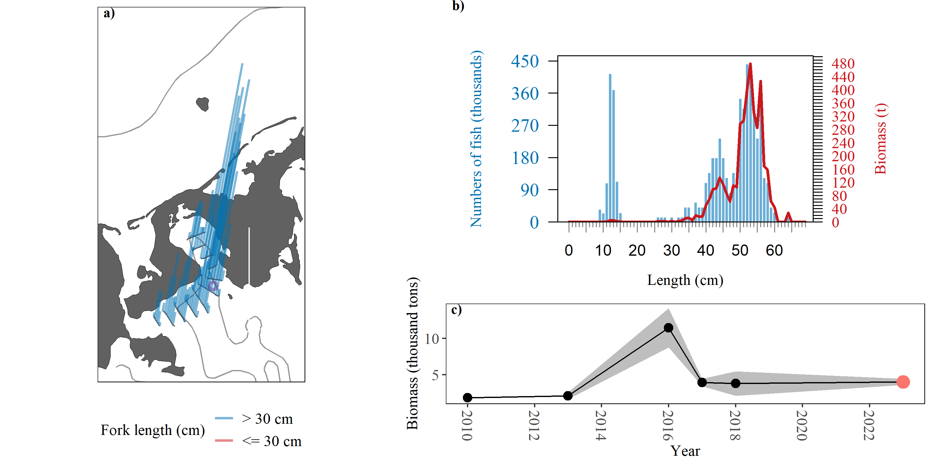

Figure A3.. -- 2023 Morzhovoi Bay sampling summary. a) Density (t/nmi^2^) attributed to pollock (vertical lines) along tracklines. Biomass densities are categorized based on haul catches comprised of mostly adult (>30 FL, blue) or juvenile (≤ 30 FL, red) pollock. Trawl locations are indicated with purple circles. b) Numbers- (blue bars) and biomass- (red line) at-length estimates of pollock. c) Summary of age-1+ pollock biomass estimates (thousands of metric tons) from 2010 to 2023. Current survey estimate in red, and shaded area indicates 1-D geostatistical 95% confidence intervals

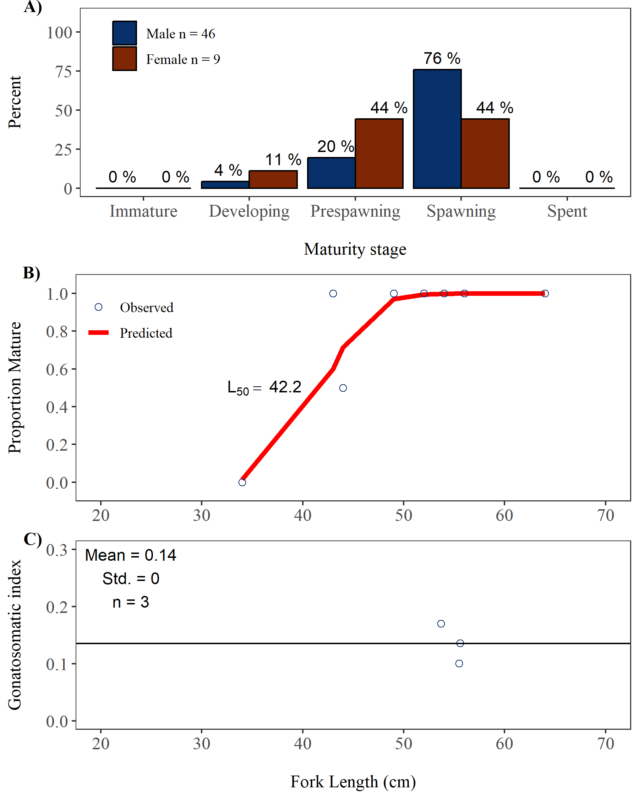

## Chirikof Shelfbreak

*Survey timing and extent*

The 2023 winter AT survey of pre-spawning pollock in Chirikof Shelfbreak was conducted between 12 March and 15 March. The entire survey area encompassed 3,745 km2 (1,092 nmi2). Acoustic backscatter was measured along 329.3 km (177.8 nmi) of transects spaced mainly 11.1 km (6 nmi) apart with spacing varying from 11.1 km to 11.1 km (6 to 6 nmi) in the survey area (Fig. ). Bottom depths in the survey area ranged from 77 m to 1291 m.

*Environmental conditions*

Sea surface temperatures (SST) measured in the Shumagin Islands in 2023 indicate relatively average thermal conditions during the survey. SST ranged from 4.1°C to 4.8°C as measured by the ship’s flow-through instrumentation along acoustic transects and averaged 4.5°C (Fig. ). The along-transect mean SST was 1.1°C cooler than observed during 2019 and 0.1°C warmer than the 2006–2019 historical mean (4.5°C). The average SST measured by the SBE 39 at all haul locations was 4.5°C (Table ), which was 1.1°C cooler than the haul-based mean SST in 2019, 0.2°C warmer than the 2006–2019 historical mean, and 0.2°C warmer than the long-term 1995–2019 historical mean. Mean SST anomalies from both sources in 2023 were less than ± 0.5, indicating average conditions relative to the 2006–2019 period (Fig. ). Mean temperature between the surface and deepest trawl (i.e. headrope) depth at all haul locations varied by approximately 0.8°C (Fig. ).

*Trawl catch summary*

Biological data and specimens were collected in the Chirikof Shelfbreak from 6 LFS1421 hauls (Fig. , Table ) targeted on backscatter attributed to pollock. The lengths of an average of 202 randomly selected pollock were measured from each haul, with an average of 31 individuals more extensively sampled for at least one of the following: body weight, maturity, and age (Table ). A total of 185 otoliths used to estimate pollock ages were collected in the Chirikof Shelfbreak (Table ).

Pacific Ocean Perch and pollock were the most abundant species by weight in the LFS1421 hauls, contributing 64.1% and 34.5% of the catch by weight respectively (Table A3.). Euphausiids and Pacific ocean perch were the most abundant species by numbers with 55% and 22% of total catch by numbers, respectively.

*Pollock maturity*

Pollock observed in the Chirikof Shelfbreak were generally in prespawning (females) or spawning (males) maturity stages. The abundance weighted maturity composition for males > 40 cm FL (n = 84) in the Chirikof Shelfbreak was 3% immature, 4% developing, 8% pre-spawning, 80% spawning, and 5% spent, and for females > 40 cm FL (n = 109) the abundance weighted maturity composition was 2% immature, 19% developing, 70% pre-spawning, 10% spawning, and 0% spent (Fig. a). The length at which 50% of female pollock were determined to be reproductively mature (i.e., pre-spawning, spawning, or spent) is 39.7 cm FL (Fig. b).

*Distribution and Abundance*

**Describe your distribution**(Fig. ). **Describe any interesting adult vs juvenile distributions**. Most adult pollock (defined as 75% of the biomass) were detected between depths of 205-365 m (Fig. a). Most juvenile pollock were detected between depths of 225-365 m (Fig. b). Most adult pollock were observed within 415 m of the bottom with, most juveniles found within 365 and ranging up to 415 m (includes 95% of the biomass) off the bottom (Fig. c and d), computed from bottom-referenced analysis. About 25% of the adult pollock biomass was observed within 10m of the seafloor, and 32% percent of biomass within 50 m of the seafloor (Fig. c).

Pollock with lengths 10-16 cm FL, indicative of age-1 pollock, accounted for 0% of the numbers and 0% of the biomass of all pollock observed in the Shumagin Islands (Fig. ). Pollock 17-24 cm FL, indicative of age-2s, accounted for 0% by numbers and 0% by biomass. Pollock 30 cm FL accounted for 100% and 100% of the numbers and biomass, respectively.

A total of 69.6 million pollock weighing 39,874.7 t were estimated to be in the Shumagin Islands at the time of the survey. The 2023 biomass was 402.5% of that observed in 2020 (9,907 t) and 227.4 % of the historic mean of 17.5 thousand tons (Table ; Fig. ). The 2023 survey biomass estimate is the largest in the Shumagin survey time series since 2015 (Table ; Fig. ). The relative estimation error of the 2023 biomass estimate based on the 1-D geostatistical analysis was 8.7%.

Table A3.. -- Catch by species and numbers of length and weight measurements taken from 6 LFS1421 hauls during the 2023 acoustic-trawl survey of walleye pollock in Chirikof Shelfbreak.

|  |  | Catch | | | |  | Measurements | |
| --- | --- | --- | --- | --- | --- | --- | --- | --- |
| Species name | Scientific name | Weight (kg) | % | Number | % |  | Length | Weight |
| Pacific ocean perch | *Sebastes alutus* | 1,897.9 | 64.1 | 2,599 | 22.0 |  | 390 | 126 |
| walleye pollock | *Gadus chalcogrammus* | 1,021.1 | 34.5 | 1,832 | 15.5 |  | 1,209 | 235 |
| rougheye rockfish | *Sebastes aleutianus* | 15.3 | 0.5 | 11 | <0.1 |  | 11 | 11 |
| giant grenadier | *Coryphaenoides pectoralis* | 6.1 | 0.2 | 2 | <0.1 |  | 2 | 2 |
| dusky rockfish | *Sebastes variabilis* | 6.1 | 0.2 | 6 | <0.1 |  | 6 | 6 |
| shortraker rockfish | *Sebastes borealis* | 5.8 | 0.2 | 2 | <0.1 |  | 2 | 2 |
| lanternfish unid. | Myctophidae (family) | 2.6 | <0.1 | 365 | 3.1 |  | 103 | 33 |
| squid unid. | Cephalopoda (class) | 0.9 | <0.1 | 151 | 1.3 |  | 52 | 34 |
| smooth lumpsucker | *Aptocyclus ventricosus* | 0.8 | <0.1 | 1 | <0.1 |  | 1 | 1 |
| northern sea nettle | *Chrysaora melanaster* | 0.6 | <0.1 | 2 | <0.1 |  | 2 | 2 |
| arrowtooth flounder | *Atheresthes stomias* | 0.5 | <0.1 | 1 | <0.1 |  | 1 | 1 |
| Pacific glass shrimp | *Pasiphaea pacifica* | 0.5 | <0.1 | 266 | 2.3 |  | 33 | - |
| northern smoothtongue | *Leuroglossus schmidti* | 0.4 | <0.1 | 26 | 0.2 |  | 11 | 11 |
| euphausiid unid. | Euphausiacea (order) | 0.4 | <0.1 | 6,494 | 55.0 |  | - | - |
| magistrate armhook squid | *Berryteuthis magister* | 0.4 | <0.1 | 1 | <0.1 |  | 1 | 1 |
| jellyfish unid. | Scyphozoa (class) | 0.3 | <0.1 | <0.1 | <0.1 |  | - | - |
| Aurelia sp. | *Aurelia sp.* | 0.2 | <0.1 | 1 | <0.1 |  | - | - |
| unsorted shab | *peanutbutter* | 0.1 | <0.1 | <0.1 | <0.1 |  | - | - |
| viperfish unid. | Stomiidae (family) | <0.1 | <0.1 | 27 | 0.2 |  | 19 | 15 |
| Pacific lamprey | *Lampetra tridentata* | <0.1 | <0.1 | 1 | <0.1 |  | 1 | 1 |
| northern pearleye | *Benthalbella dentata* | <0.1 | <0.1 | 2 | <0.1 |  | 2 | 2 |
| Periphylla sp. | *Periphylla sp.* | <0.1 | <0.1 | 8 | <0.1 |  | 3 | - |
| isopod unid. | Isopoda (order) | <0.1 | <0.1 | 3 | <0.1 |  | - | - |
| salp unid. | Thaliacea (class) | <0.1 | <0.1 | 1 | <0.1 |  | - | - |
| Total |  | 2,960.2 |  | 11,802 |  |  | 1,849 | 483 |

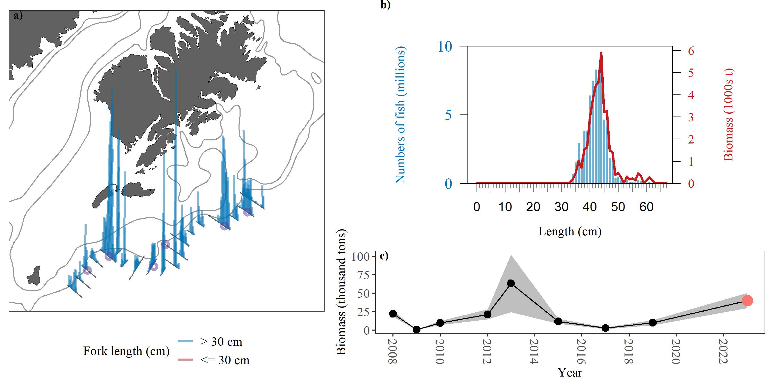

Figure A3.. -- 2023 Chirikof Shelfbreak sampling summary. a) Density (t/nmi^2^) attributed to pollock (vertical lines) along tracklines. Biomass densities are categorized based on haul catches comprised of mostly adult (>30 FL, blue) or juvenile (≤ 30 FL, red) pollock. Trawl locations are indicated with purple circles. b) Numbers- (blue bars) and biomass- (red line) at-length estimates of pollock. c) Summary of age-1+ pollock biomass estimates (thousands of metric tons) from 2008 to 2023. Current survey estimate in red, and shaded area indicates 1-D geostatistical 95% confidence intervals

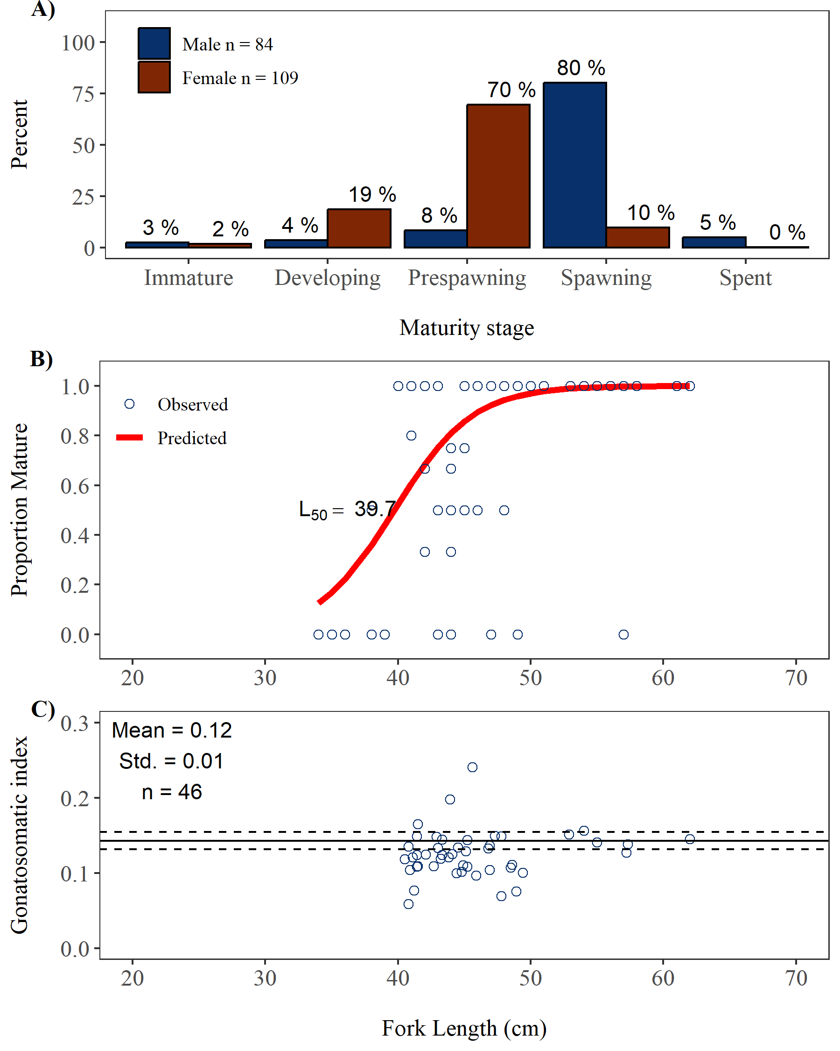

## Marmot Bay

*Survey timing and extent*

The 2023 winter AT survey of pre-spawning pollock in Marmot Bay was conducted between 15 March and 17 March. The entire survey area encompassed 1,010 km2 (294 nmi2). Acoustic backscatter was measured along 341.1 km (184.2 nmi) of transects spaced mainly 3.7 km (2 nmi) apart with spacing varying from 1.9 km to 3.7 km (1 to 2 nmi) in the survey area (Fig. ). Bottom depths in the survey area ranged from 78 m to 279 m.

*Environmental conditions*

Sea surface temperatures (SST) measured in the Shumagin Islands in 2023 indicate relatively average thermal conditions during the survey. SST ranged from 3.7°C to 4.4°C as measured by the ship’s flow-through instrumentation along acoustic transects and averaged 4°C (Fig. ). The along-transect mean SST was 0.2°C cooler than observed during 2021 and 0.6°C cooler than the 2006–2021 historical mean (4.6°C). The average SST measured by the SBE 39 at all haul locations was 3.8°C (Table ), which was 0.2°C cooler than the haul-based mean SST in 2021, 0.3°C cooler than the 2006–2021 historical mean, and 0.2°C cooler than the long-term 1995–2021 historical mean. Mean SST anomalies from both sources in 2023 were less than ± 0.5, indicating average conditions relative to the 2006–2021 period (Fig. ). Mean temperature between the surface and deepest trawl (i.e. headrope) depth at all haul locations varied by approximately 0.3°C (Fig. ).

*Trawl catch summary*

Biological data and specimens were collected in the Marmot Bay from 5 LFS1421 hauls (Fig. , Table ) targeted on backscatter attributed to pollock. The lengths of an average of 386 randomly selected pollock were measured from each haul, with an average of 45 individuals more extensively sampled for at least one of the following: body weight, maturity, and age (Table ). A total of 212 otoliths used to estimate pollock ages were collected in the Marmot Bay (Table ).

Pollock and Pacific cod were the most abundant species by weight in the LFS1421 hauls, contributing 99.1% and 0.3% of the catch by weight respectively (Table A3.). Pollock and smelt sp. were the most abundant species by numbers with 86.8% and 5.8% of total catch by numbers, respectively.

*Pollock maturity*

Pollock observed in the Marmot Bay were generally in prespawning (females) or immature (males) maturity stages. The abundance weighted maturity composition for males > 40 cm FL (n = 27) in the Marmot Bay was 47% immature, 0% developing, 0% pre-spawning, 47% spawning, and 7% spent, and for females > 40 cm FL (n = 44) the abundance weighted maturity composition was 8% immature, 26% developing, 58% pre-spawning, 0% spawning, and 8% spent (Fig. a). The length at which 50% of female pollock were determined to be reproductively mature (i.e., pre-spawning, spawning, or spent) is 46.1 cm FL (Fig. b).

*Distribution and Abundance*

**Describe your distribution**(Fig. ). **Describe any interesting adult vs juvenile distributions**. Most adult pollock (defined as 75% of the biomass) were detected between depths of 55-225 m (Fig. a). Most juvenile pollock were detected between depths of 45-125 m (Fig. b). Most adult pollock were observed within 145 m of the bottom with, most juveniles found within 145 and ranging up to 155 m (includes 95% of the biomass) off the bottom (Fig. c and d), computed from bottom-referenced analysis. About 14% of the adult pollock biomass was observed within 10m of the seafloor, and 42% percent of biomass within 50 m of the seafloor (Fig. c).

Pollock with lengths 10-16 cm FL, indicative of age-1 pollock, accounted for 57.2% of the numbers and 3.9% of the biomass of all pollock observed in the Shumagin Islands (Fig. ). Pollock 17-24 cm FL, indicative of age-2s, accounted for 5.4% by numbers and 3.1% by biomass. Pollock 30 cm FL accounted for 20.8% and 79.1% of the numbers and biomass, respectively.

A total of 62.6 million pollock weighing 9,284.4 t were estimated to be in the Shumagin Islands at the time of the survey. The 2023 biomass was 125.5% of that observed in 2020 (7,401 t) and 58.1 % of the historic mean of 16.0 thousand tons (Table ; Fig. ). The 2023 survey biomass estimate is the largest in the Shumagin survey time series since 2015 (Table ; Fig. ). The relative estimation error of the 2023 biomass estimate based on the 1-D geostatistical analysis was 8.7%.

Table A3.. -- Catch by species and numbers of length and weight measurements taken from 5 LFS1421 hauls during the 2023 acoustic-trawl survey of walleye pollock in Marmot Bay.

|  |  | Catch | | | |  | Measurements | |
| --- | --- | --- | --- | --- | --- | --- | --- | --- |
| Species name | Scientific name | Weight (kg) | % | Number | % |  | Length | Weight |
| walleye pollock | *Gadus chalcogrammus* | 4,327.0 | 99.1 | 23,056 | 86.8 |  | 1,930 | 368 |
| Pacific cod | *Gadus macrocephalus* | 11.8 | 0.3 | 3 | <0.1 |  | 3 | 3 |
| eulachon | *Thaleichthys pacificus* | 9.9 | 0.2 | 247 | 0.9 |  | 80 | 22 |
| Pacific capelin | *Mallotus catervarius* | 6.5 | 0.1 | 1,390 | 5.2 |  | 51 | 26 |
| smooth lumpsucker | *Aptocyclus ventricosus* | 4.0 | <0.1 | 4 | <0.1 |  | 4 | 4 |
| chinook salmon | *Oncorhynchus tshawytscha* | 1.8 | <0.1 | 1 | <0.1 |  | 1 | 1 |
| Pacific herring | *Clupea pallasii* | 1.8 | <0.1 | 275 | 1.0 |  | 40 | 16 |
| arrowtooth flounder | *Atheresthes stomias* | 1.2 | <0.1 | 1 | <0.1 |  | 1 | 1 |
| squid unid. | Cephalopoda (class) | 1.1 | <0.1 | 8 | <0.1 |  | 3 | 3 |
| northern sea nettle | *Chrysaora melanaster* | 1.0 | <0.1 | 4 | <0.1 |  | 4 | 4 |
| smelt unid. | Osmeridae (family) | 0.8 | <0.1 | 1,533 | 5.8 |  | 46 | - |
| Alaskan pink shrimp | *Pandalus eous* | <0.1 | <0.1 | 17 | <0.1 |  | 17 | - |
| blackmouth eelpout | *Lycodapus fierasfer* | <0.1 | <0.1 | 3 | <0.1 |  | 3 | 3 |
| isopod unid. | Isopoda (order) | <0.1 | <0.1 | 3 | <0.1 |  | - | - |
| poacher unid. | Agonidae (family) | <0.1 | <0.1 | 2 | <0.1 |  | 2 | - |
| Total |  | 4,367.1 |  | 26,547 |  |  | 2,185 | 451 |

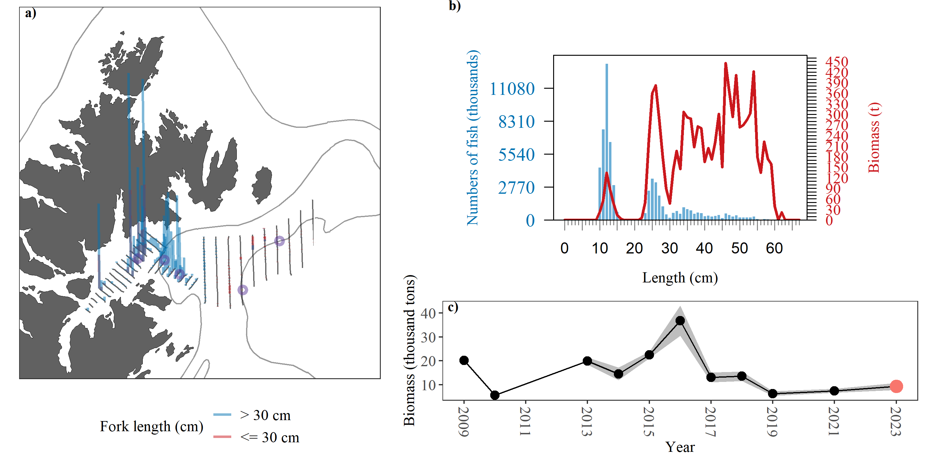

Figure A3.. -- 2023 Marmot Bay sampling summary. a) Density (t/nmi^2^) attributed to pollock (vertical lines) along tracklines. Biomass densities are categorized based on haul catches comprised of mostly adult (>30 FL, blue) or juvenile (≤ 30 FL, red) pollock. Trawl locations are indicated with purple circles. b) Numbers- (blue bars) and biomass- (red line) at-length estimates of pollock. c) Summary of age-1+ pollock biomass estimates (thousands of metric tons) from 2009 to 2023. Current survey estimate in red, and shaded area indicates 1-D geostatistical 95% confidence intervals

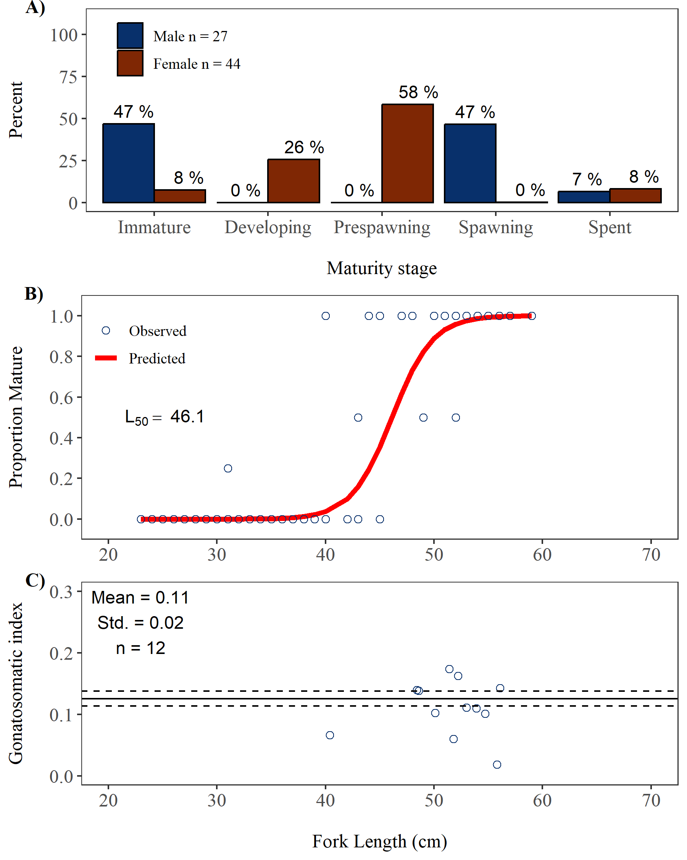

De Robertis, A., and K. Taylor. 2014. [*In situ* target strength measurements of the scyphomedusa *Chrysaora melanaster*](https://doi.org/10.1016/j.fishres.2014.01.002). Fish. Res. 153:18–23.

Demer, D. A., and S. G. Conti. 2005. [New target-strength model indicates more krill in the southern ocean](https://doi.org/10.1016/j.icesjms.2004.07.027). ICES J. Mar. Sci. 62:25–32.

Foote, K. G. 1987. Fish target strengths for use in echo integrator surveys. J. Acoust. Soc. Am. 82:981–987.

Foote, K. G., and J. J. Traynor. 1988. [Comparisons of walleye pollock target strength estimates determined from *in situ* measurements and calculations based on swimbladder form](https://doi.org/10.1121/1.396190). J. Acoust. Soc. Am. 83:9–17.

Gauthier, S., and J. K. Horne. 2004. [Acoustic characteristics of forage fish species in the Gulf of Alaska and Bering Sea based on Kirchhoff-approximation models](https://doi.org/10.1139/f04-117). Can. J. Fish. Aquat. Sci. 61:1839–1850.

Guttormsen, M. A., and C. D. Wilson. 2009. [*In situ* measurements of capelin (*Mallotus villosus*) target strength in the North Pacific Ocean](https://doi.org/doi:10.1093/icesjms/fsn205). ICES J. Mar. Sci. 66:258–263.

Kang, D., T. Mukai, K. Iida, D. Hwang, and J.-G. Myoung. 2005. [The influence of tilt angle on the acoustic target strength of the Japanese common squid (*Todarodes pacificus*)](https://doi.org/10.1016/j.icesjms.2005.02.002). ICES J. Mar. Sci. 62:779–789.

Ona, E. 2003. [An expanded target-strength relationship for herring](https://doi.org/10.1016/s1054-3139(03)00031-6). ICES J. Mar. Sci. 60:493–499.

Traynor, J. J. 1996. Target-strength measurements of walleye pollock (*Theragra chalcogramma*) and Pacific whiting (*Merluccius productus*). ICES J. Mar. Sci. 53:253–258.