YFS flatfish mcmc
SSMA Authors
10/9/2018

Marginals from MCMC runs
Model 2 (called Model 18_1 in SAFE) and Model 4 (called Model 14_2 in SAFE) need posterior of Fmsy, maybe on one figure?. For Model 18.1 (new base) need posteriors of Fmsy Bmsy, ABC biomass 2018, ABC biomass 2019, FSB and mean log recruitment.
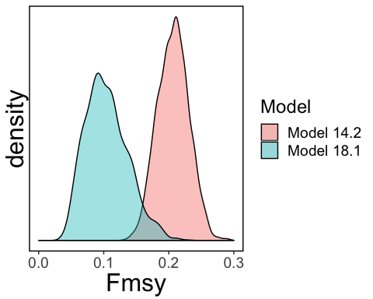

Other plots
You can also embed plots, for example:
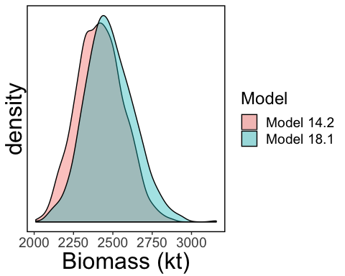
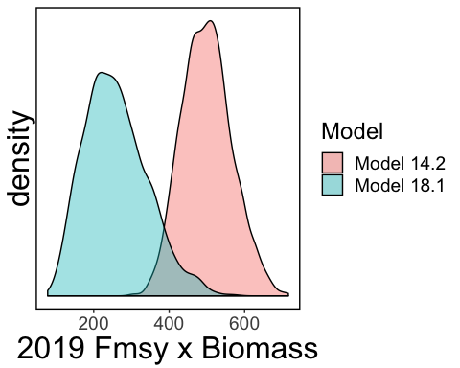
## # A tibble: 1 x 3
## FABC Biomass ABC
## <dbl> <dbl> <dbl>
## 1 0.129 2445. 316.

