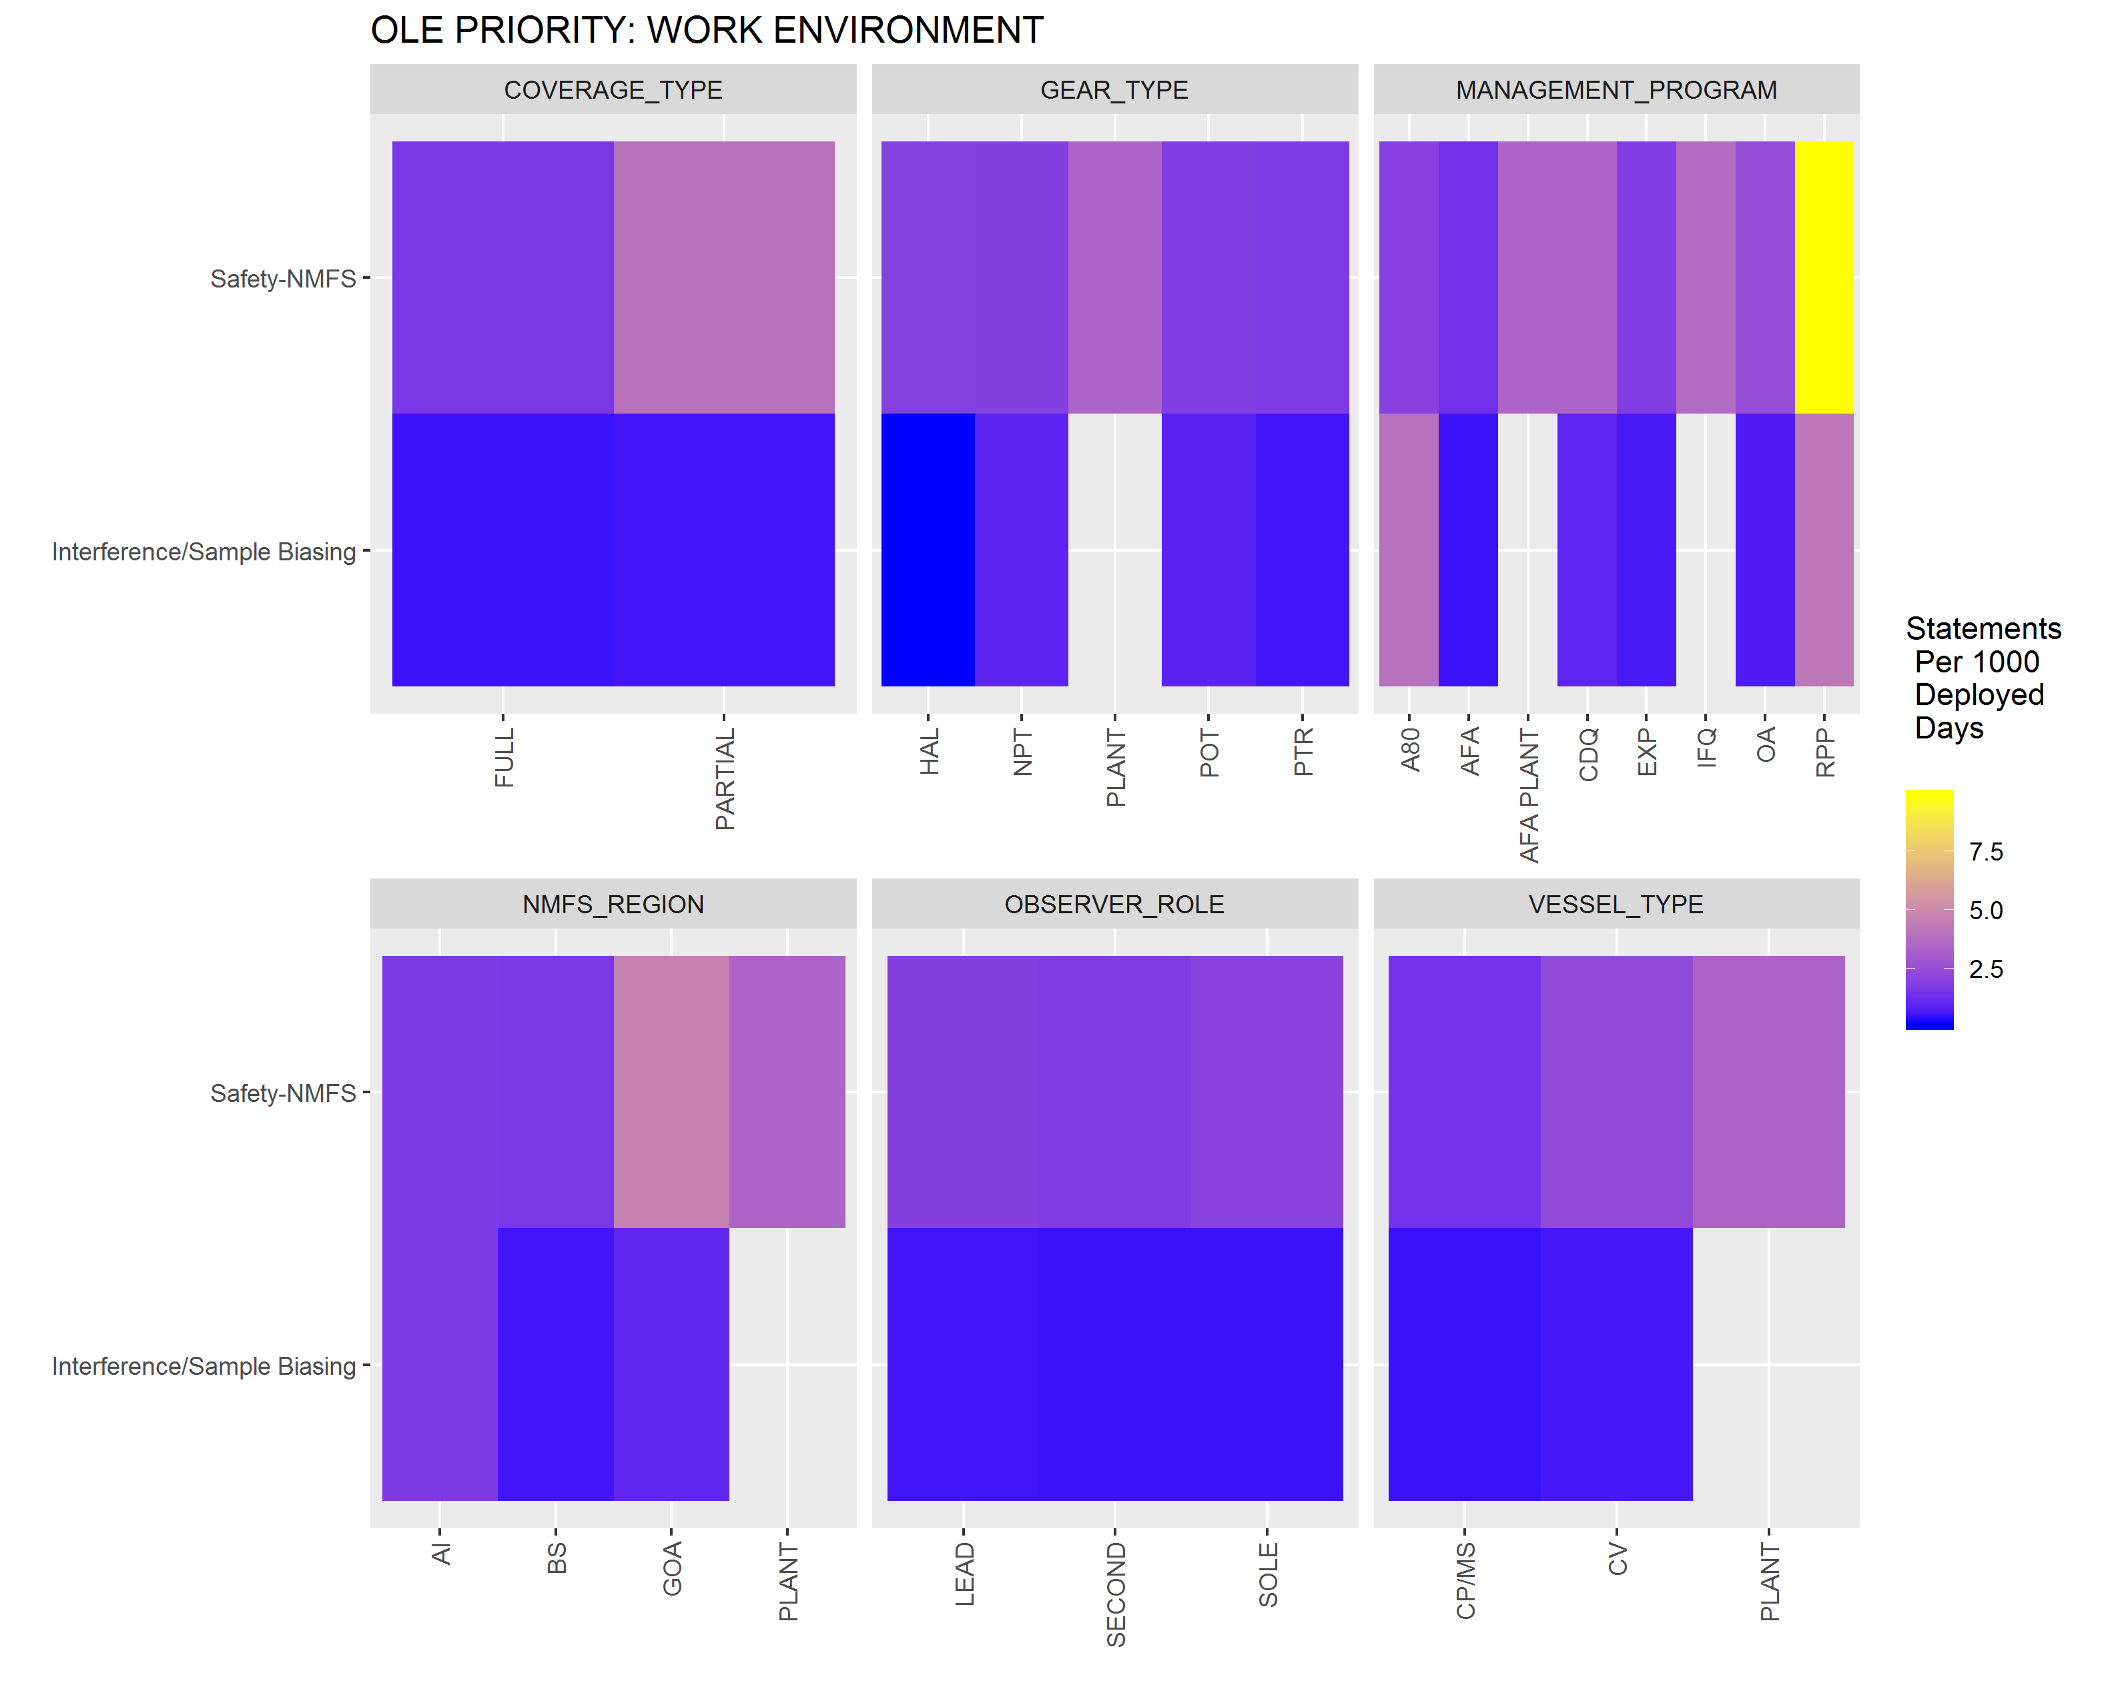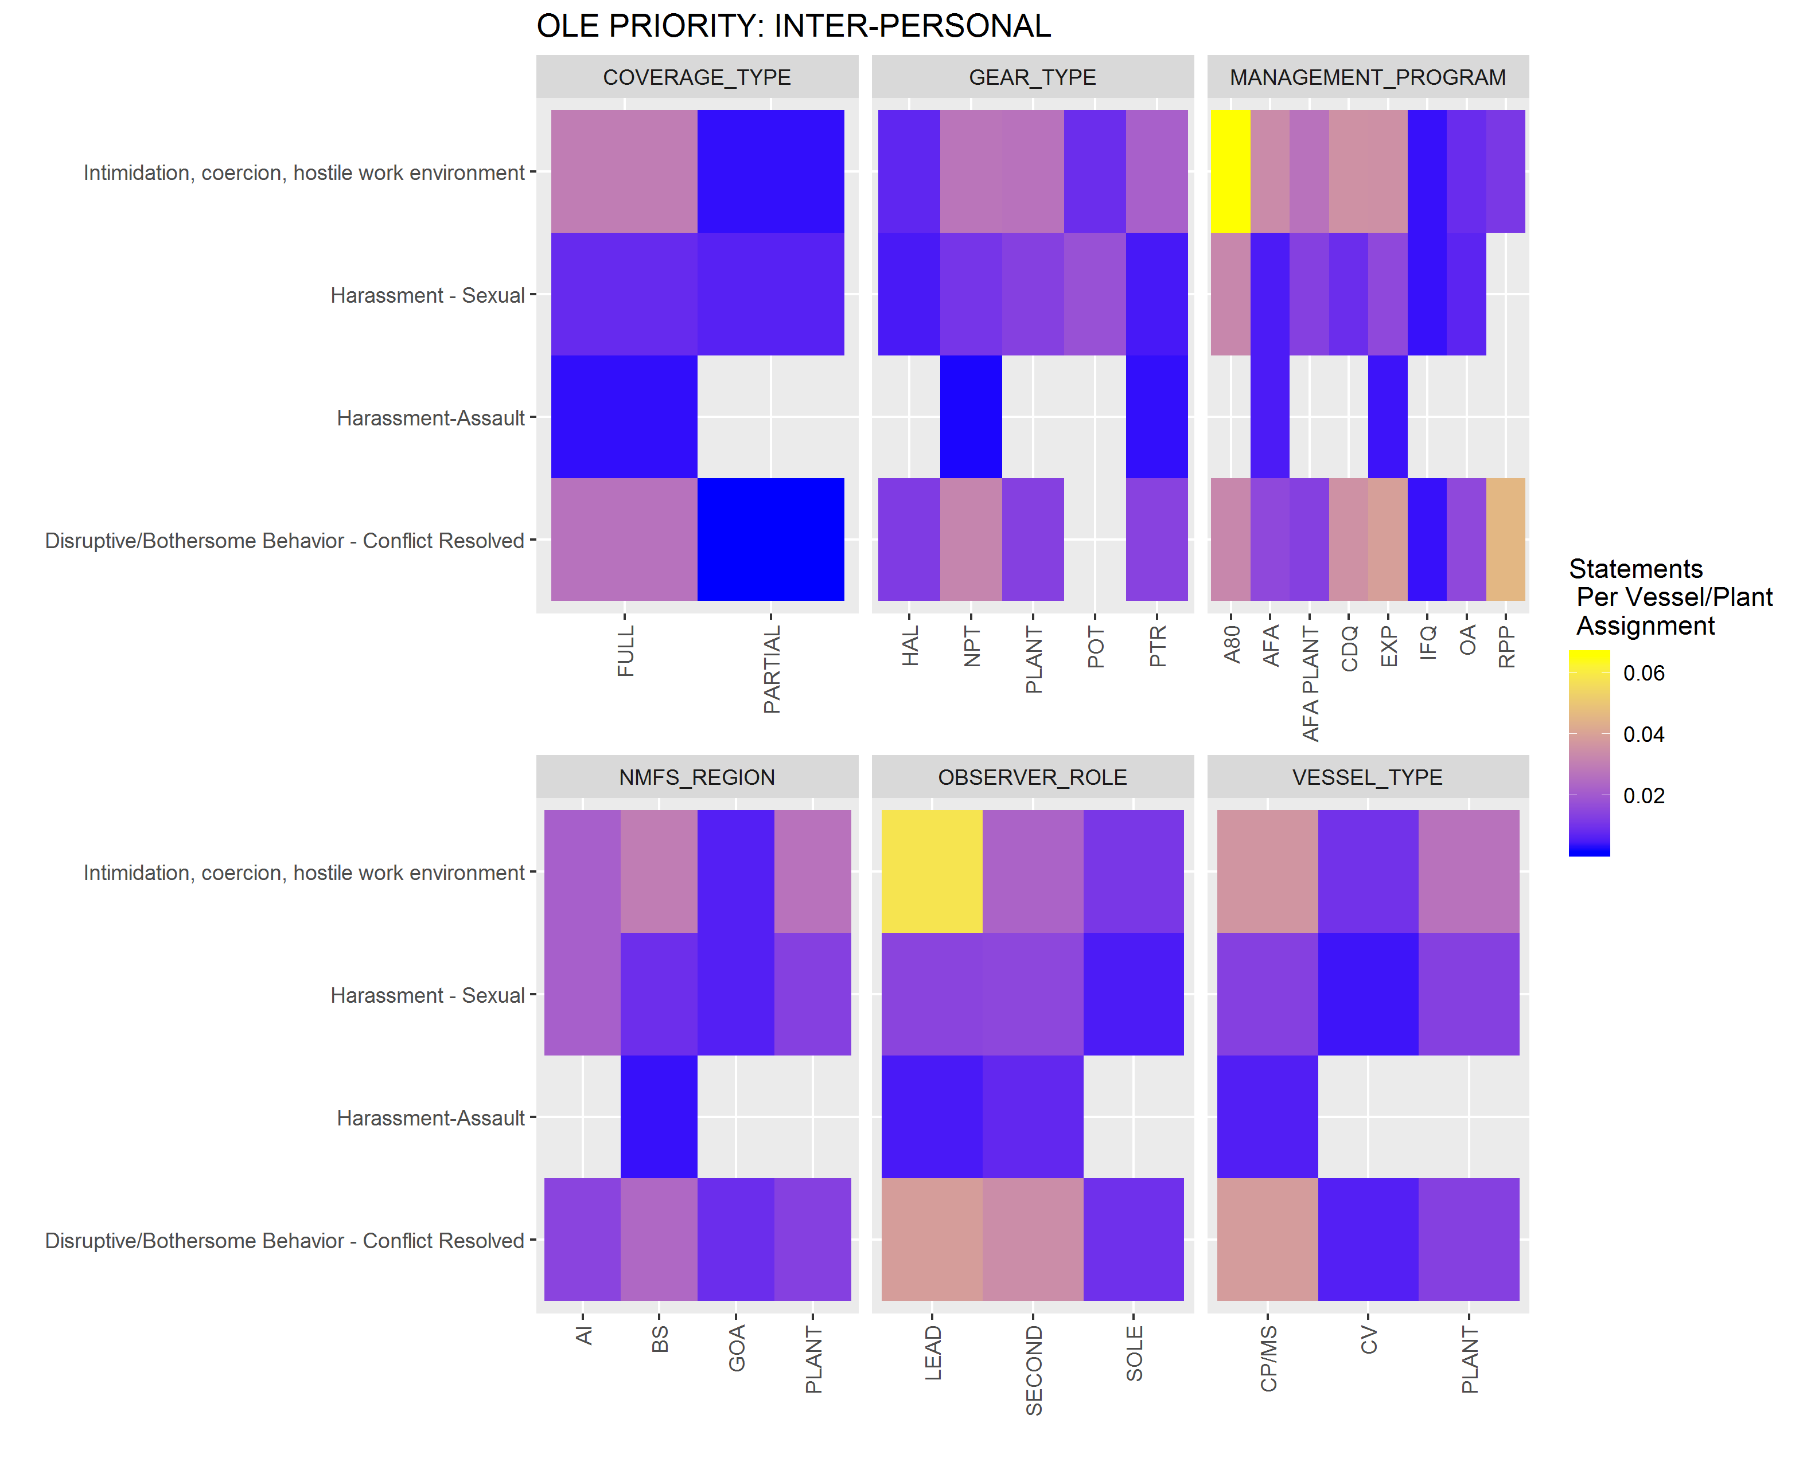

The proportion(bars), and number of ODDS-related issues reported by FMA to OLE 2015-2018. Tendering strata were introduced in 2017.