**NOAA Ship FERDINAND R. HASSLER**

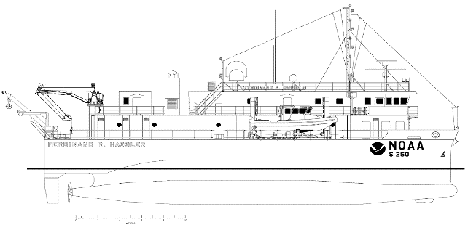**Standard Operating Procedure Document**

**Ellipsoidally Referenced Dynamic Draft Model (ERDDM)**

**Revision History**

|  |  |  |  |
| --- | --- | --- | --- |
| DATE | DESCRIPTION | VERSION | AUTHOR |
| 08/28/2020 | NOAA Ship Thomas Jefferson ERDDM SOP | 1.0 | NOAA Ship Thomas Jefferson survey personnel |
| 05/06/2021 | Expanded and edited for FH | 1.1 | ST Tigges |
| 2/26/2023 | Reviewed. Minor updates | 1.2 | LT Debroisse |
|  |  |  |  |
|  |  |  |  |

**Software Used**

* MVPOSView (acquisition)
* Hypack (optional, acquisition)
* POSPac MMS (processing)
* Pydro Charlene (processing
* Pydro POSPac AutoQC (processing)
* Microsoft Excel (processing)
* Caris HIPS and SIPS (Vessel Editor tool, processing)

**Inputs**

* POS .000 files

**Outputs**

* POSPac AutoQC plot/outputs
* Completed Microsoft Excel .xlsx spreadsheet
* Updated Caris .hvf

**General Information**

Because HSRR can get a bit technical and tricky, here is some background information related to ERDDM. **You can skip over this if you would like,** but it’s here to help if you’d like to read it.

**Definitions and Background**

**Static draft** refers to the draft of the vessel when it is not moving. The static draft depends on loading conditions such as fuel, ballast, and launches in davits. Thus, static draft values can change daily.

**Dynamic draft** refers to changes to a vessel’s static draft due to motion and can be described by settlement and squat. **Settlement** is the sinking of the vessel into a temporary trough that results from the buildup of water pressure around the vessel. **Squat** is the change in angle of the vessel’s waterline with respect to the water as the vessel moves at different speeds. In general, a vessel’s stern sinks down and its bow lifts up as it increases its speed.

An **Ellipsoidally Referenced Dynamic Draft Model (ERDDM)** is a model that we create annually for a hydrographic survey vessel during HSRR. This model represents the dynamic draft of the vessel, and the values from the model are entered into the vessel’s HIPS Vessel File (HVF), which is applied to the data during the georeferencing step (also sometimes called the merging step) of Caris processing.

**Does the vessel’s dynamic draft (and thus ERDDM) actually matter when we survey to the ellipse?**

When we survey, we use the vessel’s primary reference point (RP) as the reference point for all measurements. (Often, the vessel’s reference point coincides with the ship’s inertial measurement unit, or IMU. In the case of the *Hassler*, the reference point is the starboard IMU.)

When measuring the distance from the water’s surface to the seafloor during traditional non-ERS surveys, the sonar-to-RP and the vessel waterline-to-RP distances must both be known. The waterline-to-RP and the sonar-to-RP distances are necessary to calculate the waterline-to-sonar distance, which can be added to the sonar-to-seafloor distance to obtain the waterline-to-seafloor measurement. The waterline-to-RP measurement varies with changes to the static draft due to ship loading and ballasting. In addition to these changes in static waterline, there are dynamic changes to the waterline due to the hydrodynamics of the hull. Settlement and squat refer to the change in vessel elevation relative to the sea surface, and they change with vessel speed. Settlement can change based on water depth; measurements assume the water depth is large compared to the vessel draft, so surveying in shallow water can cause complications. Furthermore, differences in speed over ground and speed through the water due to factors such as currents can cause additional complications. In summary, static and dynamic draft observations are an important component of traditional non-ERS surveys, but they can be difficult to measure.

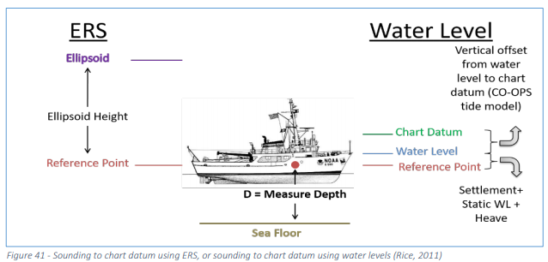 When surveying to the ellipse, all vertical movements of the vessel are included in the GNSS height observation. This encapsulates water levels or tides, heave, and static and dynamic draft. GNSS observations at the antenna are directly related to depth observations through measurements of vessel offset, giving a direct measurement from the ellipsoid to the seafloor. All sounding depths are relative to the transducer, and these are translated to the vessel RP using the sonar-to-RP elevation. The antenna determines the ellipsoidal height, which is related to the RP with the antenna-to-RP elevation. Combining the measurements of ellipsoid-to-antenna, antenna-to-RP, RP-to-sonar, and sonar-to-seafloor yields the ellipsoid-to-seafloor measurement. In this case, it is still important to measure and correct data for attitude (roll, pitch, and yaw) because vessel orientation is still relevant. We then use a separation model to reduce the ellipsoid-to-seafloor measurement to chart datum, or MLLW.

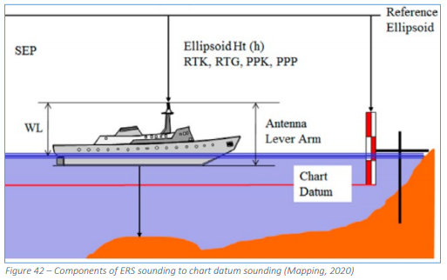 So, if all vertical movements are included in the GNSS height observation for ERS, why do we care about dynamic draft? In general, static draft, dynamic draft, and heave observations remain necessary to determine the location of the transducer within the water column, which is used for precise ray tracing calculations and to retrieve the actual water surface. Retrieving the actual water surface allows for comparison with traditional tidal techniques, and ellipsoid-to-water surface measurements can validate hydrodynamic models (Mills et al. 2014).

**How do we make an ellipsoidally referenced dynamic draft model?**

We make ellipsoidally referenced dynamic draft measurements by collecting POS data while operating the ship at different speed increments. We then use the POS data to make an SBET, which we run through POSPac AutoQC in Pydro to compute a dynamic draft model. Once we obtain this model, we enter the model values into a spreadsheet, which averages these new model values with historical model values. Then, these averaged values are entered into the HVF.

**Additional Information and Resources**

Hydrographic Surveys Specifications and Deliverables 2021, Section 5.2.3.2 Draft Corrections

Field Procedures Manual 2020, Section 1.4.4.2 Dynamic Draft, Section 4.2.8 SV Correct, and Section 7.1 Appendix 1: HVF and Offsets

5 Minute Modules - Ellipsoidally Referenced Dynamic Draft (ERDDM), <https://www.youtube.com/watch?v=UN29Rdp8Ei0>

Smart Start Module III: Datum Control

Ellipsoidally Referenced Surveying for Hydrography, Jerry Mills and David Dodd, International Federation of Surveyors (FIG) 2014, https://www.fig.net/resources/publications/figpub/pub62/Figpub62.pdf

**ERDDM Procedure**

An ERDDM procedure is described in section 1.4.4.2.1 Dynamic Draft Measurement Techniques in the 2020 Field Procedures Manual.

1. **Take a static draft measurement.**

To start, take a static draft measurement for the vessel. This is done by measuring from the main deck to the water line and plugging the values into the Waterline Calc Sheet.

Location: P:\Survey_Storage\04_SOPs\0_HSRR\8_Static Draft

Launch static drafts cannot be done while underway. You must be at a dock to take static measurements on a launch.

1. **Make a line plan in Hypack.**

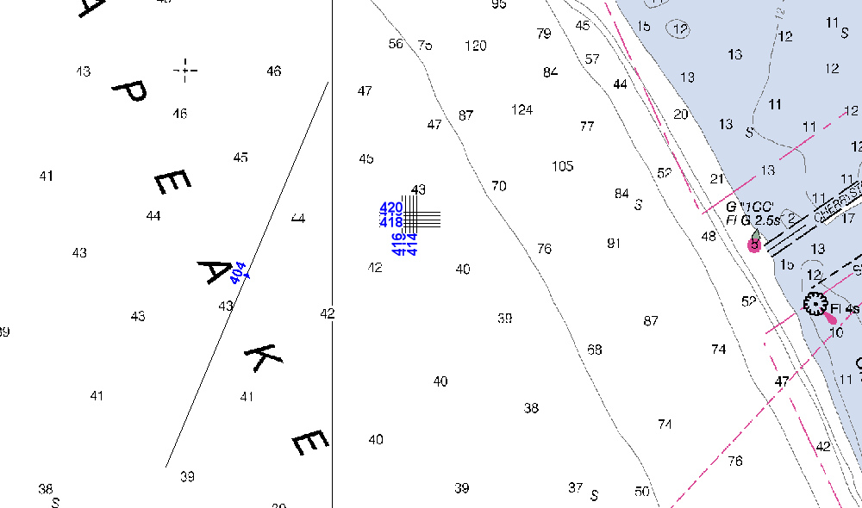In Hypack, create a line plan with one line that is around 3 to 4 nautical miles in length. For the ERDDM process to work properly, the line should be located in a spot where the ellipsoid is relatively flat to the Earth. You also want to be able to drive the line in an uninterrupted fashion, so make sure that there are no obstacles or traffic that will interfere.

1. **Create an acquisition log.**

Start an acquisition log for the ERDDM process. The log should look like the one pictured below, and a blank copy should be called VESL_ERDDM_Acquisition_Log_YYYY and located in the folder P:\Survey_Storage\04_SOPs\0_HSRR\2_ERDDM.

Rename the log appropriately and save it in the folder P:\Survey_Storage\00_PROJECTS\YYYY\HSRR\2_ERDDM. Fill out the general information at the top of the log.

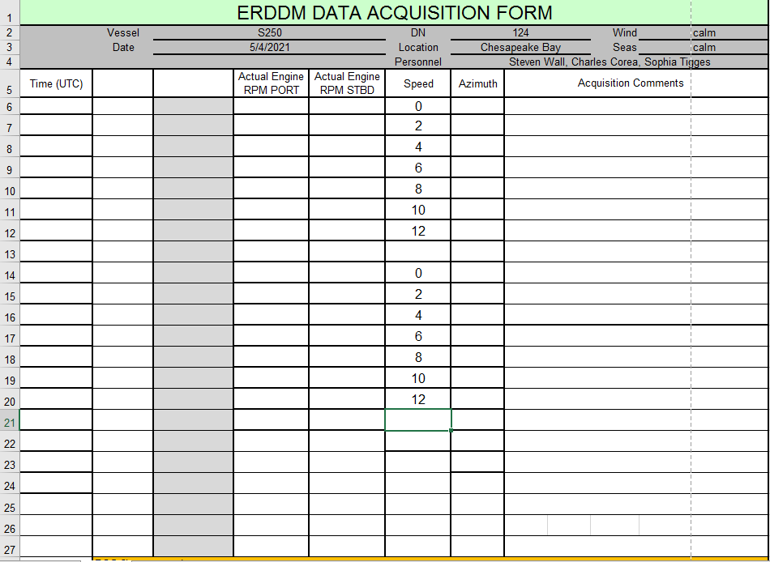Additionally, go ahead and enter the speeds that you are planning to run at. You should start with 0 kts, and typically you should increase the speed by 2 kts to eventually work up to ~12 kts. However, if clutch ahead is faster than 2 kts, you can start with the lowest possible speed and increase incrementally from there. Because you will drive the line back and forth, enter all of the speeds twice.

1. **Log POS data while driving the line at different speeds.**

Set up POS to log data.Ask the bridge to line up at the beginning of the line, then begin logging data while remaining dead in the water for at least five minutes.

Then, continue along the line while increasing speed to the first target speed. Record the time and the port and starboard RPMs. Maintain the same RPMs for at least two minutes. (Maintaining the same RPMs means that you are maintaining the same speed through the water). Then, stop the vessel and wait dead in the water for at least two to three minutes.

Repeat this process with all of the target speeds while running the line in one direction. Then, wait dead in the water for at least two minutes before repeating the process while running the line in the opposite direction. (You must run the line in both directions to account for any currents that might have an effect on the vessel’s draft.)

Once you are done running the line in both directions, you can stop logging POS data. Make sure that the acquisition log is complete.

1. **Create an SBET from the logged POS data.**

Once acquisition is complete, you can use POSPac or Charlene to create an SBET from the POS data that you logged. (Refer to the POSPac processing SOP located at P:\Survey_Storage\04_SOPs\3_Processing\2_Positioning if you need help making an SBET. Save the POSPac project and the SBET in P:\Survey_Storage\00_PROJECTS\YYYY\HSRR\2_ERDDM\PosPac_Project

1. **Run the SBET through POSPacAutoQC in Pydro.**

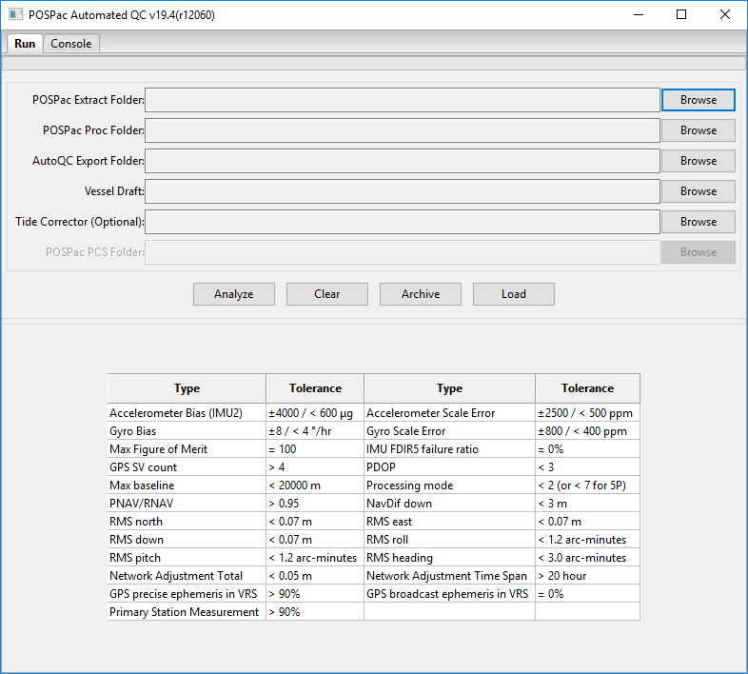After the SBET has been created, run it through POSPacAutoQC, which is a tool within Pydro. First, open Pydro and click the *+* button to expand the *ERS* menu in the sidebar on the left. Double click on *POSPacAutoQC* to open the program. The POSPacAutoQC window, shown below, should open. Follow the steps described below to set up and run POSPacAutoQC.

1. Next to the *POSPac Extract Folder* field, click the *Browse* button to browse to and select the Extract folder for the POSPac project that was made when you created the SBET. After you have made your selection in the popup window, click *OK* to proceed.
2. After you click *OK* to select the Extract folder, the *POSPac Proc Folder* field should fill automatically. (If it doesn’t, browse to and select the Proc folder for the SBET/POSPac project.)
3. Next to the *AutoQC Export Folder* field, click the *Browse* button to browse to the location where you would like the AutoQC output files to be saved. P:\Survey_Storage\00_PROJECTS\YYYY\HSRR\2_ERDDM\AutoQC
4. Next to the *Vessel Draft* field, click the *Browse* button to browse to and select the most recent HVF file for the vessel.
5. You can leave the *Tide Corrector* field blank.
6. Click the *Analyze* button to start processing. A green progress bar will fill at the top of the window, and more tabs will appear at the top of the window as the processing steps are completed.

**Progress bar will fill and tabs will populate during processing.**

**F**

**(E)**

**D**

**B**

**A**

**C**

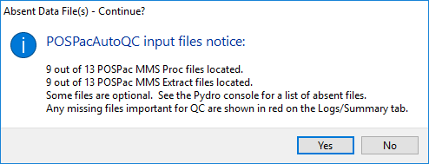Note that after you click *Analyze*, you might get a popup window with a warning that looks like the one shown below. This is fine, and you can click *Yes* to proceed.

When POSPacAutoQC is done analyzing the SBET, click on the *Dynamic Draft* tab at the top of the window.

Save this set of dynamic draft plots by clicking the floppy disk save icon at the bottom of the window. An appropriate location to save these plots could be the HSRR/ERDDM folders that you have been working with.

1. **Enter the model values into the ERDDM spreadsheet.**

Open a blank copy of the ERDDM results spreadsheet, called VSSL_ERDDM_Results_YYYY and located in P:\Survey_Storage\04_SOPs\0_HSRR\2_ERDDM.

This spreadsheet is designed to average the dynamic draft model values from the current HVF with the dynamic draft model values obtained from the ERDDM procedure that was just completed. **You should only enter values into the orange cells of the spreadsheet. The light blue cells are the values that you will enter into the HVF along with the dynamic draft uncertainty value.**

(Note: The idea with the spreadsheet is that you can take these dynamic draft measurements annually to obtain repeated measurements over a long span of time. By averaging the new measurements with the values from the previous HVF, you can give the current measurements half a weight while still giving weight to the past measurements.

However, if you are suspicious of the values in the current HVF for some reason, you don’t have to average them with the cubic model values to obtain the new values to enter into the HVF. Discuss this with the FOO, and any other relevant personnel to see what they think to make the best decision based on the measurements and the situation.

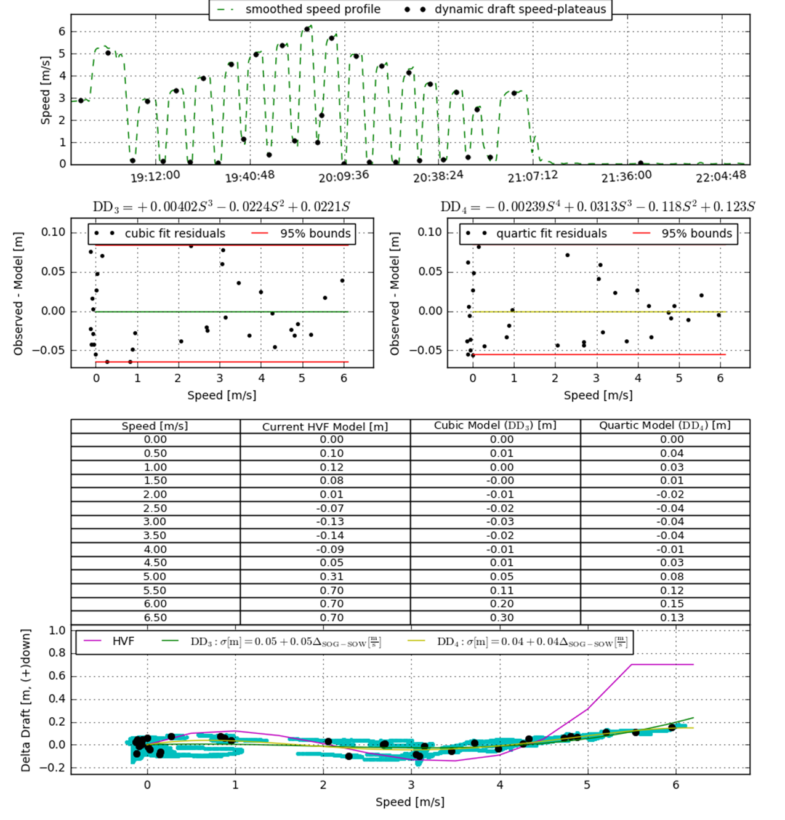For example, in the case shown below for FH ERDDM 2021, you can see that there is a very large difference between the values from the HVF and from the model. The current HVF is shown by the purple curve, the cubic model is shown by the green curve, and the quartic model is shown by the yellow curve. In such a case, you may choose not to average the new values with the old values.)

**These values from the current HVF seem high…**

**…which will throw off the new values if they are included in the average.**

**…which is shown by this large difference here…**

Open the dynamic draft plots that you saved from POSPacAutoQC. Paste a copy of the saved plot image into the spreadsheet for reference.

Then, from the table, enter the values from the *Current HVF Model*, *Cubic Model*, and *Quartic Model* into the appropriate columns of the spreadsheet. (These values and columns are shown below in red.)

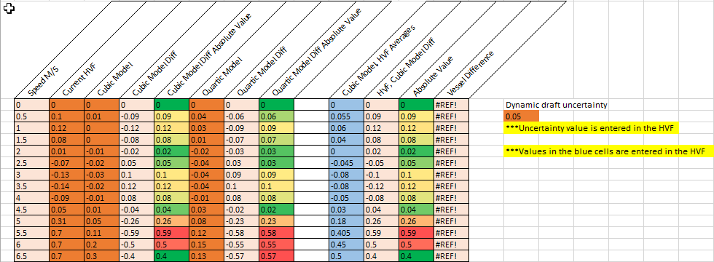Additionally, enter the dynamic draft uncertainty value into the orange cell on the right side of the spreadsheet. This uncertainty value is found in the cubic model equation displayed on the bottommost plot, as shown below in purple. (You do not want to use the uncertainty of the values themselves for the dynamic draft uncertainty. You want to use the model uncertainty. This uncertainty value is entered into the HVF and used when calculating the Total Propagated Uncertainty, or TPU.)

1. **Enter the new values into the HVF.**

Now that the spreadsheet is complete, you can enter the new dynamic draft values into the HVF for the vessel. You can modify HVFs in Caris Vessel Editor.

To open Vessel Editor, open Caris. Then, in the main Caris toolbar, click on *Tools* > *Editors* > *Vessel*. (You can also click on the *Vessel Editor* icon  in the main toolbar.) To open an HVF in Vessel Editor, click on *File* > *Open* in the main Vessel Editor toolbar, then navigate to the HVF that you want to edit.

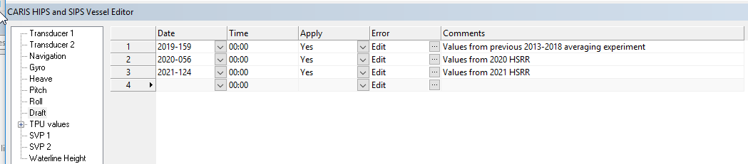Once you have opened the HVF in Vessel Editor, click on *Draft* in the pane on the left side of the window. Then, in the *Date* column, enter the date that the ERDDM procedure was performed. For the *Time*, you can leave it at 00:00. In the *Apply* column, select *Yes* from the dropdown menu. In the *Comments* column, enter any pertinent notes about the values that you are entering. Finally, to enter the values, click on the  button in the *Error* column.

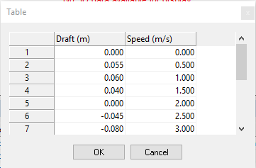The *Table* window should pop up. Enter the correct speed values in the *Speed (m/s)* column (0.0 through 6.5 m/s in increments of 0.5 m/s). Then, enter the corresponding values into the *Draft (m)* column. These values will be from the light blue column labeled *Cubic Model, HVF Averages* in the spreadsheet. Click *OK* to finish.

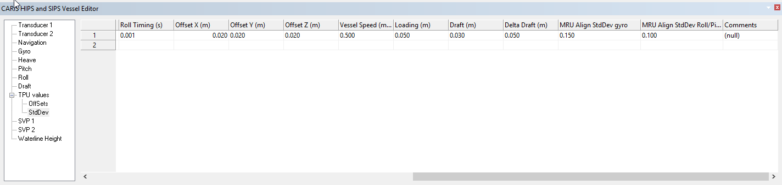 Then, in the pane on the left side of the Vessel Editor window, click the *+* button to expand the *TPU values* menu, then click on *StdDev*. Scroll to the right until you see the *Delta Draft (m)* column. In this cell, enter the dynamic draft uncertainty value from the spreadsheet.

Finally, save the HVF by clicking *File* > *Save* in the main toolbar of Vessel Editor. **Make sure that you use this updated version of the HVF from now on!** Save it in all of the appropriate locations and make sure to archive to old HVF so that is can eventually be deleted.

**Alternative Procedures**

Here are some other things that you may be asked to do or you may choose to do during ERDDM processing.

**Using the cubic or quartic model instead**

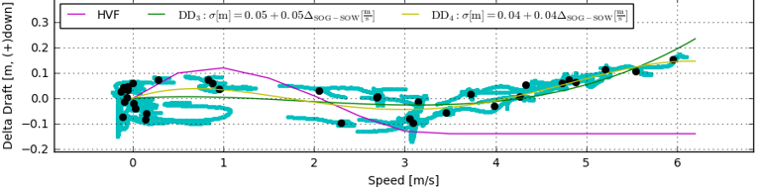In some cases, such as in the FH 2021 case shown above, you may not want to average the new model values with the old HVF values. Instead, you can use either the cubic model values or the quartic model values and their associated uncertainties. To do this, examine the models in the plot to determine which model is a better fit. (Typically, the quartic model will be a better fit because it is of a higher order, but you can see what looks best for your data points.) Then, enter the chosen model values and uncertainty into the HVF.

**…and the quartic model looks even better.**

**…the cubic model looks pretty good…**

**The old HVF values look pretty bad…**

**Making separate SBETs and performing separate analyses for each direction**

If there was any current when you were running the line back and forth, you may wish to create separate SBETs for each direction and analyze those SBETs individually in POSPac AutoQC. You can then see whether the model curves looks different from one another. For example, you may get a high curve and a low curve if your speed was different in one direction as opposed to the other due to the current, as shown below. If you get a high curve and a low curve, you can average the model values together to calculate the values to enter into the HVF. Or, depending on the situation, you may just want to use the curve produced from the analysis of the combined SBET. Ask Ops or the CST for guidance if you are unsure about what’s best.

If you do choose to average the curves, you can calculate the new uncertainty value by taking the square root of the sum of the squares of the individual uncertainties:

.

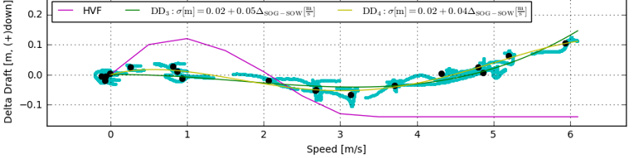

**Currents produced a “high curve” and a “low curve” for the models.**

**Northbound**

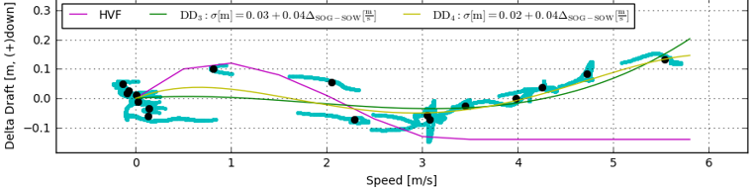

**Southbound**