**INFORMATION SYSTEMS III**

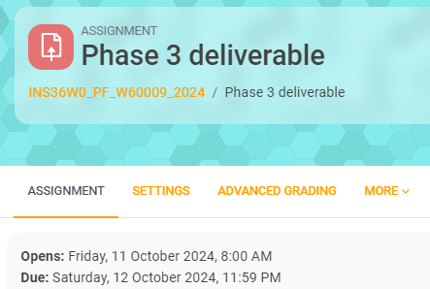

**Required**:

* **For a desktop app prepare a:**
* PowerPoint file with the project name and group members (refer to the attached example);
* Folder and submit a zip file; and
* +/- 5 minutes video explaining a step-by-step functionality of the project

(**NB**: this is required for auditing purposes).

* **For a web-based app prepare a:**
* PowerPoint file with the project name and group members (refer to the attached example);
* Folder and include a link for the application.; and
* +/- 5 minutes video explaining a step-by-step functionality of the project

(**NB**: this is required for auditing purposes).

*** No late submissions will be allowed.